**JAVA LAB ASSIGNMENT**

**WEEK 1**

**Name:PUNEETH L**

**USN: 1BM24MC069**

**1. The following table shows the employees code and the percentage of bonus for the value of basic pay.  
Employee code Bonus  
 100                     5  
 200                     1  
 300                    2  
 400                    25**

PROGRAM:

import java.util.*;

class employee {

int e_code;

int bonus;

float salary;

Scanner sc=new Scanner(System.in);

employee(int code,float salary) {

this.e_code = code;

this.salary = salary;

}

void increment() {

System.out.print("Enter the bonus percentage for employee " + this.e_code + ": ");

this.bonus = sc.nextInt();

this.salary = this.salary + (this.salary * this.bonus / 100);

System.out.println("Bonus added successfully. New salary for employee " + this.e_code + ": " + this.salary);

}

}

public class employee_bonus {

public static void main(String[] args) {

Scanner sc = new Scanner(System.in);

employee e1=new employee(1001,50000);

employee e2=new employee(1002,80000);

employee e3=new employee(1003,55000);

employee e4=new employee(1004,60000);

e1.increment();

e2.increment();

e3.increment();

e4.increment();

}

}

OUTPUT:

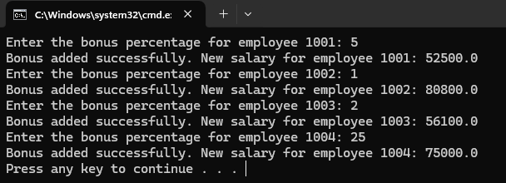

**2. Write a program to display the following output using for loop:  
  ( a)  
       1  
       1 2  
       1 2 3  
       1 2 3 4  
       1 2 3 4 5  
  ( b)   
       1  
       2 2  
       3 3 3  
       4 4 4 4  
       5 5 5 5 5  
  
  ( c)   
       * * * * *  
       * * * *  
       * * *  
       * *  
       \***

PROGRAM:

public class NumberPattern {

public static void main(String[] args) {

for (int i = 1; i <= 5; i++) {

for (int j = 1; j <= i; j++) {

System.out.print(j + " ");

}

System.out.println();

}

System.out.println();

for (int i = 1; i <= 5; i++) {

for (int j = 1; j <= i; j++) {

System.out.print(i + " ");

}

System.out.println();

}

System.out.println();

for (int i = 5; i >=0; i--) {

for (int j = i; j >0; j--) {

System.out.print("* ");

}

System.out.println();

}

}

}

OUTPUT:

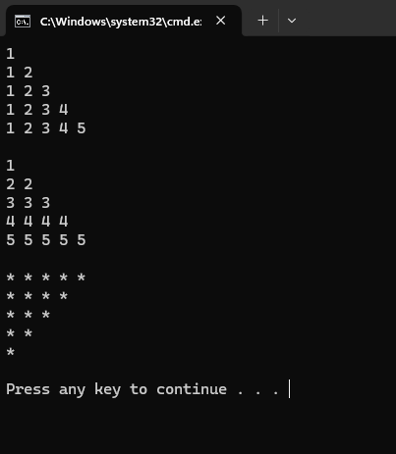

**3. Write a program that performs the following: If the user gives input as 1, the output is 2; if the input is 2 then the output becomes 1.**

**PROGRAM:**

import java.util.*;

class simpleif {

public static void main(String[] args) {

Scanner sc = new Scanner(System.in);

int num;

System.out.print("Enter a number:");

num = sc.nextInt();

if (num == 1 || num == 2) {

if (num == 1) {

num = 2;

} else {

num = 1;

}

}

System.out.println("output:" + num);

}

}

**OUTPUT:**

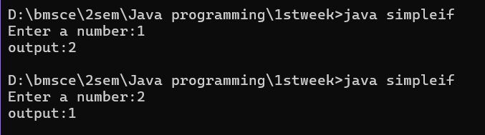

**4. Write and run a Java program that inputs three names and print them in their alphabetical order.**

PROGRAM:

import java.util.*;

class alphabetic{

public static void main(String[] args){

Scanner sc= new Scanner(System.in);

String names[]= new String[3];

for(int i=0; i<names.length;i++){

System.out.print("Enter name:");

names[i]=sc.nextLine();

}

Arrays.sort(names);

System.out.println("Names in sorted order:");

for(String name : names){

System.out.println(name);

}

}

}

OUTPUT:

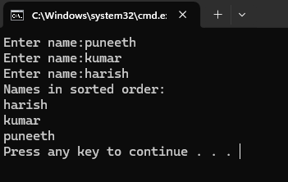

**5. A number is said to be palindrome if it is invariant under reversion; that is, the number is the same if its digits are reversed. For example, 3456543 is palindromic. Write a program that checks each of the fi rst 10,000 prime numbers and prints those that are palindromic**.

Program:

public class myclass {

public static boolean isPrime(int n) {

if (n <= 1) {

return false;}

if (n == 2) {

return true;}

if (n % 2 == 0) {

return false;

}

for (int i = 3; i <= Math.sqrt(n); i += 2) {

if (n % i == 0) {

return false;} }

return true;}

public static boolean isPalindrome(int n) {

String str = Integer.toString(n);

int left = 0, right = str.length() - 1;

while (left < right) {

if (str.charAt(left++) != str.charAt(right--)) {

return false; } }

return true; }

public static void main(String[] args) {

int count = 0;

int num = 2;

while (count < 10000) {

if (isPrime(num)) {

count++;

if (isPalindrome(num)) {

System.out.println(num); }

}

num++;

} } }

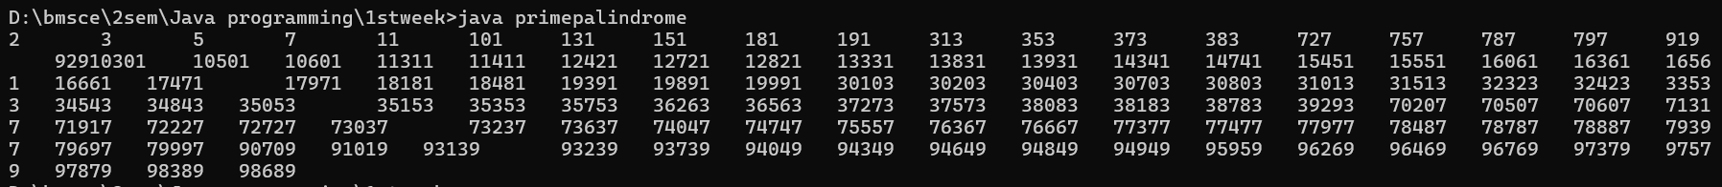

**6. Design a class to represent account, include the following members.  
   Data Members:**

* **Name of depositor—string**
* **Account Number—int**
* **Type of Account—boolean**
* **Balance amount—double**

**Methods**

* **To assign initial values (using constructor)**
* **To deposit an amount after checking balance and minimum balance 50.**
* **To display the name and balance.**

Program:

import java.util.*;

class Myaccount {

String name;

int accno;

boolean typeofacc;//true for savings, false for current.

int amt;

float balance;

Myaccount(int accno, String name, boolean typeofacc, float balance) {

this.accno = accno;

this.name = name;

this.typeofacc = typeofacc;

if (balance >= 50) {

this.balance = balance;

} else {

System.out.println("Initial balance is less than 50. Setting balance to 50.");

this.balance = 50;

}

}

void deposit(int amt) {

this.balance = this.balance + amt;

}

void display() {

System.out.println("Account holder name: " + this.name + "\nBalance:" + this.balance);

}

}

class account {

public static void main(String[] args) {

Scanner sc = new Scanner(System.in);

Myaccount m1 = new Myaccount(26523, "puneeth", true, 10000);

m1.display();

System.out.print("Enter the amount to deposit:");

int amt = sc.nextInt();

m1.deposit(amt);

m1.display();

}

}

