**JAVA PROGRAMMING**

**ASSIGNMENT 2**

**Name:PUNEETH L**

**USN: 1BM24MC069**

**Write a program called SumAverageRunningInt to produce the sum of 1, 2, 3, ..., to 100. Store 1 and 100 in variables lowerbound and upperbound, so that we can change their values easily. Also compute and display the average.**

**The output shall look like:**

**The sum of 1 to 100 is 5050**

**The average is 50.5**

**Program:**

import java.util.*;

class SumAverageRunningInt {

public static void main(String[] args) {

Scanner sc = new Scanner(System.in);

int start;

int end;

int sum;

float avg;

System.out.print("Enter the starting number:");

start = sc.nextInt();

System.out.print("Enter the ending number:");

end = sc.nextInt();

sum = (end - start + 1) * (start + end) / 2;

System.out.println("The sum of " + start + " to " + end + "is: " + sum);

avg = (float) sum / (end - start + 1);

System.out.println("The average is: " + avg);

}

}

OUTPUT:

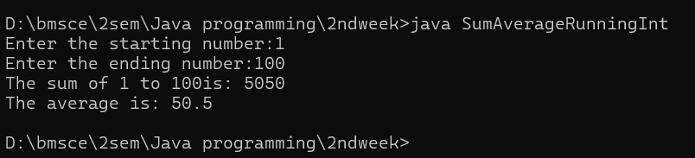

**Write a program called HarmonicSum to compute the sum of a harmonic series, as** **shown below, where n=50000. The program shall compute the sum from left-to-right as well as from the right-to-left. Are the two sums the same? Obtain the absolute difference between these two sums and explain the difference. Which sum is more accurate?**

**PROGRAM:**

public class harmonic {

public static void main(String[] args) {

int n = 50000;

double leftToRight = 0.0;

double rightToLeft = 0.0;

for (int i = 1; i <= n; i++) {

leftToRight += 1.0 / i;

}

for (int i = n; i >= 1; i--) {

rightToLeft += 1.0 / i;

}

System.out.println("Left-to-right sum: " + leftToRight);

System.out.println("Right-to-left sum: " + rightToLeft);

System.out.println("Absolute difference: " + Math.abs(leftToRight - rightToLeft));

System.out.println("More accurate sum: Right-to-left (smaller terms added first)");

}

}

**OUTPUT:**

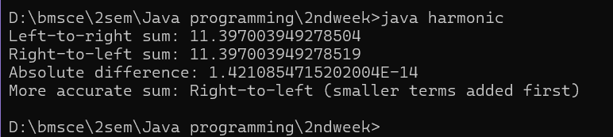

**Write a program called Fibonacci to print the first 20 Fibonacci numbers F(n), where F(n)=F(n–1) +F(n–2) and F (1) =F (2) =1. Also compute their average.**

**The output shall look like:**

**The first 20 Fibonacci numbers are:**

**1 1 2 3 5 8 13 21 34 55 89 144 233 377 610 987 1597 2584 4181 6765**

**The average is 885.5**

**PROGRAM:**

class fibonacci {

public static void main(String[] args) {

float avg;

int n = 20;

int i = 1;

int n1 = 1;

int n2 = 1;

int n3;

int sum = n1 + n2;

System.out.print("The first " + n + " Fibonacci numbers are: \n 1 1 ");

while (i <= n - 2) {

n3 = n1 + n2;

sum = sum + n3;

n1 = n2;

n2 = n3;

i++;

System.out.print(n3 + " ");

}

avg = (float) sum / n;

System.out.println("\nThe average is:" + avg);

}

}

**OUTPUT:**

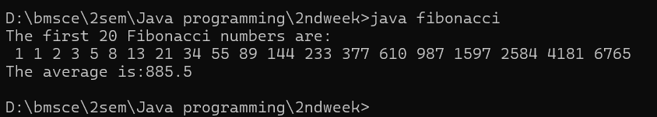

**Write a program called ExtractDigits to extract each digit from an int, in the reverse order.**

**For example, if the int is 15423, the output shall be "3 2 4 5 1", with a space separating the digits.**

PROGRAM:

import java.util.*;

class extractdigit {

public static void main(String[] args) {

int r;

Scanner sc = new Scanner(System.in);

System.out.println("Enter a number consisting of multiple digits:");

int n = sc.nextInt();

while (n != 0) {

r = n % 10;

System.out.print(r + " ");

n = n / 10;

}

}

}

**OUTPUT:**

