**JAVA PROGRAMMING**

**ASSIGNMENT 3**

**Name:PUNEETH L**

**USN: 1BM24MC069**

1. The progressive income tax rate is mandated as follows:

Taxable Income Rate (%)

First $20,000 0

Next $20,000 10

Next $20,000 20

The remaining 30

For example, suppose that the taxable income is $85000, the income tax payable is$20000*0% + $20000*10% + $20000*20% + $25000*30%.Write a program called IncomeTaxCalculator that reads the taxable income (in int). Theprogram shall calculate the income tax payable (in double); and print the result rounded to 2decimal places. Program shall repeat the calculation until user enter -1.

For example,

Enter the taxable income: $41234

The income tax payable is: $2246.80

Enter the taxable income: $-1

bye!

PROGRAM:

import java.util.Scanner;

class IncomeTaxCalculator {

public static void main(String[] args) {

Scanner sc = new Scanner(System.in);

while (true) {

System.out.print("Enter taxable income (or -1 to quit): ");

int income = sc.nextInt();

if (income == -1) {

System.out.println("bye!");

break;

}

double tax;

if (income <= 20000) {

tax = 0;

} else if (income <= 40000) {

tax = (income - 20000) * 0.10;

} else if (income <= 60000) {

tax = (20000 * 0.10) + (income - 40000) * 0.20;

} else {

tax = (20000 * 0.10) + (20000 * 0.20) + (income - 60000) * 0.30;

}

System.out.printf("The income tax payable is: %.2f\n", tax);

}

}

}

OUTPUT:

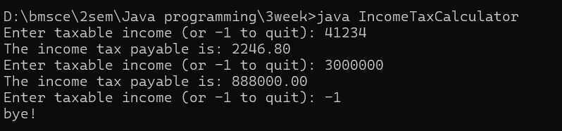

2. Both the employer and the employee are mandated to contribute a certain percentage of the employee's salary towards the employee's pension fund. The rate is tabulated as follows:

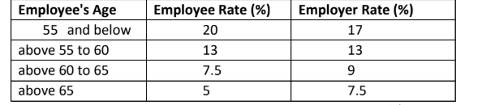

However, the contribution is subjected to a salary ceiling of $6,000. In other words, if an employee earns $6800, only $6000 attracts employee's and employer's contributions, the remaining $800 does not.

Write a program called PensionContributionCalculator that reads the monthly salary and age(in int) of an employee. Your program shall calculate the employee's, employer's and total contributions (in double); and print the results rounded to 2 decimal places.For example,

Enter the monthly salary: $3000

Enter the age: 30

The employee's contribution is: $600.00

The employer's contribution is: $510.00

The total contribution is: $1110.00

PROGRAM:

import java.util.Scanner;

class PensionContribute {

public static void main(String[] args) {

final double SALARY_CEILING = 6000;

Scanner sc = new Scanner(System.in);

System.out.print("Enter the monthly salary: $");

double salary = sc.nextDouble();

System.out.print("Enter the age: ");

int age = sc.nextInt();

double contributionSalary = Math.min(salary, SALARY_CEILING);

double employeeRate;

double employerRate;

if (age <= 55) {

employeeRate = 0.20;

employerRate = 0.17;

} else if (age <= 60) {

employeeRate = 0.13;

employerRate = 0.13;

} else if (age <= 65) {

employeeRate = 0.075;

employerRate = 0.09;

} else {

employeeRate = 0.05;

employerRate = 0.075; }

double employeeContribution = contributionSalary * employeeRate;

double employerContribution = contributionSalary * employerRate;

double totalContribution = employeeContribution + employerContribution;

System.out.printf("The employee's contribution is: $%.2f\n", employeeContribution);

System.out.printf("The employer's contribution is: $%.2f\n", employerContribution);

System.out.printf("The total contribution is: $%.2f\n", totalContribution);

}

}

OUTPUT:

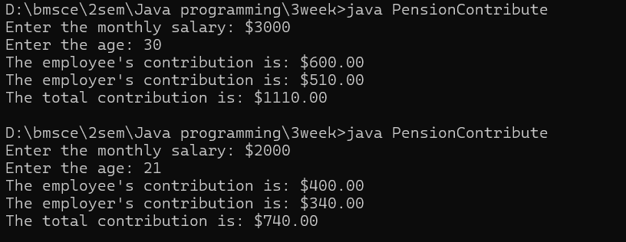

3. Write a program called ReverseString, which prompts user for a String, and prints the reverse of the String by extracting and processing each character.

The output shall look like:

Enter a String: abcdef

The reverse of the String "abcdef" is "fedcba"

PROGRAM:

import java.util.Scanner;

public class ReverseString {

public static void main(String[] args) {

Scanner sc = new Scanner(System.in);

System.out.print("Enter a String: ");

String input = sc.nextLine();

String reverse = "";

for (int i = input.length() - 1; i >= 0; i--) {

reverse += input.charAt(i);

}

System.out.println("The reverse of the String \"" + input + "\" is \"" + reverse + "\"");

}

}

OUTPUT:

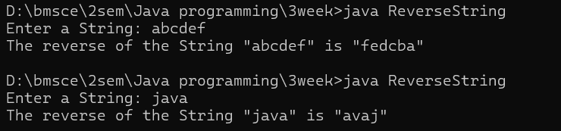

4. Write a program called CountVowelsDigits, which prompts the user for a String, counts the number of vowels (a, e, i, o, u, A, E, I, O, U) and digits (0-9) contained in the string, and prints the counts and the percentages (rounded to 2 decimal places).

For example,

Enter a String: testing12345

Number of vowels: 2 (16.67%)

Number of digits: 5 (41.67%)

PROGRAM:

import java.util.*;

class Count{

public static void main(String args[]){

Scanner sc= new Scanner(System.in);

System.out.print("Enter a string:");

String str=sc.nextLine();

int n=str.length();

int vowelCount = 0, digitCount = 0;

char[] ar = str.toCharArray();

for (char ch : ar) {

if (Character.isDigit(ch)) {

digitCount++;

} else if ("AEIOUaeiou".indexOf(ch) != -1) {

vowelCount++;

} }

float vowelper=(float)vowelCount * 100 / n;

float digitper=(float)digitCount * 100 / n;

System.out.printf("Number of vowels:%d(%.2f)\n",vowelCount,vowelper);

System.out.printf("Number of digits:%d(%.2f)",digitCount,digitper);

}

}

OUTPUT:

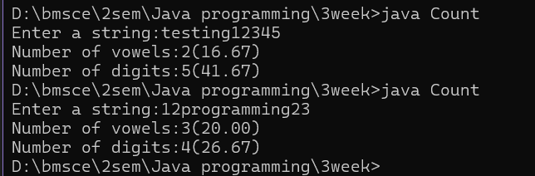

5. Write a program called Bin2Dec to convert an input binary string into its equivalent decimal number.

Your output shall look like:

Enter a Binary string: 1011

The equivalent decimal number for binary "1011" is: 11

PROGRAM:

import java.util.Scanner;

class Bin2Dec{

public static void main(String[] args) {

Scanner sc = new Scanner(System.in);

System.out.print("Enter a binary string:");

String bString=sc.nextLine();

int digi=0;

for(int i=0;i<bString.length();i++){

if(bString.charAt(i)=='1'){

digi=digi+(int)Math.pow(2,(bString.length()-1-i));

}

}

System.out.printf("The equivalent decimal number for binary %s is:%d",bString, digi);

}}

OUTPUT:

