**JAVA PROGRAMMING**

**ASSIGNMENT 4**

**Name:PUNEETH L**

**USN: 1BM24MC069**

**1. Provided that you have a given number of small rice bags (1 kilo each) and big rice bags (5 kilos each), write a method that returns true if it is possible to make a package with goal kilos of rice.**

**PROGRAM:**

import java.util.*;

class Ricebags {

public static void main(String args[]) {

Scanner sc = new Scanner(System.in);

System.out.print("Enter the number of small rice bags (1 kilo each): ");

int small = sc.nextInt();

System.out.print("Enter the number of big rice bags (5 kilo each): ");

int big = sc.nextInt();

System.out.print("Enter the kilos of rice: ");

int r_kilo = sc.nextInt();

boolean possible = isPossible(small, big, r_kilo);

if (possible) {

System.out.println("It is possible to pack the rice.");

} else {

System.out.println("It is NOT possible to pack the rice.");

}

}

static boolean isPossible(int small, int big, int r_kilo) {

int maxBigBags = r_kilo / 5;

int useBig = Math.min(big, maxBigBags);

int remaining = r_kilo - (useBig * 5);

return remaining <= small;

}

}

**OUTPUT:**

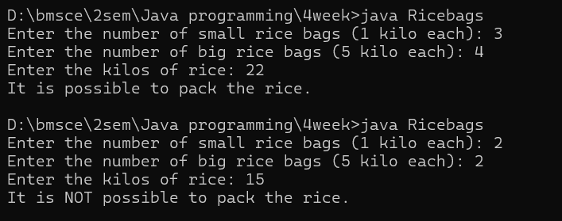

**2. Write a class called Employee, which models an employee with an ID, name and salary, is designed as shown in the following class diagram. The method raiseSalary(percent) increases the salary by the given percentage. Write the Employee class.**

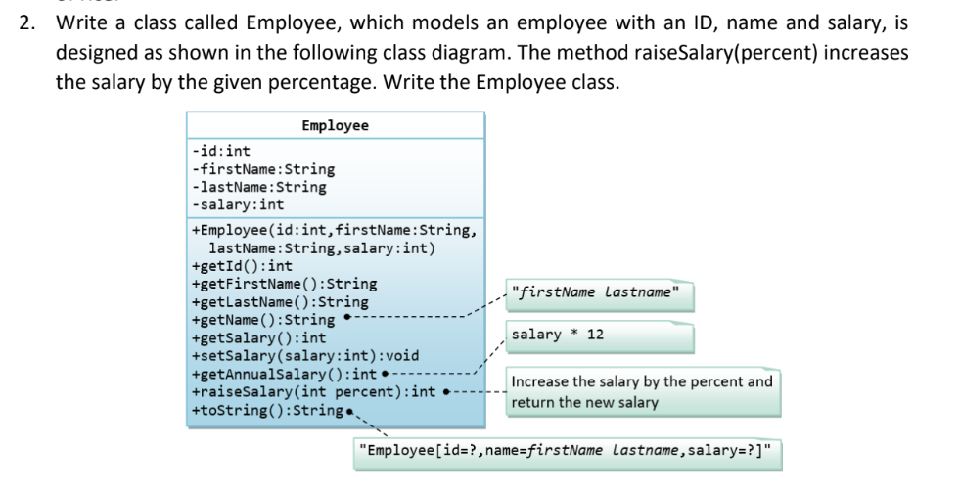

**PROGRAM:**

class Employee {

private int id;

private String firstName;

private String lastName;

private int salary;

Employee(int id, String firstName, String lastName, int salary) {

this.id = id;

this.firstName = firstName;

this.lastName = lastName;

this.salary = salary;}

public int getId() {

return id;}

public String getFirstName() {

return firstName;

}

public String getLastName() {

return lastName;

}

public String getName() {

return (firstName + " " + lastName);

}

public int getSalary() {

return salary;

}

public void setSalary(int salary) {

this.salary = salary;

}

public int getAnnualSalary() {

return salary * 12;

}

int raiseSalary(int percent) {

return this.salary = this.salary + (this.salary * percent / 100);

}

public String toString() {

return "Employee[id=" + id + ",name=" + getName() + ",salary=" + salary + "]";

}

}

public class EmployeeMain {

public static void main(String[] args) {

Employee emp = new Employee(1, "puneeth", "kumar", 15000);

System.out.println("Employee id:"+emp.getId());

System.out.println("Employee firstname:"+emp.getFirstName());

System.out.println("Employee lastname:"+emp.getLastName());

System.out.println("Employee fullname:"+emp.getName());

System.out.println("Employee salary:"+emp.getSalary());

System.out.println("Annual Salary: " + emp.getAnnualSalary());

emp.setSalary(20000);

System.out.println("New salary of employee:"+emp.getSalary());

emp.raiseSalary(30);

System.out.println("New salary after 30% raise:"+emp.getSalary());

System.out.println("Employee details: " + emp.toString());

}

}

**OUTPUT:**

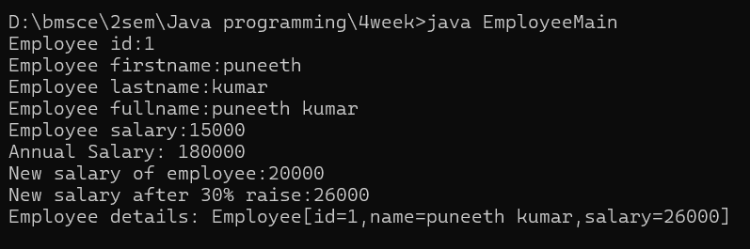

**3. Write a class called Author (as shown in the class diagram) is designed to model a book's author. It contains:**

**• Three private instance variables: name (String), email (String), and gender (char of either 'm' or 'f');**

**• One constructor to initialize the name, email and gender with the given values; public Author (String name, String email, char gender) {......}**

**• public getters/setters: getName(), getEmail(), setEmail(), and getGender();**

**• A toString() method that returns "Author[name=?,email=?,gender=?]", e.g., "Author[name=Tan Ah Teck,email=ahTeck@somewhere.com,gender=m]".**

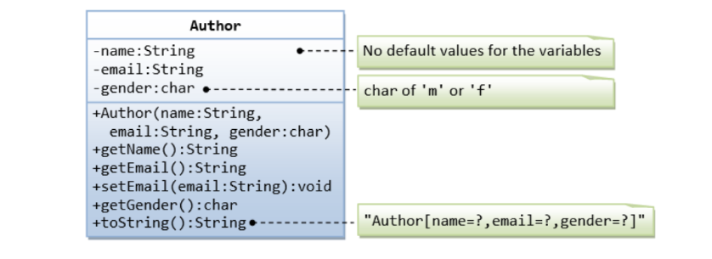

**PROGRAM:**

class Author {

private String name;

private String email;

private char gender;

Author(String name, String email, char gender) {

this.name = name;

this.email = email;

this.gender = gender;}

public String getName() {

return this.name;}

public String getEmail() {

return this.email;}

public void SetEmail(String email) {

this.email = email; }

public char getGender() {

return this.gender;}

public String toString() {

return ("Author[name=" + this.name + ", email=" + this.email + ", gender=" + this.gender + "]");

} }

class AuthorMain {

public static void main(String args[]) {

Author a1 = new Author("robert", "author@book.com", 'm');

System.out.println("Author name:" + a1.getName());

System.out.println("Author email:" + a1.getEmail());

System.out.println("Author gender:" + a1.getGender());

a1.SetEmail("author@gmail.com");

System.out.println("Author new email:" + a1.getEmail());

System.out.println("Author details:" + a1);

}

} **OUTPUT:**

**4. In this exercise, a subclass called Cylinder is derived from the superclass Circle as shown in the class diagram. Study how the subclass Cylinder invokes the superclass' constructors (via super() and super(radius)) and inherits the variables and methods from the superclass Circle.**

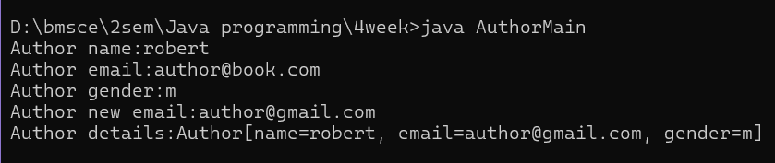

**• The subclass Cylinder inherits getArea() method from its superclass Circle. Try overriding the getArea() method in the subclass Cylinder to compute the surface area (=2π×radius×height + 2×base-area) of the cylinder instead of base area.**

**• That is, if getArea() is called by a Circle instance, it returns the area.**

**• If getArea() is called by a Cylinder instance, it returns the surface area of the cylinder.**

**• If you override the getArea() in the subclass Cylinder, the getVolume() no longer works. This is because the getVolume() uses the overridden getArea() method found in the same class. Fix the getVolume().**

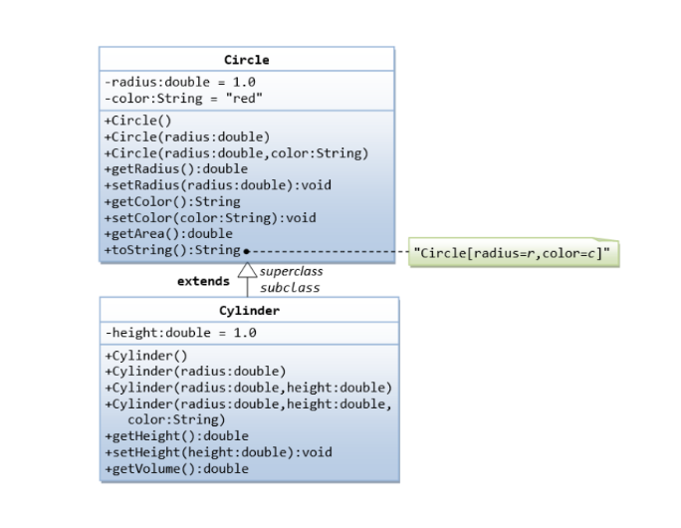

**PROGRAM:**

class Circle {

private double radius;

private String color = "red";

Circle() {

this.radius = 1.0;

this.color = "blue";

}

Circle(double radius) {

this.radius = radius;

}

Circle(double radius, String color) {

this.radius = radius;

this.color = color;

}

public double getRadius() {

return this.radius;

}

public void setRadius(double radius) {

this.radius = radius;

}

public String getColor() {

return this.color;

}

public void setColor(String color) {

this.color = color;

}

public double getArea() {

return 3.14 * this.radius * this.radius;

}

public String toString() {

return ("Circle [radius=" + this.radius + ", color=" + this.color

+ "]");

}

}

class Cylinder extends Circle {

double height;

Cylinder() {

super();

this.height = 1.0;

}

Cylinder(double radius, double height) {

super(radius);

this.height = height;

}

Cylinder(double radius, double height, String color) {

super(radius, color);

this.height = height;

}

public double getHeight() {

return this.height;

}

public void setHeight(double height) {

this.height = height;

}

@Override

public double getArea() {

double baseArea = super.getArea();

double sideArea = 2 * 3.14 * getRadius() * height;

return 2 * baseArea + sideArea;

}

public double getVolume() {

return super.getArea() * height;

}

}

class CircleCylinder {

public static void main(String[] args) {

Cylinder c = new Cylinder(2.0, 5.0, "blue");

System.out.println(c);

System.out.println("Cylinder radius:" + c.getRadius());

c.setRadius(3.0);

System.out.println("new radius:" + c.getRadius());

System.out.println("Volume:" + c.getVolume());

System.out.println("Area:" + c.getArea());

System.out.println("Height:" + c.getHeight());

c.setHeight(4.0);

System.out.println("New Height:" + c.getHeight());

System.out.println("Color:" + c.getColor());

c.setColor("green");

System.out.println("new color:" + c.getColor());

System.out.println("Volume = " + c.getVolume());

System.out.println("Cylinder details:" + c);

}

}

**OUTPUT:**

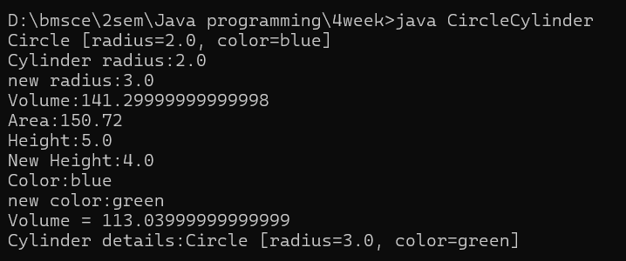

**5. Define a class CARRENTAL with the following details :**

**• Class Members are: CarId of int type, CarType of string type and Rent of float type.**

**• Define GetCar() method which accepts CarId and CarType.**

**• GetRent() method which return rent of the car on the basis of car type, i.e. Small Car= 1000, Van = 800, SUV = 2500**

**• ShowCar() method which allow user to view the contents of cars i.e. id, type and rent.**

**PROGRAM:**

import java.util.Scanner;

class CARRENTAL {

int CarId;

String CarType;

float Rent;

void GetCar(int id, String type) {

CarId = id;

CarType = type;

Rent = GetRent(); }

float GetRent() {

if (CarType.equalsIgnoreCase("Small Car")) {return 1000; }

else if (CarType.equalsIgnoreCase("Van")) {return 800; }

else if (CarType.equalsIgnoreCase("SUV")) {return 2500; }

else { return 0; } }

void ShowCar() {

System.out.println("Car ID: " + CarId);

System.out.println("Car Type: " + CarType);

System.out.println("Rent: " + Rent);

} }

public class CarRentalDemo {

public static void main(String[] args) {

Scanner sc = new Scanner(System.in);

CARRENTAL car = new CARRENTAL();

System.out.print("Enter Car ID: ");

int id = sc.nextInt();

sc.nextLine();

System.out.print("Enter Car Type (1:Small Car / 2:Van / 3:SUV)only number: ");

String type = sc.nextLine();

car.GetCar(id, type);

System.out.println("\nCar Details:");

car.ShowCar();

} }

**OUTPUT:**

