**JAVA PROGRAMMING**

**ASSIGNMENT 7**

**Name:PUNEETH L**

**USN: 1BM24MC069**

**1. Write a package called Clear, it contains one public method clrscr() to clear the screen, import the package and use it in other programs. Add another public method starline(). It prints the line of 15 starts.**

**PROGRAM:**

**//Package->Clear\Mainclear.java**

package Clear;

public class Mainclear {

    public static void clrscr() {

               System.out.print("\033[H\033[2J");

        System.out.flush();

    }

    public static void starline() {

        System.out.println("***************");

    }

}

**//Testclear.java**

import Clear.Mainclear;

public class Testclear {

    public static void main(String[] args) {

        System.out.println("This text will be cleared in 2 seconds...");

        try {

            Thread.sleep(2000);

        } catch (InterruptedException e) {

            e.printStackTrace();}

        Mainclear.clrscr();

        Mainclear.starline();

        System.out.println("Screen cleared!");

        Mainclear.starline();

}}

**OUTPUT:**

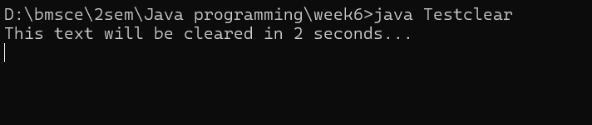

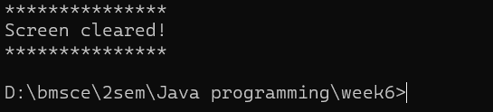

1. **Write a program in Java. A class Teacher contains two fields, Name and Qualification. Extend the class to Department, it contains Dept. No and Dept. Name. An interface named as College contains one field Name of the college. Using the above classes and Interface get the appropriate information and display it.**

**PROGRAM:**

import java.util.Scanner;

interface College {

String collegeName="BMSCE";

}

class Teacher {

String teacherName;

String qualification;

void setTeacherDetails(String name, String qualification) {

this.teacherName = name;

this.qualification = qualification;

}

}

class Department extends Teacher implements College {

int deptNo;

String deptName;

void setDepartmentDetails(int deptNo, String deptName) {

this.deptNo = deptNo;

this.deptName = deptName;

}

void display() {

System.out.println("\n--- Teacher Details ---");

System.out.println("College Name: " + collegeName);

System.out.println("Teacher Name: " + teacherName);

System.out.println("Qualification: " + qualification);

System.out.println("Department No: " + deptNo);

System.out.println("Department Name: " + deptName);

}}

public class CollegeMain {

public static void main(String[] args) {

Scanner sc = new Scanner(System.in);

Department d = new Department();

System.out.print("Enter Teacher Name: ");

String tname = sc.nextLine();

System.out.print("Enter Qualification: ");

String qual = sc.nextLine();

d.setTeacherDetails(tname, qual);

System.out.print("Enter Department Number: ");

int dno = sc.nextInt();

sc.nextLine();

System.out.print("Enter Department Name: ");

String dname = sc.nextLine();

d.setDepartmentDetails(dno, dname);

d.display();

sc.close();

}

}

**OUTPUT:**

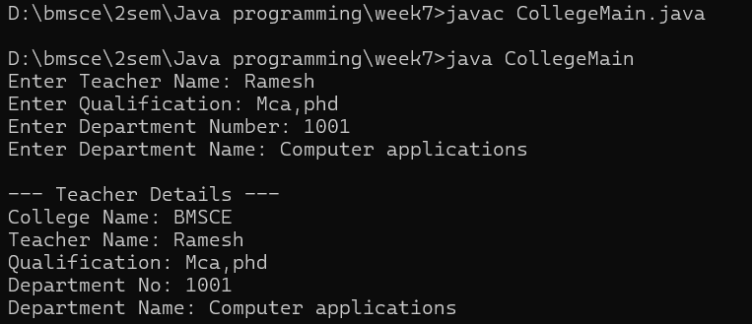

1. **Write and run the following Java program that does the following:**

**a) Declare a string object named s1 containing the string "Object Oriented Programming Java 5".**

**b) Print the entire string.**

**c) Use the length() method to find the length of the string.**

**d) Use the charAt() method to find the first character in the string.**

**e) Use charAt() and length() methods to print the last character in the string.**

**f) Use the indexOf() and the substring() method to print the first word in the String.**

**PROGRAM:**

public class stringopeartions{

public static void main(String[] args) {

String s1="Object Oriented Programming-Java 5";

System.out.println(s1);

System.out.println("Length of string:"+s1.length());

System.out.println("char at first position:"+s1.charAt(0));

System.out.println("Character at last position:"+s1.charAt(s1.length()-1));

System.out.println("First word of string:"+s1.substring(0,s1.indexOf(" ")));

}

}

**OUTPUT:**

