**JAVA PROGRAMMING**

**LAB 2**

**Name:PUNEETH L**

**USN:** 1BM24MC069

**3. Create a class hierarchy where different animals make different sounds. Use dynamic method dispatch to invoke the correct sound at runtime via a base class reference.**

**Programm:**

class Animal{

void makeSound(){

System.out.println("Some animal sound");

}

}

class Dog extends Animal{

@Override

void makeSound(){

System.out.println("Dog barks!!!");

}

}

class Cat extends Animal{

@Override

void makeSound(){

System.out.println("Cat meow!!!");

}

}

class Zoo{

public static void main(String[] args) {

Animal a;

a=new Cat();

a.makeSound();

a=new Dog();

a.makeSound();

}

}

**OUTPUT:**

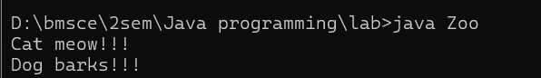

**4. Write a program using the Java package for the following scenario.**

**Package: calculator**

**Classes:Adder → int add(int a, int b)**

**Subtractor → int subtract(int a, int b)**

**In your main class (outside package):**

**Import both classes.**

**Use them to perform addition and subtraction.**

Programm:

Javapackage.java

import calculator.Adder;

import calculator.Subtractor;

public class Javapackage {

public static void main(String[] args) {

Adder adder = new Adder();

Subtractor subtractor = new Subtractor();

int sum = adder.add(10, 5);

int diff = subtractor.subtract(10, 5);

System.out.println("Sum: " + sum);

System.out.println("Difference: " + diff);

}}

**Adder.java**

package calculator;

public class Adder {

public int add(int a, int b) {

return a + b;

}}

**Subtractor.java**

package calculator;

public class Subtractor {

public int subtract(int a, int b) {

return a - b;

}}

OUTPUT:

