AI-Powered Smart Security System – Full Project Documentation
1. Introduction
This document outlines the development of an advanced AI-powered smart security system designed to provide intelligent, real-time monitoring and proactive alerting. Unlike traditional surveillance systems, this project integrates multi-stage AI analysis, including advanced person detection, high-confidence face recognition, nuanced body language interpretation, and an interactive visitor onboarding system.
The system is engineered for robust outdoor deployment using specialized hardware and is scalable for future enhancements, aiming to create a truly "digital guardian" for your property.

2. Project Objectives
- Person Detection: Accurately identify the presence of human subjects within camera feeds.
- Face Recognition: Identify known individuals (authorized users, frequent visitors) with high confidence.
- Body Language & Behavior Analysis: Detect and classify human behavior as normal, suspicious (e.g., loitering, sudden movement), or aggressive.
- Interactive Visitor Onboarding: Intelligently engage with new, non-threatening unknown visitors to enroll them into the system.
- Multi-Camera Support: Seamlessly integrate and manage feeds from multiple IP cameras for comprehensive coverage.
- Real-time Alerting: Notify the owner of suspicious or critical events via preferred channels (e.g., push notifications, email).
- Robust Event Logging: Maintain a detailed, searchable database of all detected events, identities, and behaviors.
- Adaptability: Be able to adapt to various lighting conditions and distances using appropriate hardware and software techniques.

3. System Architecture
The system operates on a "Sentry" and "Verification" model, utilizing two strategically placed cameras.
Simplified Data Flow Diagram:
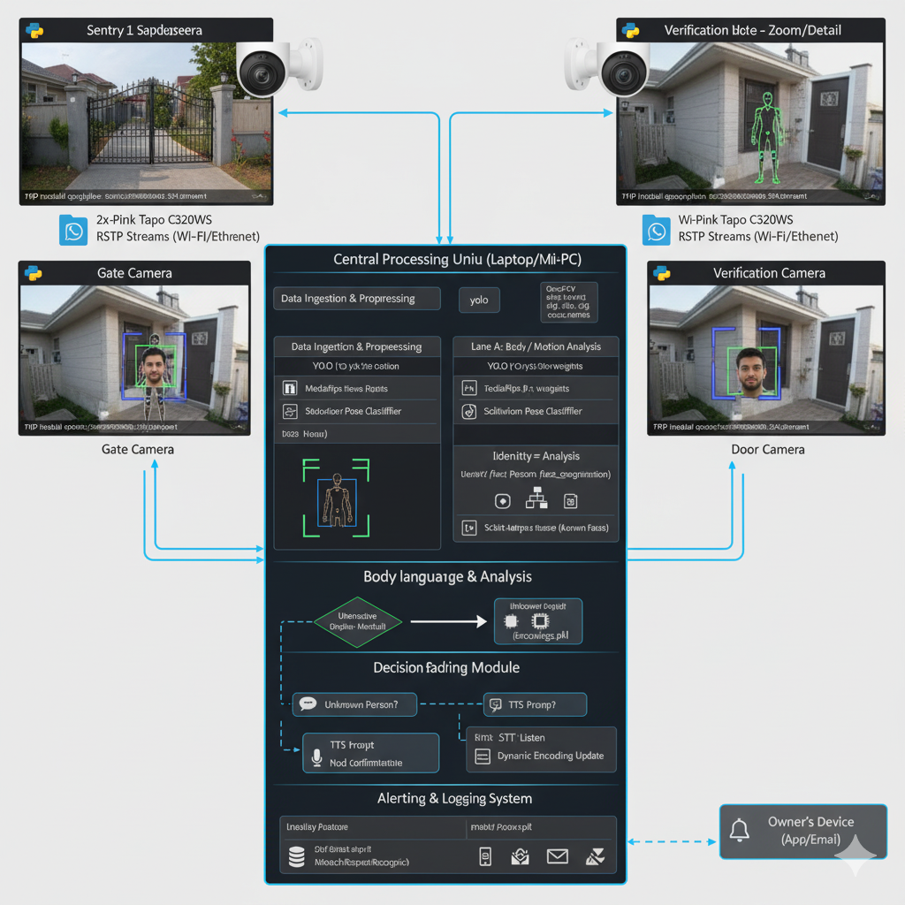

4. Hardware Requirements
4.1. Cameras (2 Units)
- Recommended Model: 2x TP-Link Tapo C320WS Outdoor Wi-Fi Security Camera
- Why this choice:
  - 2K QHD Resolution (2560x1440): Provides high-detail video essential for accurate face recognition and precise body keypoint detection, even at moderate distances.
  - ColorPro Night Vision: Crucial for effective face recognition in low-light conditions, as color information significantly enhances AI model performance compared to black-and-white IR.
  - Outdoor Durability: IP66 Weatherproof rating ensures reliable operation in various environmental conditions (rain, dust, sun).
  - RTSP Stream Support: Essential for integrating the live video feed directly into our Python application via OpenCV.
  - Wi-Fi & Ethernet Connectivity: Offers flexibility in placement and ensures stable data transfer (Ethernet preferred for reliability if possible).
4.2. Processing Unit (Laptop/Mini-PC)
- Minimum Specifications:
  - Processor: Intel Core i5 (8th Gen or newer) or AMD Ryzen 5 (2nd Gen or newer).
  - RAM: 8GB (16GB recommended for smoother multi-stream processing).
  - Storage: 256GB SSD (500GB+ recommended for logging and dataset growth).
  - Operating System: Windows 10/11, macOS, or a Linux distribution (Ubuntu recommended for AI development).
- Notes: While a dedicated GPU (NVIDIA preferred) would significantly accelerate YOLO and MediaPipe processing, our chosen YOLOv3-tiny model and MediaPipe can run adequately on modern CPUs for 2-camera analysis, especially if frame processing is optimized.

5. Software & Models Used
5.1. Core Programming Language
- Python 3.x: The primary language for all development due to its rich ecosystem of AI/ML libraries.
5.2. Key Libraries & Frameworks
- OpenCV (cv2): For video stream ingestion (from IP cameras), image preprocessing, drawing overlays, and basic image manipulation.
- dlib & face_recognition:
  - dlib: Provides core machine learning algorithms, including a robust face detector and state-of-the-art face recognition model.
  - face_recognition: A user-friendly wrapper for dlib, simplifying face detection and encoding.
- YOLO (You Only Look Once):
  - Model: YOLOv3-tiny (pre-trained on COCO dataset).
  - Purpose: Efficiently detect "person" objects in video frames as the initial filtering step.
- MediaPipe:
  - Model: MediaPipe Pose.
  - Purpose: Robust and real-time pose estimation to extract 33 skeletal keypoints per person, forming the basis of body language analysis.
- numpy & pandas: For efficient data handling and numerical operations.
- pickle: For serializing and deserializing face encodings to a file (encodings.pkl).
- sqlite3 (built-in Python module): For creating and managing a lightweight, local database for event logging and visitor management.
- pyttsx3: Python Text-to-Speech (TTS) library for verbal prompts to new visitors.
- SpeechRecognition: Python Speech-to-Text (STT) library for capturing and transcribing visitor names.

6. Detailed System Workflow
The system operates in a continuous loop, processing video feeds from both cameras simultaneously.
6.1. Phase 0: Initial Setup & Configuration
- Camera Physical Installation: Mount TP-Link Tapo C320WS cameras at the gate and near the front door, ensuring optimal field of view for their respective tasks (wide view for gate, closer view for door).
- Network Connection: Connect both cameras to your home Wi-Fi network (or Ethernet for optimal stability).
- RTSP Configuration: Using the Tapo app, configure a Camera Account (username/password) for RTSP streaming and note down each camera's Static IP Address and full RTSP URL.
- Local Environment Setup: Ensure Python 3.x and all required libraries are installed on the processing unit.
- YOLO Model Files: Download yolov3-tiny.weights, yolov3-tiny.cfg, and coco.names into the yolo/ directory.
6.2. Phase 1: Data Acquisition & Preprocessing
- Video Stream Ingestion:
  - cv2.VideoCapture() will be used to open RTSP streams from both cameras.
  - Each camera feed will run in its own thread or process for concurrent real-time processing.
- Frame Reading: Continuously read frames from both camera streams.
- Frame Preprocessing:
  - Frames are converted from BGR (OpenCV default) to RGB for face_recognition and MediaPipe.
  - Optional: Resize frames for faster YOLO processing (e.g., to 416x416).
6.3. Phase 2: Person Detection (YOLO)
- Initial Filter: Each incoming frame from both cameras is first passed through the YOLOv3-tiny model.
- Object Classification: YOLO identifies bounding boxes and confidence scores for various objects.
- "Person" Filtering: Only detections classified as "person" with a confidence score above a set threshold (e.g., 0.5) are kept.
- Region of Interest (ROI) Extraction: For each detected person, a rectangular ROI is extracted from the original frame. This significantly reduces the area for subsequent AI analysis.
6.4. Phase 3: Identity Analysis (Face Recognition)
- Face Detection: Within each "person" ROI, face_recognition is used to detect face locations (bounding boxes).
- Face Encoding: For each detected face, a 128-dimensional facial embedding (encoding) is computed.
- Comparison to Known Encodings:
  - The computed encoding is compared against the knownEncodings stored in encodings.pkl.
  - A distance metric (e.g., Euclidean distance) determines how similar the face is to known faces.
  - If the smallest distance is below a threshold (e.g., 0.6), a match is declared.
- Identity Assignment:
  - Match: The person is identified as a "Known User" (e.g., "Elon Musk").
  - No Match: The person is labeled as "Unknown."
- Contextual Hand-off: The identity (or "Unknown" status) is passed to the Decision-Making Module.
6.5. Phase 4: Body Language & Behavior Analysis (MediaPipe Pose)
- Pose Estimation: For each "person" ROI (from YOLO), MediaPipe Pose is applied to detect 33 3D skeletal keypoints (landmarks) for the head, torso, and limbs.
- Feature Extraction: From these keypoints, meaningful features are extracted:
  - Movement Velocity: Tracking the center of mass (e.g., average of hip keypoints) across frames to detect running, sudden bursts of speed, or stillness (loitering).
  - Joint Angles: Calculating angles (e.g., elbow, knee, shoulder) to detect specific gestures (raised hands, fighting stance).
  - Pose Changes: Analyzing the overall change in pose over time (e.g., sudden drop indicating a fall, sustained hunched posture).
  - "Time in Zone": Tracking how long a person remains in a specific, predefined sensitive zone (e.g., by the gate, near the window/door).
- Behavior Classification (Rule-Based & ML Hybrid):
  - Rule-Based (Initial): Simple thresholds for fast detection (e.g., IF (velocity > X AND time_in_zone > Y) THEN 'Loitering').
  - ML Classifier (Future Enhancement): Train a simple classifier (SVM, Random Forest) on sequences of extracted features to categorize behavior as:
    - Normal: Walking casually, standing, sitting.
    - Suspicious: Loitering (still for too long in a specific zone), sudden frantic movements, looking around nervously.
    - Aggressive: Running towards the property, fighting stance, sudden aggressive gestures, climbing.
- Contextual Hand-off: The classified behavior is passed to the Decision-Making Module.
6.6. Phase 5: Intelligent Decision-Making Module
This is the "brain" that combines identity and behavior to determine the appropriate response.
- Input: Takes Identity (Known/Unknown) and Behavior (Normal/Suspicious/Aggressive) from both cameras.
- Decision Logic:
  - If Known User + Normal Behavior:
    - Action: Log event, no alert.
    - Output (e.g., to smart speaker): "Welcome Home, [Name]!" (Future IoT integration).
  - If Known User + Suspicious/Aggressive Behavior:
    - Action: Log event. No alert to owner (prioritize known identity).
    - Rationale: Authorized users might rush, run, or playfully gesture.
  - If Unknown User + Aggressive Behavior:
    - Action: IMMEDIATE CRITICAL ALERT to owner (with snapshots/video). Log event.
    - NO interactive mode.
  - If Unknown User + Suspicious Behavior:
    - Action: IMMEDIATE ALERT to owner (Warning: Unknown Loitering). Log event.
    - NO interactive mode.
  - If Unknown User + Normal Behavior (at Door Camera):
    - Action: Proceed to Interactive Onboarding.
6.7. Phase 6: Interactive Visitor Onboarding (for Unknown + Normal Behavior)
This module activates only when an unknown person exhibits non-threatening behavior near the Door Camera.
- Verbal Prompt (TTS): The system uses pyttsx3 to play an audio message through a connected speaker: "Welcome! It seems you are a new visitor. After the beep, please state your full name."
- Audio Capture & Transcription (STT):
  - The system activates a microphone (connected to the processing unit).
  - SpeechRecognition captures the audio response and transcribes it to text.
- Name Confirmation:
  - The system verbally confirms: "I heard [Transcribed Name]. Is that correct? Please nod your head for yes."
  - Nod Detection: Uses MediaPipe Pose's head landmark data to detect a "nod" (a quick up-and-down movement of the head) as confirmation.
- Dynamic Enrollment:
  - If Confirmed:
    - The system automatically captures 5-10 high-quality face images from the Door Camera.
    - A new sub-folder is created in dataset/ with the Transcribed Name.
    - The captured images are saved into this new folder.
    - The encode_faces.py logic is triggered dynamically to update encodings.pkl with the new user.
    - Action: Log new visitor enrollment.
  - If Not Confirmed (or no nod):
    - System might repeat the prompt or log an "Unidentified New Visitor" event.
6.8. Phase 7: Alerting & Logging Mechanisms
- Alerting System:
  - Email (SMTP): Send detailed alerts with text, snapshots, and event descriptions.
  - Push Notifications (Future API Integration): Integration with a push notification service (e.g., Pushbullet, custom app) for instant alerts.
  - Twilio (Future SMS/WhatsApp): For SMS or WhatsApp alerts (requires Twilio account).
- SQLite Database Logging:
  - A central events.db SQLite database will store all detected activities.
  - Tables:
    - visitors: Stores name, first_seen_timestamp, last_seen_timestamp, visit_count, enrollment_status.
    - events: Stores event_id, timestamp, camera_id, person_name, behavior_status, alert_level, snapshot_path, notes.

7. Implementation Plan (Step-by-Step Guide)
This plan assumes you have purchased and set up your two TP-Link Tapo C320WS cameras on your network, obtained their static IP addresses, and configured their RTSP credentials as described in Phase 0.
Part A: Initial Setup & Laptop Camera Testing (Facial Recognition Only)
This phase focuses on getting the core face recognition working on your laptop camera first, ensuring all libraries and basic logic are correct.
Step A.1: Project Environment Setup
- Create Project Folder: Create a main folder, e.g., AI_Security_System.
- Sub-folders: Inside AI_Security_System, create dataset/ and yolo/.
- Install Libraries: Open a terminal in AI_Security_System and install the necessary Python libraries: opencv-python, cmake, dlib, face_recognition, and numpy.
- Download YOLO Files: Place the yolov3-tiny.weights, yolov3-tiny.cfg, and coco.names files into the yolo/ folder.
Step A.2: Create Your Face Dataset (Using Laptop Camera)
- Create create_dataset.py: Develop a Python script (create_dataset.py) that uses cv2.VideoCapture(0) to access your laptop's webcam.
- Face Detection: Integrate a simple face detector (e.g., OpenCV's Haar Cascade) to draw a bounding box around detected faces.
- Image Capture Logic: Implement functionality to save a frame to disk whenever a specific key (e.g., 'k') is pressed, only if a face is detected. The saved images should be stored in a sub-folder under dataset/ named after the user (e.g., dataset/Your_Name/).
- Execution: Run create_dataset.py. Enter your name when prompted and capture at least 15 images of your face with slight variations in expression and angle.
Step A.3: Encode Faces from Your Dataset
- Create encode_faces.py: Develop a Python script (encode_faces.py) that iterates through all sub-folders in the dataset/ directory.
- Image Loading and Conversion: For each image, load it using OpenCV and convert it from BGR to RGB color format (required by face_recognition).
- Face Encoding: Use face_recognition.face_locations() to find faces and face_recognition.face_encodings() to compute the 128-dimensional facial embedding for each face.
- Serialization: Store these embeddings and their corresponding names (derived from the sub-folder names) into a dictionary or similar structure. Serialize this data using pickle into a file named encodings.pkl in your main project directory.
- Execution: Run encode_faces.py after creating your dataset.
Step A.4: Test Face Recognition on Laptop Camera
- Create test_face_rec_laptop.py: Develop a Python script (test_face_rec_laptop.py) that loads the encodings.pkl file.
- Webcam Stream: Access your laptop's webcam using cv2.VideoCapture(0).
- Real-time Recognition: In a continuous loop, read frames from the webcam. For each frame (or every other frame for speed):
  - Detect face locations using face_recognition.face_locations().
  - Compute face encodings using face_recognition.face_encodings().
  - Compare these new encodings against the knownEncodings loaded from encodings.pkl using face_recognition.compare_faces() and face_recognition.face_distance().
  - Assign the name of the closest matching known face, or "Unknown" if no sufficiently close match is found.
- Overlay Display: Draw bounding boxes and text labels with the recognized name (or "Unknown") on the live video feed. Display this feed in a cv2.imshow() window.
- Execution: Run test_face_rec_laptop.py. Verify that your face is recognized and labeled correctly, and others are labeled "Unknown." This confirms the basic face recognition pipeline is working.
Part B: Full System Implementation with Tapo C320WS Cameras
This phase integrates all components into the main application, using the two IP cameras.
Step B.1: Main Application Structure for IP Camera Streams
- Create main_security_app.py: Start a new Python script (main_security_app.py) which will be the central hub of your project.
- RTSP URL Configuration: Define variables at the top of the script for your Tapo camera's RTSP username, password, and static IP addresses. Construct the full RTSP URLs for both the Gate Camera and the Door Camera.
- Threaded Video Streams: Implement a VideoStreamWidget class (or similar threading approach) to read video frames from each RTSP URL in a separate thread. This is crucial for handling multiple continuous video streams without blocking the main processing loop.
- Load Assets: Load the encodings.pkl file and initialize the YOLO model (weights, config, and labels) as done in previous steps.
- Main Loop: Establish a while loop that continuously attempts to read the latest frame from each camera's stream. Display these raw feeds in separate cv2.imshow() windows to confirm connectivity.
- Frame Processing Function: Create a process_frame(frame, camera_name) function. This function will encapsulate all the AI logic (YOLO, Face Recognition, Body Language, Decision Making) for a single frame from one camera. The main loop will call this for both camera feeds.
Step B.2: Integrate YOLO Person Detection
- Inside process_frame: Modify the process_frame function to first apply the YOLO model to the input frame.
- Filter for "Person": Identify bounding boxes corresponding to "person" objects with a high confidence score.
- ROI Extraction: For each detected person, extract the Region of Interest (ROI) from the original frame. This ensures subsequent face and pose detection only happens on relevant parts of the image.
- Overlay: Draw a bounding box around each detected "person" on the display frame.
Step B.3: Integrate Face Recognition
- Within Person ROI: For each "person" ROI detected by YOLO, apply the face detection and recognition logic similar to Step A.4.
- Contextual Naming: Assign "Known User Name" or "Unknown" to each detected face.
- Overlay: Draw bounding boxes and names on the faces within the display frame. Ensure the coordinates are correctly translated from the ROI back to the full frame.
Step B.4: Add Body Language Analysis (MediaPipe Pose)
- Install MediaPipe: Install the mediapipe library in your environment.
- Initialize MediaPipe: In main_security_app.py, initialize the MediaPipe Pose solution (mp.solutions.pose.Pose()) once outside the main processing loop.
- Inside process_frame: For each detected "person" ROI:
  - Convert the ROI to RGB.
  - Process the ROI with the MediaPipe Pose model to detect keypoints.
  - Extract features from the keypoints: calculate movement velocity (e.g., of the hip center), analyze key joint angles (e.g., for raised arms), and track pose changes over several frames.
  - Implement rule-based classification (e.g., if velocity > threshold and person_in_zone_duration > threshold then 'Loitering') to classify behavior as 'Normal', 'Suspicious', or 'Aggressive'.
- Overlay: Optionally, draw the detected keypoints and behavior labels on the display frame for visualization during development.
Step B.5: Implement SQLite Database for Logging & Visitor Management
- Create database_manager.py: Create a new Python file to encapsulate all database operations.
- Database Initialization: Include a function to connect to (or create if it doesn't exist) an events.db SQLite database. Define table schemas for visitors (containing name, first_seen, last_seen, visit_count, enrollment_status) and events (containing timestamp, camera_id, person_name, behavior_status, alert_level, snapshot_path, notes).
- CRUD Operations: Implement functions to:
  - log_event(event_data): Insert new event records.
  - update_visitor_status(name, new_visit_data): Update visit count, last seen time.
  - add_new_visitor(name): Add a new row to the visitors table upon enrollment.
- Integrate with main_security_app.py: Call these database functions from within the main application to record detections, behaviors, and identity information.
Step B.6: Develop Intelligent Decision-Making Module
- Decision Function: Create a dedicated function (e.g., make_decision(identity, behavior, camera_id)) that receives the identity (Known/Unknown) and behavior (Normal/Suspicious/Aggressive) from each process_frame call.
- Logic Implementation: Implement the conditional logic as outlined in Section 6.6, prioritizing known identities and escalating alerts for critical unknown behaviors.
- Trigger Actions: Based on the decision, this module will either:
  - Call log_event().
  - Trigger an alert (see Step B.7).
  - Initiate the Interactive Onboarding (see Step B.8).
Step B.7: Implement Alerting Mechanisms
- Email Alert Function: Create a function (e.g., send_email_alert(subject, body, snapshot_path)) that uses Python's smtplib to connect to an SMTP server (e.g., Gmail) and send an email. This function should accept a subject, body text, and an optional path to an image snapshot.
- Triggering Alerts: Integrate this function into the Decision-Making Module, ensuring it's called with appropriate details when CRITICAL or IMMEDIATE alerts are generated. Configure sender email credentials securely (e.g., environment variables).
Step B.8: Implement Interactive Visitor Onboarding
- Install Libraries: Install pyttsx3 for Text-to-Speech and SpeechRecognition for Speech-to-Text.
- TTS Prompt: Create a function to use pyttsx3 to deliver verbal prompts through your laptop's speakers (or connected speakers).
- STT Listener: Create a function to activate a microphone (connected to your processing unit), listen for speech, and use SpeechRecognition to transcribe the audio into text (the visitor's name).
- Nod Detection: Integrate MediaPipe Pose's head keypoint analysis to detect an affirmative "nod" gesture from the visitor as confirmation of their spoken name.
- Dynamic Enrollment Logic: If the visitor's name is confirmed:
  - Capture a small burst of high-quality images of their face from the Door Camera.
  - Programmatically create a new folder under dataset/ with their confirmed name.
  - Save the captured images into this new folder.
  - Programmatically call a function (similar to encode_faces.py) to re-encode all faces (including the new one) and update encodings.pkl. This should be handled carefully to avoid blocking the main stream too long; consider running this in a separate, lower-priority process.
  - Call add_new_visitor() from database_manager.py.
- Integration: Trigger this entire onboarding sequence from the Decision-Making Module when an "Unknown User" with "Normal Behavior" is detected by the Door Camera.

8. Robustness Scenarios
These scenarios demonstrate how the integrated AI modules work together to provide intelligent responses.
Scenario 1: Known User Rushing Home
- Action: You, a known user, run towards your front door after a long day.
- System Response:
  - Gate Cam: Detects "person," flags "sudden movement" (running), low-confidence face match (due to distance).
  - Door Cam: Detects "person," confirms "running" behavior.
  - Face Recognition: Achieves high-confidence match: "Your Name".
  - Decision Module: Prioritizes "Known User" identity over "running" behavior.
  - Outcome: No alert to owner. Event logged: "Your Name - Rushing Home." (Optional: "Welcome Home, [Name]!" via speaker).
Scenario 2: Unknown Intruder Attempts Break-in
- Action: An unknown person bypasses the gate cam (e.g., jumps fence), runs directly towards a window of your house, and attempts to force it open. They are briefly in the Door Cam's view for 2-3 seconds.
- System Response:
  - Gate Cam: No/brief detection (bypassed).
  - Door Cam:
    - Person Detection: Immediately detects "person."
    - Body Language: Flags "running/rapid approach towards window," then potentially "suspicious posture" (e.g., hands near window frame, bent over).
    - Face Recognition: Attempts, but likely fails or gets "Unknown" due to brief visibility/angle.
  - Decision Module: Unknown User + Aggressive/Suspicious Behavior. This is a critical threat.
  - Outcome: IMMEDIATE CRITICAL ALERT to owner (email/push), including snapshots/video. NO interactive mode. Event logged: "Unknown - Suspected Break-in Attempt at Window."
Scenario 3: New, Legitimate Visitor
- Action: A delivery person, unknown to the system, approaches your front door calmly and stands patiently.
- System Response:
  - Gate Cam: Detects "person," "normal gait," "Unknown" face.
  - Door Cam: Detects "person," "normal standing/waiting" behavior.
  - Face Recognition: Confirms "Unknown" face (high confidence it's a face, but not in encodings.pkl).
  - Decision Module: Unknown User + Normal Behavior. Triggers Interactive Onboarding.
  - Outcome:
    - System: "Welcome! It seems you are a new visitor. After the beep, please state your full name."
    - Visitor: "My name is John Doe."
    - System: "I heard John Doe. Is that correct? Please nod your head for yes."
    - Visitor: Nods head.
    - System: Captures images, adds "John Doe" to dataset, dynamically updates encodings.pkl. Logs: "New Visitor Enrolled: John Doe." (Next time, John Doe is recognized).

Scenario 4: Loitering Suspicion
- Action: An unknown individual stands idly near your gate for an extended period (e.g., 2 minutes) without attempting to enter.
- System Response:
  - Gate Cam: Detects "person."
  - Body Language: Flags "loitering" (no significant movement, prolonged presence in zone).
  - Face Recognition: Likely "Unknown" due to distance.
  - Decision Module: Unknown User + Suspicious Behavior (Loitering).
  - Outcome: IMMEDIATE ALERT to owner: "Warning: Unknown Person Loitering at Gate." Includes snapshot. Event logged: "Unknown - Loitering at Gate." NO interactive mode.

