Customer Segmentation & Personalization for E-Commerce using Cluster Based Recommendation System

In this application we are utilizing unsupervised machine learning k-means clustering algorithm for customer based segmentation and personalized E-commerce product recommendation. K-means clustering algorithm is applied to segment customers based on past purchasing similar behaviour and then apply content based personalize recommendation algorithm to fetch products from clusters which are having similar behaviour.

To train clustering algorithm we have utilize E-commerce product dataset which can be downloaded from below URL

<https://www.kaggle.com/code/farzadnekouei/customer-segmentation-recommendation-system/input>

Above dataset will be processed and then input to K-means algorithm to segment customers and then group them into similar clusters. To evaluate algorithm performance we have used Silhouette score whose value range between 0 and 1. Score closer to 0 indicate values are not arrange in propose cluster and score closer to 1 indicate all values arranged in clusters properly.

To implement this project we have designed following modules

1. Registration Here: user can sign up with the application
2. User Login: user can login to system
3. Load & Process E-Commerce Dataset: using this model will load and normalize all E-Commerce dataset.
4. Segmentation using Clustering Algorithm: All processed data will be input to clustering algorithm to train a model and this model will be applied on test data to calculate clustering silhouette score.
5. Personalized Recommendation: using this module user can enter customer ID and then clustering and content based algorithms will find similar products from matching clusters and then recommend to user.

SCREEN SHOTS

Install python 3.7.2 and then install all packages given in requirements.txt file and then install MYSQL and then copy content from ‘database.txt’ file and paste in MYSQL console to create database

To run project double click on ‘runWebServer.bat’ file to start python server and then will get below page

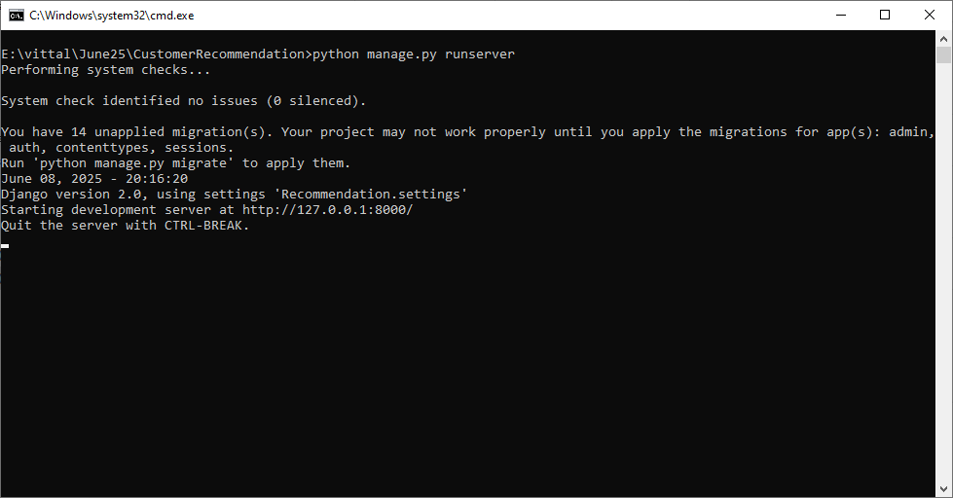

In above screen python server started and now open browser and enter URL as <http://127.0.0.1:8000/index.html> and then press enter key to get below page

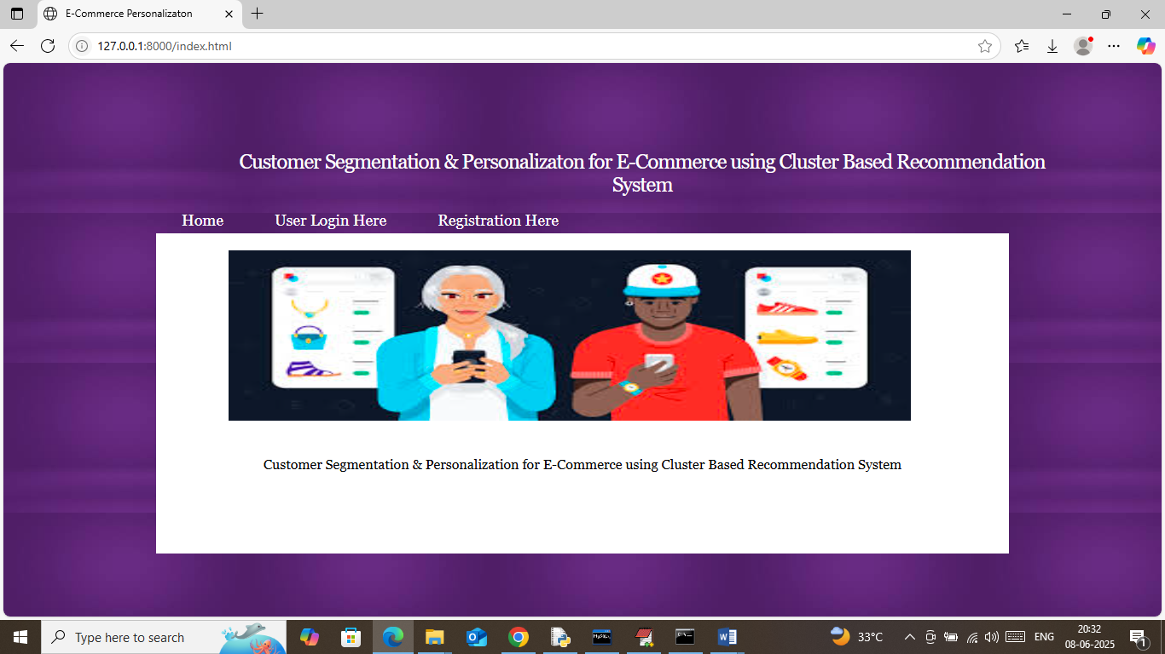

In above screen click on ‘Registration Here’ link to get below page

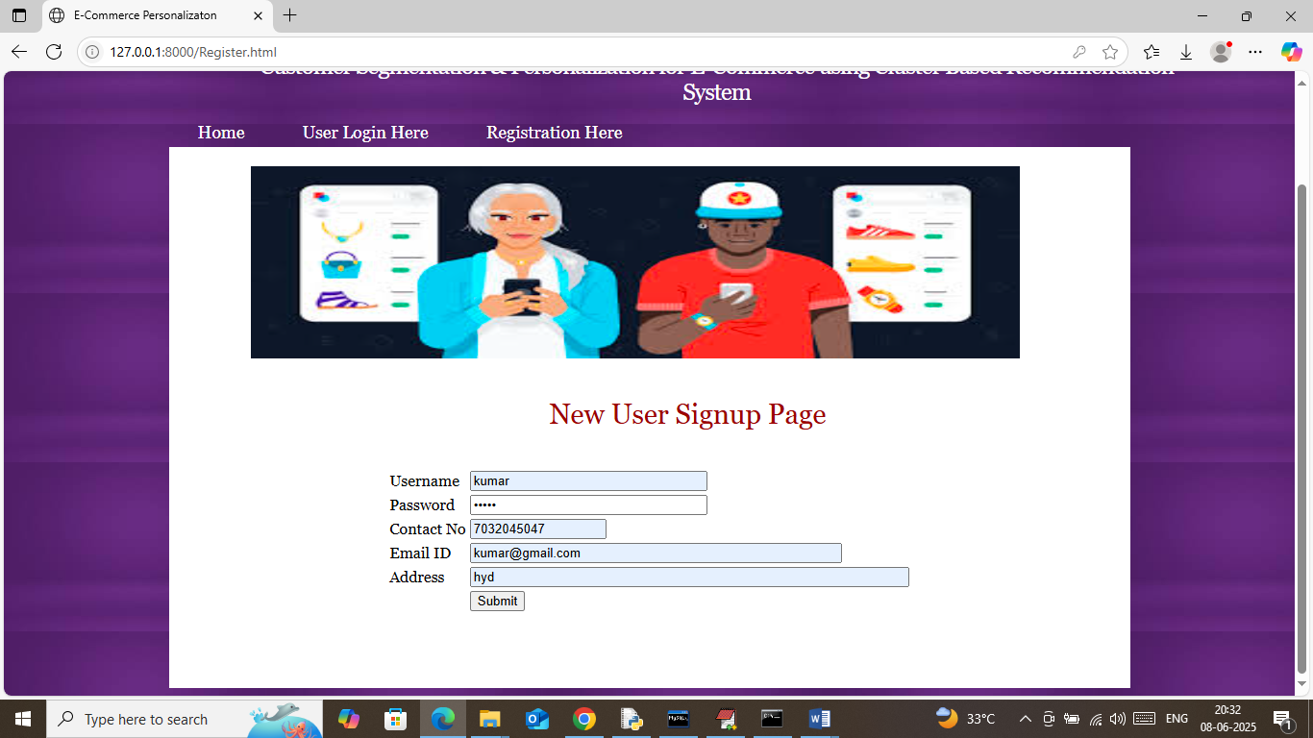

In above screen user is entering sign up details and then press button to get below page

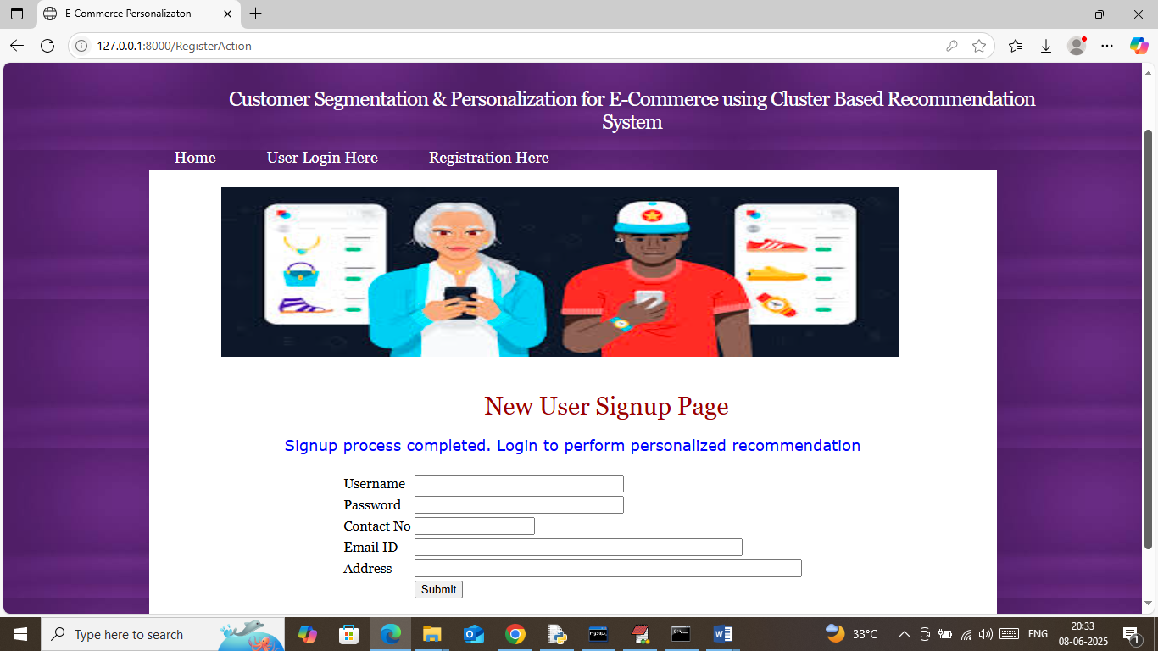

In above screen user sign up process completed and now click on ‘User Login Here’ link to get below page

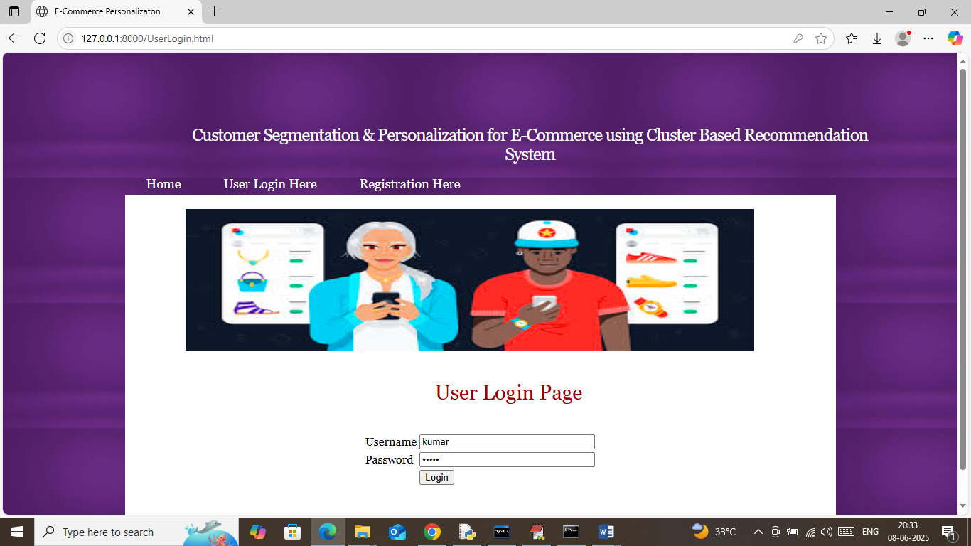

In above screen user is login and after login will get below page

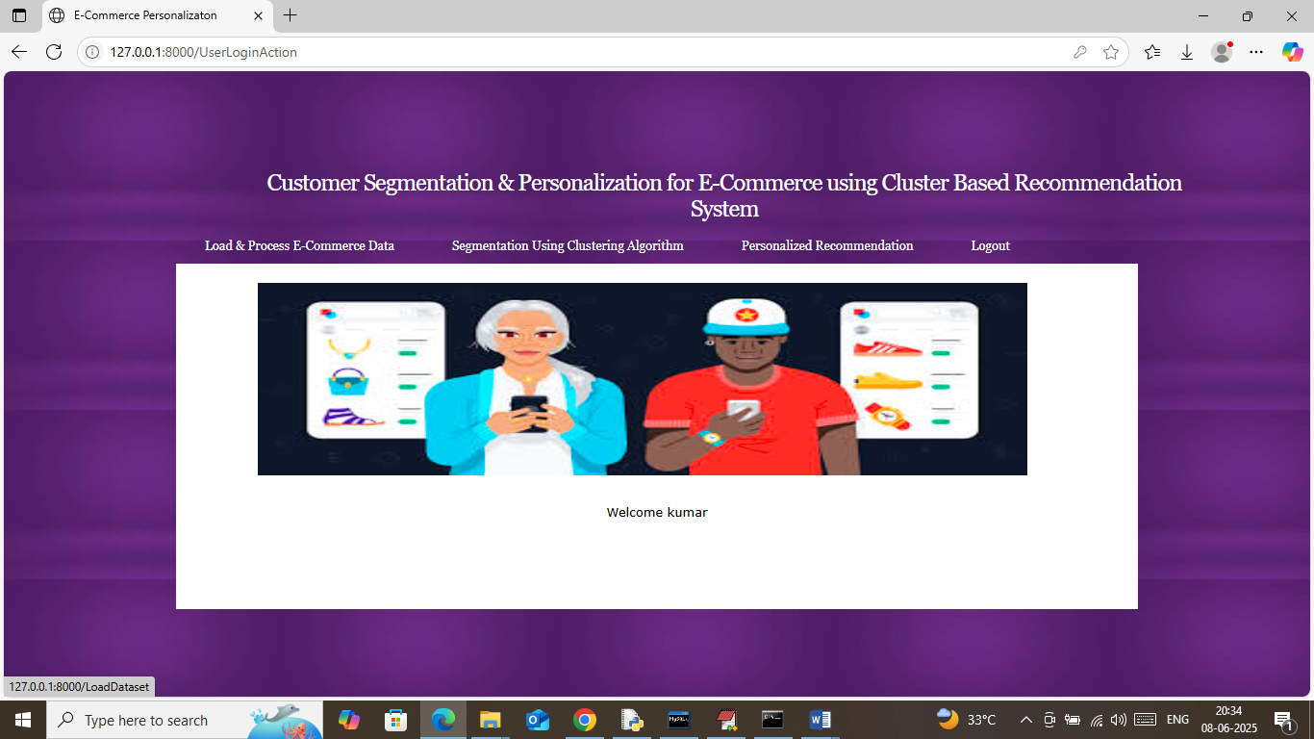

In above screen user can click on ‘Load & Process E-Commerce Dataset’ link to load dataset and then will get below page

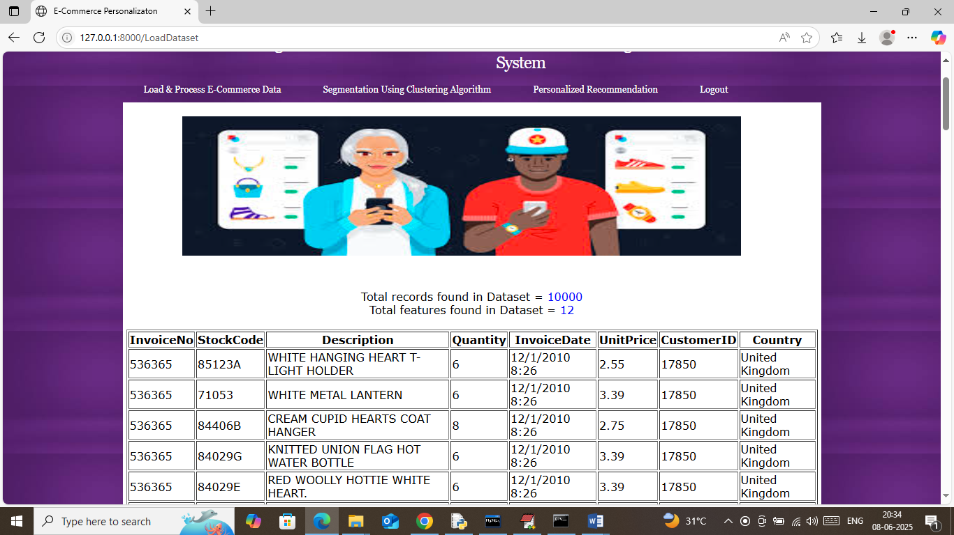

In above screen in first two lines can see dataset size along with number of features and then in table format can see all dataset values and now click on ‘Segmentation using Clustering Algorithm’ link to segment dataset and then will get below page

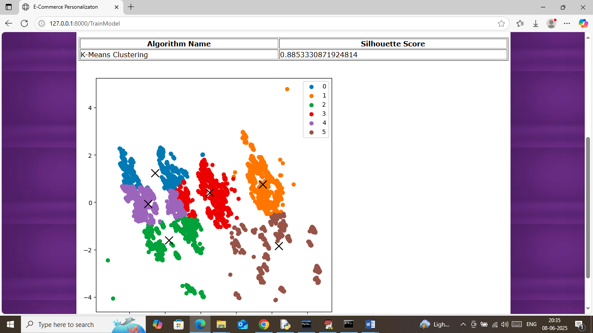

In above screen segmentation using clustering completed and in table format we can see clustering algorithm got 82% score and in graph can see all segmented users as clusters. In above graph each different colour dots represents 1 cluster and ‘X’ mark represents cluster centroid. In above screen graph can see all similar behaviour users are close to one and other and can see total 6 clusters generated. Now click on ‘Personalized Recommendation’ link to get below page

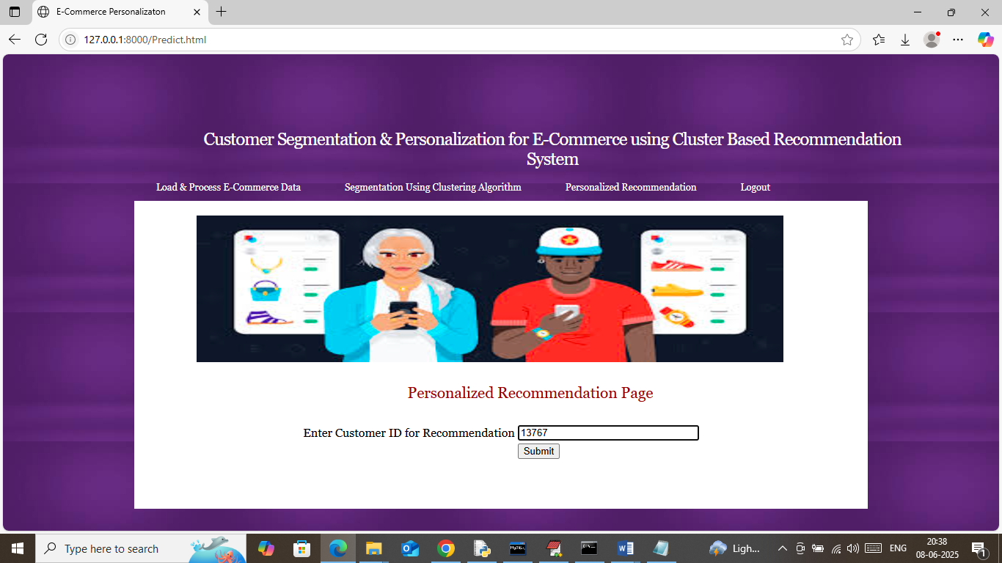

In above screen entering customer ID and then press button to get below recommendation

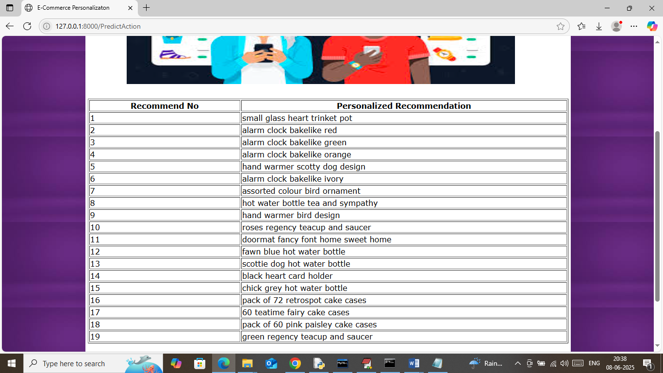

In above screen for given customer ID we got 20 best recommendation which user can purchase. Similarly you enter customer ID from dataset and then will get recommendation. For Simplicity we gave some customer id inside ‘Customer_id.txt’ file. Below is another example

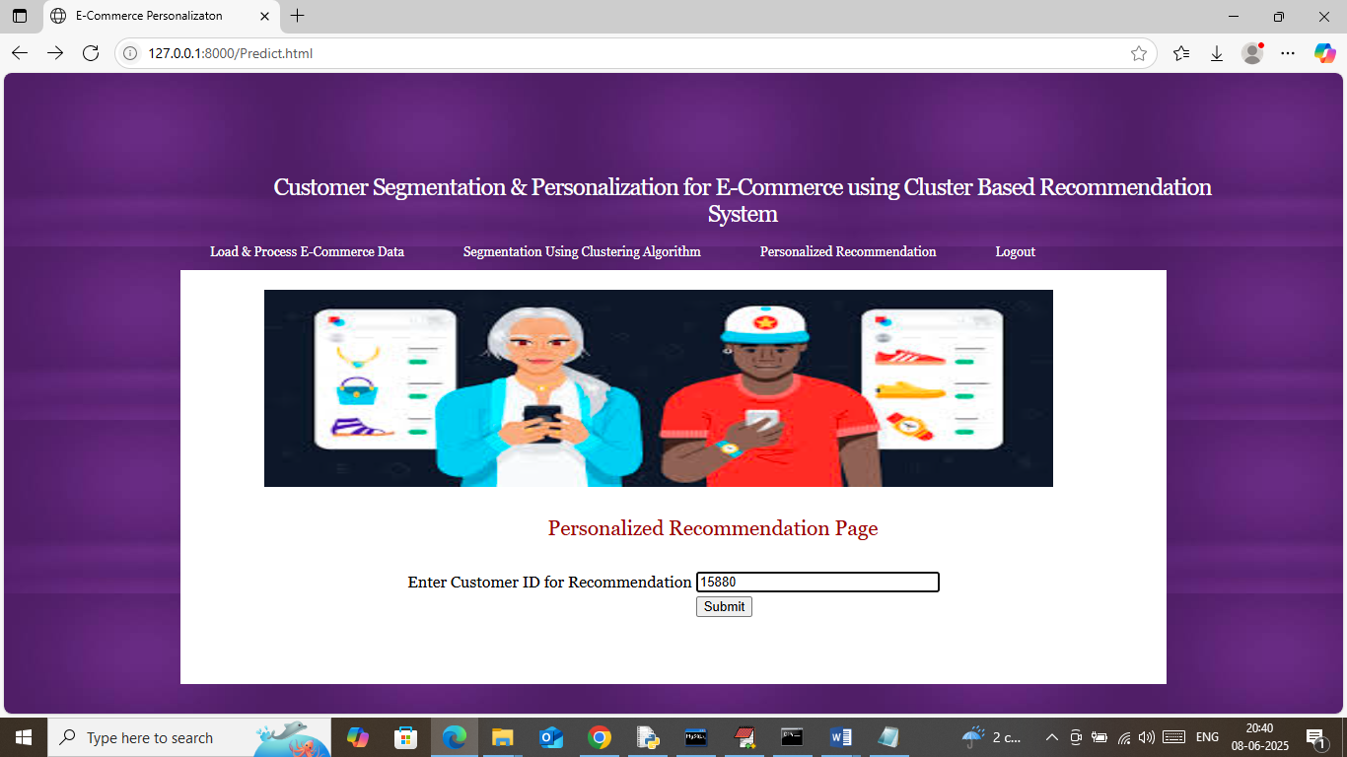

In above screen giving another customer ID and below is the output

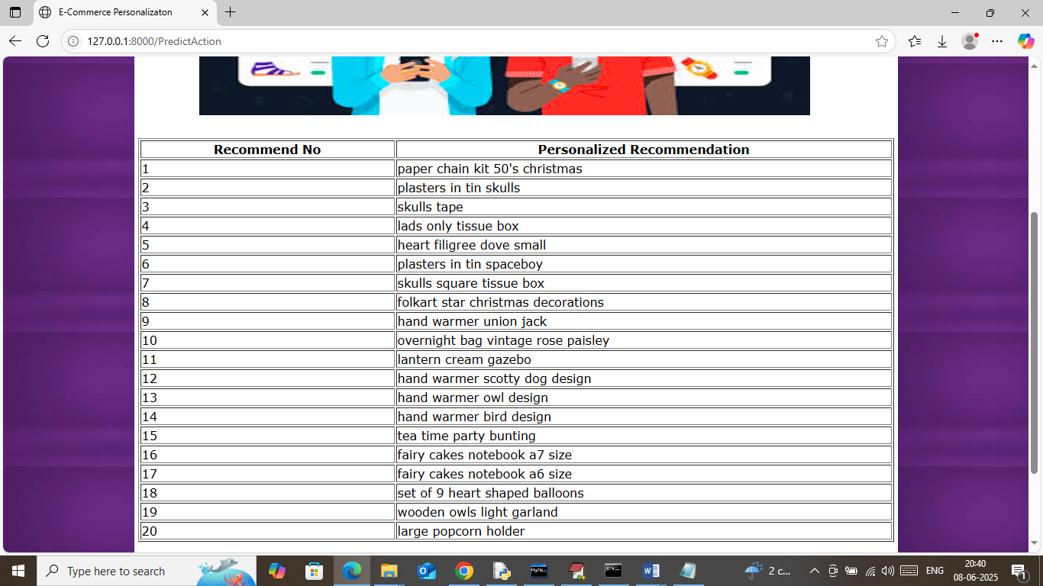

In above screen for given customer ID we got some other product recommendation.

So by using above screens you can do recommendation using segmentation with clustering and personalized recommendation using Content Based Clustering.