Appendix S1: Methodological details for the salt adaptation experiments.

Figure S1: The population yield of haploid wild-type strain of the yeast (Saccharomyces cerevisiae, Meyen) BY4741 MATa his3d1 leu2d0 met15d0 ura3d0 across 11 different NaCl concentrations. Based on these results we chose 125gL⁻¹ as the test environment for the evolutionary rescue experiments. Yield was measured as optical density (OD600nm).
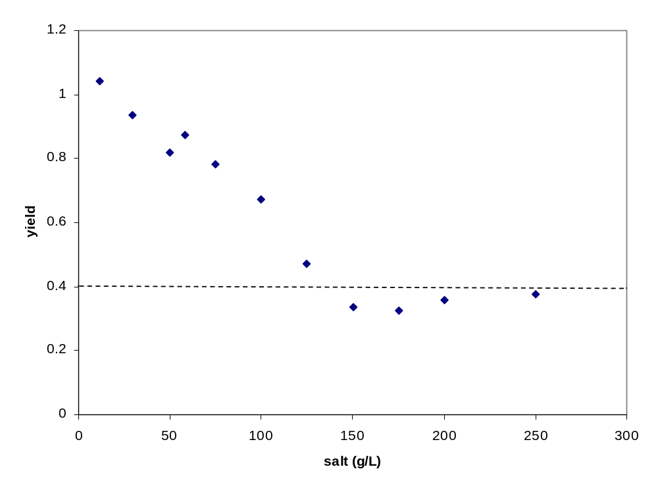

Table S1. Deletion strains used in Experiment 2 described in the Methods.

ORF name | Gene name
YCR008W | SAT4
YDR259C | YAP6
YDR276C | PMP3
YDR436W | PPZ2
YER019W | ISC1
YGR102C | -
YJL165C | HAL5
YLR138W | NHA1
YML016C | PPZ1
YNL091W | NST1
YOL064C | MET22
YOL089C | HAL9
YOR028C | CIN5
YPR005C | HAL1

Appendix S2: Cell growth on high salt

Figure S2.

Photograph of yeast colonies grown on NaCl (125g/l) and ypd agar. Small individual cells that did not grow can be seen scattered throughout the image. Four larger colonies of many cells each differing size, and thus growth rate, can be seen at the centre of the image. We estimated the frequency of adapted genotypes by calculating the proportion of colonies to inviable single cells.
