DocChain: Complete Presentation Deck (Review Ready)
This document contains the exact slide-by-slide text, tables, and architecture diagram matching the format of your reference presentation.

Slide 1: Title Slide
DOCCHAIN: Secure Document Issuance and Verification System
Introduction to Cloud Computing – Group 18
- CB.SC.U4AIE24131 – M. Sarveshwara Reddy
- CB.SC.U4AIE24144 – Varshitha P
- CB.SC.U4AIE24146 – Puneeth Kumar Kalinga
- CB.SC.U4AIE24150 – S. Tagur Misra

Slide 2: Introduction
- The DocChain system manages official documents, user accounts, verification sessions, and security access logs across a document lifecycle.
- The system provides essential document operations, including PDF issuance, dynamic QR code stamping, cryptographic hashing, and real-time public verification.
- Cloud computing enables scalable, reliable, and accessible infrastructure for hosting document databases, encrypted storage, and verification APIs.
- The project uses Microsoft Azure cloud services to support application deployment, database connectivity, and secure access.
- The final implementation integrates the frontend, FastAPI backend, and cloud database to provide a functional secure document management solution.

Slide 3: Problem Statement
Existing challenges:
- Managing large amounts of academic and institutional document records
- Maintaining document integrity and preventing digital forgery (altered grades/certificates)
- Securely handling sensitive PDF files and preventing privacy leaks
- Providing instant, automated verification without slow manual email checks
- Scaling the system reliably as verification requests increase
- Managing database availability, access control, and revocation of expired documents

Slide 4: Objectives
- Design a relational database to manage users, roles, issued documents, and verification tokens.
- Implement secure document operations, including dynamic QR code stamping, SHA-256 hashing, and AES-256 encryption.
- Maintain a tamper-proof audit trail of access logs to monitor issuance, downloads, and verification events.
- Implement user authentication, role-based authorization (Admin, Staff, Recipient), and session security using JWT tokens.
- Develop a backend REST API to integrate the frontend dashboards with cloud storage and database services.

Slide 5: Scope of the system
USER | ROLE
Recipient (Student) | Views received documents; downloads decrypted PDFs with verified stamps; checks document validity.
Staff (Issuer) | Uploads official PDF documents for students; dynamically generates QR codes; revokes issued letters when needed.
Admin | Manages system users and roles; activates or suspends accounts; oversees audit logs and system security.
Verifier (Public / Employer) | Scans QR codes via camera or uploads document images to instantly verify legitimacy and active status.

Slide 6: Architecture of the system
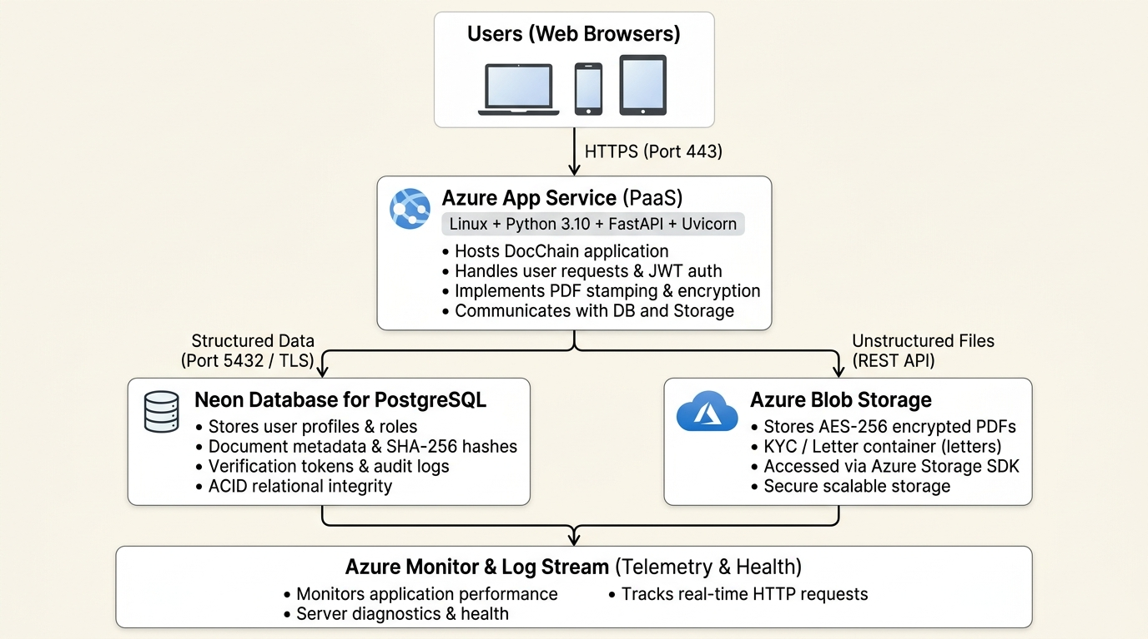
Figure: DocChain Cloud Architecture Diagram
- Users (Web Browsers): Clients access the system over HTTPS (Port 443).
- Azure App Service (PaaS): Hosts the Linux + Python 3.10 + FastAPI application, handles business logic, and coordinates stamping and cryptography.
- Neon PostgreSQL: Stores relational user data, document metadata, SHA-256 signatures, and access logs over SSL (Port 5432).
- Azure Blob Storage: Secure object store hosting AES-256 encrypted PDF files in the `letters` container.
- Azure Monitor & Log Stream: Tracks real-time HTTP requests, diagnostics, and system health.

Slide 7: Technologies Used
Component | Technology / Service Used
Frontend | HTML5, CSS3, JavaScript (Vanilla SPA)
Backend | Python (FastAPI Framework + Uvicorn)
Cloud Platform | Microsoft Azure
Cloud Database (DBaaS) | Neon Serverless PostgreSQL / SQLite (Local)
Cloud Object Storage | Azure Blob Storage (`letters` container)
Cloud Hosting (PaaS) | Azure App Service (Linux B1 Basic Tier)
Security & Cryptography | AES-256-GCM, SHA-256 Hashing, JWT Authentication
Cloud Monitoring | Azure Monitor & Log Stream (HTTP logs, telemetry, metrics)

Slide 8: Azure components
- Neon Database for PostgreSQL:
- Stores user credentials, document metadata, file hashes, and access logs in a managed cloud database.
- Supports automated backups, connection pooling, and strict relational integrity.
- Azure Blob Storage:
- Stores encrypted PDF documents in a dedicated cloud container (`letters`).
- Enables secure, scalable file storage with AES-256 encryption at rest.
- Azure App Service:
- Hosts the FastAPI-based web application and serves responsive user dashboards.
- Provides secure web access globally through HTTPS with automated SSL certificates.
- Azure Resource Group (`rg-docchain-demo`):
- Organizes all project-related Azure resources in one centralized place.
- Simplifies resource management, access control, and subscription monitoring.
- Azure Monitor / Log Stream:
- Tracks application performance, container health, and incoming HTTP requests in real-time.
- Helps identify errors, latency, and system diagnostics during operations.

Slide 9: Cloud Deployment
- Cloud Platform: Microsoft Azure
- Hosting Service: Azure App Service
- Live Application URL: https://docchain-app.azurewebsites.net/
- Deployment Details: The DocChain application is accessible globally through a web browser using secure HTTPS.

Slide 10: Future Scope
- Blockchain Integration: Anchor document SHA-256 hashes onto public or consortium blockchain ledgers (e.g., Ethereum or Polygon) for decentralized, immutable verification.
- Government Vault Integration: Connect with national digital vaults such as DigiLocker for direct document synchronization and official verification.
- Cloud Scalability & Microservices: Decompose backend components into Docker containers managed by Azure Kubernetes Service (AKS) with Azure Functions for automated document expiration triggers.
- DevOps Automation: Automate application testing and continuous cloud deployment using GitHub Actions and Infrastructure as Code (ARM / Terraform).

Slide 11: Conclusion
- Implemented secure user management, document issuance, and real-time verification.
- Ensured data integrity and tamper-proofing using SHA-256 hashing and AES-256-GCM encryption.
- Integrated responsive frontend dashboards with a high-performance FastAPI backend and PostgreSQL database.
- Deployed the web application on Microsoft Azure using Azure App Service and Azure Blob Storage.

Slide 12: Thank You

