**Q2 - SCENARIO**

Macro Life, a healthcare company has recently setup the entire Network and Infrastructure on Azure.

The infrastructure has different components such as Virtual N/W, Subnets, NIC, IPs, NSG etc.

The IT team currently has developed PowerShell scripts to deploy each component where all the properties of each resource is set using PowerShell commands.

The business has realized that the PowerShell scripts are growing over period of time and difficult to handover when new admin onboards in the IT.

The IT team has now decided to move to ARM based deployment of all resources to Azure.

All the passwords are stored in a Azure Service known as key Vault. The deployments needs to be automated using Azure DevOps using IaC(Infrastructure as Code).

1) What are different artifacts you need to create - name of the artifacts and its purpose

2) List the tools you will to create and store the ARM templates.

3) Explain the process and steps to create automated deployment pipeline.

4) Create a sample ARM template you will use to deploy a Windows VM of any size

5) Explain how will you access the password stored in Key Vault and use it as Admin Password in the VM ARM template.

**Implementation.**

Use Visual studio Create new project select Azure resource Manager and name project file.

And select create vm template or blank template and you can add your json object to create VMand create the project.

You will have project file created .

creating a VM involves below steps

create a subnet.

create a storage account.

create a public IP address.

create a network security group.

create a virtual network.

create a NIC.

create a virtual machine.

The project will have three files deploy.json, parameters.json a powershell script to deploy from template.

Change the RG, Template file and parameters file name as required.

Push this into a Git repo on Azure.

Task groups:

Next step is to create task groups for Build and release.

Build Task group:

1. In Azure DevOps create new task group and name is as build : Create vm

2. Click add task select MS Build task enter a name, Under project add the path of solution file.

3. Select latest MS Build version

4. Select the MS Build Architecture.

5. Copy file if any thing required.

6. Add publish Artifact task and publish it to path and name it as vm-creation.

Build:

1. Firstly we need to create new pipeline in azure DevOps we can name it as Env-CreateVm-CI.

2 . Add task group build : Create vm.

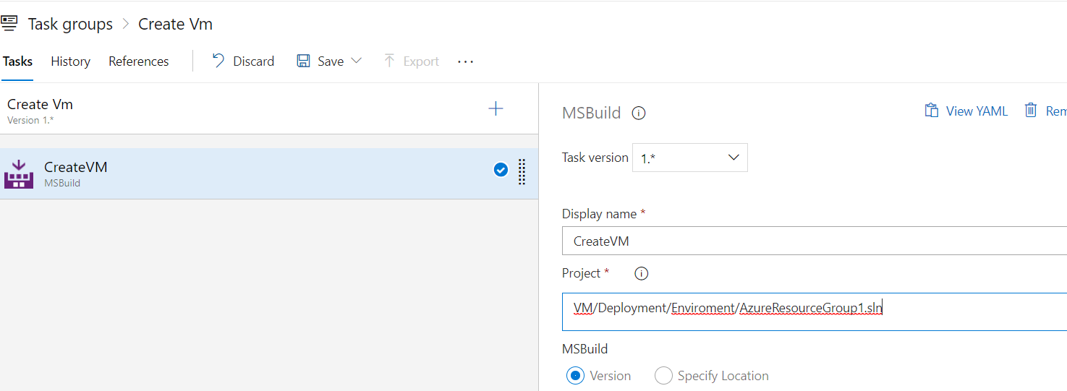

3. Trigger enable contineous integration if needed to trigger build automatically.

Release:

1. Go to Release section under pipeline, Create new pipeline.

2. In Artifact section click empty job and select source type as build select project and the build pipeline created, select version to latest

3.Add Stage DEV .

4. Start adding task in side the DEV stage created you can select Azure pipeline agent or if you have any Microsoft agent you can choose.

6. Add the task **Azure resource group deployment.,** select subscription, Action Create or update resource group, select the resource group, you can parameterize for the environment stage name using $(Release.EnvironmentName).

7. Select RG location, Template location select linked artifact and Template select createVm.Json and Template parameters select createVm.parameters.json.

8. Select deployment mode incremental.

9. Under variable section add library which has reference for username and password from valut.

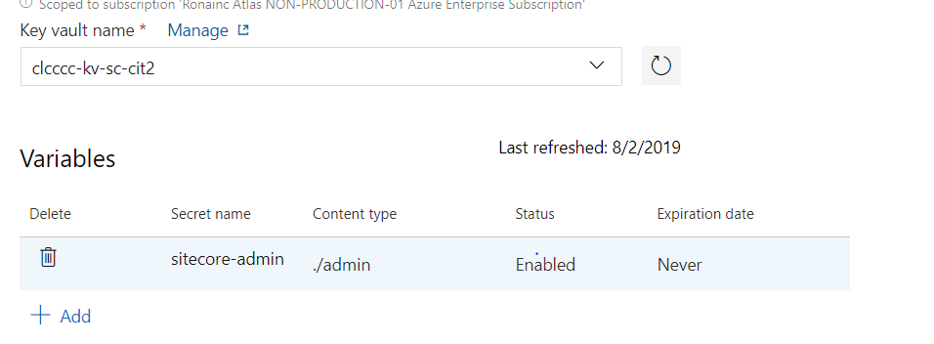

10. In template override parameters override the parameters in createVm.parameters.json.

We can follow the same steps as above Virtual N/W, Subnets, NIC, IPs, NSG if you want the taks created individually Name the Artifact accordingly.