#66d0cc -> #01016f

#079bbb -> #d8031c

#4fc9c4 -> #5252d0

#56676b -> #5a5a5a

**Dr. Niranthara Ganesh:**

Dr. Niranthara Ganesh Did His Mbbs At Ramaiah Medical College, Bangalore , and his Masters In Orthopaedics And Traumatology At World -renowned Ramaiah Medical College and Hospitals.  
  
After Returning From Abroad, from fellowship in Joint Replacement surgeries ,(Arthroplasty Surgeon) He Spent Six Years As A Orthopaedic surgeon At Ramaiah Hospitals , Bangalore.  
  
After Which He Is been practicing in Ramaiah Hospitals as A Joint Replacement Surgeon and Complex Trauma surgeon .  
  
Dr Niranthara Ganesh  Holds Basic And Intermediate certifications  Of The Ao Course, Advanced life and trauma support courses .  
  
He has conducted more than 500 free health camps in the rural and urban sectors of Karnataka ,1000 free surgeries and been actively helping the needy in the flood affected regions of Chennai in 2015 and North Karnataka in 2019.  
  
His Particular Areas Of Interest Are In Hip And Knee Replacement, Traumatology, Shoulder And Knee Arthroscopies, Spine Surgeries And Back Care, Limb Lengthening Procedures And In Sports Medicine.

**Dr. Vikram.**

Dr. Vikram. R is a young, dynamic, dedicated General and Laparoscopic Surgeon.He is a qualified, proactive professional with Masters in surgery (MS) from Mumbai. He pursued laparoscopy by obtaining Fellowship and Diploma in Minimal Access Surgery from Delhi and Fellowship in Upper and Lower GI Endoscopy from Hyderabad. He is a Member of Association of Surgeons of India and World laparoscopic surgeons. With charming bedside manners, he is known for his excellent rapport with patients. He has honed his communicative, perceptive and operative skills, attaining surgical proficiency over a period of eight years of experience in the field of Surgery.

**Dr Abhilash Venkatesh**

**Family physician**

* Under news put website ppt
* Please remove screenshot number 1image under news section

**Dr. Nalluri Sravya**

Chief cosmetologist

**MBBS, FAM, PGDCC, PGDMT**

**Photo attached**

**Dr Niranthara Ganesh D J**

**Chief Orthopaedic Surgeon**

MBBS, MS Orthopaedic Surgeon,

Joint Replacement Surgeon

instead of what you have put plea se put the below

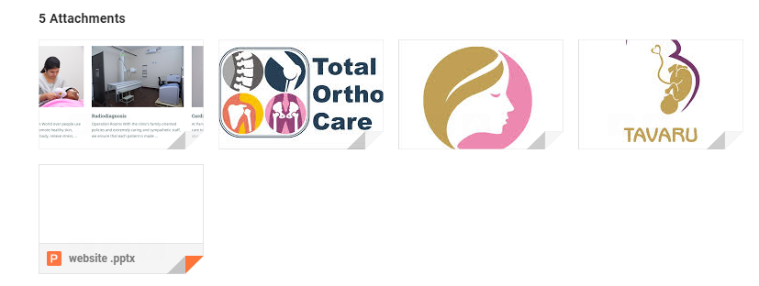

Completed

**Departments:**

obstetrics and genecology - women's health

orthopaedics

general surgery

general medicine

endocrinology

cardiology

ENT

paediatrics

radiology

Cosmetology

physiotherapy

Welcome to Parvva diagnostics and health care

Call, Mail or Book appointment online

Monday - Saturday - 6:30 am to 8:30pm

Sunday - 6:30am to 1pm

phone number: 6364911469/369

email address: correct

**Dr Chaitra S Niranthara**

**Chief Obstetrician and gynaecologist**

MBBS, MS OBG, DNB, PGDMLE

Reproductive Immunologist

Dr. Chaitra S Niranthara

Obstetrician and gynecologist

timings: 10 am -12 noon and 5:30 to 8:00 pm ( Monday to Saturday)

Dr Chaitra S Niranthara is a Obsterterian and gynaecologist specialised in Reproductive Immunology and is an Alumnus of M S Ramaiah medical college. She was awarded the Sri P Nagesam Award for the best outgoing Postgraduate and topper in M S OBG. As someone who believes in a synergy of mind, body, and soul as the ultimate outcome of patient care, she is part of Chanre immunology centre. Her areas of expertise include Reproductive immunology, infertility treatment, PCOS, Counselling, and high-risk pregnancy.

Awards and Accolades: Third Prize for poster presentation in Gnanavarsha , second place for the best original research paper at KSOGA. She has received many prizes in debates, quiz competitions and poster presentations at various conferences.

She is also received the Karnataka state award by the health family welfare department in June 2019 and The Times of India award October 2019.

Along with her clinical work, she is actively involved in planning and executing training programs, giving lectures for students, clinicians, and research.

She knows, English, Hindi, Kannada, Tamil and Telugu.

## **short story about parvva diagnostics**

Parvva diagnostics was established in the year 2019, headed by Dr. Niranthara Ganesh D J, Dr. Chaitra S Niranthara, Dr. Abhilash Venkatesh, Miss Ramya Shivananjaiah, and Dr. Nalluri Sravya. The organization is being worked over preventive medicine – strongly believing that routine screening is a must for every individual and early detection of any disorder is treatable and prevents lifelong complications.  
Team parvva has conducted various health programs and screening for women, children and the geriatric population. We have been conducting multiple public awareness camps on women’s health and nutrition. We have also conducted sensitization programs on socio-cultural causes of infertility, and presently concentrating on the major issues the IT sectors are facing - lower back pain, early detection of diabetes, obesity, hypertension, vision disturbance, etc.