EXP: 02
Case:01
PROGRAM:
clc;
clear;
clf();

rho = input("Enter the charge density rho (C/m^3): ");
R_cm = input("Enter the radius of the sphere (cm): ");

R = R_cm / 100;

eps0 = 8.854e-12;

r = linspace(0, R, 100);
r_cm = r * 100; // For plotting in cm

//======================
// ELECTRIC FLUX DENSITY
// D = rho*r/3
//======================
D = (rho .* r) / 3;

//======================
// ELECTRIC FIELD
// E = D/eps0
//======================
E = D / eps0;

//======================
// RESULTS
//======================
disp("=====================================");
disp("RESULTS");
disp("=====================================");

disp("At Center (r = 0 cm)");
disp("Electric Field E (V/m):");
disp(E(1));

disp("Electric Flux Density D (C/m^2):");
disp(D(1));

disp(" ");

disp("At Surface");
disp("Electric Field E (V/m):");
disp(E($));

disp("Electric Flux Density D (C/m^2):");
disp(D($));

figure();

subplot(2,1,1);
plot(r_cm, E);
xlabel("Radius (cm)");
ylabel("Electric Field E (V/m)");
title("Electric Field Inside Uniformly Charged Sphere");
xgrid();

subplot(2,1,2);
plot(r_cm, D);
xlabel("Radius (cm)");
ylabel("Electric Flux Density D (C/m^2)");
title("Electric Flux Density Inside Uniformly Charged Sphere");
xgrid();

output:
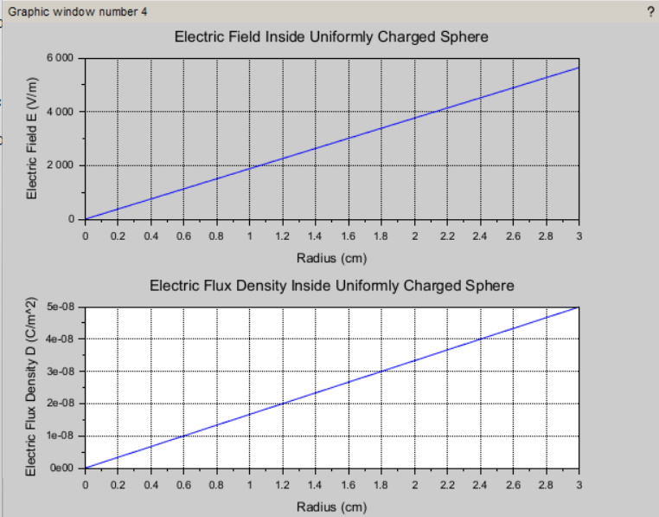

CALCULATION:
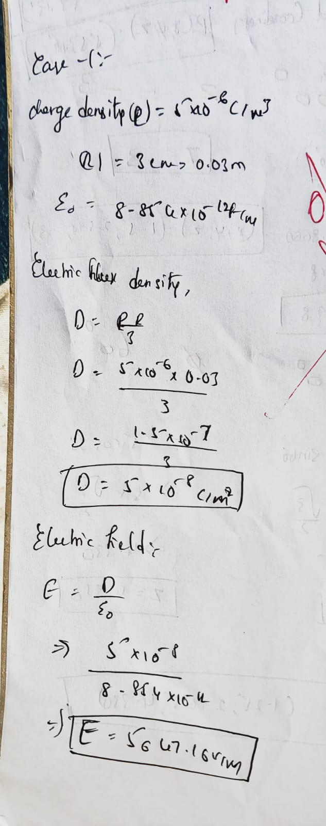
CASE:02
PROGRAM:
clc;
clear;
clf();

//======================
// INPUTS
//======================
rho0 = input("Enter the constant rho0 (C/m^4): ");
R_cm = input("Enter the radius of the sphere (cm): ");

// Convert cm to m
R = R_cm / 100;

// Permittivity of free space
eps0 = 8.854e-12;

r = linspace(0, R, 100);
r_cm = r * 100;

D = (rho0 .* r.^2) / 4;
E = D / eps0;

disp("=====================================");
disp("RESULTS");
disp("=====================================");

disp("At Center (r = 0 cm)");
disp("Electric Field E (V/m):");
disp(E(1));

disp("Electric Flux Density D (C/m^2):");
disp(D(1));

disp(" ");

disp("At Surface");
disp("Electric Field E (V/m):");
disp(E($));

disp("Electric Flux Density D (C/m^2):");
disp(D($));

figure();

subplot(2,1,1);
plot(r_cm,E);
xlabel("Radius (cm)");
ylabel("Electric Field E (V/m)");
title("Electric Field for Linearly Increasing Charge Density");
xgrid();

subplot(2,1,2);
plot(r_cm,D);
xlabel("Radius (cm)");
ylabel("Electric Flux Density D (C/m^2)");
title("Electric Flux Density for Linearly Increasing Charge Density");
xgrid();

OUTPUT:
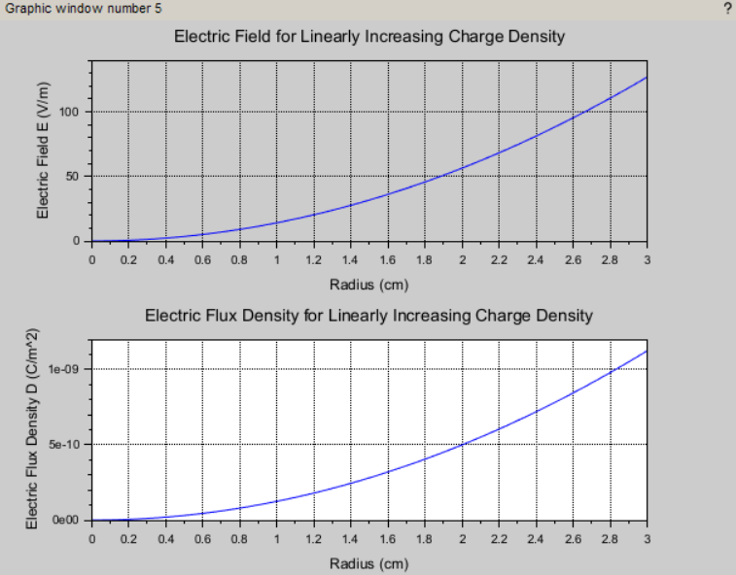

CALCULATION:
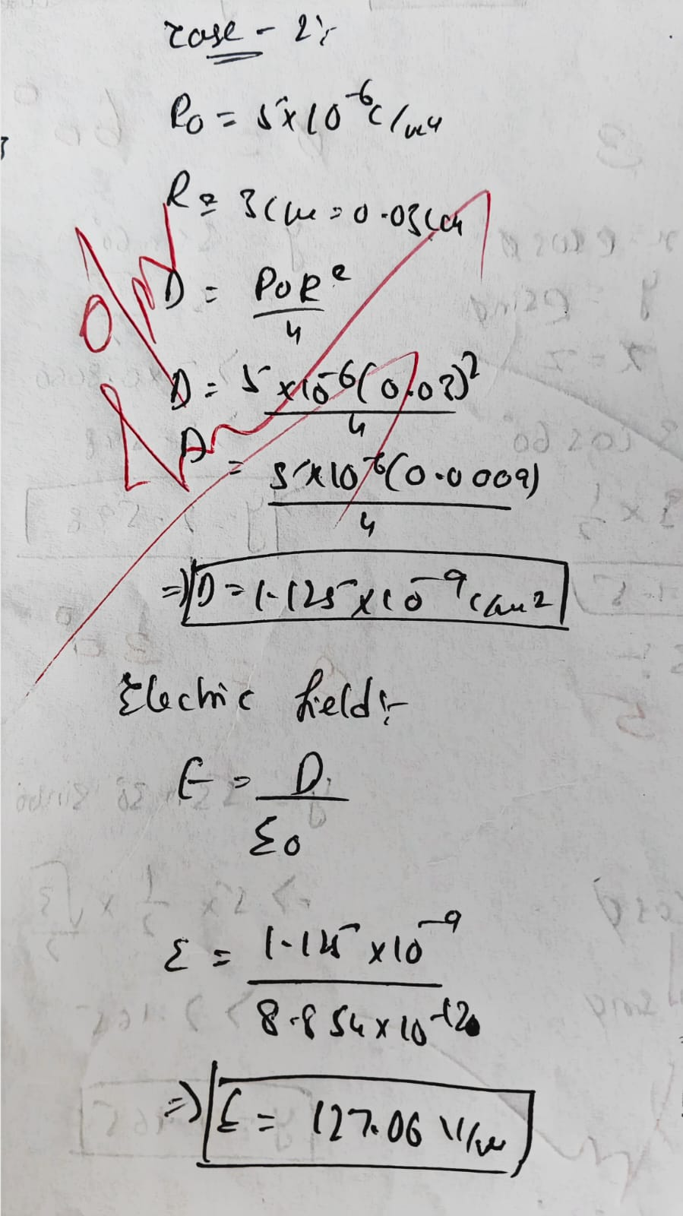
CASE:03
PROGRAM;
clc;
clear;
clf();

//=====================================
// GIVEN DATA
//=====================================
R = 2; // Radius in meters
rho = 3e-6; // Charge density (C/m^3)
eps0 = 8.854e-12;
pi = %pi;

// Total charge inside sphere
Q = rho*(4/3)*pi*R^3;

// Radial distance (0 to 4 m)
r = linspace(0,4,200);
E = zeros(r);
D = zeros(r);
for i = 1:length(r)

if r(i) <= R then

D(i) = rho*r(i)/3;
E(i) = D(i)/eps0;

else
D(i) = Q/(4*pi*r(i)^2);
E(i) = D(i)/eps0;

end

end

disp("Total Charge (C)");
disp(Q);

disp("Electric Field at Center (V/m)");
disp(E(1));

surface_index = find(r==max(r(r<=R)));

disp("Electric Field at Surface (V/m)");
disp(E(surface_index));

disp("Electric Flux Density at Surface (C/m^2)");
disp(D(surface_index));

figure();

subplot(2,1,1);
plot(r,E,'b');
xlabel("Radial Distance r (m)");
ylabel("Electric Field E (V/m)");
title("Electric Field vs Radial Distance");
xgrid();

subplot(2,1,2);
plot(r,D,'r');
xlabel("Radial Distance r (m)");
ylabel("Electric Flux Density D (C/m^2)");
title("Electric Flux Density vs Radial Distance");
xgrid();
OUTPUT:
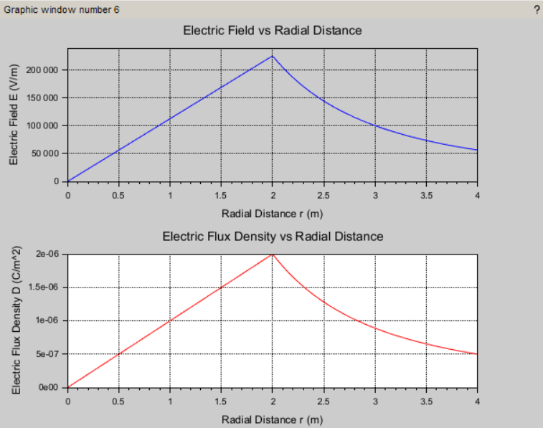
CALCULATION:
