Design and Development of an Arduino-Based Agricultural Robot
Tapasi Puneeth Reddy  Dept. of Computing Technologies  SRM Institute of Science and Technology  Kattankulathur, Tamil Nadu, India | Vigneshwaran B  Dept. of Computing Technologies  SRM Institute of Science and Technology  Kattankulathur, Tamil Nadu, India | Drona R  Dept. of Computing Technologies  SRM Institute of Science and Technology  Kattankulathur, Tamil Nadu, India
Faculty Guide: Dr. Asha Abraham
21CSE305P – SerBot: Project-Based Learning in Robotics

Abstract—This paper presents the design of an Arduino-based agricultural robot for basic field monitoring and movement. An Arduino Nano acts as the central controller and interfaces with a DHT11 temperature and humidity sensor, an analog soil-moisture sensor, an HC-SR04 ultrasonic sensor, a GPS receiver, a servo-operated soil probe, a motor driver, and a relay module. The firmware reads sensor values, evaluates soil and obstacle thresholds, controls the drive motors and servo, and reports GPS coordinates when a valid fix is available. The supplied program classifies soil as dry when the analog reading exceeds 600 and triggers a stop, reverse, and right-turn response when an obstacle is detected within 20 cm. Relay-based pump control is included as an optional interface but is disabled by default. This paper documents the system requirements, architecture, pin mapping, firmware logic, and a proposed validation procedure. Quantitative performance results are not claimed because measured test data were not supplied.
Keywords—Agricultural robotics, Arduino Nano, soil-moisture monitoring, obstacle detection, GPS, embedded control.

I. Introduction
Agricultural operations benefit from timely information about soil and surrounding environmental conditions. Manual observation may require repeated movement through a field and may not provide consistent readings at different locations. A compact mobile robot can support basic data collection while moving through an area. This project develops a low-cost prototype around an Arduino Nano [1], integrating sensor acquisition, obstacle response, motor actuation, a servo mechanism, and GPS reporting.
The prototype is intended to demonstrate an integrated embedded system rather than a fully autonomous commercial farm vehicle. It monitors temperature and humidity using a DHT11 sensor [2], reads an analog soil-moisture sensor, measures nearby distance using an HC-SR04 ultrasonic sensor [3], and obtains location data through a GPS receiver when satellite reception permits. A motor driver interfaces the controller with the drive motors, while a servo lowers and raises the soil probe.
The contributions of this work are: (1) integration of multiple low-cost sensors with an Arduino Nano; (2) threshold-based soil condition indication; (3) a simple obstacle response routine; (4) serial reporting of readings and valid GPS coordinates; and (5) an extensible relay interface for optional irrigation.

II. Related Work and Background
Low-cost agricultural automation commonly combines environmental sensing, soil-condition measurement, mobile platforms, and embedded controllers. Soil-moisture sensors provide electrical readings that can indicate relative soil wetness after calibration for the selected sensor and soil. Temperature and humidity sensors provide environmental context. Ultrasonic ranging is used in short-range obstacle detection, while GPS receivers provide outdoor position information when a valid satellite fix is available.
The present prototype combines these functions in a single Arduino-controlled platform. Its approach is threshold-based and computationally lightweight. It does not currently use machine learning, cloud analytics, precision field maps, or a global path-planning algorithm. A formal comparison with published systems requires verified literature sources and controlled measurements, which are beyond the scope of this paper.

III. System Requirements

A. Functional Requirements
The controller acquires temperature and humidity data from the DHT11, reads the analog soil-moisture output, measures obstacle distance through the HC-SR04, and parses GPS data through a serial interface. It commands the drive motors through the motor-driver input pins, moves the servo between configured probe positions, and reports readings through the serial monitor. The relay output remains inactive unless pump control is deliberately enabled in the firmware.

B. Non-Functional Requirements
The prototype is intended to be low-cost, modular, and maintainable. Sensor and actuator modules should be replaceable without redesigning the controller. The power system must provide suitable voltage and current for the Arduino, sensors, servo, motors, and any pump. Grounds must be referenced appropriately, and motor or pump loads must not be powered directly from Arduino I/O pins.

C. Hardware and Software
The hardware specified by the supplied firmware consists of an Arduino Nano, DHT11, HC-SR04, analog soil-moisture sensor, GPS module, servo motor, motor driver, relay module, DC motors, and an optional water pump. The software uses Arduino C/C++ and the DHT, Servo, SoftwareSerial [5], and TinyGPSPlus [4] libraries. The exact motor-driver model and final power-distribution arrangement must be confirmed from the physical hardware before the wiring is treated as a final schematic.

IV. Architecture and Design

A. System Architecture
The system follows a sensor–controller–actuator arrangement, as shown in Fig. 1. Sensor signals are acquired by the Arduino Nano. The controller evaluates the soil reading and ultrasonic distance, processes incoming GPS characters, and generates motor, servo, and relay commands. Sensor values and valid position information are sent to the serial monitor.
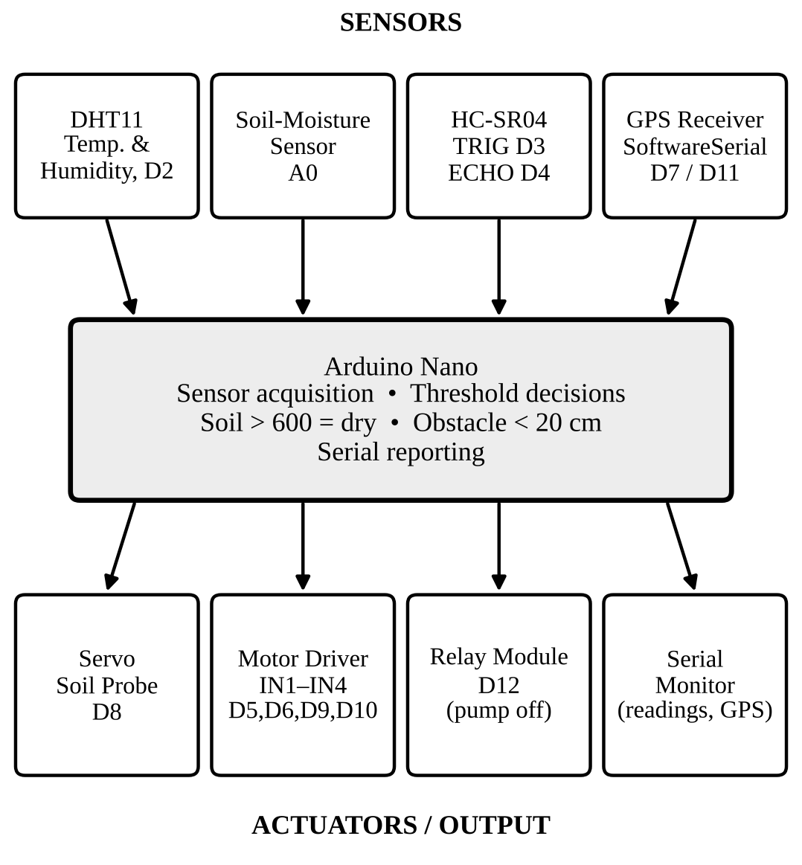
Fig. 1. Sensor–controller–actuator architecture of the Arduino Nano-based agricultural robot.
The processing sequence consists of sensor acquisition, soil-probe positioning, sensor evaluation, obstacle decision, motor and relay control, and serial/GPS reporting. The servo moves to the configured down position before the soil reading and returns to the up position afterward.

B. Pin Configuration
Table I lists the pin assignments present in the supplied firmware. These are software assignments and must be checked against the actual module labels and wiring before powering the prototype.
TABLE I
Pin Assignments in the Supplied Firmware
Module | Nano Pin | Signal / Purpose
DHT11 | D2 | DATA
HC-SR04 | D3 / D4 | TRIG / ECHO
Soil sensor | A0 | Analog output
Motor driver | D5, D6, D9, D10 | IN1–IN4
GPS | D7 / D11 | SoftwareSerial RX / TX
Servo | D8 | Signal
Relay | D12 | Control input

C. Control Logic
The soil-moisture value is compared with SOIL_DRY_THRESHOLD = 600. A value greater than this threshold is reported as dry by the current program. The threshold should be calibrated using the selected sensor in representative soil conditions. The ultrasonic obstacle threshold is 20 cm. When the measured distance is below this value, the program stops the motors, commands reverse movement, and then turns right. Otherwise, the forward movement routine is selected. Table II summarises the key firmware parameters.
TABLE II
Key Firmware Parameters
Parameter | Value | Function
SOIL_DRY_THRESHOLD | 600 | Dry if reading > 600
Obstacle threshold | 20 cm | Stop, reverse, then turn right
Timeout return | 999 | Returned if no echo
RELAY_ON / RELAY_OFF | LOW / HIGH | Active-low relay logic
ENABLE_PUMP_CONTROL | false | Pump control off by default

The GPS receiver is read through SoftwareSerial and interpreted using TinyGPSPlus. Coordinates are reported only when the library indicates a valid location. The distance routine returns 999 when the ultrasonic pulse measurement times out; timeout behaviour should be checked during testing so that an absent echo is not incorrectly treated as a clear path.

V. Implementation
The firmware separates motor actions and distance measurement into functions. Motor routines set four motor-driver input pins to implement stop, forward, backward, and right-turn actions. The getDistance() routine triggers the HC-SR04 and measures the echo pulse duration. The main loop services GPS data, reads environmental and soil sensors, moves the servo to take a soil reading, prints measurements, and applies threshold-based control decisions.
The relay logic uses active-low operation in the supplied code, with RELAY_ON set to LOW and RELAY_OFF set to HIGH. However, ENABLE_PUMP_CONTROL is false by default. Therefore, the presence of relay logic does not mean automatic irrigation is active. Pump activation should only be enabled after confirming relay polarity, pump ratings, isolation, and safe power wiring.
The GPS serial mapping uses Arduino-side receive pin D7 and transmit pin D11. The typical UART cross-connection is GPS TX to Arduino D7 and Arduino D11 to GPS RX. The voltage requirements of the specific GPS breakout must be checked before connecting its RX input.

VI. Experimental Validation and Analysis
The supplied source code defines thresholds and response logic, but no measured dataset, calibration record, or completed field-trial log was provided. Therefore, numerical accuracy, response time, navigation success rate, soil-moisture error, and irrigation performance are not reported as achieved results. The following checks should be completed and recorded during physical testing:
- DHT11 reading: compare displayed temperature and humidity with a reference instrument.
- Soil-moisture response: record raw readings for dry, moderately moist, and wet soil; calibrate the threshold.
- Obstacle response: place an obstacle around the 20 cm threshold and record stop, reverse, and turn behaviour.
- GPS acquisition: record time to valid fix and compare coordinates with a known outdoor location.
- Servo probe cycle: check that the probe lowers and raises without binding or disturbing wiring.
- Relay and pump: keep disabled until relay polarity and electrical ratings are verified; test separately.

The threshold-based design is straightforward and computationally lightweight. Its limitations include dependence on sensor calibration, environmental conditions, wheel traction, motor-driver capability, and GPS reception. The obstacle routine is a reactive manoeuvre and does not construct a map or plan a complete path. The soil-moisture sensor provides a local reading rather than a field-wide soil assessment.

VII. Conclusion and Future Work
This paper described an Arduino Nano-based agricultural robot prototype integrating environmental sensing, soil-moisture monitoring, ultrasonic obstacle response, servo-based probe positioning, motor control, and GPS reporting. The firmware uses a soil dryness threshold of 600 and an obstacle threshold of 20 cm. The relay interface is present for possible pump control, but automatic pump activation is disabled by default. The design provides a modular starting point for low-cost agricultural monitoring.
Future work includes calibrating the soil sensor for different soil types, conducting systematic field tests, improving navigation beyond a single ultrasonic sensor, logging data to removable or wireless storage, adding a live monitoring interface, and implementing safe closed-loop irrigation after validating the pump and relay hardware. A weather-resistant enclosure and documented power-distribution design are also required before outdoor deployment.

Acknowledgment
The authors express their sincere gratitude to Dr. Asha Abraham, Faculty Guide, Department of Networking and Communications, SRM Institute of Science and Technology, for her guidance, suggestions, and support throughout this project. The authors also acknowledge the Department of Networking and Communications, School of Computing, SRM Institute of Science and Technology, Kattankulathur, for providing the academic framework for the 21CSE305P – SerBot: Project-Based Learning in Robotics course project.

References
[1] Arduino, “Arduino Nano,” Arduino Documentation. [Online]. Available: https://docs.arduino.cc/
[2] Aosong Electronics, “DHT11 temperature and humidity sensor,” Product datasheet.
[3] “HC-SR04 ultrasonic ranging module,” Manufacturer technical datasheet.
[4] M. Hart, “TinyGPSPlus: Arduino NMEA parsing library,” GitHub repository. [Online]. Available: https://github.com/mikalhart/TinyGPSPlus
[5] Arduino, “SoftwareSerial library,” Arduino Documentation. [Online]. Available: https://docs.arduino.cc/

