How to setup and test the functionality:

1. Clone the repository: git clone the repo provided in the email
2. Ensure Docker is running on the host.
3. Build the Docker images: docker-compose build --no-cache
4. Start the services: docker-compose up but go to the docker-compose.yml and give the volume path (Yourhost folder: container volume) in my case it was defined as

Keep the containers mount name as content as the code goes there , also it could be configured through a prop file which was better.

volumes:

      - C:/dbtune-drive:/content

1. Verify all services are running: docker ps

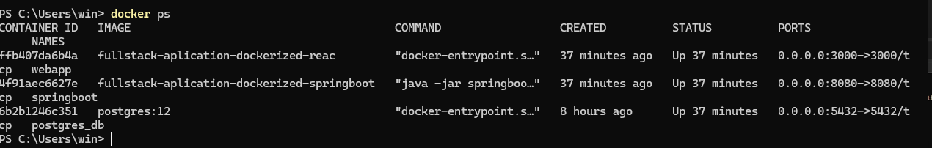

1. Open your browser and navigate to http://localhost:3000/submit to access the file upload option.
2. Upload a file and confirm the upload message indicates the file status is "STORED."

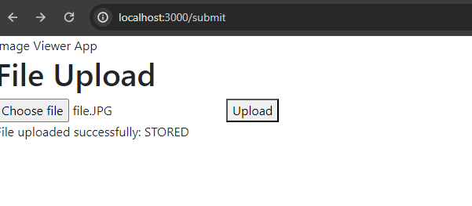

1. Check the file status using the API: GET http://localhost:8080/cms/list?page=0&size=10. The files status is STORED

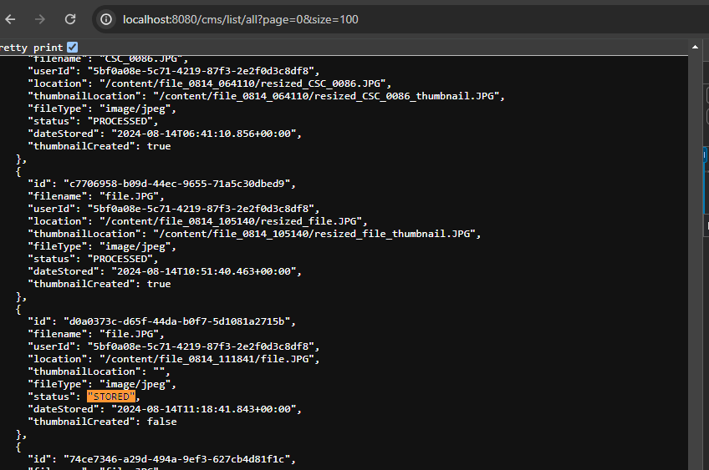

1. Process the file for resizing and thumbnail creation by issuing:
   * GET http://localhost:8080/resize/images
   * GET <http://localhost:8080/resize/thumbnails>
2. Verify the file status and details using the API: GET http://localhost:8080/cms/list?page=0&size=10. The status should be moved from "STORED," with updated file and thumbnail locations:  
   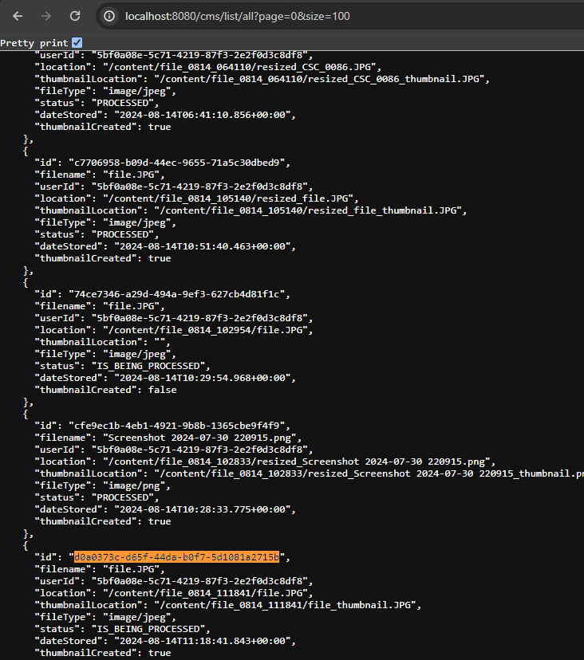

1. Now try to visit <http://localhost:3000/list> , you will have paginated GRID and TABLE VIEW

11.1 GRID allows you to download the resized image (paginated set) with other image attributes like name   
11.2 TABLE allows you to download the thumbnails of the paginated set with other attributes

11.2.1 Once you click on the thumbnail the server issues the complete resized file .

Table view

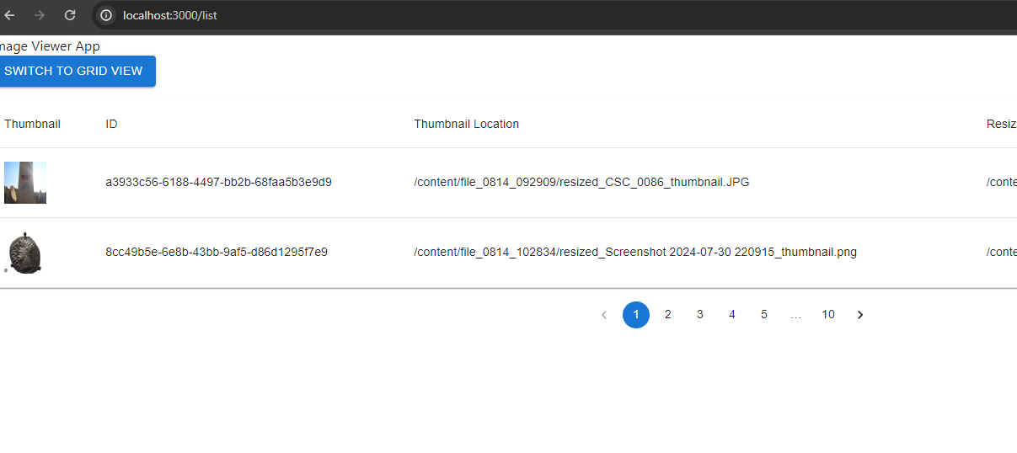

Expanded view of the image form the Table view ,it has a close button to move back to the table .  
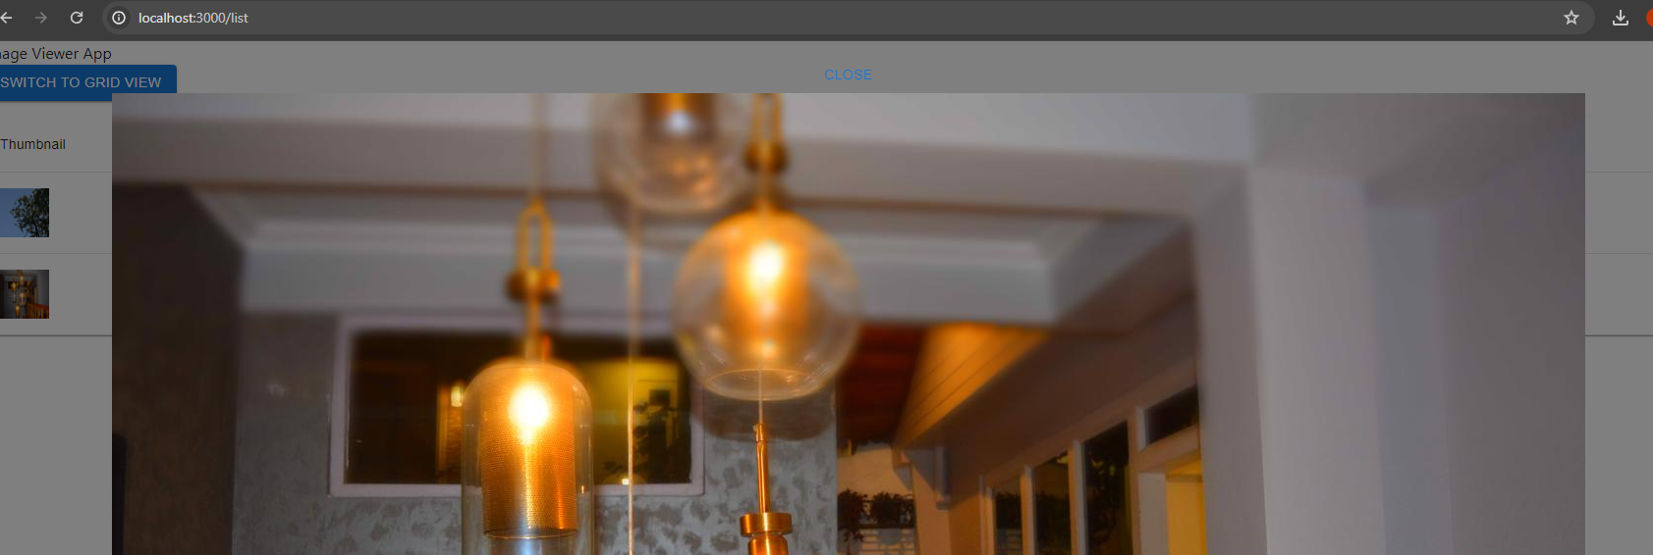

GRID view displays the full image by default ( though the fetching of the images is paginated )

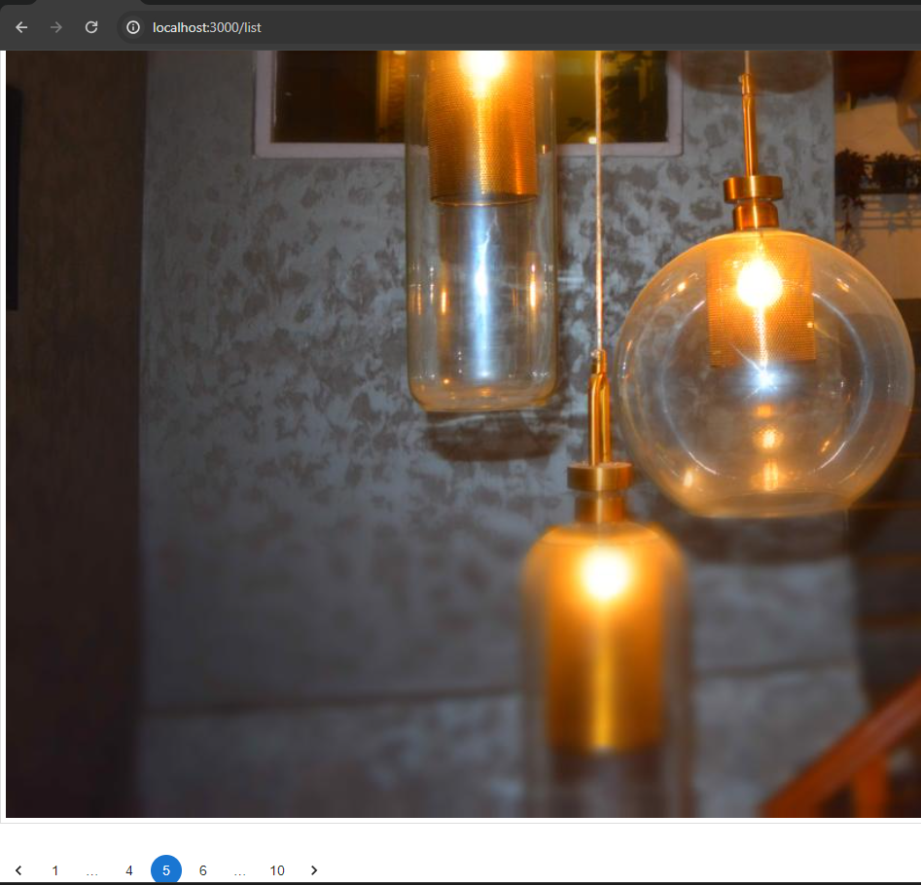

Also you can see the content from the mounted volume   
  
