The workbooks that you have downloaded has the following sheets:

1. payouts_table
2. business_partners
3. locations
4. vehicle_details
5. vehicle_mileage
6. branch_wise_rate

payout_table: This table contains data about the partners’ per kg rates and the weight they delivered in December, 2018. We will use this data to calculate the partners’ earnings (or payouts) for that month.

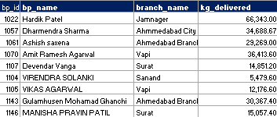

* **bp_id** - Unique id of delivery partners
* **bp_name** - Name of the delivery partners
* **branch_name** - Name of the delivery station or branch in which partner works
* **kg_delivered**- Weight in kg delivered

business_partners This table has information about business partners, such as the vehicles they own, purchase year, ownership type, etc.

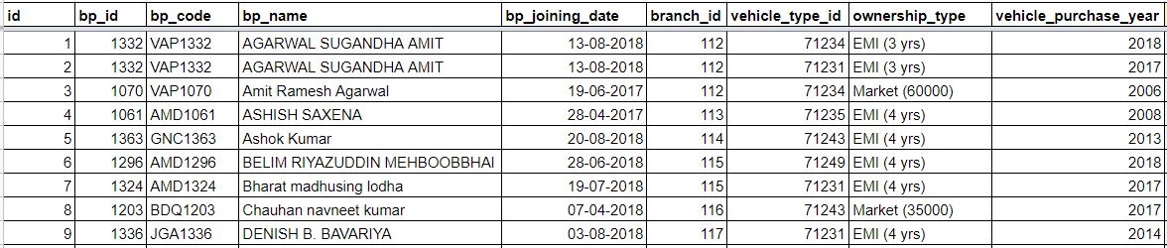

* **bp_id** Unique business partner id
* **bp_code** Partners alphanumeric code
* **bp_name** Business partner name
* **bp_joining_date** Date on which a business partner joined
* **branch_id** Delivery station ID
* **vehicle_type_id** ID of the vehicle
* **ownership_type** Type of purchase/ownership of the vehicle
* **vehicle_purchase_year** Year when the vehicle was purchased

locations: The location data set has information related to the delivery stations.

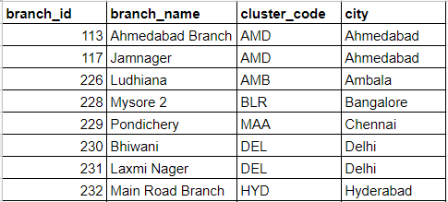

* **branch_id -** primary key of the location dataset (location refers here location of delivery station)
* **branch_name**- name of the locations e.g Vapi Branch
* **cluster_code** - code of the cluster/city/region
* **city**- name of the city in which mother hub is located

vehicle_details: This table contains vehicle data such as their carrying capacity and price.

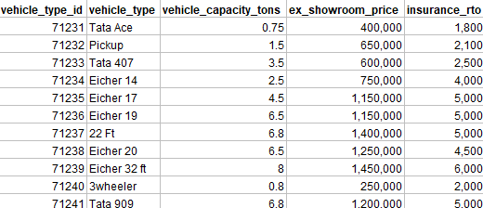

* **vehicle_type_id**- Unique id of the vehicle type represents the primary key of the data set
* **vehicle_type**- Type of vehicle owned by vendors
* **vehicle_capacity_tons**- Maximum permissible carriage capacity of vehicles in tons.
* **ex_showroom_price**- The price at which a dealer sells to retail customers. It includes dealer margins, transportation costs, and applicable excise, etc.
* **insurance_rto**- Insurance and RTO costs.

vehicle_mileage: This table contains the mileage for each vehicle type.

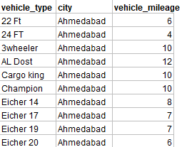

* **vehicle_type**- Type of vehicle owned by vendors.
* **city**- name of the city.
* **vehicle_mileage**- Mileage of the vehicle *in the Ahmedabad**region.*

branch_wise_rate: This table contains the per kg rate for package delivery in various branches.

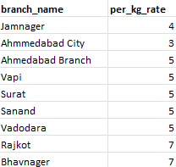

* **branch_name**- Name of the branch.
* **per_kg_rate** - Rate per kg contracted by delivery partner for package delivery.

**Data set schema**

The schema shown below represents the relationship between different tables in the data provided.

