INSURANCE DATABASE
show databases;
create database insurance;
use insurance;
create table person(driver_id varchar(10),
name varchar(20),
address varchar(30),
primary key(driver_id));

create table car(
reg_num varchar(10),
model varchar(10),
year int,
primary key(reg_num));

create table accident(
report_num int,
accident_date date,
location varchar(20),
primary key(report_num));

create table owns(
driver_id varchar(10),
reg_num varchar(10),
primary key(driver_id, reg_num),
foreign key(driver_id) references person(driver_id),
foreign key(reg_num) references car(reg_num));

create table participated(
driver_id varchar(20),
reg_num varchar(20),
report_num int,
damage_amount int,
primary key(driver_id, reg_num, report_num),
foreign key(driver_id) references person(driver_id),
foreign key(reg_num) references car(reg_num),
foreign key(report_num) references accident(report_num));

insert into person values
('d1','Ravikumar','bangaluru'),
('d2','Ravi','hubballi'),
('d3','nakul','davanagere'),
('d4','vijay','shivamogga'),
('d5','ajay','mangalore');

insert into car values
('KA01ab1234','bmw','2022'),
('KA02cd5678','ferrari','2023'),
('KA03ef91011','hyundai','2024'),
('KA04gh1213','creta','2025'),
('KA05ij1415','G-Wagon','2021');

insert into accident values
('101','2023-01-04','mgroad'),
('102','2023-01-05','ring road'),
('103','2023-01-06','airport road'),
('104','2023-01-07','nh 48'),
('105','2023-01-08','brigade road');

insert into owns values
('D1','KA01ab1234'),
('D2','KA02cd5678'),
('D3','KA03ef91011'),
('D4','KA04gh1213'),
('D5','KA05ij1415');

insert into participated values
('d1','KA01ab1234','101',150000),
('d2','KA02cd5678','102',15000),
('d3','KA03ef91011','103',1500),
('d4','KA04gh1213','104',15110),
('d5','KA05ij1415','105',1510);

Queries
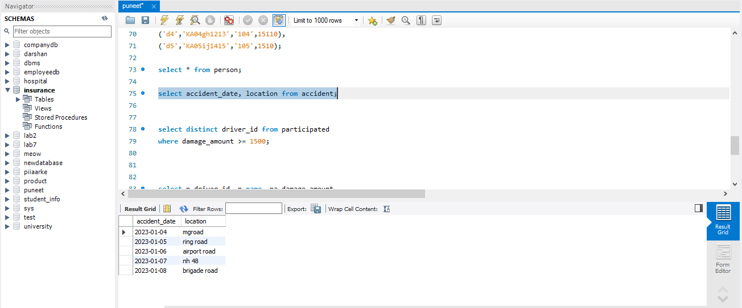
- select accident_date, location from accident;
- select distinct driver_id from participated
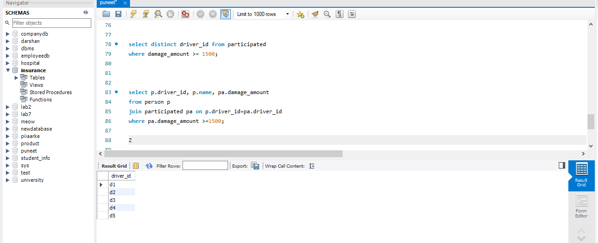
where damage_amount >= 1500

- select p.driver_id, p.name, pa.damage_amount
from person p
join participated pa on p.driver_id=pa.driver_id
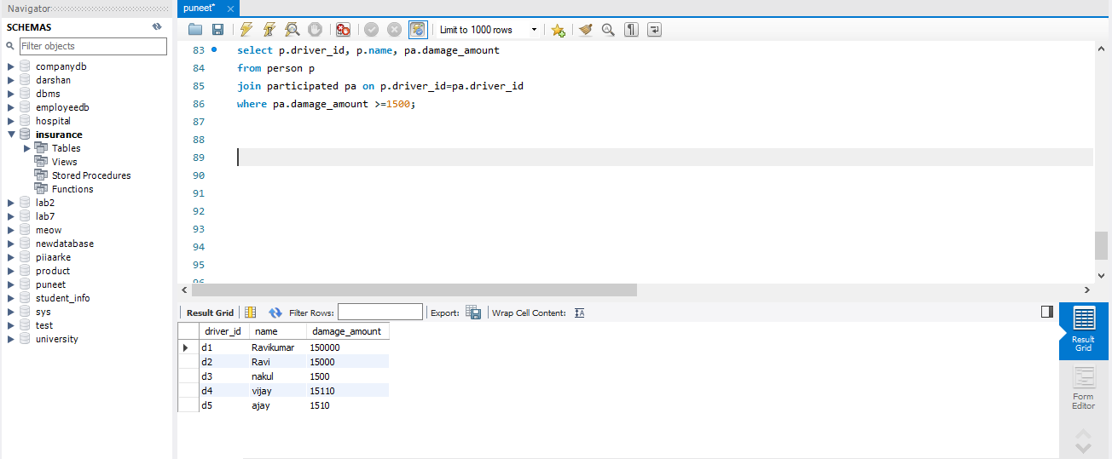
where pa.damage_amount >=1500;

