1. Create a file like nano file1.txt o Edit some data and then save the file

2. Now we will copy date from file1 to new file2 o cp file1.txt file2.txt o then see the output of file2.txt, cat file2.txt o Give screenshot

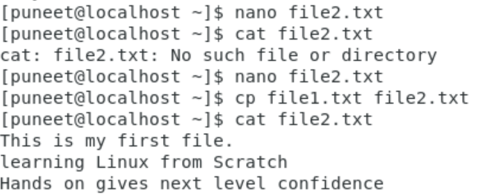

3. Now we will move the file2.txt to new folder /home o mv file2.txt /home o Then go to home directory and check ls, file exits or not? Given screenshot



4. Then we create a new file3.txt and file4.txt in home directory and add content in it.

Now do echo “Hello I am newline” > file3.txt and provide the output of file3.txt

Now do echo “Hello I am newline” >> file4.txt and provide the output of file4.txt

Tell the different between both step you follow and the reason behind it

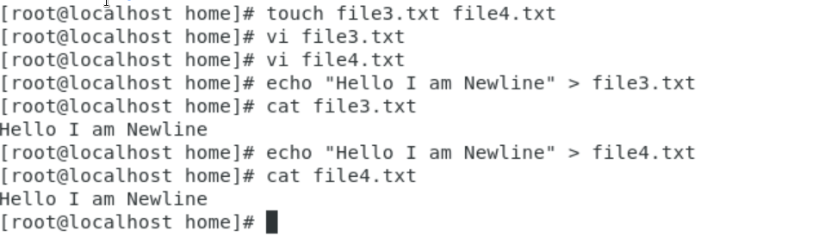

5. For remove a file or directory you can use the below two commands

To delete a file – rm

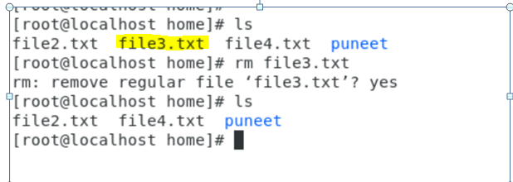

To d ele t e a dir e c t o r y - r m d i r < a n y _ d i r e c t o r y n a m e >

