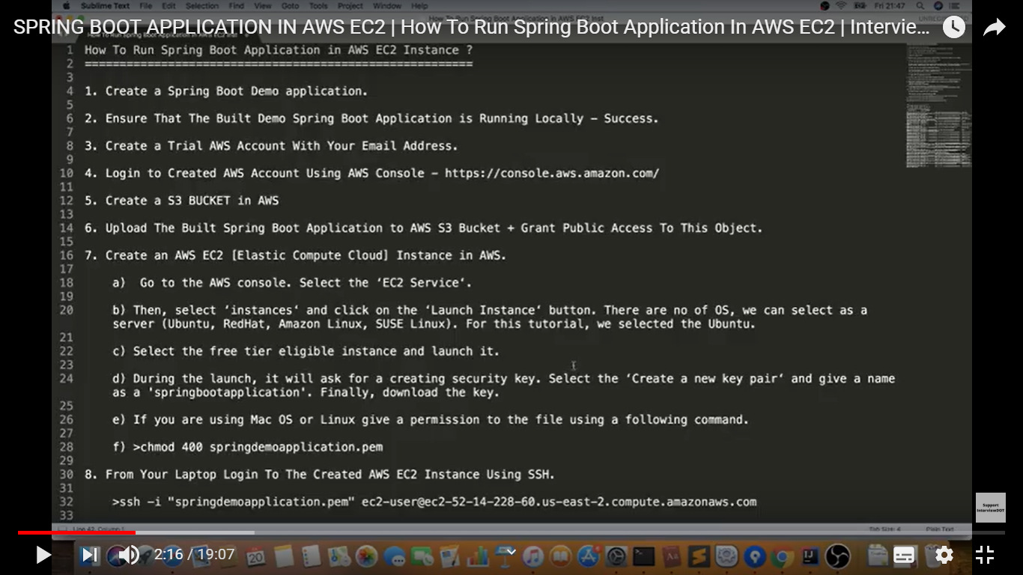

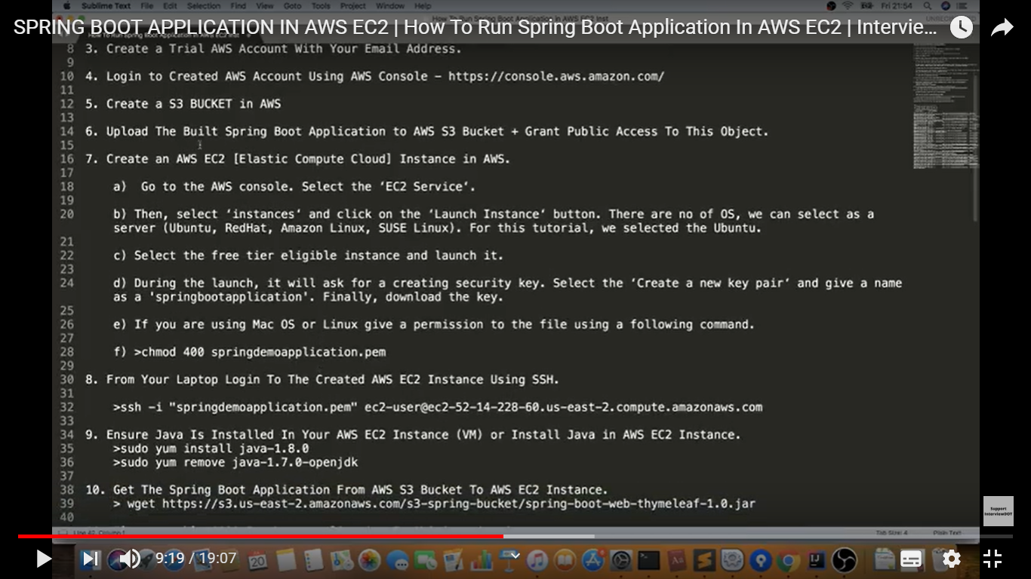

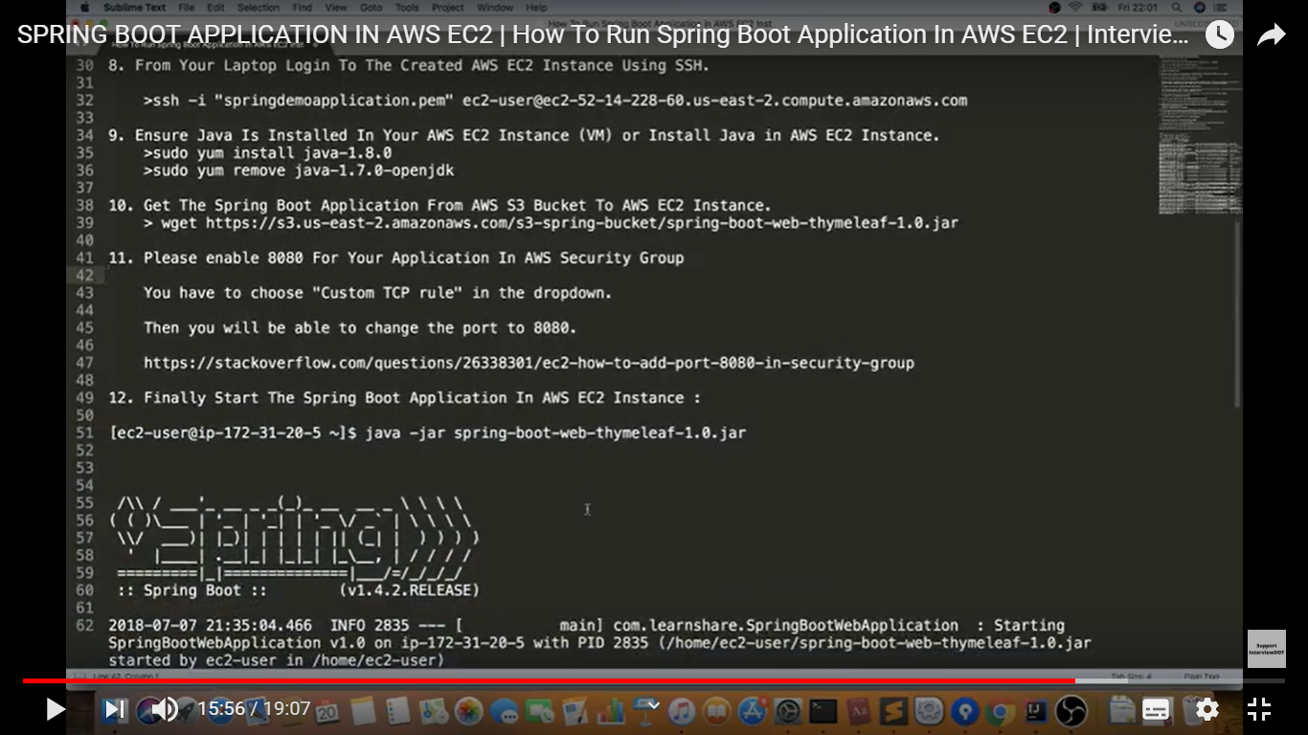

Install docker in ec2 instance

To Apply all update

**sudo yum update –y**

Install docker in ec2

**sudo yum install docker -y**

**sudo service docker start**

**TO pull image from docker hub**

**sudo docker run –p 80:8080 <image name>**