

A literature survey on the heuristic methods and their respective pros and cons in regionalization algorithms



## 

| **Bharath Mysore Nagendra**  University of California, Riverside  bmyso001@ucr.edu  ID: 862291505 | **Mohit Asudani**  University of California, Riverside  masud001@ucr.edu  ID: 862393012 |
| --- | --- |
| **Puneet Singhania**  University of California, Riverside  psing088@ucr.edu  ID: 862327375 | **Mohammed Armughanuddin**  University of California, Riverside  marmu001@ucr.edu  ID: 862395044 |
| **Anoop Puttur Nityananda**  University of California, Riverside  aputt003@ucr.edu  ID: 862251519 | **Yashwanth Eshwarappa**  University of California, Riverside  yeshw001@ucr.edu  ID: 862313223 |

# Abstract

Regionalization algorithms play a pivotal role in the field of spatial computing as they perform spatially constrained clustering by aggregating spatial units. The precise definition of spatial boundaries is useful in several domains, ranging from political science to different branches of geography. This paper is a survey that is aimed to review multiple heuristic methods which are utilized in the regionalization algorithms. There are several challenges faced by traditional approaches. This paper attempts to provide a comprehensive explanation of the most commonly used algorithms used for regionalization. We delve deeper into the advantages and disadvantages of each of these algorithms. It also provides the scope for future research on each of the topics surveyed.

# Introduction

The various regionalization methods were surveyed by Duque et al. in 2006 [59], but since then, a number of new algorithms have been developed for the various problems. For instance, the SKATER algorithm which was devised in the same year is one of the most widely used algorithms for graph-based regionalization. Our paper gives a comprehensive resource for the various algorithms available for the different regionalization methods.

In this study, we investigate different approaches related to the heuristic methods in regionalization algorithms and build on the findings of the prior survey. Different topics being covered by this paper are as follows: Section 2: Adapted hierarchical clustering algorithms, Section 3: Seeded Regions, Section 4: Modification of an initial feasible solution, Section 5: Graph-Theory based models, Section 6: Mixed heuristic models, and, Section 7: concludes the paper by summarizing and discussing the future work of multiple scenarios we surveyed.

# Adapted hierarchical clustering algorithms

* 1. **Description**

The core tenet of this regionalization approach is to use *only* the adjoining regions that are then combined using traditional hierarchical clustering algorithms. Before starting the regionalization process, each area is considered to be a separate region. With every iteration of the algorithm, areas are combined, considering one at a time until the targeted number of regions is reached, which is predetermined based on the problem statement under consideration.

|  |  |  |  |  |  |
| --- | --- | --- | --- | --- | --- |
| Spence (1968) |  |  |  |  |  |
| Webster and Burrough (1972) |  |  |  |  |  |
| Margules et al. (1985) |  |  |  |  |  |
| Byfuglien and Nordgard (1973) |  |  |  |  |  |
| Ferligoj and Batagelj (1982) |  |  |  |  |  |
| Openshaw (1973) |  |  |  |  |  |
| Perruchet (1983) |  |  |  |  |  |
| Sneath (1963) |  |  |  |  |  |

Figure: Adapted hierarchical clustering algorithms taxonomy table (The tick represents the contribution of each paper)

* 1. **Comparison of hierarchical methods**

Spence (1968) [1] talks about multifactor uniform regionalization of British counties on the basis of employment data. This approach needs a prerequisite where a contiguity constraint for the regions needs to be met. The paper aims to perform regionalization of British counties using employment data as the measure. The method proposed takes two contiguous groups at a time and then groups them to form a new group based on an objective function. The objective is to make the new group’s sum of squares of distance with respect to other groups as minimal as possible. Grouping of regions with a constraint on contiguity generates homogenous regions as well. Thus, this method allows groups of similar sizes and features to be created efficiently and quickly. The approach resulted in a very low (8.2%) loss of detail, even when the number of regions was reduced from 42 to 24 through grouping.

Webster and Burrough (1972) [2] in their computer-based soil mapping of small areas from sample data talk about an approach, which too enforces a contiguity constraint for regionalization to work. The authors calculate dissimilarities between pairs of regions based on the Canberra metric, squared Euclidean distance, and mean character distance. They found the Canberra metric to be more suited to their problem statement. These groups were then hierarchically grouped using an unweighted pair-group strategy proposed by Sokal and Sneath (1963) [8]. The paper threw light on multiple ways to accomplish the grouping strategy and chose the one that was best suited for their problem statement. This helps us to know what would work in similar situations where regionalization is required and contiguity constraints can also be enforced.

Margules et al. (1985) [3] talk about adjacency constraints in agglomerative hierarchical classifications of geographic data. This approach builds on the existing hierarchical clustering approach with minor changes and it also needs contiguity constraint to be satisfied. The paper presents contrasting results with respect to various grouping techniques and heterogeneity within the same group when the contiguity constraint is enforced and unenforced. The authors have explored multiple grouping techniques such as order based on farthest neighbor, clustering based on homogeneity, incremental sums of squares, and averaging of unweighted pair groups. This paper aims to suggest a generalized solution to the problem, that can then be tweaked as necessary with respect to the various fusion techniques.

* 1. **Hierarchical methods and identification of spatial patterns**

Byfuglien and Nordgard (1973) [4] suggest ways to identify spatial patterns that are then used to identify starting points for aggregation. The main objective here is to minimize the heterogeneity within the same group and maximize the heterogeneity across the groups and the paper explores various aggregation methods to do so. Some of them are elementary linkage analysis, regionalization by reciprocal pairs, restricted linkage analysis, average distance replacement, maximum distance replacement, and variance minimization. The paper also proposes the error sum of squares as the ideal way to compare all these various aggregation methods objectively.

* 1. **Monotonic & nonmonotonic hierarchical clustering approaches with contiguity constraint**

Ferligoj and Batagelj (1982) [5] research on clustering with relational constraint specifically focuses on the clustering problems with relational constraints such as symmetry and reflection. By narrowing down the problem space in this way, the authors then treat the regionalization problem as an optimization problem across multiple regions that can be solved mathematically. They further demonstrate how spatial contiguity constraint can be of very high significance when dendrograms at different levels are built. That is, the dendrograms can vary significantly depending on whether the spatial contiguity constraints are enforced or not.

* 1. **Reduction of similarity matrix**

Openshaw (1973) [6] in their research on regionalization programs for large data sets, propose multiple optimizations for using hierarchical clustering algorithms in regionalization problems. This is accomplished by ensuring a lower number of computations. This is in turn achieved by ensuring that the similarity matrix contains data only for the regions adjacent to each other. Through this, unnecessary calculations across non-adjacent regions are completely eliminated, resulting in significant savings with respect to time spent on complex calculations. The amount of time saved grows exponentially since the non-adjacent areas are not accounted for and this results in a significant speedup of the algorithm running on larger datasets.

* 1. **Spatial contiguity based on contiguity threshold**

Perruchet (1983) [7] in their constrained agglomerative hierarchical classification, builds on the idea from previous research. The main idea suggested in this paper is that instead of using contiguity constraint as a binary value, it is treated as a continuous value. This contiguity threshold is defined as the maximum distance, up to which two points are considered contiguous. This value is then used to determine whether two areas can be considered contiguous or not. The aggregation of regions is then performed based on this threshold value during every iteration of the clustering algorithm. It also suggests ways to estimate the ideal value for the contiguity threshold depending on the problem statement. If the threshold value is too low, it results in more computations and hence slower convergence of the algorithm. If the threshold value is too high, too many pairs of areas remain in the newly formed region, hence resulting in a not-so-distinct group of regions.

1. **Seeded Regions**

* 1. **Description**

The underlying approach behind the seeded region algorithms is to take seeds or regions into account rather than the whole area. And then add other seeds. The second seed should be furthest away from the first one. There are 2 approaches/papers to this. In one, we know the population, if a certain region has a threshold of some population it can be used as a seed. Likewise, we can add more seeds to cover the whole area. The problem with this method is there are enclaves (some regions that have very less population to be even considered) that are not considered in the algorithm. To solve this, other algorithms/paper uses hierarchical aggregation of seeds. In this method, take a seed, and add more neighboring seeds to it with a simple similarity matrix. The neighboring seeds may still not touch but have similarities and are spatially contiguous on a bigger scale.

* 1. **Multi-start algorithm**

**Computers in behavioral science, Legislative districting by computer simulation, Thoreson and Liittschwager (1967) [11]**

This paper emphasizes seeded region-based heuristic models with the use of Multi-start algorithms and, irregular and regular lattices. The problem statement behind this paper is the application of quantitative techniques in districting to impartially determine district borders. Political districting can be regarded as the act of determining geographical borders that enclose electoral populations.

**3.2.1 Use of irregular and regular lattices**

The approach is to satisfy a variety of classic districting criteria, such as contiguity, compactness, maintenance of existing political boundaries, and singular representation, in addition to the criterion for an equal population. The "population variance ratio" is one quantitative metric used to assess population equality. The ratio of the greatest to the smallest population per representative is the definition of this metric.

The minimum percentage of state citizens who live in districts that elect a commanding majority is a second metric (see Silva, 1965). Ranking the districts based on their population per representative from least to largest yields this proportion. The population of each district that gets bigger and bigger is added together until a majority of legislators is represented. At this point, the total population is divided by the population of the state to obtain the minimal percentage.

**3.2.2** **Ways to prevent enclaves**

The development of enclaves is one of the risks involved in analytical districting techniques. This occurrence happens when the development of an area isolates one or more populated areas. Usually, the imprisoned regions' low population makes it impossible for them to be organized into desirable districts. The ultimate districting arrangement will probably violate the contiguity or equal population criterion, or both if the development of enclaves is not stopped.

Compactness restricts the number of potential solutions along with population equality and proximity.

**Compactness** restricts the number of potential solutions along with population equality and proximity.

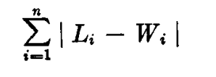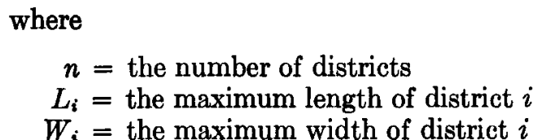

There are two methods to avoid enclaves. Method 1 is most suitable for a limited number of population regions. It is appropriate while maintaining political boundaries, such as county lines, or when areas are not all the same size. This technique has been employed frequently and has shown to be a very quick and adaptable tool. Method 2 is suitable for the greater number of population units that could be added, achieving more equal population representation when important political boundaries are not required to be preserved. The chance of increasing population equality among districts is boosted by lowering the population per unit. The technique relies on the roughly uniform geometry of the population units.

**3.3 Openshaw, S. (1977a). A geographical solution to scale and aggregation problems in region-building, partitioning, and spatial modeling. Transactions of the Institute of British Geographers, 2(4):459–472. [12]**

This research examines regionally the scale and aggregation difficulties that frequently come up in analyses of spatially aggregated data. Instead of attempting to model the effects of scale and aggregation, the problem is flipped. A set of zones that, under any relevant constraints, maximizes an objective function somewhat connected to model performance is desired. Then, problems with scale and aggregation become problems with the optimal-zone design. To perhaps resolve this problem, a heuristic approach is presented and empirical research is performed to show it.

Traditionally, a research region is divided into zones and a model is applied to each zone to do spatial analysis. The determination of these zonal borders requires the selection of the study's scale and the aggregation of data to meet that scale. Scale and aggregation both present issues. The scale problem is brought on by the uncertain quantity of zones needed for specific research. Because it is unclear how the data will be merged to produce a certain number of zones, aggregation difficulty arises.

**3.3.1 Ways to grow the regions**

The role that the optimal-zone design technique plays in the creation of spatial models is briefly explained, along with some potential implications for the analysis of spatially aggregated data. When coupled, the zone and aggregation challenges, which typically emerge when establishing zones for the study of spatial data, rank among the most challenging topics in spatial research today. Current zone design techniques are frequently careless. The scale and aggregation that are necessary to correctly characterize spatial events are frequently beyond our current understanding of them. Even when the data are sufficient for such a study, other studies rarely explore how the choice of zones influences the results and do not lay much focus on zone design. This research also offers a geographical solution to the zone design conundrum.

In addition to analyzing how aggregation effects and scale limits can alter the outcomes of using any model, the paper also looks at some potential implications for how geographers interpret spatial data. Most research on spatial zoning systems either assumes that a general theory underlying scale and aggregation phenomena may be discovered or that their effects can be reduced by employing the proper filtering and smoothing techniques. Most of them have not had a practical evaluation. Numerous economists and academicians have not made the proper attempts to address the issues. This issue, which was not previously resolved, is addressed in the paper.

The current method will result in a set of solutions that tend to converge in the optimality direction. The freedom and ambiguity embedded into any zoning system designed for use with this type of data are used to solve problems in the paper. However, Only data that has been spatially aggregated once or more are discussed in this research. Inconsistent outcomes could occur from this. The current solution deviates from perfect optimality by an unknown amount of error. Although the AZPI and AZPII methods have performed satisfactorily and credibly, caveat emptor must at least partially apply. A difficulty arises from the distribution trip model with double constraints. The result for this was only possible because of special circumstances, which would not be seen as generally acceptable.

**3.4 The identification of all possible solutions to a constituency-delimitation problem D J Rossiter, R J Johnston [13]**

This research introduces size restrictions, assesses shape, and examines the political repercussions of changes in voter opinion.

**3.4.1 Ways to grow the regions**

Given the necessary number of constituencies, the approach behind this paper takes a local authority region and creates all the contiguous sets of wards. There are T total solutions to this problem, where T = J!/((L!)^k), where L is J/K. T is incredibly big for practically every local authority. However, most of these are not workable options for a variety of reasons, some of which are that the constituencies do not form contiguous groups of wards and others do not meet the constraints of electorate size.

The approach used was based on one Openshaw outlined (1977). By selecting ward cores at random, neighbors are then added to these cores until all of the wards are included in a constituency. This method starts with a collection of wards and develops constituencies from there. However, because the procedure does not aim to create constituencies with roughly equal numbers of wards, it often results in many "failures": for example, if two or more cores are located close to one another, one or more of the constituencies may be small (outside the bounds) because none of its neighbors (or neighbors of its neighbors) are left without a constituency.

**3.4.2** To avoid this problem, the **algorithm follows these steps** -

1. Core selection - The local authority is stratified into K sets of adjacent wards, with roughly J/K wards in each stratum, to guarantee that the cores are not concentrated inside the local authority and so unlikely to fail.
2. Initiation - A core is randomly selected from each stratum. The ward with the fewest adjacent wards among the specified core wards is chosen as the foundation for the first constituency. There is chosen an electoral quota for this constituency. There is a list of all the neighboring wards that are not yet assigned to a constituency and are close to the core ward. A ward from the list is chosen at random (or nearly at random) and added to the constituency.
3. The constituency's whole electorate is identified. The constituency is deemed complete if this is further from the quota than it was before the ward was added. A check is done each time a ward is added to a constituency to see if this would cause island creation or the division of a ward into an enclave.
4. Selection of a new core - The core for the following constituency is picked from those remaining cores selected at step 2 that are still not in a constituency and have the fewest number of neighbors who are still outside of a constituency. The algorithm then returns to step 2.
5. Once every constituency has been identified and no failure has happened, the solution's uniqueness is tested (see below), the shape index is computed, and, if necessary, electoral statistics are produced.
6. Unless all of the required runs have been performed, the algorithm then goes back to step 2. The electoral quota for the first constituency is randomly selected within the given bounds as

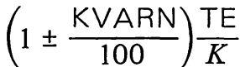

1. The range of potential electorate sizes for the subsequent constituency changes once a constituency has been established. Consequently, the electoral quota for the nth constituency is chosen at random from

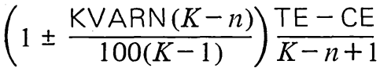

Where CE is the electorate already allocated to constituencies.

**3.5 Counterspeculation, Auctions, And Competitive Sealed Tenders by William Vickrey [14]**

These heuristics' key feature is that each region is the outcome of choosing a single area (the seed area), to which other nearby regions are assigned. The seeds can be produced serially, meaning that each seed is chosen after a region has been finished, or concurrently, meaning that each seed is chosen simultaneously.

Vickrey (1961) was the first to suggest this strategy for resolving districting issues. Vickrey's approach begins by picking a reference location at random from a larger area. The first seed for the first region is then taken from the geographically farthest area from the reference area. Next, adjacent, contiguous, unassigned areas are added in order of increasing distance to the seed.

When a region satisfies a preset requirement, such as a minimum population quota, the addition process comes to an end. When the first region is complete, the next region is designed by using the furthest unassigned area from the reference area as the initial seed. Vickrey adopted the reference area technique to prevent the formation of the 17 enclaves, which are the final unassigned territories that cannot function as a region on their own. It is necessary to allocate the enclaves to an existing region.

It should be noted that the algorithms created using Vickrey's contribution presuppose that the number of areas is known. Therefore, it is important to pay close attention to the criteria for determining when to stop adding new areas to a region. On the one hand, the target number of regions may be attained relatively quickly if the minimum population per region is set to a very low value, with many areas still awaiting assignment (enclaves). The algorithm won't be able to produce as many regions as desired, however, if the minimum population per region is set quite high.

**3.6 Legislative districting by computer by Burton C. Gearhart, John M. Liittschwager [15]**

In numerous ways, Vickrey's technique was expanded by Thoreson and Liittschwager in 1967. They first suggested that to investigate fresh ideas, the regionalization process be repeated numerous times using various reference locations. Second, they alter the algorithm by introducing one that is utilized on a regular lattice.

Later, Gearhart and Liittschwager added more termination criteria, new techniques for preventing the development of enclaves, new means to seed the regions, and a more formal, understandable presentation of the algorithm to Thoreson and Liittschwager's algorithm.

**3.6.1 The Districting Algorithm**

The use of the supporting programs that make up the rest of the redistricting system is then described in the paper. The introduction of a new termination rule to prevent the addition of basic population regions when creating single-member districts is a significant advancement in computational logic. This development supports the idea of a "moving-district quota" in achieving districts with equal populations.

The steps behind this algorithm are -

1. Choose an arbitrary initial reference region,
2. Increase k by one and if k > m, stop as the plan is completed. Otherwise, compute Qk and then from all T: with a(i) = 1 select the region which is the maximum distance from R and call this region R1. Assign R1 to district k, set a(R1) = 0, and let POPk = P
3. Define c(i) = 0 if r2 is not contiguous to any region assigned to district k. if ri is contiguous to any region assigned to district k. Determine the index i based on r, a minimal distance from R1 with a(i) = 1 and c(i) = 1. If no such index i exists, the district is complete; therefore go to Step 2. Otherwise, add P, to POPk . If POPk > Qn, let R2 = rt and go to Step 4. If POPk, < Qk , assign ri to district k, set a(i) = 0, set s = 3, and go to Step 5.
4. If POPk = Qk, assign R2 to district k as the district is potentially complete. Set a(i) = 0, s = 2, and go to Step 5. For POPk > Qk compute U = Qk - (POPk - PE2) and O = POPk - Qh where U is the amount district k would be under quota if R2 were not assigned and 0 is the amount district k would be over quota if Rz were assigned.
5. Find all regions rt contiguous to district k with a(i) = 1 and no unassigned contiguous regions. If such ri exist, assign them to district k, add their P, to POPk and set their a(i) = 0. Return to Step s.

The algorithm has two versions that allow for different choices for the initial region R1. The following two variants are comparable and only apply to the first m districts to emerge.

**3.6.2 The forced reference region**

Often, creating a district around a certain area may be desirable. This could enhance compactness in two-member districting schemes or maintain population homogeneity in a specific district of a multi-district plan. To do this, just Step 2 of the prior algorithm needs to be altered.

**3.6.3 The pseudo reference region**

On rare occasions, the geographic makeup of the area being districted makes a second form of the algorithm useful. The presumption is that a fake region, let's say r(n+1), has been specified and is situated sufficiently far from the ri's that are already in place. The main purpose of the pseudo region, which has no inhabitants, is to alter the first district's distance calculations' frame of reference.

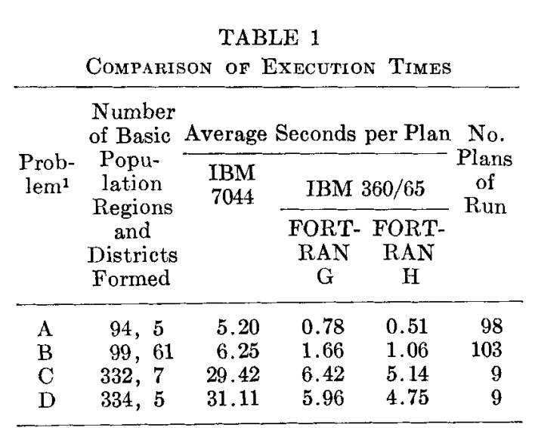

**3.7 Optimal zoning systems for spatial interaction models. by Openshaw, S. (1977b) [16]**

This research reveals that zoning systems have nontrivial effects on parameter values and model performance, and their size is far bigger than previously believed. This research illustrated a technique for determining a zoning scheme that will roughly optimize model performance. A number of empirical research serve as examples of this approach.

Whether or if the outcomes of spatial interaction modeling are behaviorally significant or whether they accurately reflect the way a study region is divided into zones cannot yet be determined. The degree to which the choice of zoning system affects model performance is also not well understood. Naturally, it is commonly acknowledged that the choice of zonal boundaries and their relative sizes have a significant impact on the patterns of intrazonal and interzonal interactions.

**3.7.1 The optimal zone-design problem**

For the spatial interaction model, the optimal zone-design problem necessary to

maximize model performance is stated as:

**optimize F(W*; T, C, K, P) = min or max F(W; T, C, K, P) , (8)**

subject to the constraints on zonal arrangement mentioned earlier. The function F( )

is a scalar function of the unknown variables W and the constant variables T, C, K, P.

It maps the performance of any partition W* onto the set of real numbers. For a

measure of partition performance F( ), which is the sum of the squared differences

between actual and predicted interactions for any aggregation of the N bsu's into M

zones, assuming the predictions are generated by model I, equation (8) can be

rewritten as:

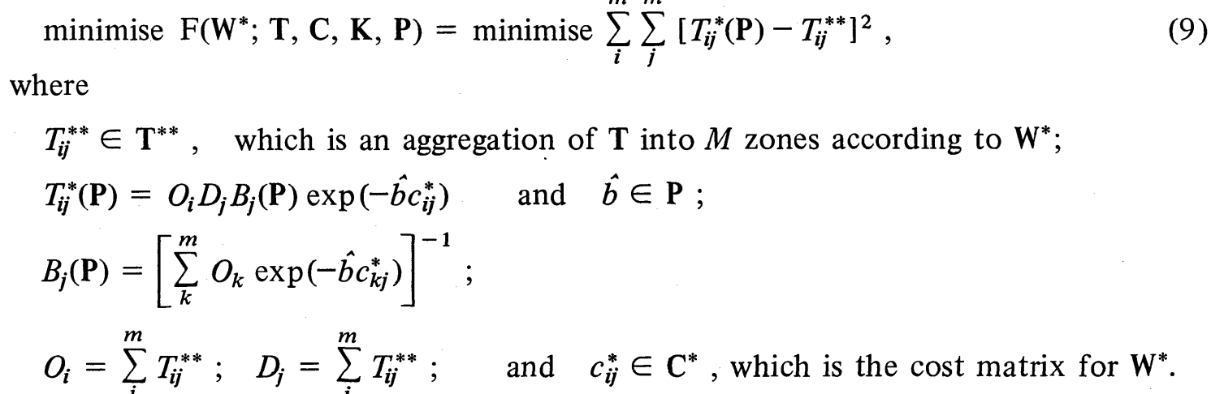

If it is assumed that there is a dependency of the model parameters P on the zoning

system produced by mapping W* onto T and C, then a more general statement of the

optimisation problem is:

**minimise F(W*, P*; T, C, K) = min or max F(W, P; T, C, K) , (10)**

**where P* = f(W*; T, C).**

The optimal-zone design problem described by equations (8) and (10) represents

some kind of hybrid combinatorial and nonlinear programming problem.

F() is not continuously differentiable in terms of its independent variables, despite the fact that it may be convex. Furthermore, the zonal layout and composition requirements, as well as the characteristics of the bsu data itself, limit the possible values that can be assigned to these variables to a discontinuous set. Furthermore, as there are more zones, these restrictions fluctuate rather than being constant. Because it is highly unlikely that an exact solution will ever exist, a heuristic procedure must be used. These heuristic procedures are defined by selecting a parameter-updating strategy.

**3.8 Some implications of the spatial organization of elections by Taylor, P. J [17]**

The seeded region's approach has also been studied by Taylor (1973). These contributions share the property that they choose the collection of seeds, referred to as "core regions," at the start of the process. Then, the cores are expanded to include the nearby locations. When all of the areas have been assigned, the process ends.

Taylor and Openshaw's methods allow the areas to grow simultaneously, in contrast to Rossiter and Johnston's method, which waits until a region is complete before considering the next seed.

**3.9 Spatial regionalization based on optimal information compression by Alec Kirkley [18]**

Among many other uses, regionalization, or spatially contiguous clustering, offers a way to lessen the impact of noise in sampled data and identify homogeneous areas for policy creation. The natural areas formed only by the data itself cannot be extracted by existing regionalization methods since they require human input, such as the number of regions or a measure of similarity between regions.

In this paper, the authors designed an effective, parameter-free regionalization method based on the minimum description length principle because they see the issue of regionalization as one of data compression. We show that our method can meaningfully coarse-grain real demographic data as well as retrieve planted spatial groupings in noisy synthetic data.

The resulting measure is more appropriate for comparing spatially contiguous partitions, and is given by -



where NMI = Normalized Mutual Information

**3.10 Object segmentation by saliency‑seeded and spatial‑weighted region merging by Junxia Li* , Jundi Ding, Jian Yang and Lingzheng Dai [19]**

The authors of this research offer a method for object segmentation in natural photos that is based on region merging. The process entails three distinct steps: To ensure that the pixels in each region are as homogeneous as possible and therefore likely to be from the same object, there are three initial segmentation steps:

1. Initial over-segmentation
2. Saliency-seeded interaction
3. Region merging using the newly introduced maximal spatially weighted similarity (MSWS) criterion.

The region merging-based method performs better because the MSWS criterion considers both the color similarity and the spatial distance of the candidate regions for merging.

**3.11** **A framework for the segmentation of high-resolution satellite imagery using modified seeded-region growing and region merging by Y. Byun, D. Kim, J. Lee & Y. Kim [20]**

In this paper, the authors introduce a novel method based on modified seeded-region growth and region merging for the image segmentation of a high-resolution pan-sharpened satellite picture. To enhance the quality of the image segmentation, we first perform some pre-processing. The suggested block-based seed-selection approach automatically chooses the initial seeds. Initial segmentation is accomplished by using the modified seeded-region growth process following the automatic selection of significant seeds. To get the final segmentation result, region merging based on a region-adjacency graph is done in post-processing.

# Modification of an initial feasible solution

## Description

Each iteration of the methods presented must be possible in terms of the spatial contiguity constraint, starting with a viable initial solution that is then improved repeatedly. Basically, moving some areas from their present region to a neighboring region and adding some conditions to it modifies the initial feasible solution. First, there must be more than one area in the donor region, which is the region that currently contains the area being moved. Second, after the area is removed, the donor region cannot lose its spatial contiguity. In this context, the Spatial Contiguity Principle refers to the actual distance between your text and on-screen images; it states that similar words and images should be kept near together for better comprehension. There are different algorithms proposed by different people in relation to this which are an improvement to the initial algorithm.

|  |  |  |  |  |  |  |  |  |  |  |
| --- | --- | --- | --- | --- | --- | --- | --- | --- | --- | --- |
| Ferligoj, A. and Batagelj, V. (1982) |  |  |  |  |  |  |  |  |  |  |
| Openshaw, S. (1977a) |  |  |  |  |  |  |  |  |  |  |
| Horn, M. E. T. (1995) |  |  |  |  |  |  |  |  |  |  |
| Browdy, M. H. (1990) |  |  |  |  |  |  |  |  |  |  |
| Macmillan, W. (2001) |  |  |  |  |  |  |  |  |  |  |
| Nagel, S. S. (1965) |  |  |  |  |  |  |  |  |  |  |
| Openshaw, S. (1978) |  |  |  |  |  |  |  |  |  |  |
| Kamyoung Kim, Denis J. Dean, Hyun Kim & Yongwan Chun (2016) |  |  |  |  |  |  |  |  |  |  |
| Openshaw, S. and Rao, L. (1995) |  |  |  |  |  |  |  |  |  |  |
| Sammons, R. (1978) |  |  |  |  |  |  |  |  |  |  |

Figure: Modification of an initial feasible solution taxonomy table (The tick represents the contribution of each paper)

## Related works regarding the modification of an initial feasible solution

We have conducted an examination of ten papers on this methodology. The study was majorly concentrated on identifying the merits and demerits of several heuristic techniques in regionalization algorithms.

The topics that were looked into are briefly described here. These topics provide great insights into the conventional techniques being used, their benefits and their challenges, and how a modification helps in solving these problems.

### 4.2.1 CLUDIA(local optimization procedure) and the hierarchical clustering procedure

Ferligoj, A., and Batagelj, V [21] mainly talk about the issues related to *clustering*. There are a few restrictions or constraints like symmetric and reflective relations that provide a challenge to the grouping. These challenges can be solved by methodologies like CLUDIA(local optimization procedure) and the hierarchical clustering procedure. The countries in Europe have been taken to demonstrate this. The basis is indicators of development. The geographic neighborhood serves as the relational constraint in this case, but other sorts of issues can also be formally classified as clustering issues with relational constraints. There are several *pros* that can be easily identified in this paper. The paper provides a solution to the clustering problem involving restricted grouping. It also provides a new solution by extending the pre-existing solutions to the common clustering problem. By using the earlier method, hierarchical solutions to clustering issues with relational constraints were frequently obtained that weren't monotonic. If the required criteria are met at each stage of the clustering procedure, the hierarchical clustering method based on the Lance and Williams formula guarantees monotonic clusterings for each dissimilarity matrix and for each relational constraint. Only the maximum clustering approach meets the third criterion among the common clustering strategies: minimum, maximum, centroid, median, group average, and Ward's. It is possible to modify Ward's strategy coefficients to also satisfy this requirement.

The values of the criterion function of the (initial) clusterings obtained with hierarchical strategies are close to the best local minima obtained, so these clusterings provide a good starting point for additional local optimization that is consistent with the experiences in other related empirical analyses. In spite of multiple pros, this paper [21] has a few cons and scope for improvement too which have been highlighted. There are still two unresolved problems: testing the connectivity of a cluster-induced subgraph and initial clustering generated at random. Additionally, the paper mentions that between several littoral countries, there are some challenges to determining the neighborhood which may impact the end result. The paper also clarifies that due to a shortage of data, the paper only investigated 27 European countries, excluding small countries. This may lead to inconsistencies and improper results.

### 4.2.2 Geographical solution to the zone design problem

Openshaw, S. (1977a) [22] discusses the *scale and aggregation* issues that typically arise in examinations of spatially aggregated data. These challenges are addressed geographically in this paper. The issue is reversed rather than attempting to model the consequences of scale and aggregation. A series of zones that optimizes an objective function somehow related to the performance of a model is sought after. Scale and aggregation issues then turn into optimal-zone design issues. Empirical research is used to illustrate a heuristic process that is described in order to potentially fix this issue. The traditional method for doing spatial analysis entails applying a model to a research region that has been divided into zones. The choice of the study's scale and the aggregation of data to fit that scale are necessary for the establishment of these zonal boundaries. The scale issue results from the unknown number of zones required for a given investigation. The aggregation challenge emerges because it is ambiguous how the data will be combined to create a specific number of zones. There are several *pros* that have been laid out in this paper. To explain this, the zone and aggregation issues usually arise when designing zones for the analysis of spatial data, and taken combined, they rank among the most difficult problems in spatial research today. Zone design practices now used are frequently haphazard. Other studies do not place much emphasis on zone design, and they rarely examine how the choice of zones affects the outcomes, even when the data are adequate for such a study. This paper addresses this problem in zone design by giving a geographical solution. Also, the paper provides an analysis of how the results of utilizing any model can be affected by aggregation effects and scale restrictions, and it also examines some potential ramifications for how geographers analyze spatial data. Additionally, the majority of studies that have been done on spatial zoning systems either make the assumption that the general theory underpinning scale and aggregation phenomena can be found or that their impacts can be minimized by using the right filtering and smoothing techniques. Most of them have not been assessed at a practical level. The efforts taken by many researchers and economists to solve the problems have not been appropriate. The paper tries to solve this problem that was left unsolved earlier. The paper solves issues by making use of the freedom and ambiguity built into any zoning system intended for use with this type of data.

In the paper by Openshaw, S. (1977a) [22], there is a brief explanation of the function that the optimal-zone design technique plays in the construction of spatial models as well as some of the potential ramifications for the study of spatially aggregated data. Despite having many advantages, this paper also has several disadvantages and room for improvement, which have been emphasized. This paper only deals with data that has been spatially aggregated once or more. AZPI and AZPII procedures have acted in a satisfactory and trustworthy manner, however, caveat emptor must at least partially apply. Also, a doubly constrained trip model of distribution poses a challenge. The outcome obtained for this was only achieved under unique circumstances, which would not be considered generally acceptable.

### 4.2.3 MARCHES

Horn, (1995) [23] outlines techniques for electoral districting and associated applications. *Finding the most compact division* of a region into a specified number of territories while maintaining intraterritorial connectivity requirements and upper and lower limits on a scalar attribute, here referred to as territory size, is the problem that this paper attempts to solve. The methods covered in this work, generally referred to as MARCHES, are included in a decision-support system known as ITA that has recently been utilized by Australian electoral authorities to redistribute electoral boundaries at both the state and federal levels. A hill-climbing principle of gradual development in the objective function serves as the foundation for the processes. The paper gives details about multiple *pros* of the techniques being utilized. The search techniques used here address challenges involving the optimization of the heuristic process. The first of them focuses on the need to prevent early convergence on suboptimal local optima. The second problem is how to deal with restrictions (in this case connectedness and compactness) that cannot be reduced to a single measure; this problem applies to many additional uses of the hill-climbing concept as well as to variations of the hill-climbing concept, such as Simulated Annealing. This paper’s proposal is intended for a specific decision-making environment.

In the paper by Horn, (1995) [23], the pre-existing method avoids the misconception that automated procedures have exclusive access to the truth in political developments and highlights the necessity for districting authorities to make informed decisions when applying political limits. Even though this paper has several advantages, there are a few drawbacks and areas for improvement that have been identified. The formulation leaves out standards related to anticipated political results. There are currently no global optima for the problems discussed here, and the vast variation in the quality of the generated solutions raises concerns about the internal logic of the techniques. Also, following the research reported above, the author undertook a preliminary investigation of a SA technique for partitioning problems, but the findings were unsatisfactory; in particular, SA failed to produce solutions that were as high-quality as those produced by the MARCHES procedures.

### 4.2.4 Simulated annealing

Browdy, M. H. (1990) [24] provides the suggestion of a novel computer model that could be applied to *redistricting automation*. It suggests that the simulated annealing algorithm can be tested for application in political redistricting. Automated redistricting requires line drawers to pre-define their redistricting objectives while a computer program actually draws the lines. The goals for automated redistricting include criteria like maximizing district compactness, achieving population parity between districts, and preserving district contiguity. An algorithm for redistricting would be used with the inputs to create a plan for political boundary lines using a computer model. This model has several advantages. One of the several advantages is that the public needs to be made aware of the potential benefits of using computers in redistricting given today's technology. Automated redistricting could be a significant policy solution to many redistricting issues. Computer scientists can employ the concept of slow cooling to find the best answers to challenging issues via simulated annealing. The focus on randomization in this method results in a plan that is independent of the basic conditions selected. The relaxation enables one to solve an unconstrained optimization issue by including constraints like population equality and contiguity in the objective function. The creation of a simulated annealing model for political redistricting may end the protracted legal disputes and ambiguity that currently surround redistricting. Once built, an automated model proposed in this paper might be used ten years after each census to quickly redistrict states.

In the paper by Browdy, M. H. (1990) [24], it can be stated that automated redistricting could reduce the amount of time and effort required of judges and lawmakers while elevating the standard of political representation. Despite having many advantages, this document also has certain drawbacks and areas for improvement, which have been noted. It takes into account the views of the people that may pose a huge challenge and lead to inconsistencies. People may never accept automated redistricting as a reasonable policy solution to a challenging issue if they continue to think about it primarily in terms of outdated computer algorithms. Also, if weights can only be selected empirically, picking the weights for a multiattribute problem may lead to issues.

### 4.2.5 SARA

Macmillan, W. (2001). [25] proposed an approach in which simulated annealing and a novel technique are used by SARA to *verify region contiguity*. Its goal is to divide a collection of populous zones into adjacent regions in order to reduce the population density disparity between the regions. The algorithm establishes a zone's ability to move from one region to another by counting the number of switching points it has in the current partition. In order to discover a partition that minimizes the variation in population between regions, the technique maintains contiguity from an initially contiguous partition and employs a directed, probabilistic search procedure within a simulated annealing structure. The paper lists multiple *pros* of the approach being utilized here. One of them is that this approach can be used to solve complex issues with limited computational power. It becomes feasible to exit dead ends in the solution space if one is willing to accept moves that cause the desired function to temporarily deteriorate. The author highlights that the approach can be produced in a variety of versions and extensions.

In the paper by Macmillan, W. (2001). [25], the article compares the connectivity approach created by Openshaw and Rao to the new contiguity verification procedure, which is based on the idea of switching points. Despite having many advantages, this document also has certain drawbacks and areas for improvement, which have been mentioned. The performance comparison metrics are rudimentary and only take into account one problem. Also, the effectiveness of the contiguity verification routine continues to be crucial to the success of the entire process.

### 4.2.6 Simplified Bipartisan Computer Redistricting

Nagel, S. S. (1965) [26] highlighted that the main objective is the creation of a basic and politically viable program that can aid in *redistributing* members of a legislature or other institution representing geographic districts. The proposed redistricting program is made to carry out the value judgments of those in charge of reapportionment. The program allows the user to modify the relative weights to be given to three important factors. The first factor is the relative equality of population among the districts (the one man, one vote requirement). The second factor is the contiguity and degree of compactness of the districts. The third factor is the effect of redistricting on the political balance of power. Additionally, the program allows the user to keep some political entities intact. The main *pros* highlighted by the author are as follows. One of the objectives of this paper is to outline certain fundamental computer programming methodologies to assist in solving policy issues that cannot be satisfactorily addressed by conventional computer or non-computer techniques. Also, it can translate a set of agreed-upon values into a practical plan, as well as offer alternate redistricting plans based on opposing values and encourage compromise. Additionally, for an agreed-upon redistricting design, the program can offer valuable data on equality, compactness, and politics. The main advantage it has over the existing conventional methods is the quicker speed with which it can produce districting patterns. This adequately describes whatever political value judgments are supplied into the computer while simultaneously complying with the legal requirements of one man, one vote, and compact, contiguous districts. This study could be seen as an effort to provide a mechanism to refine the one-person, one-vote rule of the US Supreme Court.

In the paper by Nagel, S. S. (1965) [26], the program can be used by different entities or groups which include nonpartisan, partisan, or organizations with politically divergent ideologies like a legislative committee. Despite having many advantages, this document also has certain drawbacks and areas for improvement, which have been outlined. The typical statistical programs attempt to anticipate everyone's requirements, but in doing so, they produce extra output and use up too much computer time.

### 4.2.7 Optimal zoning approach

In this paper whose author is Openshaw, S. (1978) [27], a different method for the spatial study is developed, and it is suggested that problems involving inherently spatial data can best be resolved geographically through the use of a suitable zone design approach. The *absence of any fixed or distinctive spatially aggregated data*, which is fundamentally a *zone design challenge*, is the most basic issue in spatial analysis. There are 2 steps for designing a zoning system. First, an effort is made to locate one or more zoning systems that meet specific design criteria. Next, the zoning systems are evaluated in light of a specific model to determine which ones are satisfactory. Unfortunately, there hasn't been a lot of second-stage investigation, so the efficacy of the various design criteria isn't fully understood. The paper has several advantages over the conventional methodologies. The outcomes in the research paper show that there is a significant correlation between the zoning system utilized and the outcomes of the analysis of spatially aggregated data for a variety of linear and non-linear models. The paper justified the need for a critical reevaluation of the traditional approach to spatial research and covered the specifics of a different paradigm that is clearly based on the requirement for conscious spatial engineering when establishing zoning systems.

The paper by Openshaw, S. (1978) [27], mentions the claim that the zone design criteria are complex in that it is becoming fashionable to conceptualize in terms of numerous criteria, and are fundamentally arbitrary, lacking any formal basis. Even though this article has many advantages, there are a few disadvantages and areas for improvement that have been recognized. The general issues with spatial representation cannot be fully resolved by an optimal zone design technique alone. Additionally, although the zoning system may be the most significant method for incorporating space into the analysis of spatially aggregated data, it is not the only one. One could argue that in order to explicitly account for spatial impacts, the models themselves may need to be amended.

### 4.2.8 Automated Zoning Procedure-Center Interchange (AZP-CI)

This paper [28] mentions that for regionalization issues, also referred to as *p-regions problems*, spatial optimization techniques are applied. When applied to huge settings, the conventional methods are impractical. For the p-regions problem, many heuristics offer efficient techniques to locate nearly ideal solutions. However, the majority of heuristic methods are created especially for certain geographical contexts. The integration of a set of spatial contiguity constraints into the solution methodology is a crucial difficulty in regionalization problems. The majority of models use mathematical formulations to convey spatial contiguity constraints. The complexity of the models brought on by the extra constraints makes them computationally intractable to even small-size issues. The p-functional regions problem (PFRP), which produces regions by merging small sections that share characteristics with predefined functional locations and have tight connections among themselves through spatial interaction, is addressed in this paper using a new heuristic approach called Automated Zoning Procedure-Center Interchange (AZP-CI). The PFRP can generate a model for the regionalization problem and a precise solution, but due to the existing computational capabilities, this approach is fundamentally unsuited for handling a very big problem. Two separate procedures make up AZP-CI. For that, the process of splitting improves diversification and results in a thorough study of the solution space. Although it is based on the AZP, the AZP-CI employs a different interchange technique. The AZP-SA, a pure meta-heuristic algorithm for the AZP, are two widely used possible alternatives that are compared to the performance of the AZP-CI in this work. The paper gives details about multiple *pros* of the techniques being utilized. In this, two empirical datasets of various sizes and two randomly generated simulated datasets were used to test the AZP-CI. These comparisons show that AZP-CI surpasses simulated annealing and the AZP, in terms of solution quality and reliability of production regardless of initial parameters. Also, AZP-CI can be readily applied to generic regionalization issues. The method combines two different approaches to provide superior solutions than a single greedy or meta-heuristic framework would. Moreover, in particular for large-scale issues like labor or housing market areas or city regions, AZP-CI can be directly utilized for various functional region delineations based on spatial interaction.

In the paper [28], it is highlighted that when used in conjunction with cyberinfrastructure, AZP-CI may be a more scalable technique for resolving computationally demanding spatial optimization issues. The AZP-Center Interchange (AZP-CI), which includes a center interchange procedure in addition to the normal AZP, is a hybrid heuristic approach that is proposed in this study. Even though this article has many advantages, there are a few disadvantages and areas for improvement that have been highlighted. Based on the context of a regionalization issue, the AZP-CI can involve changes. The scenarios include more difficult regionalization issues where the number of functional centers is determined endogenously or multicenter areas need to be defined with non-exclusive influential areas. Also, since a superior hybrid-type algorithm can be established by integrating the benefits of more than two heuristics, the efficacy of the AZP-CI needs to be evaluated in comparison with other greedy-based algorithms and meta-heuristics.

### 4.2.9 Census zone design and the use of GIS

Openshaw, S. and Rao, L. (1995) [29] mention that the ability to construct *one's own census geography* is possible because of the accessibility of GIS technology and the digital bounds of census output areas. Geographic information systems (GISs) made it simple to reaggregate zonal digital borders to whichever higher level of standard census geography is deemed relevant. In this regard, two options for user-controlled flexibility in census zone design are noted. The first occurs when the census agency decides on the spatial framework to be used to deliver the census, and the second occurs when the user decides which collection of areal units is most appropriate for a given analysis goal. For this, the census analyst has the responsibility of redesigning the census geography for the 1991 Census in order to at least mitigate some of the perceived issues. The paper lists several advantages of its application. The 1991 small area boundary data files offer census users the first true chance to create their own census geographies and spatial zoning systems using the smallest census building blocks, allowing them to break free from the control of a predetermined and arbitrarily imposed set of census geographies.

In the paper by Openshaw, S. and Rao, L. (1995) [29], the new opportunity made possible by the availability of the 1991 Census ED borders is to create new zoning systems that might aid users in recovering from the MAUP rather than just to show how widespread the MAUP’s impacts are or to bias the findings by distorting the spatial aggregate employed in this. Despite the fact that this paper offers many advantages, certain disadvantages have also been mentioned. The confidentiality constraints imposed on the data from the 1991 Census are not supported by any scientific understanding of the issue, which adversely harms the data and fosters a bureaucratic mindset. Moreover, it is quite difficult to determine appropriate zone-design roles, and the related issue of understanding how to assess alternative zonations is also difficult.

### 4.2.10 Zoning system design and the contiguity constraints

Sammons, R. (1978) [30] provides the detail that numerous analytical techniques that excel at solving issues with *zoning system design* have been created in the field of political science. The most popular algorithm is add-or-trade. The method makes use of an already-existing spatial system and adds, subtracts, or exchanges basic population units between nearby zones until the component districts meet the required performance standards or cannot be further improved. There are a bunch of *pros* provided by the author in this regard. The analysis of redistricting methods shows that the formation of groupings of fundamental data units is significantly influenced by contiguity constraints. Contiguity restrictions can be especially important in addressing some of the specific needs of zoning system design, as well as improving the efficiency of their operation. The improvements made in the practical application achieved the anticipated result of greatly lowering the range of variation that was linked to this influence, even if the sensitivity to the certain group starting positions was maintained.

In the study by Sammons, R. (1978) [30], it is highlighted how the proper definition of shape and contiguity constraints can be used to adjust a simple type of electoral redistricting algorithm to match up to the needs of zoning system design. The cons of this paper have been highlighted, despite the fact that it has many advantages. An issue can be raised as to how much the advantages to be gained from this additional effort will likely be justified in terms of enhanced model performance acquired using the resulting zoning scheme directly. Also, the later changes brought about by taking into account different factors considered in the third stage of the zoning system design sequence may trivialize any further marginal improvements in the quality of the basic viable solution.

# Graph-theory-based models

## Description

Graph theory-based models are one of the most widely used methods in regionalization. In this approach, the objective is to achieve two goals. Graph theory-based models are implemented when the clustering has to satisfy certain constraints. As highlighted by Maurizio Maravalle & Bruno Simeone (1995), one of the most common types of constraints is contiguity conditions. Here, objects such as cities, towns, and neighborhoods need to be clustered into districts. In graph terminology, the objects can be pictured as the vertices of the graph and the edges can correspond to several aspects depending on the objective of clusterization. Edges might define objects connected by specific transport methods such as rail or air, utilities such as electricity and telephone lines, or simply, the distance between them. Then the district formation problem is reduced to finding connected subgraphs.

The regular objectives of regionalization apply to graph-based models as well, with both maximalities of homogeneity between the vertices in a cluster and separation between the clusters being the prime objectives of the approach. The advantage of this method is the consistency of the contiguity constraints. That is, it is not necessary to revalidate the constraints at each iteration since deleting any p-1 links from a spanning tree T of G still gives a feasible solution (Duque, Ramos, and Surinach, 2006).

There are a few disadvantages of the constraint-based models as well. The consistency of the contiguity constraints is a disadvantage as well since these constraints can prove to be quite rigid at times, and since these are defined manually, it might affect the overall accuracy of the classification. Secondly, it has been proven that the constraints are not scalable at times. That is, a given set of constraints might not be effective when the geographical characteristics change. As highlighted in A graph convolutional neural network for classification of building patterns using spatial vector data (2019), constraints for rural areas might not work for urban areas and vice versa. This limits the range of the defined constraints.

|  |  |  |  |  |  |  |  |  |  |  |
| --- | --- | --- | --- | --- | --- | --- | --- | --- | --- | --- |
| Nystuen et al. 1961 |  |  |  |  |  |  |  |  |  |  |
| Marvelle et al. 1995 |  |  |  |  |  |  |  |  |  |  |
| Duque et al. 2012 |  |  |  |  |  |  |  |  |  |  |
| AssunÇão et al. 2006 |  |  |  |  |  |  |  |  |  |  |
| Aydin et al. 2018 |  |  |  |  |  |  |  |  |  |  |
| Silva et al. 2008 |  |  |  |  |  |  |  |  |  |  |
| Guo 2008 |  |  |  |  |  |  |  |  |  |  |
| Yan et al. 2019 |  |  |  |  |  |  |  |  |  |  |
| Aksac et al. 2019 |  |  |  |  |  |  |  |  |  |  |
| Daw et al. 2022 |  |  |  |  |  |  |  |  |  |  |
| Feng et al. 2022 |  |  |  |  |  |  |  |  |  |  |
| Folch et al. 2014 |  |  |  |  |  |  |  |  |  |  |

## Related Works Regarding Graph-Theory-Based Models

We have evaluated a total of twelve papers that propose various models for graph-theory-based regionalization. While some of them provide alternatives to the same problem, others target a different problem area.

### 5.2.1 Regionalization with Nodal Structures

John D. Nystuen and Michael F. Dacey (1961) [31] was one of the first to use graphs for the regionalization problem. They use nodal structures for solving the problem, with nodal structures having the following features.

1. The cities are represented by points in the nodal structure. The points are weakly connected to other points which are a part of the component. Each point is assigned to only one component.
2. The components of the nodal structures have a central city that is unique.
3. Then, the largest flow from these cities is found, and it is called the nodal flow. The flow determines the association of cities, with the structure defining the hierarchy of the cities.

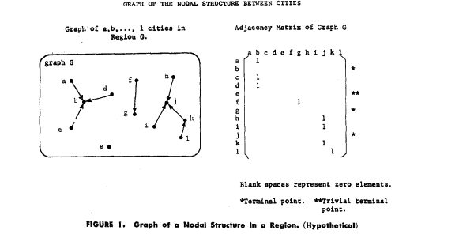

Since it was one of the first regionalization methods, there are some obvious drawbacks, such as the lack of flexibility for the subordinate cities, which puts them lower in the hierarchy despite being significantly more important.

### 5.2.2 MIDAS

Maurizio Maravalle & Bruno Simeone (1995) [32] reduce the problem to finding *“a minimum inertia partition of the vertex-set of G into a prescribed number of connected clusters.*” The method is called MIDAS. The steps involved are as follows.

1. Find a spanning tree T of G
2. Generation of a partition by deleting p-1 links where p is initially defined as the number of regions.
3. Modify p-1 links by replacing an existing link in T with one of the links in p-1.
4. To account for differences in the solutions due to the selection of T, the fourth step, known as tree modification, generates a new spanning tree to evaluate solutions that were not possible in the spanning tree.

The major drawback of this approach is that while it works quite well for a given value of p, the running time increases significantly for multiple values of p. The advantage is that the method clearly dominates other inertia minimization programs such as AGRAF. by the generation of better initial and final partitions in all instances.

### 5.2.3 Max-P Problem

Juan C. Duque, Luc Anselin and Sergio J. Rey [33] define a new problem in spatially constrained clustering known as the max-p-regions problem. Here, the problem is defined as the *“clustering of a set of geographic areas into the maximum number of homogeneous regions such that the value of a spatially extensive regional attribute is above a predefined threshold value.*” The solution is a two-stage process.

1. In the first stage, the goal is to find the maximum number of feasible regions which align with the constraints given by the users.
2. In the second stage, the areas are swapped between neighboring regions and then each of the regions is evaluated. This evaluation is once again defined by the user, and accordingly, the best region is chosen.

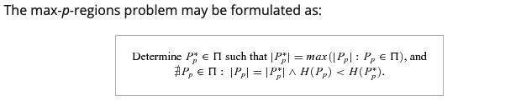

David C. Folch and Seth E. Spielman (2013) [9] modified this algorithm to account for greater flexibility in constraints as well as searching for solutions. Moreover, they also improve the accuracy of the algorithm by conducting large-scale experiments to find the optimum parameter settings.

Feng, Rey, and Wi (2021) [10] integrate a compactness measure into the max-p regionalization process by constructing a multiobjective optimization model that maximizes the number of regions while optimizing the compactness of identified regions.

The major advantage of this solution is that it has excellent flexibility and applies to a broad range of problems. Drawbacks of the algorithm surface with the use of irregular latices, as it significantly reduces the capacity of the algorithm to reduce the evaluation criterion, although the convergence of the algorithm increases significantly.

### 5.2.4 SKATER Algorithm

AssunÇão, Neves, Câmara & Freitas [34] devised an algorithm based on an approach similar to the AZP algorithm. Graph-based approaches work quite well because spatial adjacency is a crucial aspect of the entire process. However, there are a number of challenges faced due to the use of this method. Firstly, the computational cost of optimization is a huge issue, and it is quite pivotal to reduce it. Secondly, the sensitivity reduction for the choice of the initial position of tree partitioning is equally important as well. The Spatial ‘K’luster Analysis by Tree Edge Removal (SKATER) algorithm is designed to address these two issues. It takes place in two steps.

1. In the first step, a minimum spanning tree is created from the neighborhood graph. This represents the statistical summary of the neighborhood graph and is the foundational process for the regionalization algorithm.
2. The next step is where the improvement has been implemented. A heuristic to prune the MST is implemented.

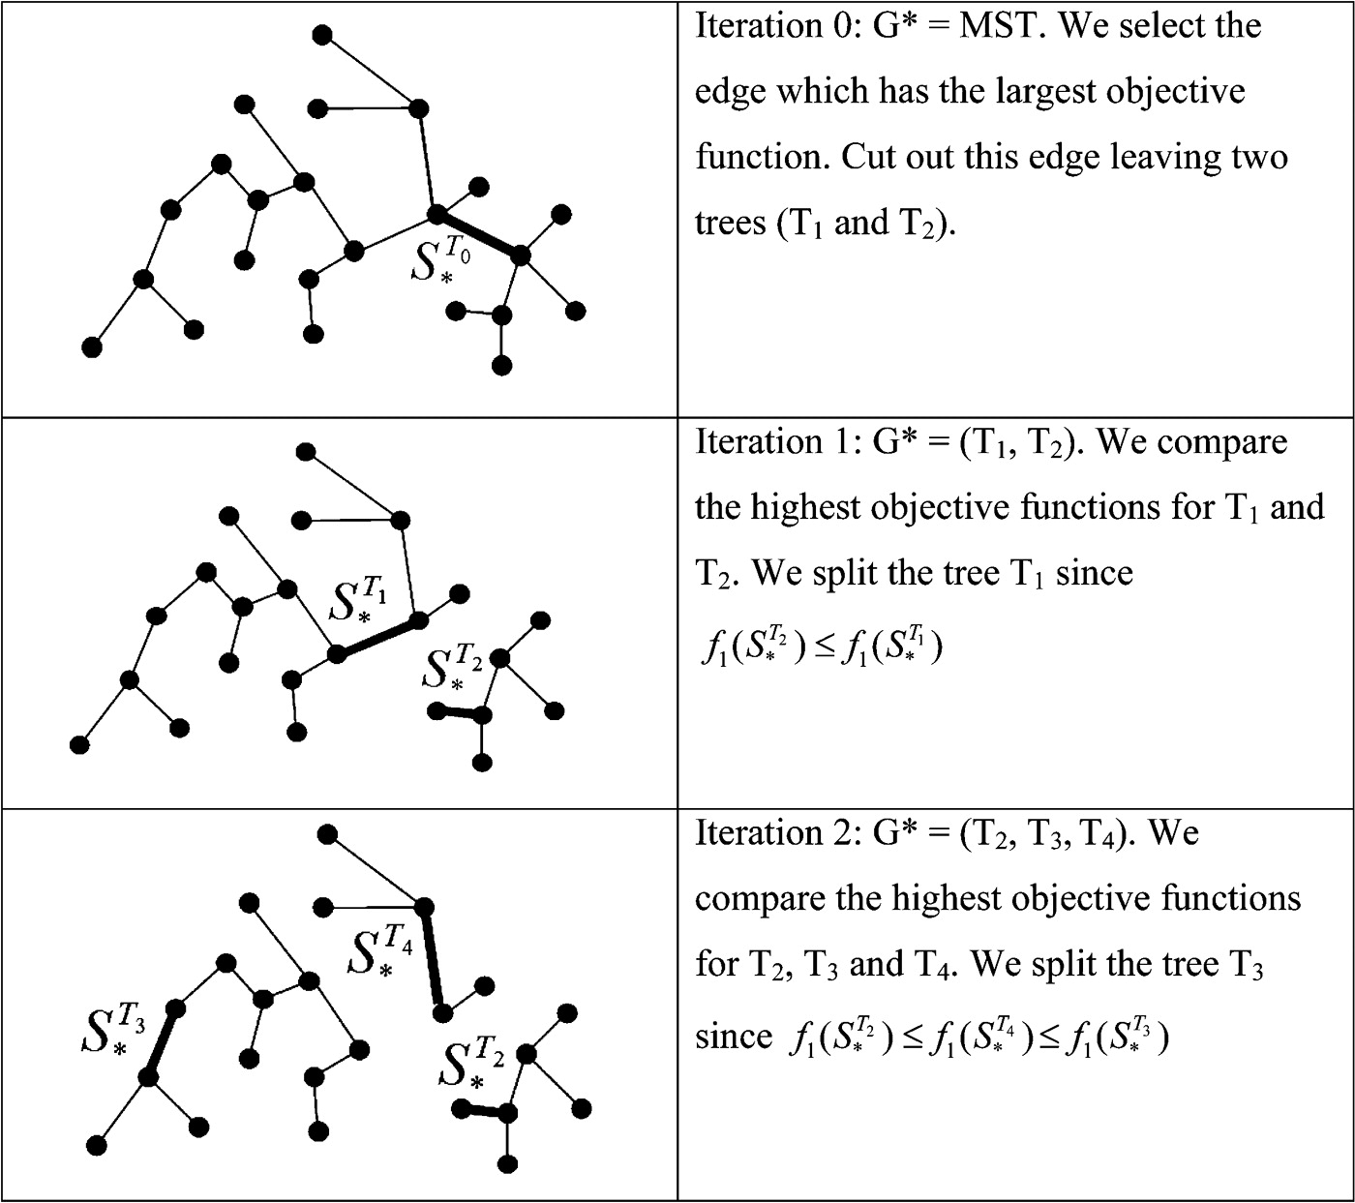

The SKATER algorithm works significantly better than the existing AZP algorithm in terms of the quality of the partitions and the processing speed, however, it has a number of drawbacks. Firstly, the contiguity matrixes are static, which means that if two objects are not neighbors, in the beginning, the fact that they can become neighbors, later on, is not considered. Secondly, it suffers from the chaining problem of minimum spanning trees. Thirdly, it is not suitable for large datasets.

### **5.2.5 SKATER-CON Algorithm**

Aydin, Assunção, Janikas, and Lee [35] used the work done on the previously defined SKATER algorithm to overcome the shortcomings of deterministic tree algorithms. In SKATER-CON, the spatial data is partitioned via a consensus-based framework that forms and ensembles regionalizations. This is defined by the SKATER algorithm, the deterministic counterpart of SKATER-CON, and it is applied along stochastic search paths. However, the unique aspect of this algorithm is that it performs the partitions with the help of Random Spanning Trees.

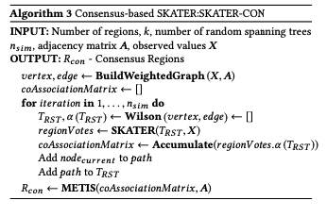

While the algorithm returns more compact regions as compared to some of the widely used state-of-the-art algorithms and is equally stable at the same time, in extremely fuzzy cases the algorithm underperforms to some extent.

### **5.2.6 Evolutionary Algorithm For Aggregated Weighting Areas Problem**

Silva [36] proposes an evolutionary algorithm for the aggregated weighting areas problems. The problem is to form K partitions comprised of Weighting Areas (WAs) of the demographic census. These WAs should satisfy a number of constraints, such as minimum total population and homogeneity criteria and contiguity. Using evolutionary heuristics, the algorithm generates K partitions by removing K-1 edges from the T.

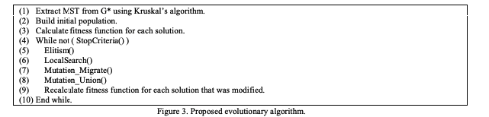

This algorithm is essentially an alternative to the SKATER algorithm since it also speeds up the MST partitioning scheme. However, its exact efficiency is something that hasn’t been detailed in the research work. There are a number of configurational variations proposed in the algorithm to improvise for the different clusters, however, they are compared amongst themselves which limits the scope of this algorithm.

### 5.2.7 REDCAP

Guo [37] presents a family of six regionalization methods, known as Regionalization with dynamically constrained agglomerative clustering and partitioning, which are designed, based on three contiguity‐constrained hierarchical clustering methods and two different constraining strategies. Out of them, the Full‐order constrained complete linkage clustering has experimentally proven to be the most efficient. This method is similar to the Full‐order constrained single linkage clustering algorithm with the only difference being instead of sorting the edges, we keep the distances in a matrix. Here is how the Full‐order constrained single linkage clustering method works.

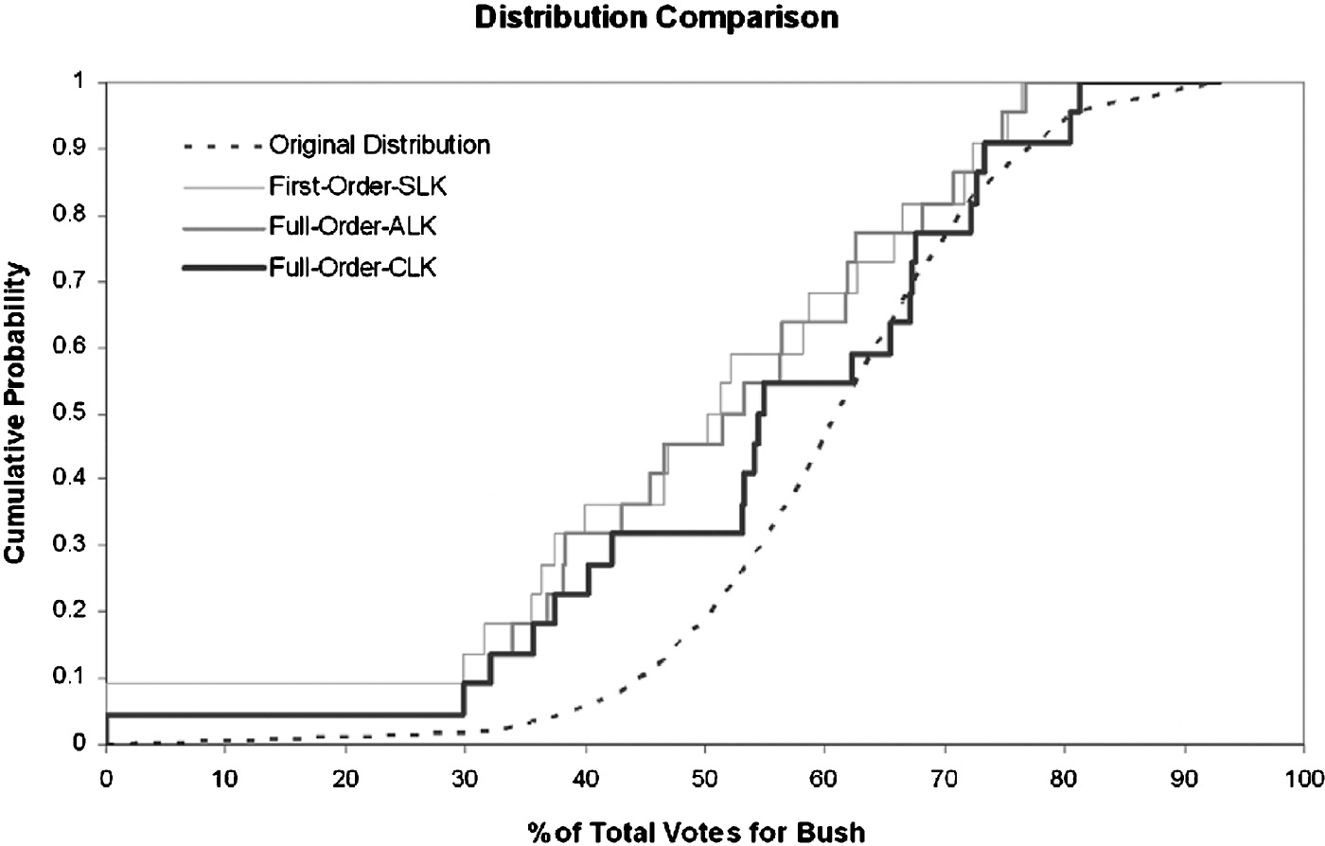

1. Start with a complete graph G, spatial contiguous graph G*, and the contiguity matrix C.
2. Edges in G and G* are sorted in ascending order, separately.
3. Each edge e in G is evaluated following the ascending order
4. If e connects two spatially contiguous clusters, the shortest first‐order edge e* in G* that connects the two clusters is added to T.
5. The contiguity matrix C is then updated to reflect the effect of this new merge.
6. After each merge, the edges (sorted already) in G are re‐evaluated from the beginning because some clusters that are previously non‐contiguous to each other now become eligible for the next merge.

As is evident from the algorithm itself, it fixes several drawbacks of the SKATER algorithm which were highlighted in the previous section.

### 5.2.8. Graph Convolution Neural Network

Yan, Ai, Yang and Yin [38] propose a novel graph convolution by converting it from the vertex domain into a point-wise product in the Fourier domain using the graph Fourier transform and convolution theorem. Additionally, the graph convolutional neural network (GCNN) architecture is proposed to analyze graph-structured spatial vector data.

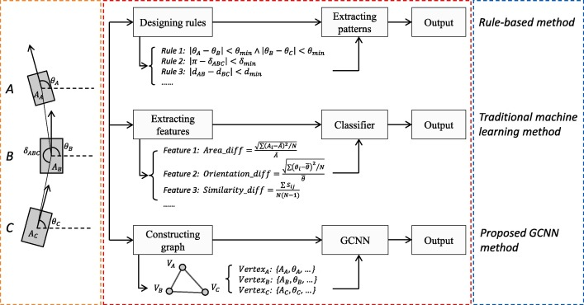

Considering this is a machine learning algorithm, a number of drawbacks of rule-based algorithms have been solved, since it is not necessary to define any strict patterns for the classification process. However, there are several drawbacks as well. The first issue is how to combine the multi-scale representation of geographical data with pooling. The second aspect that needs to be considered is the polynomial approximation of the convolution kernel. Thirdly, the study is confined to just two building perceptual patterns: regular and irregular.

### 5.2.9 CutESC

Aksac, Ozyer and Alhajj [39] propose a cut-edge algorithm for spatial clustering (CutESC) based on proximity graphs. This algorithm uses a different way of removing edges by dynamically calculating cut-edge values and removing the edges if its endpoints are below a threshold. The dynamic cut-edge value is calculated by using statistical features and spatial distribution of data based on its neighborhood. The main advantage of this algorithm is that it can form clusters automatically without requiring any preliminary input. The steps involved are as follows.

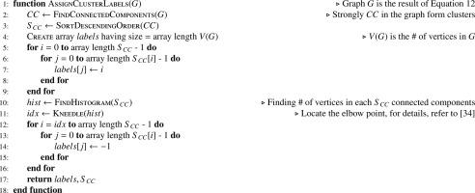

1. Construct a sparse graph using Delaunay triangulation
2. Form a Gabriel graph
3. Calculating a threshold for graph partitioning
4. Assigning objects to clusters

The algorithm works pretty well in comparison with the other methods which use Delaunay triangulation and is much more efficient. However, it has its drawbacks and cannot work well in some cases. One of these is when there are many outliers spread over the space in a way that destroys the separateness and homogeneity of the intended clusters.

### 5.2.10 Supervised Spatial Regionalization using Karhunen-Loève Expansion

Daw and Wikle [40] propose a method to use Karhunen-Loève Expansion to define the regionalization error so that the ecological fallacy is minimized. It is a two-step process and takes place as follows.

1. In the first step, the ecological fallacies are mitigated by projecting the response variable onto the space of the optimal eigenfunctions using the Karhunen-Loève Expansion of the underlying spatial process.
2. The second step involves spatial partitioning using Minimum Spanning Trees. Here, the spatial data is considered as a connected graph where the locations are the vertex and the edge sets contain the location tuples that are neighbors. The dissimilarities in the feature space are used to assign loss functions to the edges, which gives a unique MST. Finally, the MST is pruned using a heuristic algorithm to get the regions.

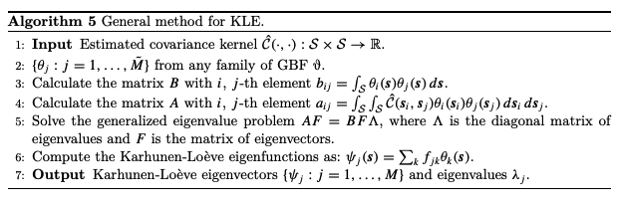

While the advantages of this method have already been discussed, there are a few drawbacks as well. Firstly, the effectiveness of large datasets has not been measured. Secondly, outliers affect both MSTs and KLE significantly, so that could pose issues as well.

# Mixed Heuristics models

* 1. **Description**

The use of mixed heuristic methods is to merge in one model the computational power of heuristic approaches with the mathematical accuracy of exact models. This combination has been made in two different ways: first, the exact model can be applied in a set of neighboring regions to redraw their borders, achieving improvements in the aggregation criteria; second, information obtained from multiple solutions generated by any regionalization heuristic is used to reduce the number of variables and constraints in an exact model.

|  |  |  |  |  |  |  |  |  |
| --- | --- | --- | --- | --- | --- | --- | --- | --- |
| [41] |  |  |  |  |  |  |  |  |
| [43] |  |  |  |  |  |  |  |  |
| [45] |  |  |  |  |  |  |  |  |
| [47] |  |  |  |  |  |  |  |  |
| [48] |  |  |  |  |  |  |  |  |
| [50] |  |  |  |  |  |  |  |  |
| [53] |  |  |  |  |  |  |  |  |
| [54] |  |  |  |  |  |  |  |  |
| [55] |  |  |  |  |  |  |  |  |
| [57] |  |  |  |  |  |  |  |  |
| [58] |  |  |  |  |  |  |  |  |

Figure: Mixed heuristics model taxonomy table (The tick represents the focus of each paper)

* 1. **A Two-Phase Hybrid Heuristic Algorithm For The Capacitated Location-Routing Problem**

The paper [41] proposes a two-phase hybrid heuristic algorithm to solve the capacitated location routing problem (CLRP). It combines both depot location and routing decisions. The input for this algorithm is a set of identical vehicles each having a capacity and a fixed cost, a set of depots with restricted capacities and opening costs, and a set of customers with deterministic demands. The main purpose is to determine the number of depots to be opened, the customers and the vehicles to be assigned to each open depot, and the routes to be performed to fulfill the demand of the customers. The objective function here is to minimize the sum of the costs of the open depots, of the fixed cost associated with the used vehicles, and of the variable traveling costs related to the performed routes. It has two phases, the construction phase which is a modified granular search with different diversification strategies which are applied during the second phase which is the improvement phase, it considers five granular neighborhoods, three diversification strategies, and a perturbation procedure which is applied whenever the algorithm remains in a local optimum for a given number of iterations.

The experiments are conducted on standard benchmarks and compared against the five most effective published heuristics on CLRP. The effectiveness of the proposed algorithm is several computing times faster than previous algorithms. The results also show that the proposed approach can be extended to PLRP (Periodic Location Routing Problem) and MDVRP (Multi Depot Vehicle Routing Problem)

* 1. **A Gis-Based Optimization Framework For Competitive Multi-Facility Location-Routing Problem**

The paper [42] tries to solve the problem of multi-facility location-routing which arises in operating a chain of retail stores, banks or any other kind of retail chain. This involves factors such as budget, location, etc. This paper aims to extend the body of existing knowledge of competitive facility location decisions using models where logistics issues are of concern and also offer a GIS-based framework with an algorithmic approach that could lead to an effective decision support system for analysts. The author proposes an integrated location-routing model that addresses not only location-based decisions but also takes into account the routing decisions as well. The objective of this is to maximize total profit, which is the gross profit margin obtained from sales minus facility costs. The authors have come up with a genetic algorithm to make location-based decisions along with routing. Also, they have come up with a GIS framework for this. The experimental results conducted from supermarket store data from Istanbul show that the developed model is effective and efficient in providing solutions. Experimental results show that it is very practical.It solves a specific problem and could have been generalized.

* 1. **Novel hybrid models combining meta-heuristic algorithms with support vector regression**

In the article[43], the author discusses how Geospatial Information Systems, statistical modeling, machine learning, data mining, and ensemble models have been used to map groundwater potential. Plans for groundwater development can be developed using these models by planners and decision-makers. Nevertheless, if the irrelevant extra features are not removed, then useless information must be stored alongside useful information, incurring a computing cost. To extract the appropriate features for a Support Vector Regression model in a mixed-heuristic manner, three metaheuristic algorithms were employed, namely Genetic Algorithms (GA), Biogeography-Based Optimization (BBO), and Simulated Annealing (SA). The authors conducted experiments and through those results, they showcase how SVR models improve accuracy significantly by combining both tuning and feature selection methods. Also utilizing different hybrid heuristic models in modeling will improve the performance and hence the decision-makers can use the information and can consider the best decision for the problem. The results also show that using different hybrid models in modeling improves model performance, thus helping the decision-makers take highly informed decisions concerning the best model for the problem under consideration.

* 1. **Routing Problems: A Survey**

The paper[44] is a survey of routing problems. The author has classified routing problems into two main categories namely path-finding problems and tour construction problems based on the objectives and complexity. The author has compared the routing problems to all kinds of algorithmic problems such as Dynamic Programming, Graph, etc. Also with proper heuristics, we can apply all the traditional algorithms to solve the problems using GIS. The author has come up with a simple explanation for the routing problems classification, making it easier to understand them. There is no wider research made for practical applications and experimental results.

* 1. **Heuristic Concentration For The P-Median**

The paper [45] shows the application of Heuristics Concentration for a p-median problem and explores the effects of the efficacy of a common 1-opt interchange heuristics and heuristics of concentration for the location-allocation problem. The experimental results show that HC is successful in the interchange of heuristics. The most popular 1-opt interchange heuristics is of no use for a generic problem taken here to find the global optimal solution. The authors have also shown a map analysis of the data with certain demand points. HC is very simple and transparent to use and the metaheuristics used are very relative. The authors have come up with strong experimental results for HC over 1-opt interchange heuristics. The experiments conducted here are too narrow on a single dataset.Other competitive methods of p-median are not taken into consideration.

* 1. **A Gis-Based Optimal Facility Location Framework**

The paper [46] tries to formulate the facility location problem as MCLP(Maximal Covering Location Problem) to compute the minimum number of charging stations needed in a particular region such that there will not be any demands. The authors have taken a dataset for a specific city, Raleigh, NC. Also, they have considered both housing and actual highway traffic data as inputs to mimic EV charging demand. They have used a regular MCLP solution to solve this, but with the effective parameters which will be effective in solving the problem. The authors have also implemented a practical GIS-based solution framework on this model. Effective utilization of parameters. A very practical solution can be used on a large scale with some modifications.

* 1. **COBRA: A New Formulation Of The Classic P-Median Location Problem**

The paper [47] proposes a novel approach that uses a substitution technique that eliminates up to 60 percent of the variables used in classic model formulations. It uses a property associated with geographical proximity and makes it possible to eliminate most of the model variables. This tries to solve the p-median problem more efficiently. The objective function used here combines the previous methods and is named COndensed Balinski constraints with the Reduction of Assignment (COBRA) variables. The objective function used in this technique minimizes the total weighted distance. The proposed approach reduces the variables used from 10% to 80% from the traditional methods. It is a substantial improvement from the previous classic models. In the experiment mentioned in the paper, the datasets used are very less and have only 79 villages in 5 counties, this doesn’t indicate the practicality of the approach. The paper also proposes further study is needed for the implication of the proposed approach heuristic concentration, this makes it incomplete.

* 1. **The Large-Scale Dynamic Maximal Covering Location Problem**

The paper [48] proposed an approach that tries to solve the problem of dynamic maximum covering for location problems where a decision has to be made for one period. The authors have taken the supply chain and its coordination with production and service facilities. It uses simulated annealing to solve this problem. And the experimental results have indicated that it gives a fair amount of exactness. Among all the approaches to picking the facility variants, simulated annealing is the most effective one. It is a well-known metaheuristic for a location-specific problem. It prevents getting stuck in local optima by using dynamic probability throughout the process. Several experiments have shown that this method gives fine-tuned optimal parameters for the problem. This method builds on top of traditional MLCP to be dynamic. The experiments have proved that this method has negligible errors. The authors have not taken into consideration comparing various existing heuristics on the location problem. The experimental data is very specific to the problem of the supply chain and the dataset used is not very clear.

* 1. **A Hybrid Nested Partitions Algorithm For Banking Facility Location Problems**

The paper [49] proposes an approach for banking facility location problems in an optimized manner. It applies an existing hybrid nested partitions algorithm to the large-scale situation. It enhances on top of MCLP (Maximal Covering Location Problem) model which captures important features such as varied costs and revenues, multitype facilities, and flexible coverage functions. It uses heuristic-based extensions to generate feasible solutions more efficiently. The experimental results show that the proposed approach is effective and efficient in a reliable manner. It uses the nested partitions method, a randomized method for solving global optimization problems. The objective function is defined for a banking facility location problem and then it is solved using a nested approach. In order to make the sampling process of nested partitions more efficient, a mathematical model is applied to guide the sampling process. The experimental results show that it is a promising approach both in terms of efficiency and effectiveness. It can be further extended to problem-specific heuristic rules. Even though experimental results are promising, the experiments conducted are very narrow and related to banking.

* 1. **A Gamma Heuristic For The P-Median Problem**

The paper [50] tries to solve the classic p-median heuristic of choosing p sites or facilities on a network of n nodes. There are multiple ways to select p sites optimally. This paper introduces Heuristics Concentration (HC) which is a two stage metaheuristic approach to solving combinatorial problems. The first stage of HC repeatedly applies random start interchange heuristics to generate a number of alternative facility configurations. Here the authors have introduced a three-layer heuristics on top HC Gamma Heuristic. In the gamma heuristic layer, there are sets of rules called metaheuristics to filter out the dataset based on the parameters defined in the first two stages. The experimental results have shown that this can be applied to any p-median problem to generate results efficiently. The proposed approach improves the results from Heuristics Concentration. It relies on HC for the first two stages. The experiments shown here are too narrow.

* 1. **Design Of Homogenous Territorial Units**

To identify homogeneous territorial units related to the analyzed phenomena, an optimization model is proposed in this paper [51]. A number of disadvantages have been identified in previous studies when it comes to automated regionalization tools. In order to obtain faster results from the model, the paper recommends using the Regionalization Algorithm with Selective Search(RASS). A variety of territorial configurations can be detected using the proposed methodology, taking into account contiguous elements in the grouping process. When dealing with large problems, this model works well and the experiments showed that Initial feasible solutions are provided by the model. But, it does not guarantee the Optimal solution compared to regionalization methods like Linear Optimization Model.

* 1. **Exact Models For The Regionalization Problem**

Using the spatial contiguity constraint to classify regionalization methods, the paper [52] presents a taxonomic scheme defining eight categories of regionalization methods. A qualitative comparison of these categories based on a set of characteristics is presented, along with suggestions for future research to extend and improve these methods. A reduced optimization model is formulated based on information about neighboring areas that have never been allocated to the same solution.

* 1. **Supervised Regionalization Methods**

To solve regionalization problems, the paper [53] showcases the Mixed heuristics models which are a classification of heuristics that combine heuristic and exact optimization models. The paper utilizes the computational power of the heuristic approach along with the mathematical accuracy of exact models to perform the computations. Firstly, to redraw neighboring regions' boundaries, the exact model can be applied which helps in improving the aggregate criteria. Then, all the information is generated from multiple solutions using any regionalization heuristic which can be then used to reduce constraints and variables in the exact model. The paper demonstrates how regionalization problems can be solved more efficiently by utilizing mathematical computations along with a combination of heuristic and exact optimization models.

* 1. **Geographical Distillation**

The paper [54] describes how a reasonable amount of time cannot be spent solving regionalization problems using flow-based regionalization models (FlowRM) without distillation. Researchers have previously used exact methods to solve regionalization problems. In this article, the authors propose that each solution improves upon the best-known solution based on the heuristic distillation approach i.e geographical distillation. Regionalization relies heavily on distillation, but its strength lies in its ability to fix information structures and distill variables. The FlowRM fix would significantly extend the time it would take to solve the problem.

* 1. **Heuristic Concentration**

The paper [55] demonstrates how the Heuristic Concentration approach is being used to address these larger problems using the 2 stages. An interchange heuristic is first tested using a random start, in order to create a data set. Following this, a small portion (m) of these solutions (q) is analyzed in order to develop the Concentration Set. An exact or heuristic solution is determined at stage two of the CS process. When an exact method is applied to the Concentration Set, the result will be the optimal solution if the optimal solution is found within the CS. Consequently, the likelihood of optimality is determined by the quality of the Concentration Set. A comprehensive understanding of the Concentration Set requires understanding the parameters q and m. In order to gain a better understanding of the CS, it is necessary to specify good values for these parameters.

* 1. **ScatterD: Spatial Deployment Optimization With Hybrid Heuristic**

The paper [56] describes how deploying with real-time scheduling constraints, for example, presents an NP-hard problem for designing automated algorithms. Industrial-sized problems like integer programming typically do not scale well with exponential algorithms. The highly-constrained solution spaces characteristic of spatial deployment problems are not conducive to evolutionary algorithmic techniques, such as genetic algorithms. The hybrid heuristic algorithm like ScatterD addressed this problem by improving the performance in deriving topologies for spatial deployment. This paper used heuristic bin-packing and an evolutionary algorithm for a hybrid heuristic approach. Compared to strictly evolutionary algorithms, the hybrid ScatterD algorithm significantly reduced power consumption in the empirical results. The disadvantage of this approach is that a combination of heuristic algorithms and evolutionary algorithms must be rigorously tested in order to find an effective method.

* 1. **Heuristic Concentration: Two-Stage Solution Construction**

This paper [57] proposes a combinatorial approach for the p-median problem. Here two layers of optimization are superimposed. The first layer is a conventional heuristic and the second layer is for an exact procedure that draws on the concentrated solution set which will be generated by the first heuristic. The motive of the paper is to provide an alternative heuristic procedure for the p-median problem which is most useful in location decision analysis and will provide an optimal solution than existing methods. The solution is very general and can be applied to a number of contexts. It makes use of a concentrated set from the initial heuristic method. The proposed approach uses location allocation interchange to find the optimal pattern which in terms to find the concentrated set of SPP(Stable Partition Pattern) The algorithm mentioned stops after finding the stable partition pattern, which makes it effective. Some disadvantages of the paper are that the method proposed is not very efficient because of the overhead of a two-step process. The paper will not be very efficient if multiple similar SPP’s are found. The experiments conducted are too restrictive because of the size of the data and it also uses interchange heuristics alone as objective, this could have been better.

* 1. **Metaheuristics In Combinatorial Optimization**

The paper [58] performs a conceptual comparison of various metaheuristics. The author based on the way they are implemented utilized the Intensification and diversification of the search process. The comparison is done by characterizing the algorithmic components they are dependent upon such as guiding functions and randomization. The effect of using these different metaheuristics experiments in the search process and results show that some metaheuristics perform better than others. The author concludes that mixing and hybridizing often perform better than the pure optimization methods.

# Conclusion

There are multiple pros as described in the multiple papers we have examined related to the heuristic methods. While they have been useful in most of the scenarios, there have been a few disadvantages of them as well. There is also scope for future improvements. We have explained all of them in the following paragraphs.

* 1. **Adapted hierarchical clustering algorithms**

Hierarchical clustering approaches are well suited if the problem statement needs hierarchy to be established at multiple resolutions or scales. Intermediate aggregations are available in this approach, since, during every iteration of the algorithm at every scale, we have a partial solution and at least two selected areas get merged. This type of nesting occurs by design since two distinct areas at a lower scale will end up being part of the same region at a higher scale due to the hierarchical nature of the algorithm. This approach may not be efficient and/or optimal in specific cases where the solution is needed only at a single specific scale.

* 1. **Seeded regions**

In this study, we evaluate contributions made to regionalization methods over the course of more than 40 years. We also suggest a taxonomy for the many regionalization approaches that have been studied in the literature, depending on how they approach the contiguity constraint. The main characteristic of these heuristics is studied in different research papers ie. selecting one area (seed area) to which other neighboring areas are assigned. The seeds can be produced serially, meaning that each seed is chosen after a region has been finished, or concurrently, meaning that each seed is chosen simultaneously. Various algorithms and regionalization techniques are discussed along with their limitations.

## 

## Modification of an initial feasible solution

We went through a total of ten papers for this section. In all of the papers, numerous algorithms that are an improvement over the original approach have been offered by various stakeholders. There are various challenges faced in the fields of clustering, scaling and aggregation, identification of the most compact division of a region, redistricting automation, verification of region contiguity, member redistribution, zone design, p-regions, and zoning system design. There are several traditional approaches to solve these problems but they don’t work effectively. That is why different stakeholders have come up with novel solutions that are built on top of the existing implementation. Furthermore, these are not the most optimal solutions and there is definitely room for more research in this space.

* 1. **Graph-based models**

We went through a total of ten papers which gave us valuable insights into the various methods that can be used for regionalization with the help of graphs. A lot of the papers have used MSTs for solving regionalization problems, however, it has been highlighted time and again that MSTs suffer from the chaining problem. While a few have managed to eradicate these issues, their efficacy for larger datasets or in the presence of outliers is something that is a major problem or hasn’t been tested effectively. Thus, there is still a lot of scope for improvement in the efficacy of graph-based models and the building of scalable solutions for regionalization problems.

* 1. **Mixed Heuristics models**

In various papers and research, it is observed that the Mixed Heuristics model breaks down the regionalization problem into subproblems, and uses the computational power of a heuristic concentration approach and a heuristic distillation approach to solving the regionalization problem. As well as ensuring spatial continuity, this model provides a range of other benefits. Nonetheless, the approach does not always yield guaranteed results, and the solutions might not be optimal. In addition, it cannot easily be adapted to any aggregation criteria. Optimum models like this do not work well for solving large optimization problems.

# References

* + 1. Spence, N. A. (1968). A multifactor uniform regionalization of British counties on basis of employment data for 1961. Regional Studies, 2(1):87–104
    2. Webster, R. and Burrough, P. A. (1972). Computer-based soil mapping of small areas from sample data .1. multivariate classification and ordination. Journal of Soil Science, 23(2):210– 234.
    3. Margules, C. R., Faith, D. P., and Belbin, L. (1985). An adjacency constraint in agglomerative hierarchical classifications of geographic data. Environment and Planning A, 17(3):397–412
    4. Byfuglien, J. and Nordgard, A. (1973). Region-building - a comparison of methods. Norwegian Journal of Geography, 27:127–151
    5. Ferligoj, A. and Batagelj, V. (1982). Clustering with relational constraint. Psychometrika, 47(4):413–426.
    6. Openshaw, S. (1973). A regionalisation program for large data sets. Computer Applications, 3- 4:136–147
    7. Perruchet, C. (1983). Constrained agglomerative hierarchical-classification. Pattern Recognition, 16(2):213–217.
    8. Sokal, R.R. and Sneath, P.H.A. (1963) Principles of Numerical Taxonomy. W.H. Freeman & Co., New York.
    9. David C. Folch & Seth E. Spielman (2014) Identifying regions based on flexible user-defined constraints, International Journal of Geographical Information Science, 28:1, 164-184
    10. Feng, X., Rey, S., & Wei, R. (2022). The max-p-compact-regions problem. Transactions in GIS, 26, 717– 734

[11] Computers in behavioral science, Legislative districting by computer simulation, Thoreson and Liittschwager (1967)

[12] Openshaw, S. (1977a). A geographical solution to scale and aggregation problems in region-building, partitioning, and spatial modeling. Transactions of the Institute of British Geographers, 2(4):459–472.

[13] The identification of all possible solutions to a constituency-delimitation problem D J Rossiter, R J Johnston

[14] Counterspeculation, Auctions, And Competitive Sealed Tenders by William Vickrey

[15] Legislative districting by computer by Burton C. Gearhart, John M. Liittschwager

[16] Optimal zoning systems for spatial interaction models. Openshaw, S. (1977b)

[17] Some implications of spatial organization of elections Taylor, P. J

[18] Spatial regionalization based on optimal information compression Alec Kirkley

[19] Object segmentation by saliency‑seeded and spatial‑weighted region merging Junxia Li* , Jundi Ding, Jian Yang and Lingzheng Dai

[20] A framework for the segmentation of high-resolution satellite imagery using modified seeded-region growing and region merging

Y. Byun, D. Kim, J. Lee & Y. Kim

* + 1. Ferligoj, A. and Batagelj, V. (1982). Clustering with relational constraint. Psychometrika, 47(4):413–426.
    2. Openshaw, S. (1977a). A geographical solution to scale and aggregation problems in region-building, partitioning and spatial modeling. Transactions of the Institute of British Geographers, 2(4):459–472.
    3. Horn, M. E. T. (1995). Solution techniques for large regional partitioning problems. Geographical Analysis, 27(3):230–248.
    4. Browdy, M. H. (1990). Simulated annealing: an improved computer model for political redistricting. Yale Law & Policy Review, 8:163–179.
    5. Macmillan, W. (2001). Redistricting in a GIS environment: An optimization algorithm using switching points. Journal of Geographical Systems, 3:167–180.
    6. Nagel, S. S. (1965). Simplified bipartisan computer redistricting. Stanford Law Review, 17(5):863–899.
    7. Openshaw, S. (1978). Spatial Representation and Spatial Interaction, chapter An optimal zoning approach to the study of spatially aggregated data, pages 95–113. Leiden ; Boston : M. Nijhoff Social Sciences Division.
    8. Kamyoung Kim, Denis J. Dean, Hyun Kim & Yongwan Chun (2016) Spatial optimization for regionalization problems with spatial interaction: a heuristic approach, International Journal of Geographical Information Science, 30:3, 451-473, DOI: 10.1080/13658816.2015.1031671
    9. Openshaw, S. and Rao, L. (1995). Algorithms for reengineering 1991 census geography. Environment and Planning A, 27(3):425–446.
    10. Sammons, R. (1978). Spatial Representation and Spatial Interaction, chapter A simplistic approach to the redistricting problem, pages 71–94. Leiden ; Boston : M. Nijhoff Social Sciences Division.
    11. Nystuen, J.D., Dacey, M.F. A graph theory interpretation of nodal regions. Papers of the Regional Science Association 7, 29–42 (1961)
    12. Maurizio Maravalle & Bruno Simeone (1995) A spanning tree heuristic for regional clustering, Communications in Statistics - Theory and Methods, 24:3, 625-639
    13. Duque, Juan Carlos C. and Anselin, Luc and Rey, Sergio J., The Max‐P‐Regions Problem (August 2012). Journal of Regional Science, Vol. 52, Issue 3, pp. 397-419, 2012
    14. R. M. AssunÇão, M. C. Neves, G. Câmara & C. Da Costa Freitas (2006) Efficient regionalization techniques for socio‐economic geographical units using minimum spanning trees, International Journal of Geographical Information Science, 20:7, 797-811
    15. Orhun Aydin, Mark V. Janikas, Renato Assunção, and Ting-Hwan Lee. 2018. SKATER-CON: Unsupervised Regionalization via Stochastic Tree Partitioning within a Consensus Framework Using Random Spanning Trees: Research Paper. In Proceedings of the 2nd ACM SIGSPATIAL International Workshop on AI for Geographic Knowledge Discovery (GeoAI'18). Association for Computing Machinery, New York, NY, USA, 33–42
    16. Semaan, Gustavo Silva et al. “An Efficient Evolutionary Algorithm for the Aggregated Weighting Areas Problem.” (2008).
    17. D. Guo (2008) Regionalization with dynamically constrained agglomerative clustering and partitioning (REDCAP), International Journal of Geographical Information Science, 22:7
    18. Xiongfeng Yan, Tinghua Ai, Min Yang, Hongmei Yin, A graph convolutional neural network for classification of building patterns using spatial vector data, ISPRS Journal of Photogrammetry and Remote Sensing, Volume 150, 2019,Pages 259-273
    19. Alper Aksac, Tansel Özyer, Reda Alhajj, CutESC: Cutting edge spatial clustering technique based on proximity graphs, Pattern Recognition, Volume 96, 2019
    20. Ranadeep Daw, Christopher K. Wikle, Supervised Spatial Regionalization using the Karhunen-Loève Expansion and Minimum Spanning Trees, J. data sci. 20(2022), no. 4, 566-584
    21. John Willmer Escobar, Rodrigo Linfati, and PaoloToth. A two-phase hybrid heuristic algorithm for the capacitated location-routing problem.
    22. Burcin Bozkaya, Seda Yanık, Selim Balcisoy. A GIS-Based Optimization Framework for Competitive Multi-Facility Location-Routing Problem.
    23. A'kif Al-Fugara, Mohammad Ahmadlou, Rania Shatnawi, Saad AlAyyash, Rida Al-Adamat, Abdel Al-Rahman Al-Shabeeb & Sangeeta Soni. Novel hybrid models combining meta-heuristic algorithms with support vector regression (SVR) for groundwater potential mapping.
    24. Khalid A. Eldrandaly, AbdelHadi N. Ahmed, Abdel Monaem F.M. AbdAllah. Routing Problems: A Survey
    25. K.E.Rosing, M.John Hodgson. Heuristic concentration for the p-median: an example demonstrating how and why it works
    26. Usman Zafar, I. Safak Bayram, Sertac Bayhan. A GIS-based Optimal Facility Location Framework for Fast Electric Vehicle Charging Stations
    27. Richard L. Church. COBRA: A New Formulation of the Classic p-Median Location Problem
    28. Mohammad Hossein FazelZarandi, Soheil Davari, Seyyed Ali Haddad Sisakht. The large-scale dynamic maximal covering location problem
    29. Li Xia, Wenjun Yin, Jin Dong, Teresa Wu, Ming Xie, Yanjia Zhao. A Hybrid Nested Partitions Algorithm for Banking Facility Location Problems
    30. K.ERosing, C.SReVelle, D.ASchilling. A gamma heuristic for the p-median problem.
    31. DESIGN OF HOMOGENOUS TERRITORIAL UNITS: A METHODOLOGICAL PROPOSAL <https://www.researchgate.net/publication/23731357_Design_of_homogenous_territorial_units_a_methodological_proposal>
    32. Duque, J. C., Church, R. L., and Middleton, R. S. (2006). Exact models for the regionalization problem. In Western Regional Science Association annual meetings, Santa Fe.
    33. Duque, J. C., Ramos, R., & Suriñach, J. (2007). Supervised Regionalization Methods: A Survey. International Regional Science Review, 30(3), 195–220. <https://doi.org/10.1177/0160017607301605>
    34. Middleton, Richard. (2006). Geographical distillation: Application of the p-median, traveling salesman, and regionalization problems, Geography.
    35. Rosing, K.E. (1998). Heuristic Concentration: Its Care and Feeding. In: Griffith, D.A., Amrhein, C.G., Huriot, JM. (eds) Econometric Advances in Spatial Modelling and Methodology. Advanced Studies in Theoretical and Applied Econometrics, vol 35. Springer, Boston, MA. <https://doi.org/10.1007/978-1-4757-2899-6_11>
    36. Jules White, Brian Dougherty, Chris Thompson, and Douglas C. ScatterD: Spatial Deployment Optimization with Hybrid Heuristic / Evolutionary Algorithms. <https://www.dre.vanderbilt.edu/~schmidt/PDF/white-spatial-deployment.pdf>
    37. K.E. Rosing, C.S. ReVelle. Heuristic concentration: Two stage solution construction, European Journal of Operational Research, Volume 97, Issue 1, 1997, Pages 75-86, ISSN 0377-2217, https://doi.org/10.1016/S0377-2217(96)00100-2.
    38. Blum, Christian & Roli, Andrea. (2001). Metaheuristics in Combinatorial Optimization: Overview and Conceptual Comparison. ACM Comput. Surv.. 35. 268-308. 10.1145/937503.937505
    39. Duque, J. C., Ramos, R., & Suriñach, J. (2007). Supervised Regionalization Methods: A Survey. International Regional Science Review, 30(3), 195–220.