

**User’s Guide**

Log Analysis Tool

**Contents**

1. Introduction ………………………………………………………………………………………………………………………… 3
2. Installation ………………………………………………………………………………………………………………………….. 3  
   2.0.1 Installing and Configuring Client Specific Changes ……………………………………………………… 3

2.0.2 Things To Keep In Mind ………………………………………………………………………………………………. 4

1. User’s Manual …………………………………………………………………………………………………………………….. 4

3.0.1 Initial Application DB Check ………………………………………………………………………………………... 4

3.0.2 Home Window ……………………………………………………………………………………………………………. 4

3.0.3 Extracting Work Orders By Date Range ………………………………………………………………………. 5

3.0.4 System Specific Logs Display Window …………………………………………………………………………. 5

3.0.5 Advanced Operations Window ……………………………………………………………………………………. 9

3.0.6 Log Type Specific Logs Window …………………………………………………………………………………… 9

1. **Introduction**

The tool has been developed to simplify the process of analysing log files at times of crash, trouble shooting or intercepting communications between the various systems of a particular client as bifercated by the WorkOrders.

Tool has the capability to fetch all the relevant logs from log files inside the Errors folder of all the systems and display them on a single screen. There are six types of logs that can be fetched by this application. These are VBEventLog, WitStatusLog, VBLog, MainLog, SerialOutput and DBLogs(Extracted from Database through EventLog Database inside the table AllEvents).

1. **Installation**

The tool can be installed on any PC of any Client given that the host of this application has access to all locations where log files can be found. Most of the settings are generically fetched by the DB itself and hence the only setting which needs to be changed before installing or publishing this software for a particular client is it’s DB Connection String.

2.0.1 **Installing and Configuring Client Specific Changes**

DB Connection String can be changed in visual studio inside the App.Config file and the project can be built again to get an installer for the latest build version. To change the DB Connection String :-

1. Open project LoggerAnalysisTool in Visual Studio
2. Open App.Config file
3. Locate a key ‘DBConnectionString’ inside <AppSettings> tag
4. Change only the DataSource field of the Connection String
5. After changing the database, Locate project folder inside the Solution Explorer, Right Click on it and click on Publish(Fig 1.0) to publish the SetUp file by selecting a suitable location to Publish Application Installation File.

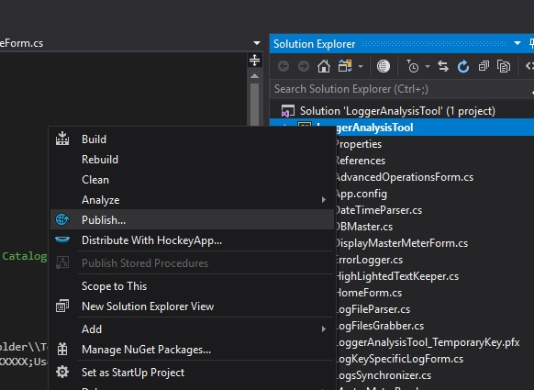

Fig 1.0 Publishing Log Analysis Tool Project

1. New folder containing all the published files (Fig 2.0)should be ready to be moved to any client system and installed for Logs Analysis.

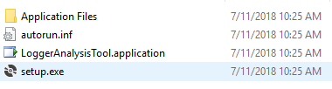

Fig 2.0 Published Files

1. Application can be installed by double clicking Setup file and following the procedure as mentioned by Setup Wizard.
2. Application can be found by using a Search option inside Start Menu and Searching for ‘Log Analysis Tool’.

2.0.2 **Things to Keep In Mind**

When changing configurations inside ‘App.Config’ file (Fig 3.0),check whether the key ‘genericErrorFolderPath’ and key ‘genericErrorFolderPathLoomSystem’ points to the errors folder of each System having log files when XXXXX is replaced by the system name. (Do not change XXXXX to system name as the system name is fetched by Database and replaced by XXXXX).



Fig 3.0 App.Config (Configurable Settings)

1. **User’s Manual**

3.0.1 **Initial Application DB Check:** The application starts up by checking and finding the names of all relevant DBs involved in fetching different types of logs into the application by making a connection with the above changed DB Connection String. If the application is unable to do so because of any reason (wrong DB Connection String or No Access to DB Server through the host), the application will let the user know about it by a pop up dialog with Error Message.

3.0.2 **Home Window:** If the above mentioned process is successful, User will be able to see the Home Window which looks like Fig 4.0.

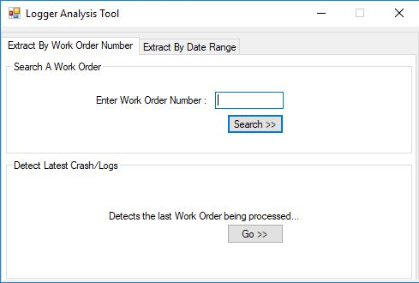

Fig 4.0(a) Home Window (Extract by Work Order Number)

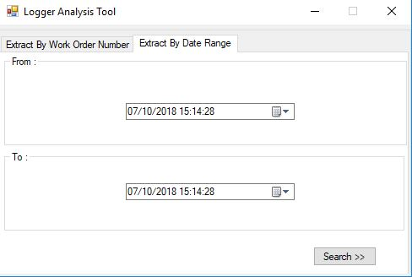

Fig 4.0(b) Home Window (Extract by Date Range)

Home Window has two tabs to begin with, one can be used to search a Work Order by its Work Order Number or to detect the latest Crash or latest Logs written to all the logs Fig 4.0(a), and the other one can be used to extract all Work Orders processed between two given times Fig 4.0(b).

3.0.3 **Extracting Work Orders by Date Range:** If the user selects to extract Work Orders by Date Range, a work orders range Display Dialog (Fig 5.0) pops up which lists all the Work Orders which were processes by the system in the time interval input by user. User can select any Work Order and click on Watch to see System Specific Logs of that particular Work Order.

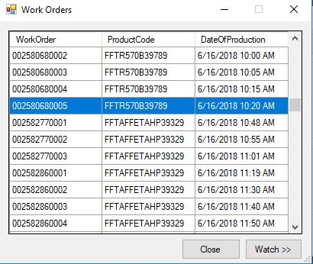

Fig 5.0 Work Orders in Range Display

3.0.4 **System Specific Logs Display Window:** This log window shows all types of logs for a particular Work Order inside a particular PC (Eg. FrontEnd, CS1M1, CS2M2 (Fig 6.0)). This window offers multiple tools which can be used to analyse logs, these tools can be found inside the ‘Tools’ menu item on the menu strip on top of the Window (Fig 7.0).

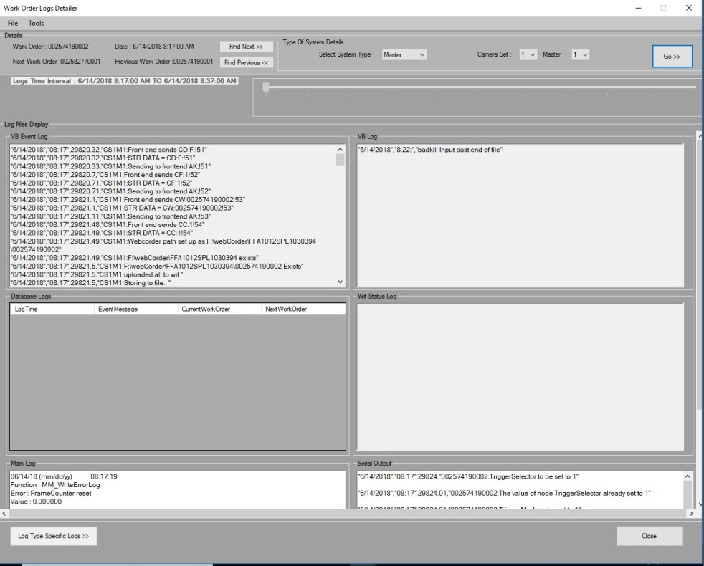

Fig 6.0 System Specific Logs Display

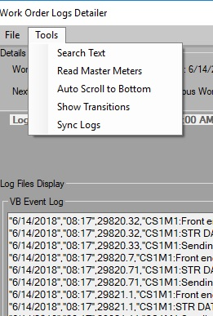

Fig 7.0 Tools Menu Item

Tools inside the tools Menu Item are explained as follows:

3.0.4.1 **Search Text Tool:** (Fig 8.0)Search Text can be used to search text keywords inside each log file fetched by the application.

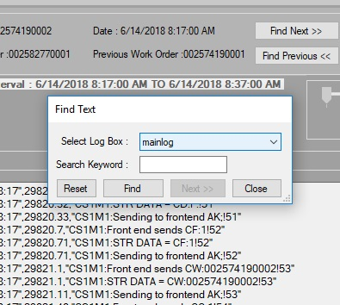

Fig 8.0 Find Text Dialog

3.0.4.2 **Read Master Meters Tool:** This tool (Fig 9.0) can help discover the Master Meter Readings sent by each Master to Front End. This tool item will only get enabled when you are viewing logs of Front End System on the Window (System Type can be selected by changing System Type Settings on top right Corner of System Specific Logs Window).

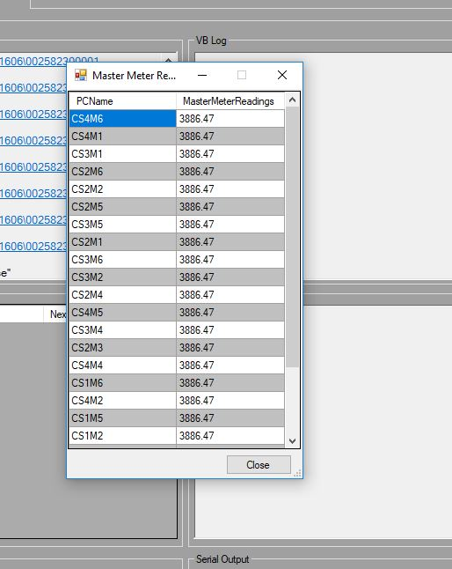

Fig 9.0 Read Master Meters

3.0.4.3 **Auto Scroll To Bottom Tool:** This tool scrolls each log to the bottom (last line fetched for that particular work Order).

3.0.4.4 Show Transitions Tool: This tool takes into Account the Next and Previous Work Order and hence displays logs for three consecutive Work Orders inside the Logs Display Area.

3.0.4.5 **Sync Logs Tool:** This tool helps in synchronizing the logs with time and provides a common scroll bar in the form of a track bar to scroll through logs with respect to time(Fig 10.0). But if it fails to read the system ticks in any of the files it shifts sync Configuration to Old build and pops up a message box (Fig 11.0) to inform User about this shift.

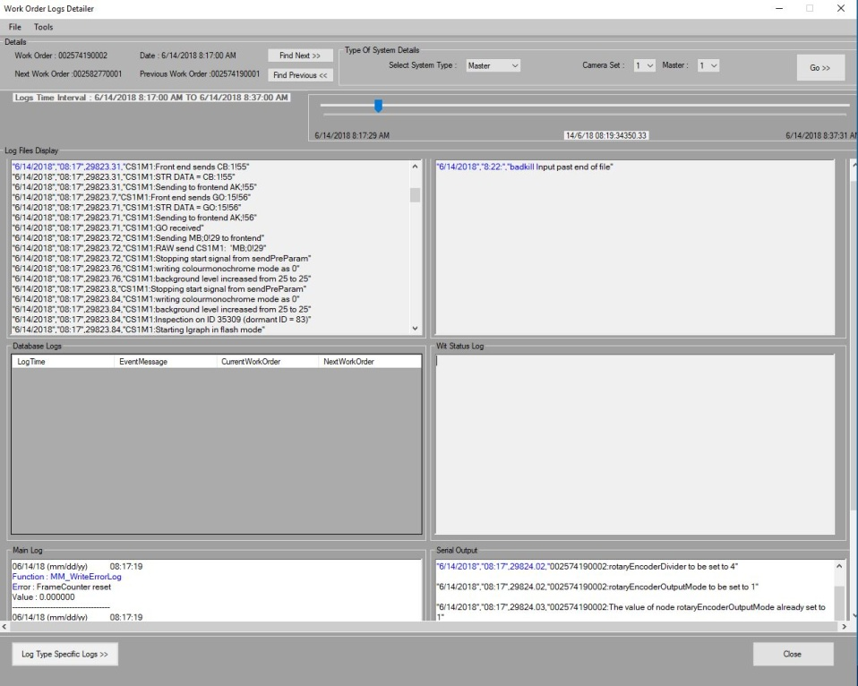

Fig 10.0 Synchronized Logs

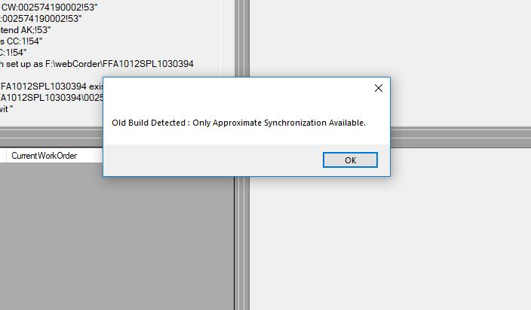

Fig 11.0 Old Build Detected

Apart from above Mentioned tools the User can move to Next Work Order or Previous Work Order by clicking on the respective ’Find Next >>’ and ‘<< Find Previous’ Buttons on the System Specific Log System Window on top Mid of the screen inside Details Box of the User Interface.

User can click on Log Type Specific Logs to Display an Advanced Operations Window which helps to view single type of log file for multiple Systems.

3.0.5 **Advanced Operation Window:** This window (Fig 12.0) can be used to select number of PCs and a single type of log to display same type of log for multiple systems. Clicking on Next will take User to Log Type Specific Log Display Window.

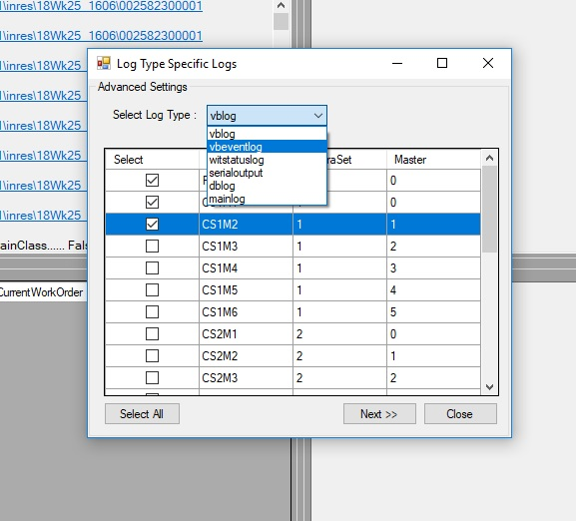

Fig 12.0

3.0.5 **Log Type Specific Logs Window:** This window Fig(13.0) shows the logs as selected on Advanced Operations Window and has an option to Sync Logs and search Keywords with same Approach as mentioned in System Specific Logs Window.

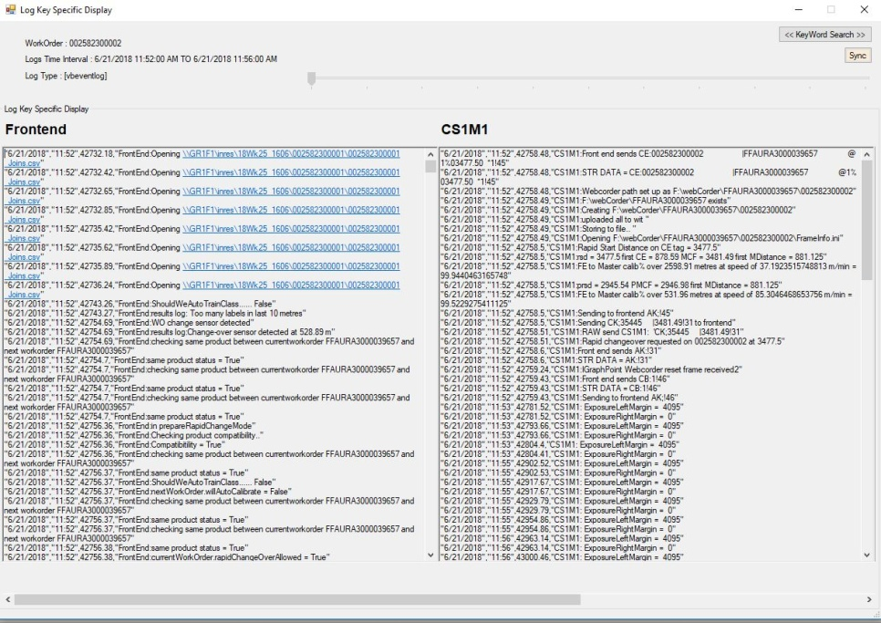

Fig 13.0