**PROJECT REPORT**

**WORD-LEVEL VISUAL SPEECH RECOGNITION**

**(LIP READING)**

**Anem Puneet Surya–s5229054**

**Rayarala Anurag Vijay kumar–s529899**

**Shiva Narayana Dhulipala - s5229871**

**Table of Contents**

1.0 Introduction 3

1.1 Front Matter 3

2.0 Problem definition and analysis 5

2.1 Related Work 5

3.0 Methodology 6

3.1 Database 6

3.1.1 Visual Speech Recognition Framework 6

3.2 Deep Learning Modules 7

3.2.1 Facial milestones and information enlargement 7

3.2.2 Spatiotemporal front-end 7

3.2.3 Waiting Framework 7

3.2.3 3D Convolutional Neural Networks 7

4.0 Experiments 8

4.1 Check results 8

4.2 Outcomes utilizing our structure 8

5.0 Discussion 11

6.0 Conclusion 13

7.0 Reference 14

# 1.0 Introduction

## 1.1 Front Matter

Visual Speech Recognition additionally alluded to us lip reading is utilized to get a handle on or unravel talk without hearing it, a procedure particularly aced by individuals with hearing troubles. (Bregler, 1994) Lip reading empowers an individual with a get-together debilitation to chat with others and to look into social exercises, which in any case would be badly arranged. Advancing impels in the fields of PC vision, plan confirmation, and sign dealing has actuated making energy for robotizing this inconvenient errand of lip analysing. Certainly, mechanizing the human capacity to lip investigate, a framework proposed as visual speech recognition (VSR) (or from time to time talk looking at), is basic for the advancement of related applications. (Bregler, 1994) Visual talk is a field of making thought, which is a trademark improvement to sound-based talk confirmation that can ease interpretation in boisterous conditions and empower quiet correspondence in workplaces and open spaces. It is in a way significant in applications identified with improved minimized speakers and biometric assertion. Lip reading is the spot the discussion assertion and PC vision frameworks meet one another and consolidate the advances of each field.

VSR has gotten a lot of thought in the most recent decade for its idle breaking point use in applications, for example, human-PC joint exertion (HCI), various media talk certification (AVSR), speaker assertion, talking heads, correspondence through movements confirmation and video recognition. (C. Chandrasekaran, 2009) As such, VSR manages the visual region of talk and fuses picture arranging, man-made scholarly ability, object ID, structure assertion, quantifiable appearing, and so forth.

There are two arranged basic ways to deal with the VSR issue, the visemic strategy and the broad strategy, both have their qualities and lacks. The standard ways to deal with overseeing modified lip perusing depend upon visemes. In any case, two or three issues create while utilizing visemes in visual talk attestation frameworks, for example, the low number of visemes (some spot in the extent of 10 and 14) separated from phonemes (some spot in the extent of 45 and 53).

The broad methodology considers the mark of the entire word rather than a segment of the word. The strategy gives an option to the visemic approach as far as various order and exercises. Its viability relies upon the preparation of explicit areas of words like numbers, postcodes, and urban communities. (C. Chandrasekaran, 2009) VSR framework comprises of the accompanying stages:-

1. Detection of the human face

2. Lip limitation

3. Lip perusing

The achievement of the framework principally relies upon the component of lip limitation and the breadth of the removed highlights. The mouth lip locale shows the most significant visual discourse data for a VSR framework.

When an audio is corrupted, the audio-visual recognition is an important solution that is considered including other visual recognition systems that uses speaker confirmation in many speaker cases. Its main function is to leverage the removed information from a case scenario and to enhance the other modality by complementing the unavailable information.

# 2.0 Problem definition and analysis

Most of the work done on VSR got through the advancement of audio-visual speech recognition AVSR frameworks, the visual sign finishes the sound signature, and in this manner improves the presentation of these frameworks. ( Goecke, R, 2000) Majority of the proposed lip perusing courses of action involve two noteworthy advances, feature extraction, and Visual talk incorporate affirmation. Techniques for incorporate extraction can be requested as:

1. Geometric highlights anchored methodology - get geometric data from the mouth zone, for example, the shape of the mouth, tallness, and the width.
2. Look-anchored methodology –the pixel estimations of the mouth zone is mostly considered by the system; this is applied to both lessen and disguised pictures. Consistently a dimensionality decreases of the locale of intrigue (return on initial capital investment) (the mouth territory) is utilized.
3. The picture changed relating to methods of reasoning – By utilizing a given change strategy, there is a procedural separation of visual highlights by changing the picture of the mouth to a broad highlight.
4. Half assortment moves close, which endeavour highlights from more than one procedure.

The project report is mainly to broadly explain findings and research on the spatiotemporal significant learning framework for word-level visual speech recognition. The report also aims to look at clearing the ambiguities in a noisier environment. A proposal is also made for the use of 3Dimension Convolutional Neural Network architecture. This would largely assist map the two modalities to evaluate the correlation of audio-visual streams by the learned multimodal features.

## 2.1 Related Work

Before the appearance of profound learning, the greater part of the work in lip reading depended on available built highlights that were typically demonstrated by the HMM-based pipeline. Spatiotemporal descriptors, for example, dynamic showcase models and optical ﬂow, and SVM classiﬁers have besides been recommended, progressively advancing works pass on huge learning techniques either for removing "huge" highlights or for working from start to finish structures. (Hazen, T. J, 2004)

# 3.0 Methodology

## 3.1 Database

Preparing and testing of the calculation on the troublesome LRW (Lip Reading in the Wild) database is to be led. The discourse parts that were extracted from BBC TV imparts formed the basis of the database that was used i.e. imparts (News, Talk Show). This is mainly due to the high levels of irregularity regarding speakers and stance. The target word amount was five hundred words, this was higher in terms of noteworthy degree than an unreservedly present database (GRID, CUAVE,). The closeness of a set of words is another component that makes the database by sharing most of the visames. (Sagheer, A, 2006) These models described exist in singular and plural structures (for instance advantage benefits, 23 sets) and activity words in the present and past tenses (for instance grant allowed, 4 sets).

The major troublesome viewpoint to continue is the way that the objective words show up inside articulations as opposed to being secluded. The preparation set includes up to 1000 events for each eyed word, on the other hand, the approval and assessment set both involve 50 events for every word.

### 3.1.1 Visual Speech Recognition Framework

VSR frameworks need evaluation and analysis of highlight vectors. This is not related to the conversation linked visual signs, in ROI in the social event of the speaker face charts while conveying the verbally imparted talk. In a perfect world, the basic section delineations of words must catch unequivocal visual data that is steadfastly connected with the imparted word, to draw in the insistence of the word and recollect it from different words. (Romdhani, S, 2004) To discover such an engraving or a sign for each word, we must locate a legitimate strategy for clearing the most material highlights, which acknowledge a critical movement in observing that word.

Accordingly, utilizing the appearance-based element extraction alone does not take singular contrasts into thought, and prompts wrong outcomes. (Romdhani, S, 2004) Additionally, appearance-based component extraction strategies generally need power in certain brightening and lighting conditions.

## 3.2 Deep Learning Modules

### 3.2.1 Facial milestones and information enlargement

This pre-handling step remembers the disposal of excess data to the centre for the mouth district. This is finished by a 2d variant of the proposed calculation. There are 2 stages required to handle the relapse:

1. This progression includes the identification and extraction of warmth maps. This accumulated data is utilized by the ensuing relapse organization. Because of the 66 facial tourist spots, the pictures are trimmed and resized to a fixed 112×112 size.
2. Changes are done to the edges making them dim scale and are standardized concerning the general mean and fluctuation. At long last, information increase is performed during preparing, this is done by irregular trimming (±5 pixels)

### 3.2.2 Spatiotemporal front-end

Spatiotemporal convolution is used in the pre-managed plot stream by an initial collection of layers. The layers are set in the mentality for getting the shuddering bits of the mouth district and they are demonstrated to be critical, regardless, when dull frameworks are sent for the back end. (Sagheer, A, 2006) They include a convolutional layer with 64 (3Dimension) segments of 5×7×7 size (time/width/stature), trailed by Pack Normalization (BN) and Rectiﬁed Straight Units (ReLU).

### 3.2.3 Waiting Framework

The 3D highlights maps encounter a holding up structure (ResNet), one for each progression. We utilize the 34-layer character mapping structure; this recommends for ImageNet. Two convolutional layers make up the structure squares, and with BN and ReLU, while the skip affiliations empower data proliferation. (Morris C, 2006) Observation is made that there was no utilization of pre-prepared models, as they are improved for completely various assignments (for example static coloured pictures from ImageNet or CIFAR).

### 3.2.3 3D Convolutional Neural Networks

The proposed designing will combine both spatial and transient information commonly to satisfactorily find the association between passing information for different modalities. By using a for the most part little framework plan and much smaller dataset, our proposed method outflanks the introduction of the current equivalent systems for wide media organizing which use CNNs for feature depiction. We moreover display that effective pair decision strategy can basically extend the introduction.

# 4.0 Experiments

## 4.1 Check results

The best benchmark result dispersed is the VGG-M. It incorporates a huge amount of equal VGG models (towers) sharing the weights. They are related and use pooling, while the remainder of the system is proportionate to the standard VGG-Outcomes are shown in Table 1 to the degree word precision. Net -1 relates to the level of times the word was suitably identiﬁed.

|  |  |  |  |  |
| --- | --- | --- | --- | --- |
| Network | Net-1 | Net -3 | Net -5 | Net -10 |
| Benchmark | 61.1% | 76.2% | - | 90.4% |

**Table 1: Word accuracies for benchmark networks (VGG-M)**

## 4.2 Outcomes utilizing our structure

We start by utilizing a more surprising model than the one proposed, to explore the assignment of every segment of the structure. The main composed 2D rendering rather than 3D. 2D appropriation is being talked about by ResNet, while the back end relies upon dynamic rather than LSTMs. More definitely, we utilize two fleeting layers of execution, all followed by BN, ReLU and Max Pooling that dismiss the standard condition for the second explanation.

At long last, a Sky Pooling layer is included, looked at by the vertical and SoftMax layer. The outcome is introduced in Table 2 (demonstrated by A1). The postponed after-effects of the examination model, anyway with 3Dimensional accessibility are additionally introduced in Table 2 (demonstrated by A2). To test ResNet thinking we overlay it with the Noteworthy Neural System (DNN) for revolution and correlation parameters number (2020). The DNN is made out of 3 related layers, with BN and ReLU. Its establishment is a 3Dimension disappointment map, which is treated as a vegetable (one stage). DNN separately lessens the size of the fixings as 61158 - 595 - 479 - 312. The outcomes are introduced in Table 2 (connected by A3).

|  |  |  |  |  |
| --- | --- | --- | --- | --- |
| Network | Net-1 | Net -3 | Net -5 | Net -10 |
| A1 | 65.4% | 80.1% | 92.2% | 96.8% |
| A2 | 72.5% | 82.2% | 93.5% | 98.5% |
| A3 | 66.7% | 81.5% | 94.0% | 96.7% |

**Table 2: Word accuracies using common convolution back-end.**

The use of the LSTMs and the end of the network is applied as opposed to the usual theory in this step. Network number 1 in Table 3 (denoted by A 4) uses the single-layer Bi-LSTM, on the other hand, the latter (indicated by the A 5) uses the two-layer Bi-LSTM layer. The two programs are not configured to start completing. As I prepare for the front end, the 3D endorsement layer and ResNet (double from A 2) remain intact. Besides, the sales of two direct LSTMs are included rather than combined.

|  |  |  |  |  |
| --- | --- | --- | --- | --- |
| Network | Net-1 | Net -3 | Net -5 | Net -10 |
| A 4 | 76.6% | 80.4% | 92.8% | 97.8% |
| A 5 | 78.5% | 82.4% | 93.5% | 98.5% |
| A 6 | 80.7% | 81.5% | 94.0% | 98.8% |

**Table 3: Word accuracies using various LSTM in the back end**

The diagram below gives an architectural overview of the experimental data and findings. It describes the stages involved from the initial process to the product of word output. It is a Convolution Neural Network with the training of different networks with different weight sets. For the visual system, the lip movements spatial data close by the transient data are fused mutually and will be melded for abusing the fleeting relationship. For the sound system, the extricated vitality highlights are considered as a spatial measurement, and the stacked sound edges structure the transient measurement. In the proposed 3D CNN engineering, the convolutional tasks are performed on progressive fleeting edges for both broad media streams.

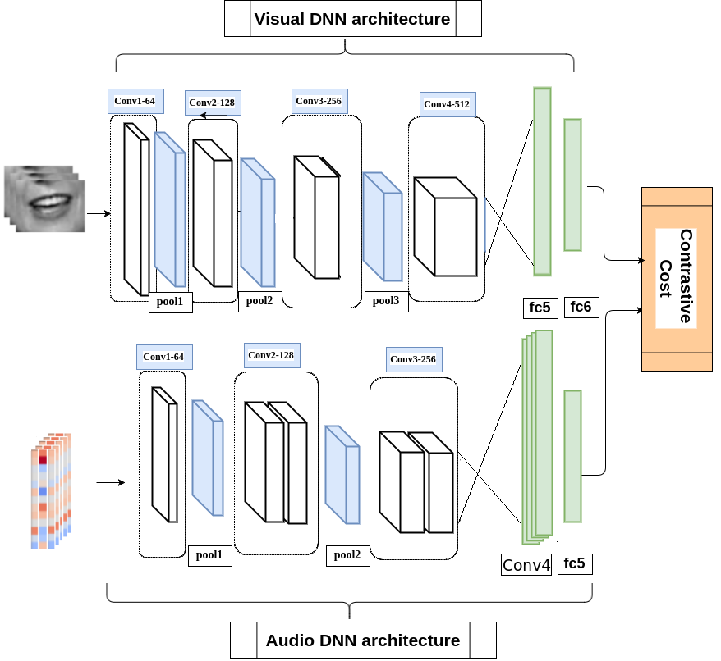

**Figure 1: an architectural overview**

# 5.0 Discussion

The dissolution of a couple can be found in the results presented above. Above all, by placing a check from N1, we are looking at our little mental system that produces 8.5% unparalleled advances over the VGG-M design. Besides, the application of 3Dimension (A2) rather than 2Dimension (A1) promotes 5.0% unparalleled development, underscoring the need to display temporal components of the oral field in the foreground. By comparing A 2 and A 3 we see that ResNet achieves 4.9% better performance when compared to 3 DNNs with parameters that are the same.

Alternatively, when applying just one-layer Bi-LSTM (A 4) in contrast to the back-to-back endpoint, a full-scale development is achieved, highlighting the outstanding power of LSTMs in the expression of group interactions. Besides, the use of two-layer-LSTMs (A 5) provides almost complete development. The results illustrate the importance of the entire approach to getting ready for high precision.

Table 5 has the major persistent faults committed by our best-fit framework (A 6). We note that most word sets tend to come close to their phonetic and "error" content. A note is a highlight that particles have precision by moving before and through words, as they are extracted from constant expression.

|  |  |  |
| --- | --- | --- |
| Target Word | Decision | Error Rate (%) |
| SEND | SPENT | 20 |
| DIFFERENT | DIFFERENCE | 14 |
| MOULD | MILD | 18 |
| ACHIEVER | ACHIEVED | 18 |
| CONTRACT | CONTRACTOR | 14 |
| EXCEPT | EXEMPT | 14 |

The results and graphical impressions display the effects of the method to be used on the accuracy and speed of delivery.

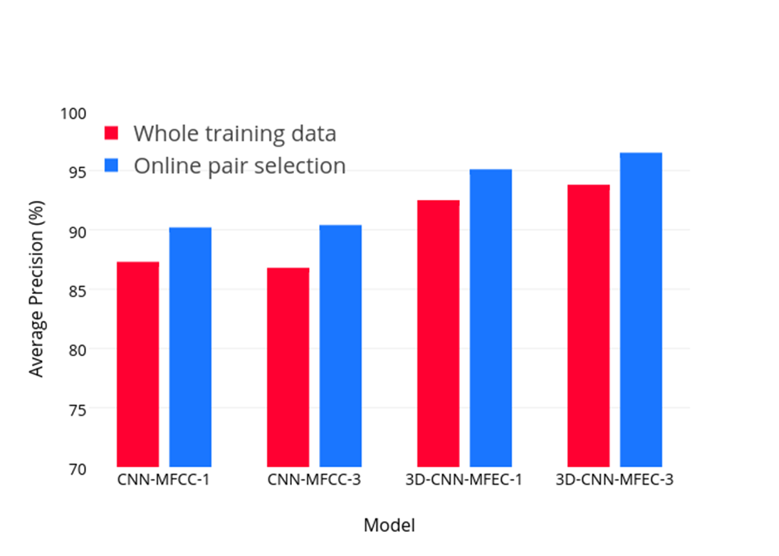

# 6.0 Conclusion

A proposal was made whereby we recommend a spatiotemporal colossal demonstrating structure for word-level visual talk affirmation. We chose to inquire about various lanes concerning the LRW database, since it joins diverse captivating qualities, for instance, colossal size (∼500K cuts), and high flimsiness in speakers, act, and enlightening. We investigated a few framework conﬁgurations, and we showed the centrality of each building square of the structure relatively as the augmentation in execution accomplished by techniques for setting up the structure beyond what many would consider possible. The suggested arrangement produced 83.0% work precision, this identifies with less than a tremendous area of the goof pace of the measure VGG-M structure and 6.8% rigid progression over the top-level 76.2% exactness, accomplished by an attentional encoder-decoder sort.

# 7.0 Reference

1. “EMOTION, PERSONALITY AND CULTURAL ASPECTS IN CROWDS: towards a Geometrical Mind.” *EMOTION, PERSONALITY AND CULTURAL ASPECTS IN CROWDS: towards a Geometrical Mind*, by RODOLFO MIGON. FAVARETTO, SPRINGER, 2019.
2. Bregler, Christoph, and Yochai Konig. *"Eigenlips" for Robust Speech Recognition*. II, International Computer Science Institute, 1994.
3. Goecke R, et al. “Automatic Extraction of Lip Feature Points.” Monash University - Conference Management Office, *ACRA 2000: Proceedings of the Australian Conference on Robotics and Automation, August 30 - September 1, 2000, Melbourne Convention Centre, Melbourne, Australia*, 2000, pp. 31–36.
4. J, Hazen T, et al. “ A Segment-Based Audio-Visual Speech Recognizer: Data Collection, Development and Initial Experiments, .” ACM, *Proceedings of the International Conference on Multimodal Interfaces*, 2002, pp. 235–242.
5. Morris C., Koreman j., Sellahewa h., Ehlers j., Jassim s., Allano L., & Garcia-salicetti s. (2006). The SecurePhone PDA Database, Experimental Protocol and Automatic Test *Procedure for Multimodal User Authentication, technical report*, Secure-Phone (1EC IST-2002-506883) project, Version 2.1.
6. Satapathy, Suresh Chandra., et al. *Information Systems Design and Intelligent Applications Proceedings of Third International Conference INDIA 2016, Volume 2*. Springer India, 2016.
7. Taniguchi, Sagheer Tsuruta, and R. I. & Maeda. “Appearance Feature Extraction versus Image Transform-Based Approach for Visual Speech Recognition.” *International Conference on Computational Intelligence and Multimedia Applications (ICCIMA 2007)*, vol. 6, 2006, pp. 101–122., doi:10.1109/iccima.2007.401.