**Effects of Workplace Learning on Young Teachers’ Professional identity in Henan Province, China**

*Zhijuan He*M.Ed in Educational Management (International Program)  
Department of Education, Faculty of Social Sciences and Humanities, Mahidol University   
E-mail: h809907847@gmail.com

*Poschanan Niramitchainont, Ph.D.*Associate Professor, Educational Management (International Program) Department of Education, Faculty of Social Sciences and Humanities, Mahidol University   
E-mail:poschanann@gmail.com

**Abstract**

The purposes of this study were to explore the current situation of teachers' professional identity and workplace learning, the correlation between teachers' professional identity and workplace learning, and the effective factors of workplace learning on young teachers' professional identity. The questionnaire collected data from 424 teachers in public schools in Henan between August and September 2019 with Cronbach's alpha-coefficient and Item-objective congruence (IOC). The reliability of teacher professional identity and workplace learning questionnaires were 0.957 and 0.949, respectively, and the validity of questionnaires was above 0.67, indicating that the validity of the two questionnaires was acceptable.

The results showed that the current status of teacher professional identity is high level and the workplace learning was above average. There is a positive correlation between teacher professional identity and workplace learning.  
The findings from this study gave us more understanding of the correlation between professional identity and workplace learning and the lack of teachers’ professional 1identity and workplace learning. This outcome could lead to the review and development of improvements to existing levels of teacher professional identity and workplace learning, and the planning and development of appropriate human resource policies and implementation to promote better workplace environments. However, other aspects of this relationship should be studied further in order to improve teachers’ professional identity.

*Key words: Young Teacher, Professional Identity, Workplace Learning, Public schools.*

**1. Introduction**

Young teachers are the driving force in education, so they are always in the spotlight in the world. Compared with teachers of other ages, young teachers are more likely to get tired of their jobs, job burnout and even resign or change job due to various external influences .The turnover rates of teachers are highest in the age range between 20-40 [1].

It is generally believed that the professional identity of teachers is a very important factor influencing teacher turnover. Professional identity of teachers is correlated with job involvement, job satisfaction, organizational identity, work pressure, resignation intention, etc. Corresponding with the life-long learning theory or adult learning, the most significant way to improve the professional identity of teachers who work in school is to take advantage of the workplace. Workplace learning is considered as a key process to develop employees' professional skills and knowledge, solve organizational problems and adapt to organizational changes[2]. That’s why the workplace learning become more and more popular in the world, which is main approach for adults improve themselves after they starting their career [3]. Comparing with the traditional methods of training programs, workplace learning is more economical in terms of human, material and financial resources.

What’s more, faced with the fact that China is the most populous country, in order to ensure that the Chinese students can learn in schools, the government has issued many policies to train a large number of teachers and build schools during the beginning of 21st century. But nowadays, the government and society are all emphasise students can learn in the good quality of schools1 rather than the students can learn in schools. Teachers are the key factor in determining the quality of education. The quality of teachers' teaching depends not only influenced by their professional knowledge or teaching skills, but also the professional ethics, teachers' professional attitudes and emotions. So, improving teacher professional identity became an essential factor for successful education.

The teacher education reform and the teacher professionalization wave put forward higher requirements for the teacher professional identity. In the process of personal growth and professional development, teachers should not only meet the traditional concept of learning requirements for teachers, but also need to update learning concepts and learning ideas. Through active and independent learning, teachers constantly update their knowledge structure to achieve self-transcendence and development[4]. Therefore, it is necessary for this study to assess the level of teacher professional identity and workplace learning, as well as to explore the correlation between teacher professional identity and workplace learning.

At present, there is no relevant research on the level of workplace learning and teacher professional identity of young teachers in public primary and secondary schools in Henan province. There is also no relevant research on the correlation of workplace learning and professional identity of young teachers. What is the relationship between workplace learning and professional identity of young teachers in China, and what is the impact of workplace learning on professional identity of young teachers, are still issues for us to find and explore. This research aims to discover the current situation of workplace learning and professional identity of young teachers, and correlation between teacher professional identity and workplace learning, and to investigate the effect of workplace learning on teacher professional identity. Thereby, providing theorical references about improving teacher professional identity and the different methods of workplace learning, as well as to help teachers in young to develop themselves and so on.

***1.1 Research Objectives***

1. 1)  To study the level of workplace learning and teacher professional identity of young teachers in public school in China;
2. 2)  To explore the relationship between workplace learning and professional identity of young teachers in China;
3. 3)  To investigate the effect of workplace learning on teacher professional identity of young teachers in public school in China;

***1.2 Conceptual Framework***

In this study, the current status of young teacher professional identity and workplace leaning will be studied, as well as the correlation of workplace learning and teacher professional identity for young teachers.  
Therefore, there are two variables, which include dependent variable and independent variable. As for the aim of this research is to investigate the effect of workplace learning on teachers professional identity, the dependent variable is teacher professional identity, while the independent variable.

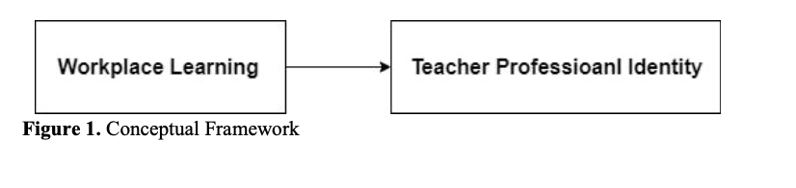

**2. Literature Review**

***2.1 Teacher professional identity***

Teacher professional identity is about whether the teachers have confidence to defeat all the challenges they faced in their teaching career; how teachers view their job and their career; whether the teachers feel they are one of the teachers’ group and whether they belong to the workplace they are in[5]. The answers of these questions are the source of teachers' deep acceptance and love of their work, an internal power that supports teachers to keep moving forward and face challenges with confidence. Teachers’ professional identity is a continuous constructed procedure or a changeable state of teachers view of their profession, and it is also shaped by the personal factors and the social context. Thereinto, the personal factors include self-learning, personal achievement and so on; and the social context include the leadership methods, family factors, and expectations etc.

There are many factors divided external and internal aspects effected teacher professional identity and have been investigated and identified by researchers. Johnson[6] contributed that the factors include cultural background, contextual factors, attitudes, motivations influence teacher professional identity.

Workplace learning includes the most important part of the self-development of adults[7] Adult learning is focus on the group of adults, which is different with other age stages. Workplace learning is adults develop themselves in their workplace. In this part, the definition, concept and the popular theories will be shown.

***2.2 Workplace learning***

Workplace learning includes the most important part of the self-development of adults[8]. Adult learning is focus on the group of adults, which is different with other age stages. Workplace learning is adults develop themselves in their workplace. Collin[9] notes, learning is seen as a natural aspect of everyday work, and work itself is seen as a rich source of learning. Not only does the workplace learning equips adults with skills that they need to be productive in the worksite, it also has multiple wider benefits for health, working life, and socialization.

Even there are various concepts of workplace learning, but most of researchers are strongly agreeing with the workplace learning is a process of studying in worksite with mindful reflections and experiences sharing between workers to realise their personal and organizational goals [10]; Two domains are included are: Studying in the worksite, personal and organizational goals.

***2.3 Related research***

There are some researches to study the effect of workplace learning on teacher professional identity. The scholars mostly focus on the exact workplace-learning methods, like mentoring, training, coaching and other systems in workplace to improve teacher professional identity and solve a series of problems according the causes and concrete phenomenon of low teacher professional identity.

1) Leeferink, Koopman, Beijaard & Schellings[11] reports on teachers' learning in the workplace is the result of the interaction between the personal and professional aspects of becoming a teacher.

2)  David & Anna[12] explored that there is not only the advantages of mentoring relationship, but also reflects its important responsibilities, which cannot be separated from the negative impact of mentoring relationship on the construction of teachers' professional identity.

3)  Anne & Andrew[13] found that establishing clear goals, a commitment to the teaching and mentoring process, had positive short-term and long-term effects on teaching practice. Through conscious engagement and opportunities to connect with like-minded colleagues, professional identity is strengthened and confidence and responsibility are restored.

4) Ma[14] proves the teacher self-development and self-study can improve the teachers’ professional identity. And the teacher professional identity also has a significant effect on teachers’ self-study.

**3. Research Methodology**

***3.1 Research Design***

This research uses quantitative method to investigate the current status of teacher professional identity and workplace learning for young teachers, as well as the correlation between teacher professional identity and workplace learning. The data collected with the two questionnaires, teacher professional identity questionnaire and workplace learning questionnaire from primary and secondary school teachers in Henan public schools.

***3.2 Population & Sample***

The research investigated the workplace learning and teacher professional identity in rural and urban areas. The research used simple Quota sampling methods to select more than 384 teachers in public schools in Henan, China.  
Considering the possible inefficiency of questionnaire survey, this study investigated 424 primary and junior high school teachers through simple random sampling. So, there were nearly equal amounts of teachers in a rural and urban area. 218 teachers and 206 teachers were chosen in rural and urban areas by Quota sampling separately.

***3.3 Research Instrument***

Questionnaire will be used in this research to collect data from more than 400 teachers in public school in Henan province from urban and rural equally. The questionnaire includes three parts: personal information, the questionnaire of workplace learning and questionnaire of teacher professional identity.In this study, the Cronbach’s Alpha Value of questionnaires is from 0.957 and 0.949. And the lowest value 0.949 >0.7, so the reliability questionnaire in this research is acceptable.

***3.4 Data collection***

The survey was conducted in the month of September 2019 through printed questionnaires on three aspects of teachers’ professional identity and five dimensions of workplace learning. The researcher conducted the survey by visiting the schools without interfering the normal teaching hours of the teachers.

**4 Data Analysis and Results**

The descriptive statistics of workplace learning and teacher professional identity were analyzed using mean and standard deviation. The significance of relationship between workplace learning and teacher professional identity was analyzed using Pearson’s correlation. The effect of workplace learning on teacher professional identity of young teachers in public school in China. was analyzed using simple regression analysis.

***4.1 Presentations of teacher professional identity by categories***

The table 4.1 indicated the overall level of teachers’ professional identity through statistical analysis based on mean and standard deviation as below:

**Table 4.1 The overall level of teacher professional identity**

**(n=424)**

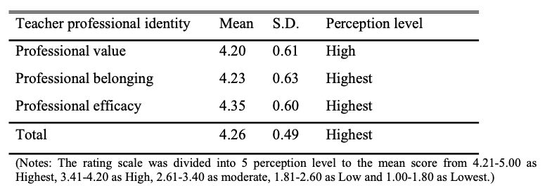

The overall perception level of teacher professional identity is Highest level and the average score is 4.26. Thereinto, the perception level of the professional efficacy is Highest level with 4.35 points, which is highest score in three components. The levels of professional belonging and value are very consistent, 4.23 and 4.20 respectively. The perception level of professional belonging is Strongly Agree and professional value is High level.

***4.2 Presentations of workplace learning by categories***

The table 4.2 showed the overall level of workplace learning with five components through statistical analysis based on mean and standard deviation as below:

**Table 4.2 The overall level of workplace learning**

**(n=424)**

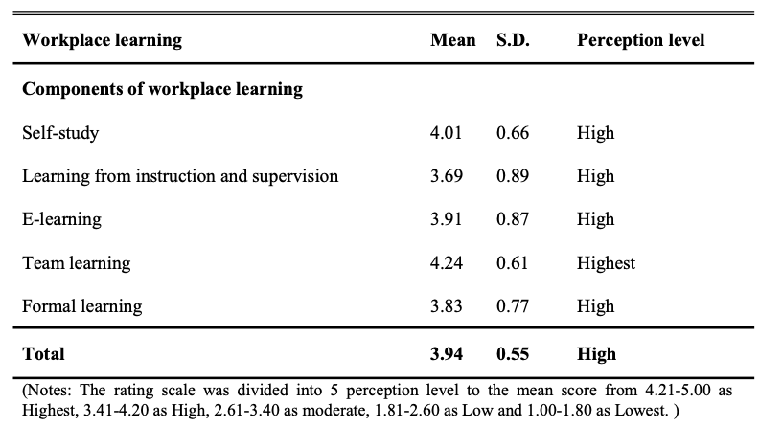

According the table 4.6 the overall level of workplace learning, we can know that the overall perception level of workplace learning is High level and the average score is 3.94. Thereinto, the perception level of the Team learning is Highest level with 4.24 points, which is highest score in three components. The levels of Learning from instruction and supervision is lowest score as 3.69 with Agree level. Formal learning and E-learning are very consistent, 3.83 and 3.91 respectively. The perception level of Self-study is high level with 4.01 points.

***4.3 Relationship between Workplace Learning and Teacher Professional Identity***

Pearson correlation analysis was used to determine whether there was a correlation between Workplace learning variable and Teacher professional identity variable.

**Table 4.3 Relationship between Workplace Learning and Teacher Professional Identity**

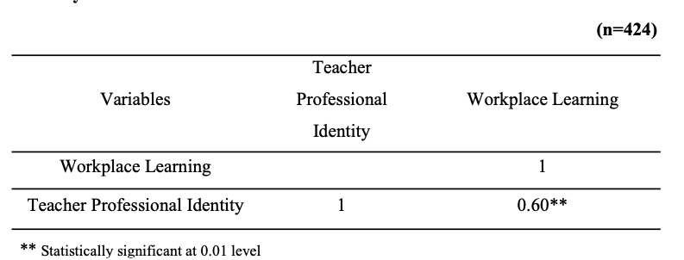

As we can see from the above table, the variables in this study have positive correlation between the five elements of workplace learning and teacher professional identity. The results show that there is a strongly positive correlation between workplace learning and teacher professional identity with the statistically significant at the 0.00 level (r =.60), which indicates that when the level of workplace learning increases, the level of teacher professional identity also increases.

***4.4. The predictive factors for teacher professional identity***

This part predicts that the workplace learning can impact the levels of teacher professional identity in primary and secondary public schools in Henan province.  
The table 4.4 showed the results as below:

**Table 4.4 Predictive factors of teacher professional**

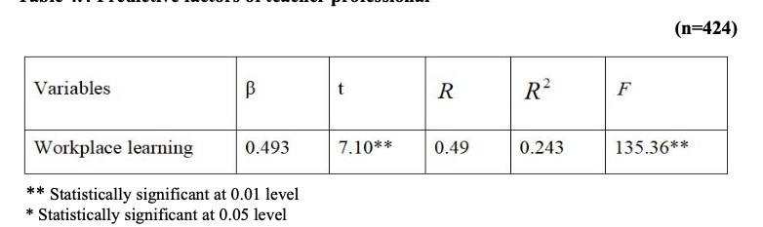

Table 4.13 shows that there is a positive correlation between workplace learning and teacher professional identity. Therein fore, workplace learning effect on teacher professional identity with statistically significant at 0.012 level (β = 0.493). workplace learning could predict 24.3% of teacher professional identity with statistically significant at 0.001 level  
**5 Discussions**

***5.1 Research Objective 1: To study the level of teacher professional identity and workplace learning among primary and secondary school teachers in Henan province, China***It is found that the overall perception level of teacher professional identity is strongly agree with the average score is 4.26, which means teacher professional identity presents a high level on the whole. This result is similar with many researchers. Pang[15], Wei[16] and Li[17]also found that teachers in primary and secondary schools have a higher professional identity through their own researches. There into, the perception level of the professional efficacy is Strongly Agree with 4.35 points, which is higher than the average score. The levels of professional belonging and value are below of average score with 4.23 and 4.20 respectively. The perception level of professional belonging is Strongly Agree and professional value is Agree. Fang[18] identified the the perception level of teacher professional value is lower than

other components of professional identity, which set teachers teaching in university as research samples. In this study, the perception level of teacher professional belonging with 4.23 is lower than teacher professional efficacy with 4.35. Coincidentally, there are some scholars give the same research results with this study. Wang & Xie[19] investigated the teachers in preschool and discovered that the overall of professional identity is in high level. Furthermore, teacher professional belonging is lower than professional efficacy and teacher professional value,which is similar with the result in this study.

The overall perception level of workplace learning is Agree and the average score is 3.94. Thereinto, the perception level of the Team learning is Strongly Agree with 4.24 points, which is highest score in three components. The levels of Learning from instruction and supervision is lowest score as 3.69 with Agree level. Formal learning and E-learning are very consistent, 3.83 and 3.91 respectively. The perception level of Self-study is Agree with 4.01 points. The reason why Team Learning have highly perception level is the regulations of the Ministry of Education. In China, the teachers' teaching and research group activity is such a school-based collective teaching cooperation activity, and it has a history of nearly twenty years[20]. The school organizes teachers to carry out collective activities on a regular basis, to prepare lessons together, attend lectures, and evaluate classes, and to unify the teaching schedule and plan, as well as to discuss problems and puzzles encountered in practice around teaching. Teachers are no longer only rely on themselves for professional development, but communicate, in which they can discuss and learn from each other with their colleagues. It can be said that it is an important base for the school to promote the professional development of teachers, as well as the main organizational form of teachers' cooperation[21].Refer to Learn from Instruction and Supervision, there is lowest identity. The management of the teaching and research group is limited to textual supervision with little substantive process management. It would be easy to treat assessment as a superficial form, and the activity itself would be useless[22].

***5.2 Research Objective 2: To explore Correlation between professional identity and workplace learning as perceived by primary and secondary school teachers in Henan province, China***There are some scholars identified someway to improve teacher professional identity as followed: Wang[23] identified that mentoring and team learning are useful to teachers professional development in Shanghai. David & Anna and Izadinia[24] also support the view of Wang[25] that "mentoring relationships" can help improve teachers' professional identity, but they prove that a bad mentoring relationship can have a negative impact on teachers' professional identity. in the research of Hong & LV[26], they suggested that to using team-study to improve professional belonging. Sardabi, Biria& Golestan[27] improved formal learning is useful to improve teacher professional identity. Ma[28] mentioned the way to improve teacher professional identity is Self-study, which is positively correlated with professional identity. Leeferink, Koopman, Beijaard & Schellings[29] detailed that the most important factor to effect teacher professional development is Internal personal reasons. Therefore, self-study is a good way to improve themselves.

***5.3 The predictive factors for teacher professional identity***

There is a positive correlation between teacher professional identity and workplace learning among public primary and junior high school teachers in Henan province. The workplace learning is a predictor that influence teacher professional identity highest (β=0.493). workplace learning can predict 24.3% of teacher professional identity with the statistically significant at the 0.012 level.

**6. Conclusion**

The present situation of the public primary and secondary school teachers in Henan province is high level but with only 4.26, which is nearly drop down to the ‘Agree’ level. Especially, Teacher professional belonging got only 4.23, which is lower than average mean. In addition to professional value, all components of teachers' professional identity are of high level, and only the level of the "Agree" perception. Additionally, the level of workplace learning is still

not positive. There is a positive relationship between teacher professional identity and workplace learning.  
**7.Recommendations**

***7.1Recommendation for School Principals***

1) School principals should encourage teachers’ own development more, involve teachers in school rules making and decision-making discussions, not just conclusions. Lead teachers to know their role in the school is important.  
2) School principals need to define the professional roles and responsibilities of teachers and mentors, to set up an evaluation system for the work of the supervisor or project leader based on there is no exact evaluation system for them to assessment, and to build the reward and punishment measures.

3) School principals should provide the learning climate that support teachers to work as a team, provide some learning material such as e-learning package, textbooks or effective internet signal that teacher can use to enhance their teaching knowledge by themselves, and school principal should also assign the mentor for young teacher to supervise their teaching and learning skill, and also support them during the first or second year of working.

***7.2Recommendation for Ministry of Education in Henan province***

1) Ministry of Education should pay more attention to the impact of curriculum reform on teachers than to the results brought by students. The series of training and guidance should be provided to schools and teachers by Ministry of Education at the same time of curriculum reform, instead of just setting curriculum goals for teachers to implement.

2) Ministry of Education should take various measures and attach importance to external rewards such as teachers' salary and social respect.  
3) Ministry of Education should advocate schools cooperate with other schools, as for teacher has the opportunity to participate in cooperation and communication with other organizations, schools, or colleagues. Mobilize excellent mentors to support teachers’ Self-study. Establish self - learning evaluation system and reward teachers who participate in self-improvement to motivate teachers’ self-study.

**8.8 Acknowledgement**

First and foremost, I would like to express my deepest appreciation and sincere gratitude to my major advisor Associate Professor Dr. Poschanan Niramitchainont who was always with me for continuous support with her immense knowledge,patience, and motivation during the journey of my research work. Her resourceful contribution and timely guidance had given me lots of strengths in shaping this thesis into a final form. Besides my advisor, I would also like to genuinely thank my co-advisors: Lect. Dr. Sovaritthon Chanseangsee, Lect. Dr. Panchit Longpradit for their encouragement, comments and valuable suggestions which helped me in improving my thesis.

Thanks to the professors who have given me selfless help in the past two years, I can see the vast ocean. I want to thank my classmates who have given me care and support in my life. Although we come from different countries, you make me feel the warmth of home. With you, college life is colorful. I would like to thank Mahidol university for providing me with the top educational resources in Thailand, allowing me to experience different ways abroad, giving me a rational perspective on the world, and giving me a delicate perception to experience every true feeling. I sincerely wish my mentors, professors, friends and Mahidol university can become a world-class university in the 21st century.

**9 Reference**

[1]Xu. (2010). Study on the Flow of Preschool Teachers in Wuhan. .Central China Normal University,  
[2]Clarke, N. (2005). Workplace Learning Environment and its Relationship with Learning Outcomes in Healthcare Organizations. Human Resource Development International   
[3]Billett. (2002). Critiquing workplace learning discourses: Participation and continuity at work. Studies in the Education of Adults, pp. 56–67.   
[4]Zhang, K. (2008, 11). Research on the status and promotion methods of vocational identity of secondary vocational teachers in nanchang. Research on vocational education, pp. 73-74. [5]Li, x., & Yan, b. (2018). Model construction and scale establishment of teachers' professional identity. department of education, east China normal university, Shanghai 200062, China.

[6]Johnson, K. (2003). “Every experience is a moving force”: Identity and growth through. Teaching and Teacher Education, pp. 19(8), 787–800. .  
[7]Boud , D., & Middleton, H. (2003). Learning from others at work:communities of practice and informal learning. Journal of workplace learning, pp. 194-202.

[8]Boud , D., & Middleton, H. (2003). Learning from others at work:communities of practice and informal learning. Journal of workplace learning, pp. 194-202.  
[9]Collin, Kaija. (2002). Conceptions of Learning at Work. Studies in Continuing Education. Development Engineers'

[10] Marsick, V. (1987). Learning in the Workplace. Croom Helm, London.  
[11]Leeferink, H., Koopman, M., Beijaard, D., & Schellings, G. L. (2019). Overarching professional identity themes in student teacher workplace learning (2019). complementary Index.  
[12]David, C., & Anna, G. (2017). The role of mentoring in early career physics teachers’ professional identity construction. International Journal of Mentoring and Coaching in Education, 2017, Vol. 6, Issue 2, pp. 128-142.  
[13]Anne H, S., & Andrew P, D. (2018). Mentoring and professional identity formation for teaching stream faculty : A case study of a university Peer-to-Peer mentorship programInternational. Journal of Mentoring and Coaching in Education, 2018, Vol. 7, Issue 4, [14]Ma, t. (2016). Research on the status quo of middle school teachers' professional identity and its influencing factors. Yunnan normal university.  
[15]Pang Qian. (2012). Analysis on the relationship between professional identity and turnover intention of rural education masters. [J]; University (academic edition); 11, 2012..  
[16]Wei, s. (2008). Research on teachers' professional identity. Doctoral dissertation of southwest university.2008.11.  
[17]Liu, G. (2017, 5). Research on the present situation of lifelong learning for teachers of basic education. College of vocational and education, central China normal university. [18]Fang, m. j. (2007). Investigation and analysis on the status quo of professional identity of university teachers in China. Higher education research .  
[19]Wang, q., & Xie, l. (2019). Investigation on the status quo of professional identity of preschool teachers in demonstration kindergartens -- a case study of jiangmen city. Jiangmen vocational and technical college;.  
[20]CPC, c. c. (1999). Decision of the central committee of the communist party of China and the state council on deepening educational reform and comprehensively promoting quality-oriented education promulgated.  
[21]Xu. (2010). Study on the Flow of Preschool Teachers in Wuhan. .Central China Normal University,  
[22]Jiang, X. (2004). Current situation analysis and countermeasures of teaching and research groups in primary and secondary schools;. Teaching and management.  
[23]Wang, w. (2013). Strategies for promoting professional identity of young teachers in universities and colleges. Education exploration.  
[24]Izadinia, M. (2015). A closer look at the role of mentor teachers in shaping preservice teachers' professional identity . In Teaching and Teacher Education November 2015 52:1-10. [25]Wang, w. (2013). Strategies for promoting professional identity of young teachers in universities and colleges. Education exploration.  
[26]Hong, M., & LV, S. (2016). Organizational identity and professional identity of primary and secondary school teachers and their relations. School of Education Sciences,Lingnan Normal University;School of Education Sciences ,Guizhou Normal University;.   
[27]Sardabi, N., Biria, R., & Golestan, A. A. (2018). Reshaping Teacher Professional Identity through Critical Pedagogy-Informed Teacher Education. International Journal of Instruction, v11 n3 p617-634 Jul 2018. 18 pp.  
[28]Ma, t. (2016). Research on the status quo of middle school teachers' professional identity and its influencing factors. Yunnan normal university.

[29]Leeferink, H., Koopman, M., Beijaard, D., & Schellings, G. L. (2019). Overarching professional identity themes in student teacher workplace learning (2019). complementary Index.