**A Design Prototype of International Student Application System in Japanese Universities**

Reiko Sato and Panchit Longpradit*

Department of Education, Faculty of Social Science and Humanities, Mahidol University, Nakorn Pathom, Thailand

*Corresponding author, E-mail: panchit.lon@mahidol.ac.th

**Abstract**

The purposes of this research were to 1) investigate the practice of the current international student application system in Japanese universities at bachelor level, 2) propose a design prototype of an international student application system, and 3) evaluate expert and student satisfaction of the design prototype. Research methodologies adopted were a gap analysis of qualitative research design for the investigation of the current practices, system development as a research method for designing a model and prototype, and a quantitative research design by means of questionnaires for expert and student evaluation. Data analysis was carried out using descriptive statistics.

The research results are that firstly the investigation of the top 5 Japanese universities with the highest number of international student acceptances revealed that although some of Japanese universities have introduced online application, only one university allowed the applicants to finish all application processes online. Secondly, the information system development resulted in a concept design, construction of the system architecture and prototyping using Prott application. Based on the ideal application model of information system development, there were 8 processes for the application and admission process, applicant registration, all users log in, completion of application form, staff document screening, applicant interviews, decision making by program administrator, staff contacting applicants, and administrator data management. Thirdly, the expert review and international students expressed a positive satisfaction toward the design prototype in terms of timeliness, reliability, access, adequacy and ease of use. Paper-based application systems are inconvenient and present difficulties for both applicants and staff. Hence, it can be concluded that the proposed design prototype could form the foundations for attracting more international applicants while reducing the burden on university staff.

**Keywords:** International student application, application system, admission system

**1. Introduction**

The international student total population reached 4.5 million (OECD, 2014) and international student policy is considered important in many countries politic and economic strategies. Organization for Economic Co-operation and Development (OECD) expects that the world higher education market will expand to 262 million and among that number, worldwide international student population will be 8 million by 2025 (OECD, 2014).

The Japanese government is trying to increase international students, who have student visa, in Japanese universities. In 2008, the Japanese government announced the “300,000 International Students Plan", in which Japan hopes to accept at least 300 thousand foreign students a year by 2020 (Ministry of Education, Culture, Sports, Science and Technology, 2008). Today, Japanese universities are accepting a great number of international students and the number of Japanese university students attending foreign universities is getting larger. Consequently, the workload of Japanese universities, with regard to checking applicant eligibility and validation of entry qualifications is increasing, this places a high demand for Japanese higher education to examine and recognize foreign education qualifications or credits of international applicants. The preference of Japanese universities for paper-based and handwritten application documents from international students is costly for the applicant in terms of delivery and costly for the university staff in digitising these documents. The paper based application system can be a deterrent to international students. Improving accessibility, for example, introducing online application, credit card payment, conducting only document screening without students coming to the university to take interview or paper test, improves the number students accepted (Horiuchi, 2018). IT can improve the applicant’s experience in the university application process and help university staff work efficiently. To introduce IT into the university application process, information system development is necessary. Information system development as a research method involves 5 stages, namely concept design, construction of the system architecture, prototyping, product development and technology transfer (Hasan, 2003).

The purposes of this research were therefore to find the current practices of international student acceptance to universities and from this finding a universal model will be proposed, the model will be then implemented to a design prototype of the application system, and it will finally be evaluated by experts and international students. This study will inform the policy makers about current international student application and acceptance system problems and help to make students move between Japanese education and foreign education more smoothly and at the same time maintain the quality of higher education in Japan while still accepting many more foreign students. In addition, the online application system will help humans (applicants, university staff, and administrators) stay inclusive and work more conveniently and efficiently.

There are two variables involving in this study, the use of design prototype and satisfaction. The design prototype was created based on the result of the objective 1. Regarding satisfaction in this research, it is based on the study of Debons, Ramage, & Orien (1978). There were originally nine dimensions suggested in their system evaluation; however, only 4 criteria were adopted for this prototype evaluation, namely timeliness, reliability, access and adequacy. In addition, the criterion ‘ease of use’ was added as the fifth dimension because ‘ease of use’ is one of valuables which is used in various studies related measuring satisfaction (Amin, Rezaei, & Abolghasemi, 2014; Kim & Lee, 2014; Su Mei et al. 2013). Figure 1.1. shows the conceptual framework of this study.

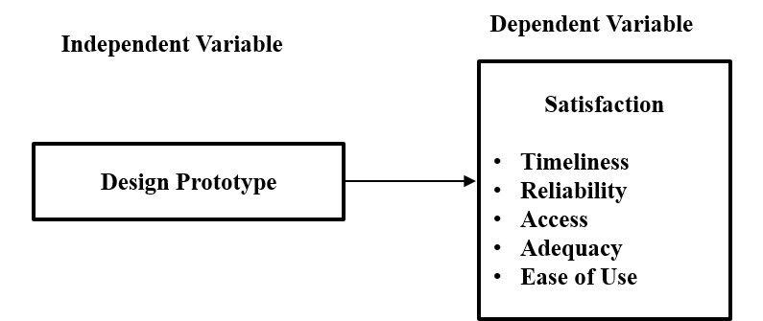

**Figure 1** Conceptual Framework

**2. Objectives** The research objectives are as follows:

2.1 To investigate the current practice of international student application system in Japanese universities at bachelor level.

2.2 To propose a design prototype of international student application system.

2.3 To evaluate the satisfaction toward the proposed design prototype of international student application system by means of expert and international student reviews.

**3. Methods**

This section describes the research instruments and participants employed in this research.

3.1 Research Instruments

There are three research instruments in this study. The first research instrument was a design prototype of international student application system, created based on the proposed model resulting from a gap analysis of literature about international student application system and international application websites of the top 5 Japanese universities accepting international student numbers in 2018 (the result of research objective 1). The prototype was developed and served three distinct groups of users, applicants, university staff, and administrators, by using Prott Web application (<https://prottapp.com/ja/>). An example of screenshot of the design prototype was shown in Figure 2.

The second research instrument was an expert evaluation questionnaire that was originally created for this research. The questionnaire was designed and verified by means of Index of Item Objective Congruence (IOC) by the three educational experts, in order to be used for the study of satisfaction towards the proposed design prototype of international student application system in five dimensions: Timeliness, Reliability, Access, Adequacy and Ease of use. The questionnaire consisted of twenty-five questions altogether, each criterion comprised five questions, plus a question regarding the overall satisfaction of the proposed design prototype. Responses were coded in terms of level of satisfaction as 1(highly dissatisfied), 2(dissatisfied), 3(moderate), 4(satisfied), and 5 (highly satisfied) on a Likert scale. Interpretation of measurement of 5-point Likert scale are that 1.00 to 1.80 is inferred as lowest, 1.81 to 2.60 is read as low, 2.61 to 3.40 is read as moderate, 3.41 to 4.20 is inferred as high, and 4.21 to 5.00 is taken as highest (Best, 1981).

Finally, the third research instrument was a student evaluation questionnaire. Like the expert evaluation questionnaire, the questionnaire with IOC validity consisted of 25 questions, and an additional question about the overall satisfaction. The differences between the expert and student questionnaires are that the expert questionnaire focuses on the whole system processes and in particular the three groups of users, namely applicants, university staff and administrators, whereas the student questionnaire merely emphasises the application process and the applicant user. In addition, there are two questions added in the student questionnaire requiring the applicants to answer, one is to choose if they are an international student in a 3-6 year bachelor programme, and another is to specify their nationality.

**Figure 2** Design Prototype of Top Page

3.2 Participants

Participants in this study were the following. First, 10 experts with experiences as a university staff working in international student registrar office and in IT field over 3 years, were purposively selected. Second, 25 international students who is or was studying in a 3-6 year bachelor programme in a different from their own country were randomly selected.

**4. Results and Discussion**

The results of the three objectives are as follows.

4.1 Based on the gap analysis of the literature reviews, website visits and informal interviews performed, the results of the investigation on the current practice of international student application system at bachelor level of the top 5 universities in terms of international acceptance number in Japan, namely Waseda University, Tokyo University of Social Welfare, the University of Tokyo, Japan University of Economics, and Ritsumeikan Asia Pacific University, revealed that although the studied universities have introduced the online application system, only one university (Ritsumeikan Asia Pacific) in this study allowed the applicants to finish all application process online. Other 2 universities (Waseda University and the University of Tokyo) introduced partial online application system. Although applicants are allowed to input personal information on their application website, applicants still need to submit printed paper application forms and other documents by post. From this finding, an application system model was proposed by means of referring gap between ideal list and the current systems, as shown in Figure 3

**Figure 3** The ideal application system summary flowchart

As can be seen in Figure 3, there are 4 processes in the ideal application system: Input data and payment process, showing result, online interview/assessment and checking document authenticity. With the ideal process, the applicants can finish all application process online. University staff do not need to key in data manually from paper application documents. Interview or assessment can be finished online, so universities do not need to prepare interview venues, and applicants do not need to take care of travel fee or visa problems. However, application documents with high risk of forgery, such as high school graduation certificate, academic transcript, English examination score still need to be verified for authenticity. This means that applicants need to submit original documents when they are offered a place at the university, the university and staff can then verify for authenticity. In addition, although staff still need to check the documents authenticity, the number of documents which staff have to validate is much smaller than checking all documents in the traditional application system.

4.2 Based on the gap analysis result in the first objective study and adopting the information system development as a research method (Hasan, 2003), involving 5 stages: concept design, construction of the system architecture, prototyping, product development and technology transfer, the concept design, construction of the architecture of the system, and prototyping were particularly undertaken in this study. Figure 4 illustrates a concept model of this study.

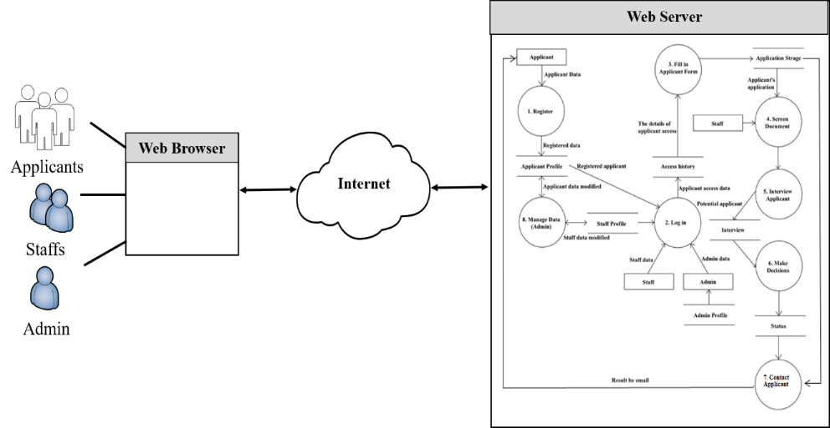

**Figure 4** A conceptual model of international student application system in Japanese Universities

As shown in Figure 4, the proposed system was aimed to serve three different types of users, involving the applicants, staff, and administrator. Based on the Web architecture, all users could get access to the applicant information system via their Web browser, where they would get authenticated using their username and password. The Web server hosts the system and allows the connection between the system and the data storage. From this conceptual model, a Data Flow Diagram as shown in Figure 5 was drawn.

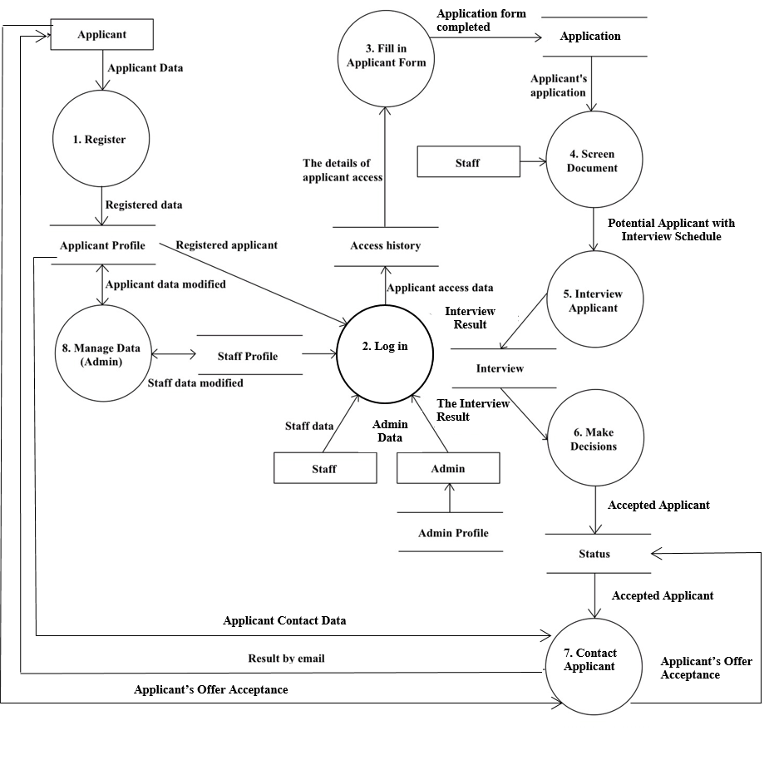

**Figure 5** Data Flow Diagram (DFD) Level 1 of international student application system

30

As exhibited in Figure 5, the processes of international student application involve eight processes, namely Register, Log in, Fill-in application form, Screen document, Interview applicant, Make Decisions, Contact applicant, and Manage data for Administrator, respectively. The details are presented as follows.

**Process 1** Register is a process for applicants to register to the system using their personal data, including username and password, which these data are stored in the Applicant profile storage and the applicants have to use these data to log in to the system.

**Process 2** Log in is a process for all users including applicants, staff and administrator to log into the system using the username and password registered. The three distinctive users have their username and password stored separately in the Applicant profile, Staff profile, and Admin profile, respectively.

**Process 3** Fill in application formis a process for applicants to fill in application form with all required information, including academic history and standardized English test score.

**Process 4** Screen documentis a process intended for staff to check the applicants’ information and documents. If the documents are submitted correctly, the process would continue to Process 5. However, if some of the documents or information are missing, or are incorrectly provided, staff might send messages to applicants by means of Process 7.

**Process 5** Interview applicant is a process aimed at staff to organize a face-to-face meeting with professors and lecturers and choose a potential applicant for a web interview system.

**Process 6** Make Decisions is a decision-making process for staff. Once all applicants have had a web interview, staff will again arrange a meeting with professors and lecturers to make decisions based on applicants’ academic records and interview. The staff will provide a list of accepted applicants visible in the system, and the system offers the functionality for the staff to sort applicants by results of each standardized test result, academic transcript and interview result.

**Process 7** Contact applicant is another process for staff to contact the applicants for any matter, including informing the applicants about the university offer. The university upload results on the application website. Applicants can confirm their result by log in to the application system.

**Process 8** Manage data (for Administrator only) is a process designed for the use of administrator only, who can access to the system and modify applicant and staff data, excluding the username and password. The administrator can only view this sensitive data but cannot manipulate it. In case of forgotten username and password, the administrator can issue a new username or password for the applicants and staff.

From the DFD level 1, a design prototype of international student application system in Japanese Universities was developed in the prototyping stage of Hasan’s model (Hasan, 2003). Figure 6-8 demonstrates some examples of design prototype for applicants, administrators, and university staff, respectively.

|  |  |
| --- | --- |
|  |  |

**Figure 7** Design prototype of managing applicant data for administrator

**Figure 6** Design prototype of applicant’s registration confirmation page

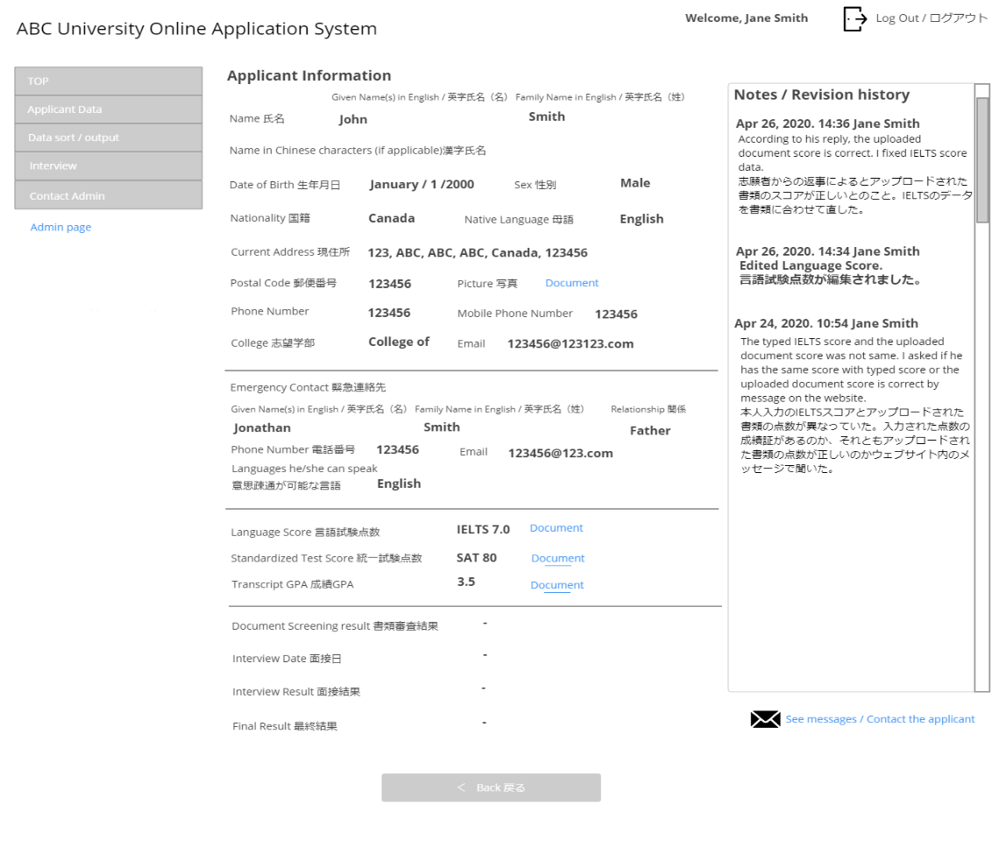

**Figure 8** Design prototype of applicant information for staff

4.3 Regarding the results of the third objective, firstly, the 10 expert evaluation revealed that, overall, the mean score was at a high level of satisfaction (Best, 1981) (=3.95, SD=0.89), meaning that the experts satisfied highly with the design prototype developed. When considering each aspect, it was found that most questions attained the high to highest level of mean scores (Best, 1981). The item receiving the highest mean score was Q21: “Making applications was straightforward” (=4.50, SD=0.53). Similarly, Q12: “This design prototype allowed all the users to access the system functions easily” attained the second highest mean core (=4.40, SD=0.70). On the other hand, Q8: “All types of users were confident in the way the information system was designed.” had the lowest mean score (=3.10, SD=1.10), meaning that this question received the least satisfaction towards the evaluation criteria. However, it was still in the moderate category. Table 1 exhibits the evaluation result from expert reviews.

With regard to the open-ended questions, the expert suggestions include the functionalities assisting the applicants, such as tracking system, instant notification system to inform the applicants about any update on application progress, and multiple-page document uploading; whereas the functionality supporting staff could include the provision of colour annotation of the name list of applicants who have not been contacted by staff regarding their application, so that the names standout and the staff can get back to them in timely fashion, instead of having to browse all the list of applicants.

**Table 1:** Evaluation of the Expert Satisfaction toward the Proposed Design Prototype (n=10)

|  |  |  |  |
| --- | --- | --- | --- |
| **Criteria and Questions** | **Level of Satisfaction** | | |
|  | **SD** | **Meaning** |
| **Timeliness refers to time length in getting needed information or results offered by the design prototype** |  | | |
| Q1. This design prototype reduced the overall time of making application and admission. | 4.20 | 0.92 | High |
| Q2. This design prototype allowed all the tasks performed by the applicants, staffs and  administrator, to be completed more quickly. | 3.70 | 0.95 | High |
| Q3. This design prototype helped the applicants to communicate with university staffs timely. | 3.20 | 0.92 | Moderate |
| Q4. This design prototype reduced or shortened the steps for staffs and applicants to complete the  application and admission processes. | 3.80 | 1.03 | High |
| Q5. This design prototype responded to the choice made by the applicant quickly so it was worth using. | 3.80 | 0.92 | High |
| **Reliability refers to the user confidence and consistence of information provided by the design prototype** |  | | |
| Q6. Each process in the design prototype functioned and met the applicant’s needs. | 4.10 | 0.99 | High |
| Q7. The applicants, staffs and administrator could operate the design prototype and realised its  effectiveness. | 4.00 | 0.94 | High |
| Q8. All types of users were confident in the way the information system was designed. | 3.10 | 1.10 | Moderate |
| Q9. Navigating the design prototype could be made in consistent way. | 4.10 | 0.88 | High |
| Q10. The applicants could be confident in making application. | 3.60 | 0.97 | High |
| **Access refers to ease of retrieving, uploading, sharing and receiving information offered by the design prototype.** |  |  |  |
| Q11. The design prototype was accessible by means of user authentication. | 3.80 | 0.92 | High |
| Q12. This design prototype allowed all the users to access the system functions easily. | 4.40 | 0.70 | Highest |
| Q13. The design prototype was uncomplicated for all types of users to navigate around the system. | 4.10 | 0.88 | High |
| Q14. The users could access the system without seeking helps. | 4.10 | 0.74 | High |

**Table 1:** Evaluation of the Expert Satisfaction toward the Proposed Design Prototype (n=10)(cont.)

|  |  |  |  |
| --- | --- | --- | --- |
| **Criteria and Questions** | **Level of Satisfaction** | | |
|  | **SD** | **Meaning** |
| **Access refers to ease of retrieving, uploading, sharing and receiving information offered by the design prototype. (cont.)** |  |  |  |
| Q15. The prototype was designed in such a way that allowed the applicants to retrieve, upload,  share and receive information. | 4.10 | 0.74 | High |
| **Adequacy refers to fairness of way to do some tasks regarding the application and admission processes with the design prototype.** |  |  |  |
| Q16. The overall design prototype was appropriate. | 4.00 | 0.82 | High |
| Q17. The design prototype was developed with appropriate application and admission acceptance  processes. | 3.80 | 1.03 | High |
| Q18. The design prototype was created with fair application and admission acceptance processes. | 3.80 | 0.63 | High |
| Q19. All stages needed by international student admission process were included in this design  prototype. | 3.70 | 0.82 | High |
| Q20. The processes in the design prototype were of applicant’s requirements. | 4.20 | 0.79 | High |
| **Ease of use refers to convenience or easiness of using and learning how to use the design prototype.** |  |  |  |
| Q21. Making applications was straightforward. | 4.50 | 0.53 | Highest |
| Q22. The design prototype was developed with user friendly interfaces. | 4.10 | 0.74 | High |
| Q23. All the processes related to application and admission acceptance were easy to access and use. | 4.10 | 0.99 | High |
| Q24. The overall design prototype was easy to use. | 4.20 | 0.92 | High |
| Q25. This design prototype allows for more convenient application than when I applied to an  international programme at university. | 4.20 | 0.92 | High |
| Q26. Overall satisfaction toward the design prototype | 4.00 | 0.67 | High |
| **Overall Level of Satisfaction** | **3.95** | **0.89** | High |

Note: 1.00-1.80 = lowest, 1.81-2.60 = low, 2.61-3.40 = moderate, 3.41-4.20 = high, 4.21-5.00 highest (Best, 1981)

Secondly, due to the COVID-19 situation, there was 25 students responded to the questionnaire, instead of 30 responses, and the result revealed that, overall, the mean score was at a highest level of satisfaction (Best, 1981) (=4.32, SD=0.84), meaning that the students satisfied very highly with the design prototype. When considering each aspect, it was found that most questions attained the high to highest level of mean scores (Best, 1981). Like the expert reviews, the item receiving the highest mean score was Q21: “Making applications was straightforward” (=4.80, SD=0.45). This means that the respondents found that the design prototype allowed for the straightforward application making process. Similarly, there were six questions attained the second highest means core (=4.60, SD=0.55), including Q11: “The design prototype was accessible by means of user authentication.”; Q17: “The design prototype was developed with appropriate application and admission acceptance processes.”; Q20: “The processes in the design prototype were of applicant’s requirements.”; Q23: “All the processes related to application and admission acceptance were easy to access and use.”; Q24: “The overall design prototype was easy to use.”; and Q25: “The design prototype allows for more convenient application than when I applied to my international programme at university.”.

On the other hand, Like the expert reviews, Q8: “All types of users were confident in the way the information system was designed.” had the lowest mean score (=3.60, SD=1.14), meaning that students had the least satisfaction toward the design prototype regarding this issue. However, it was still in the high satisfaction category. Table 2 exhibits the student evaluation result.

**Table 2:** Evaluation of the Student Satisfaction toward the Proposed Design Prototype (n=25)

|  |  |  |  |
| --- | --- | --- | --- |
| **Criteria and Questions** | **Level of Satisfaction** | | |
|  | **SD** | **Meaning** |
| **Timeliness refers to time length in getting needed information or results offered by the design prototype** |  | | |
| Q1. This design prototype reduced the overall time of making application and admission. | 4.40 | 0.89 | Highest |
| Q2. This design prototype allowed all the tasks performed by the applicants, staffs and  administrator, to be completed more quickly. | 4.40 | 0.55 | Highest |
| Q3. This design prototype helped the applicants to communicate with university staffs timely. | 4.20 | 1.30 | High |
| Q4. This design prototype reduced or shortened the steps for staffs and applicants to complete the  application and admission processes. | 4.20 | 0.84 | High |
| Q5. This design prototype responded to the choice made by the applicant quickly so it was worth using. | 4.00 | 1.22 | High |
| **Reliability refers to the user confidence and consistence of information provided by the design prototype** |  | | |
| Q6. Each process in the design prototype functioned and met the applicant’s needs. | 4.20 | 0.84 | High |
| Q7. The applicants, staffs and administrator could operate the design prototype and realised its  effectiveness. | 3.80 | 0.84 | High |
| Q8. All types of users were confident in the way the information system was designed. | 3.60 | 1.14 | High |
| Q9. Navigating the design prototype could be made in consistent way. | 4.00 | 1.00 | High |
| Q10. The applicants could be confident in making application. | 4.20 | 1.30 | High |
| **Access refers to ease of retrieving, uploading, sharing and receiving information offered by the design prototype.** |  |  |  |
| Q11. The design prototype was accessible by means of user authentication. | 4.60 | 0.55 | Highest |
| Q12. This design prototype allowed all the users to access the system functions easily. | 4.20 | 0.84 | High |
| Q13. The design prototype was uncomplicated for all types of users to navigate around the system. | 4.20 | 0.84 | High |
| Q14. The users could access the system without seeking helps. | 4.40 | 0.89 | Highest |
| Q15. The prototype was designed in such a way that allowed the applicants to retrieve, upload,  share and receive information. | 4.40 | 0.55 | Highest |
| **Adequacy refers to fairness of way to do some tasks regarding the application and admission processes with the design prototype.** |  |  |  |
| Q16. The overall design prototype was appropriate. | 4.20 | 1.30 | High |
| Q17. The design prototype was developed with appropriate application and admission acceptance  processes. | 4.60 | 0.55 | Highest |
| Q18. The design prototype was created with fair application and admission acceptance processes. | 4.40 | 0.55 | Highest |
| Q19. All stages needed by international student admission process were included in this design  prototype. | 4.20 | 1.30 | High |
| Q20. The processes in the design prototype were of applicant’s requirements. | 4.60 | 0.55 | Highest |
| **Ease of use refers to convenience or easiness of using and learning how to use the design prototype.** |  |  |  |
| Q21. Making applications was straightforward. | 4.80 | 0.45 | Highest |
| Q22. The design prototype was developed with user friendly interfaces. | 4.40 | 0.89 | Highest |
| Q23. All the processes related to application and admission acceptance were easy to access and use. | 4.60 | 0.55 | Highest |
| Q24. The overall design prototype was easy to use. | 4.60 | 0.55 | Highest |
| Q25. This design prototype allows for more convenient application than when I applied to an  international programme at university. | 4.60 | 0.55 | Highest |
| Q26. Overall satisfaction toward the design prototype | 4.40 | 0.89 | Highest |
| **Overall Level of Satisfaction** | **4.32** | **0.84** | Highest |

Note: 1.00-1.80 = lowest, 1.81-2.60 = low, 2.61-3.40 = moderate, 3.41-4.20 = high, 4.21-5.00 highest (Best, 1981)

All in all, the design prototype was highly satisfied by the experts and international students. The experts reviewed the criterion ‘ease of use’ the highest satisfaction, followed by the criterion ‘access’ and the criterion ‘timeliness’ the lowest satisfaction. This can be due to the fact that there are a number of processes that applicants have to fill in and upload, and this prototype allows for one stop services that in turn enables the applicants to complete the application processes conveniently. However, it might still take a long time to finish the whole application process.

Similarly, the students also had the highest satisfaction with the criterion ‘ease of use’. The second highest satisfaction was the criterion ‘adequacy’. However, they gave the lowest satisfaction with the criterion ‘reliability’. This can be due to the fact that the international students expressed their positive views on the overall design prototype but since it is not yet an actual system, they have not gained confidence in operating with the system.

Gao et al. (2018) investigated properties of the Usefulness, Satisfaction, and Ease of Use (USE) and revealed that the USE questionnaire is a valid and reliable instrument and as evaluation criteria.

This has affirmed that ‘ease of use’ is one of the widely used evaluation criteria for application or system evaluation, particularly for evaluation of user interaction design, prototypes, user interfaces (UI) and user experiences (UX).

**5. Conclusions**

In this study, a design prototype for a university application system for international students was created based on the gap analysis of the current the systems, and the results of the evaluation by experts and international students were presented. Overall, the experts and students expressed a positive attitude toward this design prototype for an international student application system. The main achievement of this study is the development of a design prototype for an international student application system. The prototype mainly serves three entities: applicants, university staff, and system administrators. Given that few universities have implemented application systems which allow applications to be completed online without sending documents by postal mail, this design prototype could therefore provide guidance for international student applications and facilitate a new method of applying from overseas. The need to rely on postal mail or make visits to the relevant country for the purpose of undertaking examinations, which may entail difficult visa application process, could be eliminated. Paper-based application systems are inconvenient and present difficulties for both applicants and staff. Hence, it can be concluded that the proposed design prototype could form the foundations for attracting more international applicants while reducing the burden on university staff. The policy makers can make use of the research findings as an alternative to promote and invest in the online application system development, which would in turn be beneficial in increasing the number of foreign students to study in Japan. With this online technology, it can help humans (applicants, university staff, and administrators) to stay inclusive and work more conveniently and efficiently.

Further study could include implementing this design prototype to an actual application or system, as well as adding more functionalities such tracking and notification systems, as suggested by the experts in order to enhance the user experiences toward the system.

**6. References**

Amin, M., Rezaei, S., & Abolghasemi, M. (2014). User Satisfaction with Mobile Websites: the impact of perceived usefulness (PU), perceived ease of use (PEOU) and trust. *Nankai Business Review International*, *5*(3), 258–274. https://doi.org/10.1108/NBRI-01-2014-0005.

Best, J. W. (1981). Research in Education (4th ed.). Englewood Cliffs, N.J .: Prentice-Hall

Debons, A., Ramage, W., & Orien, J. (1978). Effectiveness Model of Productivity. *NSF Grant Apr-20546*, *2*.

Gao, M., Kortum, P. & Oswald, F. (2018). Psychometric Evaluation of the USE (Usefulness, Satisfaction, and Ease of use) Questionnaire for Reliability and Validity. *Proceeding of the Human Factors and Ergonomics Society 2018 Annual Meeting*. Retrieved from https://journals.sagepub.com/ doi/pdf/10.1177/1541931218621322.

Horiuchi, K. (2018). The Relationship between Admissions on English-medium Program and Attitudes toward International Students: Features and Ambivalence Reflected upon Application Guidelines. *Ryugaku Koryu*, *87*(6), 15–23.Kim, Y., & Lee, H. S. (2014). Quality, perceived usefulness, user satisfaction, and intention to use: An empirical study of ubiquitous personal robot service. *Asian Social Science*, *10*(11), 1–16. https://doi.org/10.5539/ass.v10n11p1

Kim, Y., & Lee, H. S. (2014). Quality, Perceived Usefulness, User satisfaction, and Intention to Use: An empirical study of ubiquitous personal robot service. *Asian Social Science*, *10*(11), 1–16. https://doi.org/10.5539/ass.v10n11p1.

Ministry of Education, Culture, Sports, Science and Technology. (2008). *300,000 International Students Plan*.

OECD. (2014). *Education at a Glance 2014*. https://doi.org/10.1787/eag-2014-en.

Su Mei, T., Shan Shan, C., Bo-I, C., & Liu, E. Z. F. (2013). Perceptions of Satisfaction, Usefulness, and Ease-of-use in the Use of Health Education Website. *International Journal of Education and Information Technologies*, *7*(4), 187–194.