**DAILY ONLINE ACTIVITIES SUMMARY**

|  |  |  |  |  |  |  |  |
| --- | --- | --- | --- | --- | --- | --- | --- |
| **Date:** | **18-05-2020** | | | | **Name:** | **PUNITH S** | |
| **Sem & Sec** | **4th Sem B sec** | | | | **USN:** | **4AL18CS064** | |
| **Online Test Summary** | | | | | | | |
| **Subject** | | **Complex analysis, probability and statistical methods** | | | | | |
| **Max. Marks** | | **30** | | **Score** | |  | |
| **Certification Course Summary** | | | | | | | |
| **Course** | **Blockchain Essentials V2** | | | | | | |
| **Certificate Provider** | | | **[Cognitiveclass.ai](http://Cognitiveclass.ai" \o "http://Cognitiveclass.ai)** | **Duration** | | | **3 hours** |
| **Coding Challenges** | | | | | | | |
| **Problem Statement: 1.Triplet 2.anagram 3.string operation 4.Hellofriend 5.thread**  **triplets such that sum of two elements equals the third element.**  **Problem Statement 2: Write a C program to check whether the two strings are Anagram**  **or not.** | | | | | | | |
| **Status: C**ompleted | | | | | | | |
| **Uploaded the report in Github** | | | | **Yes** | | | |
| **If yes Repository name** | | | | **[https://github.com/puni2426/lockdown-coding](https://github.com/puni2426/lockdown-coding" \o "https://github.com/puni2426/lockdown-coding)** | | | |
| **Uploaded the report in slack** | | | | **Yes** | | | |

Online Test Details: (Attach the snapshot and briefly write the report for the same)

18MAT41 online test was scheduled from 9:15 am to 9:45 am And the test scores are not yet received .The portion for the IA was 1st module there were 30 questions and the time assigned was 30minutes the questions were MCQ type.

Certification Course Details: (Attach the snapshot and briefly write the report for the same)

**NAME :PUNITH S**

**USN : 4AL18CS064**

**COURSE NAME : Blockchain Essential V2**

**LINK : <https://cognitiveclass.ai/courses>**

**Cognitive Class: BC0101EN**

**Org By : IBM**

**Start date : 18-05-2020**

**Duration : 3 hr**

**Progress on 18-05-2020**

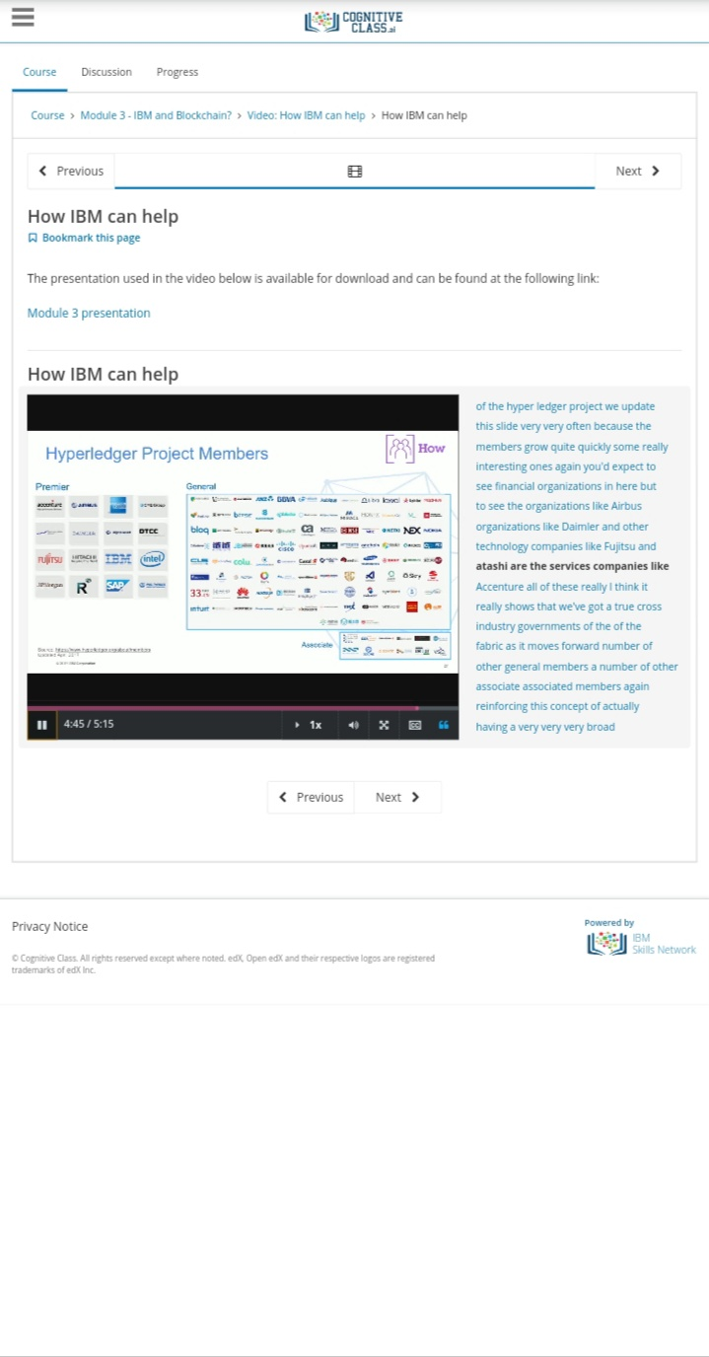

Coding Challenges Details: (Attach the snapshot and briefly write the report for the same)

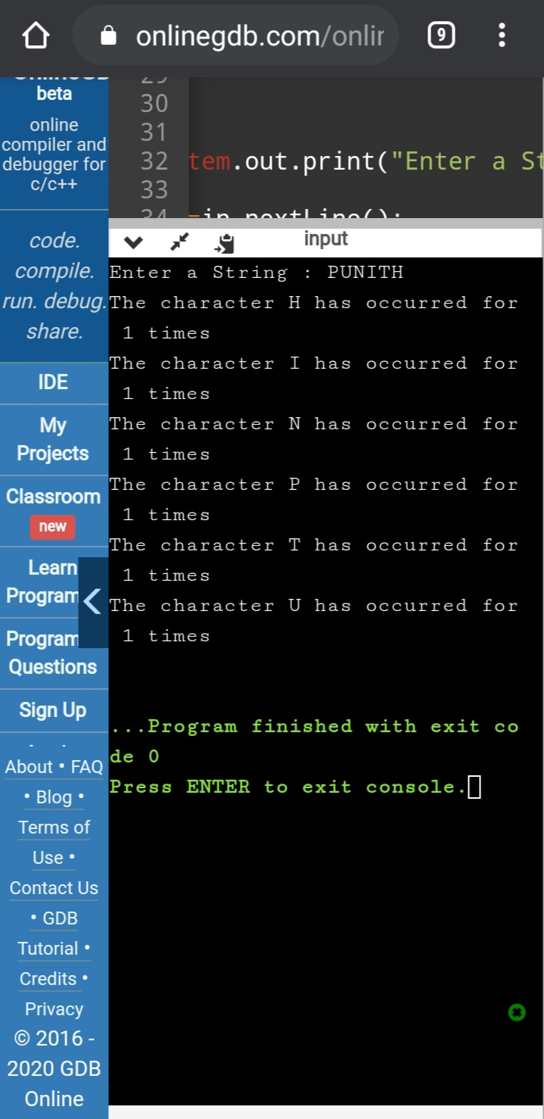

[https://github.com/puni2426/lockdown-coding](https://github.com/puni2426/lockdown-coding" \o "https://github.com/puni2426/lockdown-coding)

[https://github.com/puni2426/lockdown-certificate-course](https://github.com/puni2426/lockdown-certificate-course" \o "https://github.com/puni2426/lockdown-certificate-course)