**DAILY ONLINE ACTIVITIES SUMMARY**

|  |  |  |  |  |  |  |  |
| --- | --- | --- | --- | --- | --- | --- | --- |
| **Date:** | **19-05-2020** | | | | **Name:** | **PUNITH S** | |
| **Sem & Sec** | **4th Sem B sec** | | | | **USN:** | **4AL18CS064** | |
| **Online Test Summary** | | | | | | | |
| **Subject** | | **Design and analysis of algorithm** | | | | | |
| **Max. Marks** | | **30** | | **Score** | | **07** | |
| **Certification Course Summary** | | | | | | | |
| **Course** | **Blockchain Essentials V2** | | | | | | |
| **Certificate Provider** | | | **Cognitiveclass.ai** | **Duration** | | | **3 hours** |
| **Coding Challenges** | | | | | | | |
| **Problem Statement: 1.substring 2.shotest palindrome 3.linkedlist palindrome**  **the second string or the second string is a sub sequence of the first string. Assume that,**  **the length of the first string is smaller than or equal to the length of the second string.subsequence of**  **the second string or the second string is a sub sequence of the first string. Assume that,**  **the length of the first string is smaller than or equal to the length of the second string sequence ofsequence of**  **the second string or the second string is a sub sequence of the first string. Assume that,**  **the length of the first string is smaller than or equal to the length of the second string**  **the second string or the second string is a sub sequence of the first string. Assume that,**  **the length of the first string is smaller than or equal to the length of the second string.**  **sequence of the other. Program prints “yes” if either the first string is a sub sequence of**  **the second string or the second string is a sub sequence of the first string. Assume that,**  **the length of the first string is smaller than or equal to the length of the second string.** | | | | | | | |
| **Status: C**ompleted | | | | | | | |
| **Uploaded the report in Github** | | | | **Yes** | | | |
| **If yes Repository name** | | | | **[https://github.com/puni2426/lockdown-coding](https://github.com/puni2426/lockdown-coding" \o "https://github.com/puni2426/lockdown-coding)** | | | |
| **Uploaded the report in slack** | | | | **Yes** | | | |

Online Test Details: (Attach the snapshot and briefly write the report for the same)

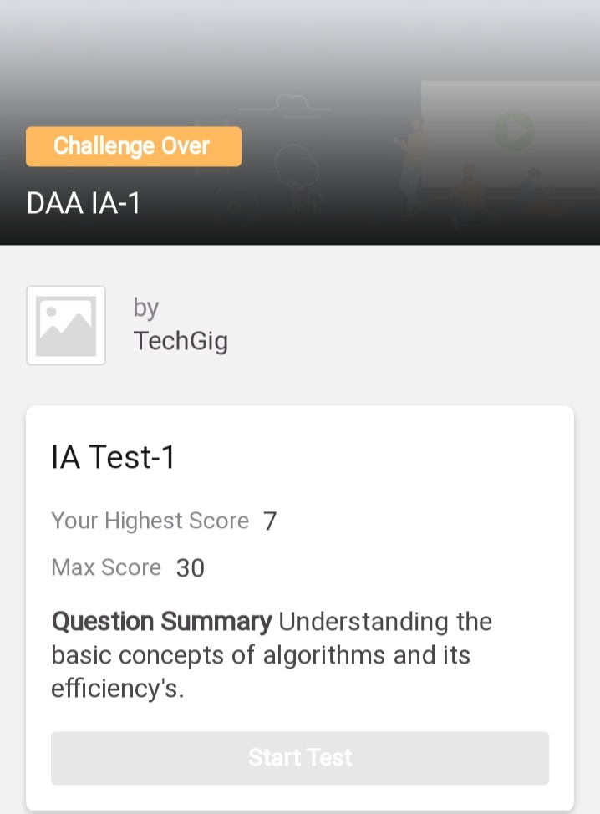

18CS42 test was scheduled from 9:25 am to 9:55 am and the testscores are not yet received .The portion for the IA was 1st module there were 25 questionsand the time assigned was 40 minutes the questions were mcq type. But there was an issuewith the time mentioned, so that we got only 30mins. to finish the test. The time was not sufficient to answer all the questions. There were 20 questions of 1 mark and 5 questions of 2 marks respectively.

Certification Course Details: (Attach the snapshot and briefly write the report for the same)

**NAME :PUNITH S**

**USN : 4AL18CS064**

**COURSE NAME : Blockchain Essential V2**

**LINK : <https://cognitiveclass.ai/courses>**

**Cognitive Class: BC0101EN**

**Org By : IBM**

**Start date : 18-05-2020**

**Duration : 3 hr**

**Progress on 19-05-2020**

* **Topic Completed Today**

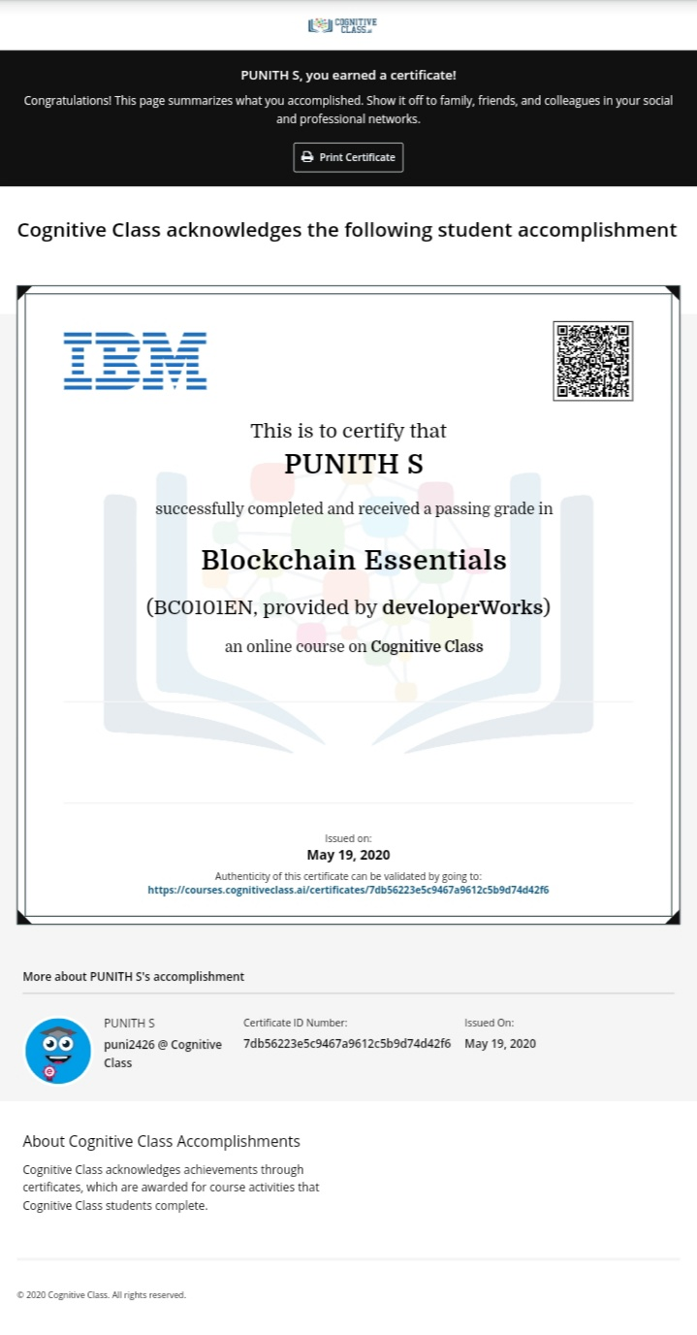

Coding Challenges Details: (Attach the snapshot and briefly write the report for the same)

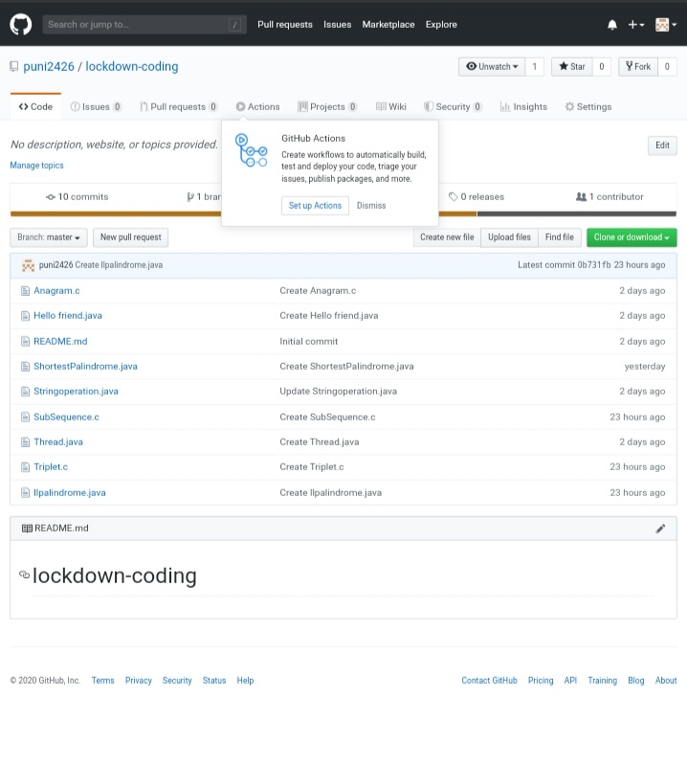

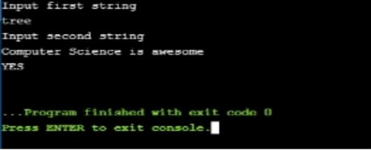

[https://github.com/puni2426/lockdown-coding](https://github.com/puni2426/lockdown-coding" \o "https://github.com/puni2426/lockdown-coding)

[https://github.com/puni2426/lockdown-certificate-course](https://github.com/puni2426/lockdown-certificate-course" \o "https://github.com/puni2426/lockdown-certificate-course)