**DAILY ONLINE ACTIVITIES SUMMARY**

|  |  |  |  |  |  |  |  |
| --- | --- | --- | --- | --- | --- | --- | --- |
| **Date:** | **20-05-2020** | | | | **Name:** | **PUNITH S** | |
| **Sem & Sec** | **4th Sem B sec** | | | | **USN:** | **4AL18CS064** | |
| **Online Test Summary** | | | | | | | |
| **Subject** | | **Object Oriented Concept** | | | | | |
| **Max. Marks** | | **30** | | **Score** | | **14** | |
| **Certification Course Summary** | | | | | | | |
| **Course** | **Python with Machine Learning** | | | | | | |
| **Certificate Provider** | | | **[Cognitiveclass.ai](http://Cognitiveclass.ai" \o "http://Cognitiveclass.ai)** | **Duration** | | | **12 hours** |
| **Coding Challenges** | | | | | | | |
| **Problem Statement: Array problem,first come first serve, reverse of number,subsequence.**  **triplets such that sum of two elements equals the third element.**  **Problem Statement 2: Write a C program to check whether the two strings are Anagram**  **or not.** | | | | | | | |
| **Status: C**ompleted | | | | | | | |
| **Uploaded the report in Github** | | | | **Yes** | | | |
| **If yes Repository name** | | | | **[https://github.com/puni2426/lockdown-coding](https://github.com/puni2426/lockdown-coding" \o "https://github.com/puni2426/lockdown-coding)** | | | |
| **Uploaded the report in slack** | | | | **Yes** | | | |

Online Test Details: (Attach the snapshot and briefly write the report for the same)

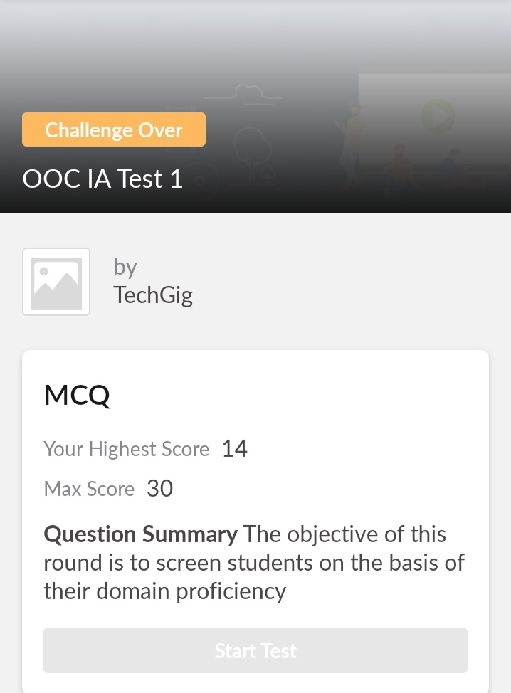

Object Oriented Concept Internals was conducted. A total of 30 questions were there in which 20 of them were Multiple Choice Questions and 10 questions were programming based questions.The above snapshot is the result sheet which was mailed to us by the Techgig team.

Certification Course Details: (Attach the snapshot and briefly write the report for the same)

**NAME :PUNITH S**

**USN : 4AL18CS064**

**COURSE NAME : Python with Machine Learning**

**LINK : <https://cognitiveclass.ai/courses>**

**Cognitive Class: ML0101ENv3**

**Org By : IBM**

**Start date : 20-05-2020**

**Duration : 12 hr**

**Progress on :20-05-2020**

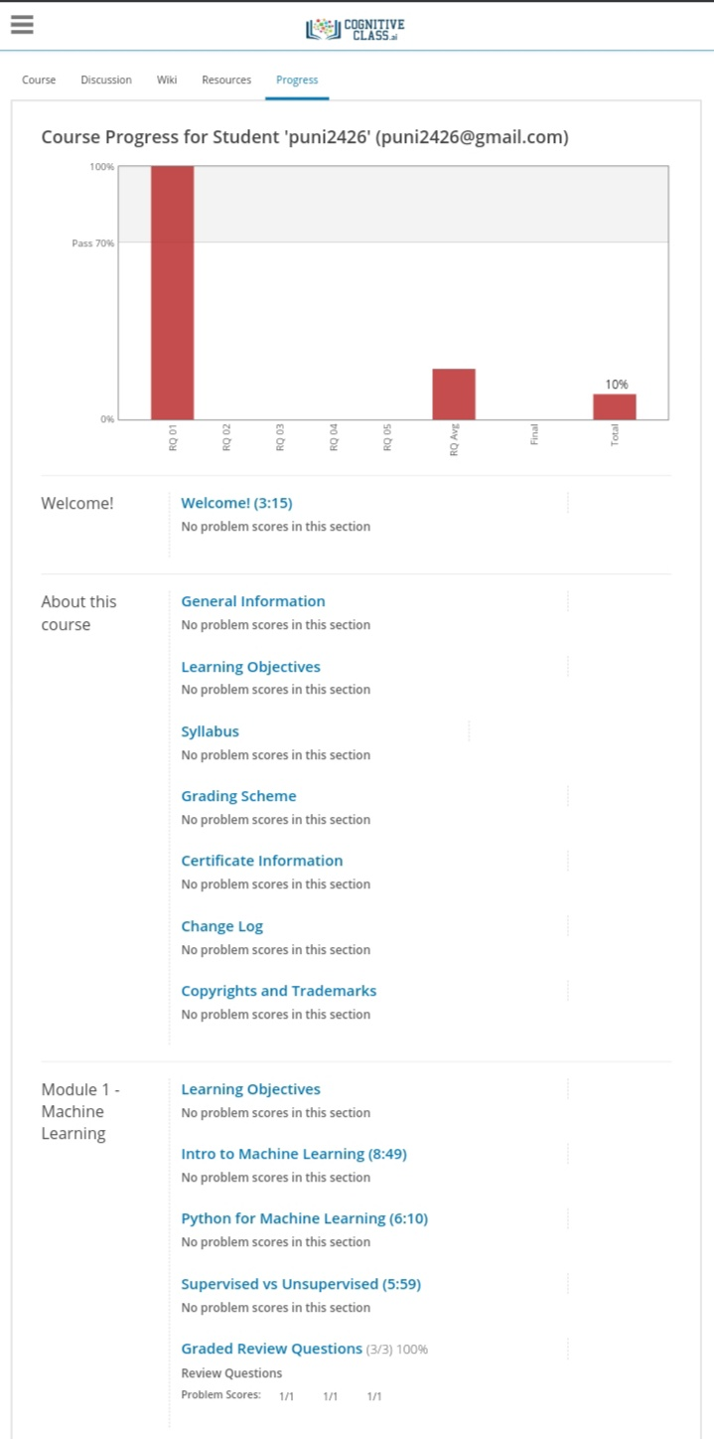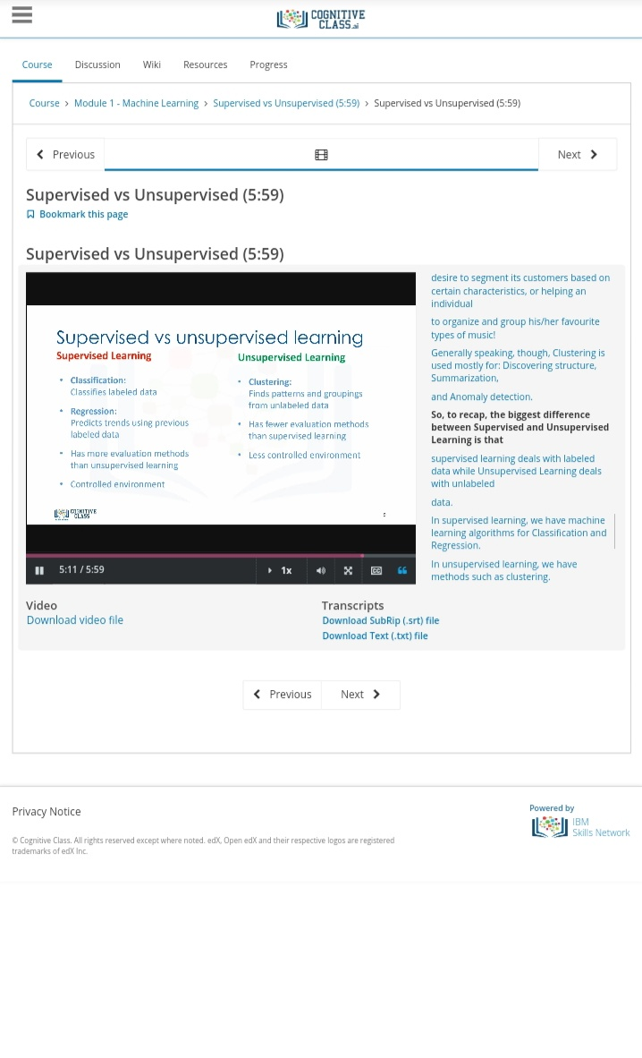

Coding Challenges Details: (Attach the snapshot and briefly write the report for the same)

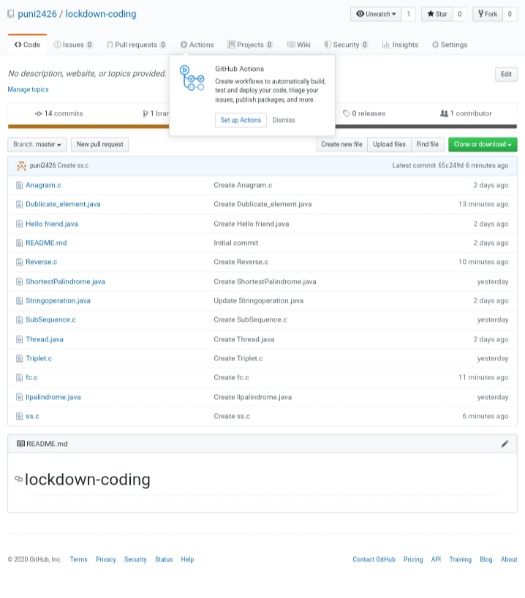

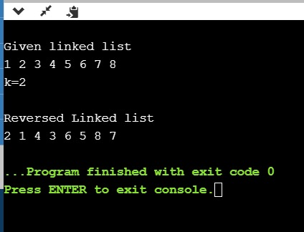

Given an array a[] of size n which contains elements from 0 to n-1, write a program printDuplicates which prints the duplicate elements of the given array. If no duplicate element is found print -1.

[https://github.com/puni2426/lockdown-coding](https://github.com/puni2426/lockdown-coding" \o "https://github.com/puni2426/lockdown-coding)

[https://github.com/puni2426/lockdown-certificate-course](https://github.com/puni2426/lockdown-certificate-course" \o "https://github.com/puni2426/lockdown-certificate-course)