**The final report**

The purpose of this project is to create a model determining the authenticity of Banknotes.

Data was explored and statistical measures were evaluated.

mean V1: **0.433735** V2: **1.922353**

standard deviation **V1:** **2.841726 V2 : 5.866907**

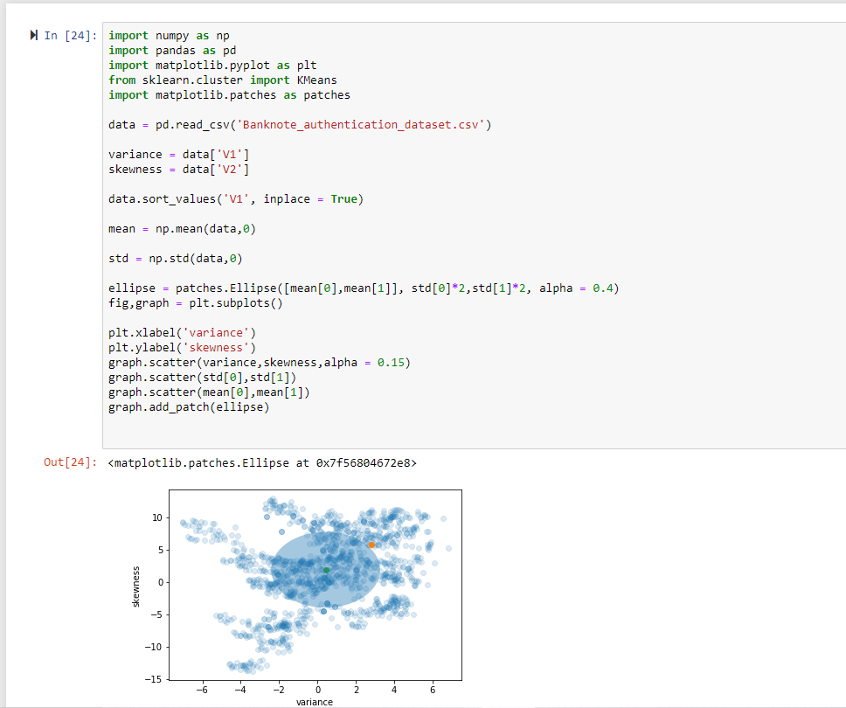

The data was visualised with a scatterplot.

I have used 3 custers usung K Means clustering.

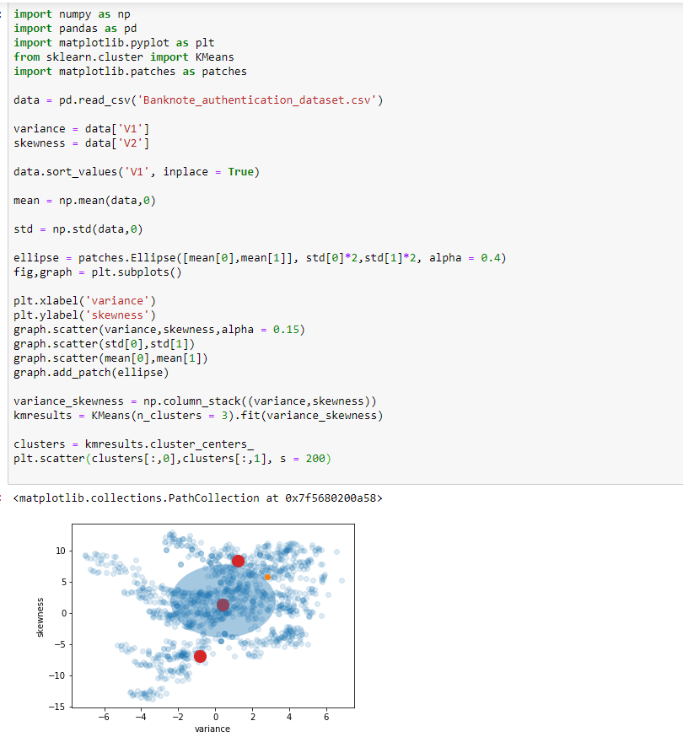

The data wass run several times to train the algorithm.

After all the re runs and test, the model was stable.

The model words seemingly well and can predict the aunthenticity of the bank notes.

According to the model, on an average of 6 out of 10 notes were real.

I can say that the model works better than random guesses.

RECOMMENDATION FOR THE CLIENT:

I would like to say, the model works better than random guesses,it would be better with more training data and testing, 6 out of 10 score is not so reliable but still I can assure that it works better than random guesses.