Shrimad Rajchandra Institute of Management and Computer
Application
Uka Tarsadia University
M.C.A (2nd Semester)
Subject: CC7001 Cloud Computing with DevOps
202504104610092_set-B

Q.1 (A) What is Docker? Explain its components and steps to containerize an application
What is Docker?

Docker is an open-source containerization platform that allows developers to package an application along with its dependencies, libraries, and configurations into a container.
Containers ensure that the application runs the same way in development, testing, and production environments.
Docker uses OS-level virtualization and is lightweight compared to traditional virtual machines.
Components of Docker
1 Docker Engine

The core part of Docker that runs and manages containers.
It includes:
Docker Daemon (dockerd) – Runs in the background and manages containers.
Docker CLI – Command-line tool to interact with Docker.
REST API – Allows communication between client and daemon.

2 Docker Image
A read-only template used to create containers.
It contains:
Application code
Dependencies
Runtime
System tools
Images are created using a Dockerfile.

3 Docker Container
A running instance of a Docker Image.
It is lightweight, isolated, and portable.

4 Dockerfile
A text file that contains instructions to build a Docker image.
Example instructions:
FROM
RUN
COPY
CMD

5 Docker Hub
A cloud-based repository where Docker images are stored and shared.

6 Docker Registry
A storage system for Docker images (Docker Hub is a public registry).

Step-by-Step: Containerizing an Application
Assume we have a simple Node.js application (app.js).

github link:https://github.com/punit6513/0092_B.git

index.html
<!DOCTYPE html>
<html>
<head>
<title>Faculty Login</title>
<link rel="stylesheet" href="css/style.css">
</head>
<body class="login-body">

<div class="login-container">
<h2>Faculty Login</h2>
<form onsubmit="login(event)">
<label>Faculty ID</label>
<input type="text" placeholder="Enter Faculty ID" required>

<label>Password</label>
<input type="password" placeholder="Enter Password" required>

<button type="submit">Login</button>
</form>
</div>

<script>
function login(event){
event.preventDefault();
window.location.href="dashboard.html";
}
</script>

</body>
</html>

dashboard.html

<!DOCTYPE html>
<html>
<head>
<title>Faculty Dashboard</title>
<link rel="stylesheet" href="css/style.css">
</head>
<body>

<div class="navbar">
<h2>Faculty Dashboard</h2>
<a href="index.html">Logout</a>
</div>

<div class="container">

<h3>Add Elective Subject</h3>
<form id="subjectForm">
<input type="text" placeholder="Course" required>
<input type="text" placeholder="Semester" required>
<input type="text" placeholder="Subject Code" required>
<input type="text" placeholder="Subject Name" required>
<input type="text" placeholder="Propose" required>
<button type="submit">Add Subject</button>
</form>

<h3>Available Subjects</h3>
<table>
<thead>
<tr>
<th>Course</th>
<th>Semester</th>
<th>Subject Code</th>
<th>Subject Name</th>
<th>Propose</th>
<th>Students Selected</th>
</tr>
</thead>
<tbody id="subjectTable">
<tr>
<td>BCA</td>
<td>5</td>
<td>CS501</td>
<td>Artificial Intelligence</td>
<td>Open Elective</td>
<td>45</td>
</tr>
</tbody>
</table>

</div>

<script>
document.getElementById("subjectForm").addEventListener("submit", function(e){
e.preventDefault();

let table = document.getElementById("subjectTable");
let row = table.insertRow();

for(let i=0; i<5; i++){
let cell = row.insertCell(i);
cell.innerHTML = e.target[i].value;
}

let studentCell = row.insertCell(5);
studentCell.innerHTML = "0";

e.target.reset();
});
</script>

</body>
</html>

style.css

body {
font-family: Arial, sans-serif;
margin: 0;
background-color: #f4f6f9;
}

.login-body {
display: flex;
justify-content: center;
align-items: center;
height: 100vh;
background-color: cornflowerblue;
}

.login-container {
background: white;
padding: 30px;
width: 300px;
border-radius: 8px;
}

.login-container h2 {
text-align: center;
}

.login-container input {
width: 100%;
padding: 8px;
margin: 8px 0;
}

.login-container button {
width: 100%;
padding: 8px;
background: #4e73df;
color: white;
border: none;
}

.login-container button:hover {
background: #2e59d9;
}

.navbar {
background: #4e73df;
color: white;
padding: 15px;
display: flex;
justify-content: space-between;
}

.navbar a {
color: white;
text-decoration: none;
}

.container {
padding: 20px;
}

form input {
padding: 8px;
margin: 5px;
}

form button {
padding: 8px 15px;
background: #1cc88a;
border: none;
color: white;
cursor: pointer;
}

table {
width: 100%;
border-collapse: collapse;
margin-top: 15px;
}

table, th, td {
border: 1px solid #ccc;
}

th {
background: #4e73df;
color: white;
padding: 10px;
}

td {
padding: 8px;
text-align: center;
}

output ss

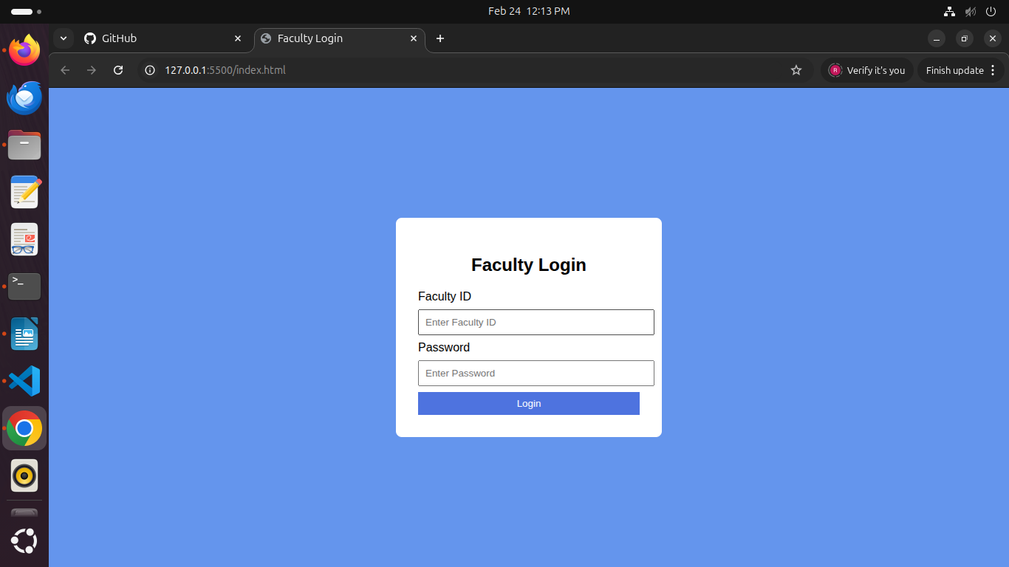

2
