FUZZY CONTROLLED
ANTI-LOCK BRAKING SYSTEM

ABSTRACT

This thesis describes an intelligent approach to control an Antilock Braking System (ABS) employing a fuzzy controller. Stopping a car in a hurry on a slippery road can be very challenging. Anti-lock braking systems (ABS) take a lot of the challenge out of this sometimes nerve-wracking event. In fact, on slippery surfaces, even professional drivers can't stop as quickly without ABS as an average driver can with ABS. Anti-lock Brake improves the controllability of vehicles in compare with brake systems lacking ABS. Fuzzy is a multi-valued logic developed to deal with imprecise or vague data. Classical logic holds that everything can be expressed in binary terms: 0 or 1; in terms of Boolean algebra, everything is in one set or another but not in both. Fuzzy logic allows for partial membership in a set, values between 0 and 1. When the approximate reasoning of fuzzy logic is used with an expert system, logical inferences can be drawn from imprecise relationships.
Fuzzy anti-lock Braking systems were developed to reduce skidding and maintain steering control when brakes are used in an emergency situation. Fuzzy controllers are potential candidates for the control of non-linear, time variant and complicated systems. There are many control algorithms for ABS systems and they are partially responsible for their performance. Here, in this paper we have discussed how Anti-Lock Braking system is controlled using Fuzzy Logic.

INTRODUCTION TO FUZZY LOGIC
Fuzzy logic is a mathematical technique for dealing with imprecise data and problems that have many solutions rather then one. Although it is implemented in digital computers which ultimately makes yes-no decisions, fuzzy logic works with ranges of values, solving problems in a way that more resembles human logic.

Fuzzy logic, a more generalized data set, allows for a “class” with continuous membership gradations. It is rigorously structured in mathematics. One advantage is the ability to describe systems linguistically through rule statements.
FUZZIFICATION

The fuzzy controller takes input values from real world. These values referred to as “crisp” values. Since they are represented as single number, not a fuzzy one. In order for the fuzzy controller to understand the input, the crisp input has to be converted to a fuzzy number. This process is called fuzzification.

DEFUZZIFICATION

It is the process of producing a quantifiable result in fuzzy logic. Typically, a fuzzy system will have a number of rules that transform a number of variables into a “Fuzzy” result, that is result is described in terms of membership in fuzzy set. Simplest but least useful defuzzification method is to choose the set with highest membership.Once all the rules are evaluated, their output are combined in order to provide a single value that will be fuzzified.

FUZZY CONTROL

A fuzzy control system is a real-time expert system, implementing a part of human operator’s which does not lend itself to being easily expressed in PID-parameters or differential equations but rather in situation/action rules. Fuzzy control has been so successful in areas where classical control theory has been dominant for so many years. It differs from classical control theory in several aspects. One main feature of fuzzy control system is their existence at two distinct levels: First, there are symbolic if-then rules and qualitative, fuzzy variables and values such as

“If pressure is high and slightly increasing then energy supply is medium negative”

Here ‘slightly increasing’ and ‘pressure is high’ are fuzzy values and ‘and’ is a fuzzy operator. The IF part is called the "antecedent" and the THEN part is called the "consequent". .

Fuzzy control aims at replacing differential equation based techniques and solving the whole problem with artificial intelligence methods. One way to combine fuzzy and PID-control is to use a linear PID system around the set-point, where it does its job, and to ‘delinearize’ the system in other areas by describing the desired behavior or control strategy with fuzzy rules. Fuzzy controllers are very simple conceptually.

They consist of

- an input stage,

- a processing stage and

- an output stage.

The input stage maps sensor or other inputs, such as switches, thumbwheels, and so on, to the appropriate membership functions and truth values. The processing stage invokes each appropriate rule and generates a result for each, then combines the results of the rules. Finally, the output stage converts the combined result back into a specific control output value.
Typical fuzzy control systems have dozens of rules. There are several different ways to define the result of a rule, but one of the most common and simplest is the "max-min" inference method, in which the output membership function is given the truth value generated by the premise. Rules can be solved in parallel in hardware, or sequentially in software. The results of all the rules that have fired are "defuzzified" to a crisp value by one of several methods. The "centroid" method is very popular, in which the "center of mass" of the result provides the crisp value. Another approach is the "height" method, which takes the value of the biggest contributor. The centroid method favors the rule with the output of greatest area, while the height method obviously favors the rule with the greatest output value. Here, in this paper “centre of gravity” method is followed.

ABS-Anti-Lock Braking System

Anti-Lock Braking System is a safety system on automobiles which prevents wheels from locking while braking. It is also known as CAB-Controller Anti-
Lock Brake. ABS is implemented in automobiles to ensure optimal vehicle control and minimal stopping distances during hard or emergency braking. The theory behind anti-lock brakes is simple. A skidding wheel (where the tire contact patch is sliding relative to the road) has less traction than a non-skidding wheel. ABS are non-linear and dynamic in nature. ABS is now accepted as an essential contribution to vehicle safety.
The methods of control utilized by ABS are responsible for system performance.

COMPONENTS OF ABS

There are four main components in ABS. They are

- Wheel speed sensors

- Electronic Controller Units (ECU’s)

- Hydraulic valves

- Pumps

The anti-lock braking system needs some way of knowing when a wheel is about to lock up. The wheel speed sensors, which are located at each wheel provides this information. The ECU constantly monitors the rotational speed of each wheel and controls the valves. Wheel speed sensors transmit pulses to the ECU with a frequency proportional to wheel speed. The ECU then processes this information and regulates the brake accordingly. There is a valve in the brake line of each brake controlled by the ABS. On some systems, the valve has three positions:
In position one, the valve is open; pressure from the master cylinder is passed right through to the brake. In position two, the valve blocks the line, isolating that brake from the master cylinder. This prevents the pressure from rising further should the driver push the brake pedal harder. In position three, the valve releases some of the pressure from the brake. Since the valve is able to release pressure from the brakes, there has to be some way to put that pressure back. So when a valve reduces the pressure in a line, the pump is there to get the pressure back up. ABS significantly improves safety and control for drivers in most on-road situations.
FUZZY CONTROL OF ABS
Fuzzy controllers are potential candidates for the control of non-linear, time variant and complicated systems. ABS which is a non-linear system may not be easily controlled by classical control methods. An intelligent fuzzy control method is very useful for this kind of non linear system. An intelligent fuzzy ABS controller can adjust the slipping performance for variety of roads. The main disadvantage of ordinary brakes is that a driver cannot precisely control the brake torque applied to the brake. Moreover, as the driver does not have enough information of road condition, he may cause locking of wheels by applying extra pressure on brake pedal. Anti-lock Brake improves the controllability of vehicles in compare with brake systems lacking ABS.
When a vehicle accelerates or brakes, the tractive force Ftf and Ftr developed by front and rear tyre, respectively are proportional to the normal forces of the road acting on the tyre. The coefficient of proportionality mu, is called road coefficient of adhesion and it varies depending on road surface type. 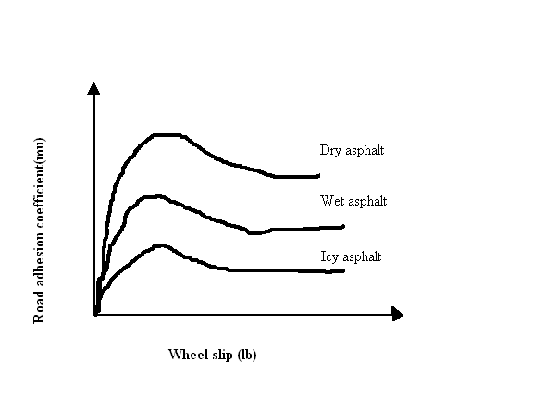

The wheel slip, denoted by lb, is the ratio of difference between the velocity of vehicle and the translational velocity of wheel to the velocity of vehicle. The goal of the ABS is to hold each tyre of the vehicle operating near the peak of mu-lb curve for that tyre, which implies the performance of ABS is strongly related to the surface condition.

WORKING OF FUZZY ABS
There are many different variations and control algorithms for ABS systems. Control algorithm is partially responsible for ABS performance. The controller monitors the speed sensors at all times. It is looking for decelerations in the wheel that are out of the ordinary. Right before a wheel locks up, it will experience a rapid deceleration. If left unchecked, the wheel would stop much more quickly than any car could. It might take a car five seconds to stop from 60 mph (96.6 kmph) under ideal conditions, but a wheel that locks up could stop spinning in less than a second. The ABS controller knows that such a rapid deceleration is impossible, so it reduces the pressure to that brake until it sees an acceleration, then it increases the pressure until it sees the deceleration again. It can do this very quickly, before the tyre can actually significantly change speed. The result is that the tyre slows down at the same rate as the car, with the brakes keeping the tyres very near the point at which they will start to lock up. This gives the system maximum braking power. Fuzzy ABS require more complex control constructs than simple “if-then” rules. In “if-then” rules, input variables marks directly to the output variables. It is possible to build a control with intermediate fuzzy variables.
One such rule using fuzzy variables is as follows:

“If the rear wheels are turning slowly and a short time ago the vehicle speed was high then reduces rear brake pressure”

When the ABS system is in operation a pulsing in the brake pedal is experienced; this comes from the rapid opening and closing of the valves. Some ABS systems can cycle up to 15 times per second. The figure below describes the working of ABS.

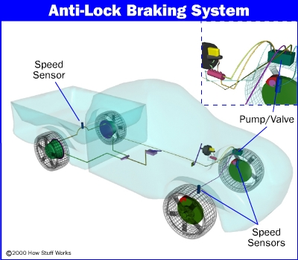

Electronic stability control
Modern Electronic Stability Control (ESC or ESP) systems are an evolution of the ABS concept. Here, a minimum of two additional sensors are added to help the system work: these are a steering wheel angle sensor, and a gyroscopic sensor. The theory of operation is simple: when the gyroscopic sensor detects that the direction taken by the car does not coincide with what the steering wheel sensor reports, the ESC software will brake the necessary individual wheel(s), so that the vehicle goes the way the driver intends. The rule governing ESC is
“If steering wheel sensor reports are not equal to gyroscopic sensor reports then brake the necessary individual wheel”
BLOCK DIAGRAM OF FUZZY ABS
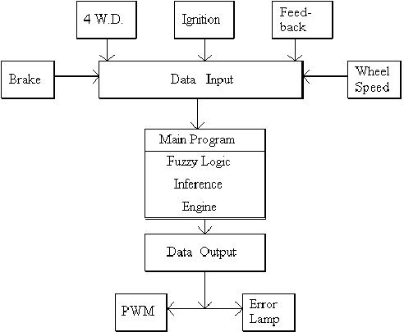
Anti-Lock Brake Types
Anti-lock braking systems use different schemes depending on the type of brakes in use.

Four-channel, four-sensor ABS - This is the best scheme. There is a speed sensor on all four wheels and a separate valve for all four wheels. With this setup, the controller monitors each wheel individually to make sure it is achieving maximum braking force.

Three-channel, three-sensor ABS - This scheme, commonly found on pickup trucks with four-wheel ABS, has a speed sensor and a valve for each of the front wheels, with one valve and one sensor for both rear wheels. The speed sensor for the rear wheels is located in the rear axle. This system provides individual control of the front wheels, so they can both achieve maximum braking force.
One-channel, one-sensor ABS - This system is commonly found on pickup trucks with rear-wheel ABS. It has one valve, which controls both rear wheels, and one speed sensor, located in the rear axle.

Benefits of fuzzy ABS:
- Automobiles can be stopped faster and the distance of braking is reduced.
- Steering is possible while braking.

CONCLUSION
.
Fuzzy ABS has reduced the percentage of road crashes by a considerable amount. Experts predict that 35% to 50% of all cars built worldwide in five years will have ABS as standard equipment. Though it has many advantages, there are few disadvantages such as increased braking distance in snow/icy regions at present. These drawbacks can be overcome in future by fuzzy controlled ABS.

REFERENCE

- “An Introduction to Fuzzy control” by D Drainkov, H Hellendoorn, M Reinfrank.
- “Fuzzy logic control advances in applications” by Hent B verbruggen and Robert
Babuska.
- “A fuzzy logic control for an ABS braking system” by G.F.Mauer

