Capstone Project
Stock Market Anomaly Detection

Detecting Unusual Market Days Using Rolling Statistics,
Rule-Based Detection, K-Means & DBSCAN Clustering

Universe: QQQ, AAPL, AMZN, GOOG, FB, ADBE, CSCO
Dataset: NASDAQ Daily OHLCV (Kaggle)
Train: 2018 | Validation: 2019 | Test: 2020-Q1

Table of Contents

1. Project Overview
Goal: Detect unusual market days and stock days using only daily price and volume data. An observation is considered unusual when it shows very large price moves (spikes or crashes), unusually high trading volume, or unusually wide intraday ranges compared to recent history.
Approach: This project uses no labels, no news feeds, and no complex deep learning models. Instead, it relies on rolling statistical features and simple unsupervised methods (rule-based thresholds, K-Means, and DBSCAN clustering) to flag anomalies.
Why This Matters: Markets frequently experience stress days. Identifying them enables portfolio monitoring (detecting broad market stress), diagnostics (finding individual stocks behaving differently from peers), and learning best practices for time-series analysis without data leakage.

1.1 What We Built
- Feature Engineering: Return z-score, volume z-score, and intraday range percentile computed with rolling windows using only past data.
- Rule-Based Detector: If any feature exceeds its threshold, the day is flagged and labeled as crash, spike, or volume_shock.
- K-Means Clustering: Points far from cluster centroids are flagged as anomalies.
- DBSCAN Clustering: Noise points (label = -1) from density-based clustering are flagged.
- Date Query: Input a date, get market status and anomalous tickers.
- Monthly Mini-Report: Summarizes abnormal dates and their causes for any given month.

2. Dataset Description
The dataset comes from Kaggle (NASDAQ Stock Market Dataset) containing daily OHLCV (Open, High, Low, Close, Adj Close, Volume) data for thousands of stocks and ETFs. Data ends on April 1, 2020.

2.1 Selected Universe
Ticker | Type | Description
QQQ | ETF | NASDAQ-100 Index Tracker (market proxy)
AAPL | Stock | Apple Inc.
AMZN | Stock | Amazon.com Inc.
GOOG | Stock | Alphabet Inc. (Google)
FB | Stock | Meta Platforms (Facebook)
ADBE | Stock | Adobe Inc.
CSCO | Stock | Cisco Systems Inc.

2.2 Data Columns
Column | Description
Date | Trading date (YYYY-MM-DD)
Open | Opening price
High | Highest price during the day
Low | Lowest price during the day
Close | Closing price
Adj Close | Adjusted close (accounts for splits/dividends) - used for returns
Volume | Number of shares traded

2.3 Data Splits
Split | Period | Purpose
Train | 2018-01-01 to 2018-12-31 | Fit models, compute thresholds, fit scaler
Validation | 2019-01-01 to 2019-12-31 | Tune hyperparameters (k, q, eps)
Test | 2020-01-01 to 2020-03-31 | Locked thresholds, evaluate on COVID crash
After feature computation: Train = 1,757 stock-days, Validation = 1,764 stock-days, Test = 434 stock-days (total 42,506 scored rows across all time).

3. Theory & Concepts

3.1 What is an Anomaly?
An anomaly is an observation that looks unlikely relative to recent behavior. In financial markets, this means:
- Point anomaly: One day that is extreme (e.g., a large crash or spike).
- Contextual anomaly: Extreme relative to context. A 2% move might be normal in volatile months but unusual in calm months.

3.2 Rolling Windows & Leakage Prevention
Rolling window: When deciding about day t, compute statistics using only days t-1, t-2, ..., t-k. This ensures no future information leaks into the decision.
Leakage: Using information from day t or the future to decide about day t. Our design avoids this by strictly using past-only windows.
Window sizes used: W_return = 63 trading days (~3 months) for returns, W_volume = 21 days (~1 month) for volume, W_range = 63 days for intraday range.

3.3 Z-Scores (Standardized Surprise)
A z-score measures how many standard deviations a value is from the mean. For a rolling window: z_t = (x_t - mean) / std. A z-score of 2.5 means the observation is 2.5 standard deviations from the rolling mean, which is very unusual.

3.4 Intraday Range Percentile
The intraday range is (High - Low) / Close. We compute its percentile rank against the previous 63 days. A percentile above 95% means the day had a wider trading range than 95% of recent days.

3.5 Market Breadth
Market breadth is the fraction of tickers with positive returns on a given day. Breadth below 0.3 (fewer than 30% of stocks are up) indicates broad market stress. Combined with the mean market return, this gives a daily market status.

4. Feature Engineering
Three features are computed per stock per day using strictly past data:
Feature | Window | Formula & Meaning
ret_z (Return Z-score) | 63 days | z = (r_t - mean(r)) / std(r) over past 63 days. Measures how surprising today's return is.
vol_z (Volume Z-score) | 21 days | z = (log(V_t) - mean(log V)) / std(log V) over past 21 days. Measures volume surprise (log-scale).
range_pct (Range Percentile) | 63 days | Percentile rank of (High-Low)/Close vs past 63 days. Measures how wide the trading range was.
Warm-up rule: No day is scored until at least 63 past observations exist for that ticker, preventing unreliable statistics from small windows.

5. Detection Methods

5.1 Rule-Based Detector
A stock-day is flagged as anomalous if any of these conditions hold:
- |ret_z| > 2.5 (extreme return)
- vol_z > 2.5 (extreme volume)
- range_pct > 0.95 (extreme range)
Type labels assigned:
- crash: negative return + |ret_z| > 2.5
- spike: positive return + |ret_z| > 2.5
- volume_shock: vol_z > 2.5 (can co-exist with crash/spike)

5.2 K-Means Anomaly Detection
Training: Features are standardized using a StandardScaler fit on the 2018 training set only. K-Means is fit on training data with k chosen via silhouette score (elbow and silhouette plots produced).
Scoring: For each point x, compute d(x) = distance to nearest centroid. If d(x) exceeds the q-th percentile threshold for that cluster (computed from training data), flag as anomaly.
Tuning: The quantile threshold q is tuned on the 2019 validation set to keep flag rate between 2-8% while maximizing overlap with the top 5% absolute return days. Best k=3, best q=95.0.

5.3 DBSCAN Anomaly Detection
Training: eps is chosen from the k-distance elbow plot to target approximately 5% noise rate on training data. min_samples = 15.
Walk-Forward Scoring: For validation and test sets, DBSCAN is refit on an expanding window (all history up to t-1 plus the new block). Points labeled -1 (noise) are flagged as anomalies.
Result: eps = 0.645, min_samples = 15, producing 1 main cluster with ~4.7% noise rate on training data.

5.4 Hybrid Consensus
- Union: anomaly if K-Means OR DBSCAN flags (higher recall)
- Intersection: anomaly if both flag (higher precision)

5.5 Market-Level Detection
A market day is flagged as anomalous if: |market_return| exceeds its rolling 95th percentile, OR breadth < 0.3. Additionally, flag_rate (fraction of tickers flagged per day) serves as a market stress indicator.

6. Results & Metrics

6.1 Model Parameters
Parameter | Value
K-Means clusters (k) | 3
K-Means silhouette score (train) | 0.3568
K-Means quantile threshold (q) | 95.0
DBSCAN eps | 0.645
DBSCAN min_samples | 15
DBSCAN clusters (train) | 1 main cluster
DBSCAN noise rate (train) | 4.7%

6.2 Train Set (2018) - 1,757 stock-days
Method | Flagged | Flag Rate | Tail Overlap 5% | Tail Overlap 2%
Rule-Based | 233 | 13.26% | 80.7% | 94.4%
K-Means | 90 | 5.12% | 25.0% | 36.1%
DBSCAN | 83 | 4.72% | 30.7% | 33.3%
Union | 123 | 7.00% | 38.6% | 47.2%
Intersection | 50 | 2.85% | 17.0% | 22.2%

6.3 Validation Set (2019) - 1,764 stock-days
Method | Flagged | Flag Rate | Tail Overlap 5% | Tail Overlap 2%
Rule-Based | 141 | 7.99% | 57.3% | 72.2%
K-Means | 91 | 5.16% | 20.2% | 38.9%
DBSCAN | 48 | 2.72% | 28.1% | 50.0%
Union | 103 | 5.84% | 28.1% | 50.0%
Intersection | 36 | 2.04% | 20.2% | 38.9%

6.4 Test Set (2020-Q1 / COVID Crash) - 434 stock-days
Method | Flagged | Flag Rate | Tail Overlap 5% | Tail Overlap 2%
Rule-Based | 150 | 34.56% | 100.0% | 100.0%
K-Means | 32 | 7.37% | 31.8% | 33.3%
DBSCAN | 14 | 3.23% | 22.7% | 33.3%
Union | 34 | 7.83% | 36.4% | 44.4%
Intersection | 12 | 2.76% | 18.2% | 22.2%

6.5 Interpretation of Results
- Rule-Based detector has the highest tail overlap (catches most extreme days) but also flags the most points. During the COVID crash (2020-Q1), it flags 34.56% of stock-days, reflecting the extreme market conditions where most days were genuinely unusual.
- K-Means maintains a controlled flag rate (5-7%) across all splits, with moderate tail overlap. It identifies structurally outlying points in the feature space, catching different types of anomalies than the rule-based approach.
- DBSCAN is the most conservative (2-5% flag rate) with strong precision. It excels at finding isolated outliers. During validation, its 2% tail overlap of 50% shows high precision: when it flags, it tends to be correct.
- Union/Intersection provide flexible consensus: union catches more anomalies (higher recall), intersection ensures both methods agree (higher precision).

7. Visualizations

7.1 K-Means Elbow & Silhouette Analysis
The elbow plot shows inertia decreasing as k increases. The silhouette plot confirms k=3 as optimal, with the highest average silhouette score of 0.357.
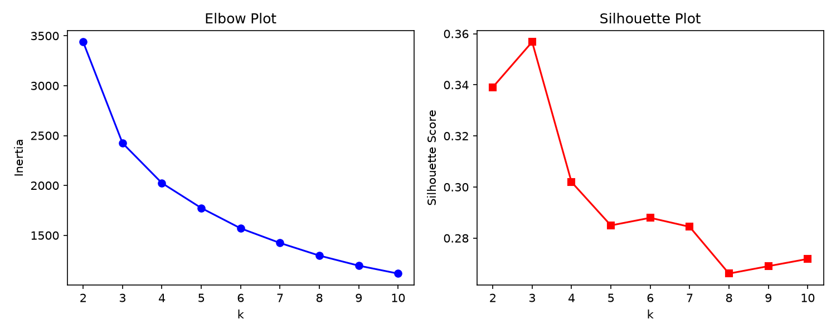

7.2 K-Means Anomaly Scatter Plot
Scatter plots of Return Z-score vs Volume Z-score across Train, Validation, and Test sets. Red points are K-Means anomalies (far from centroids). Note how the test set (2020-Q1) has more extreme points due to COVID volatility.
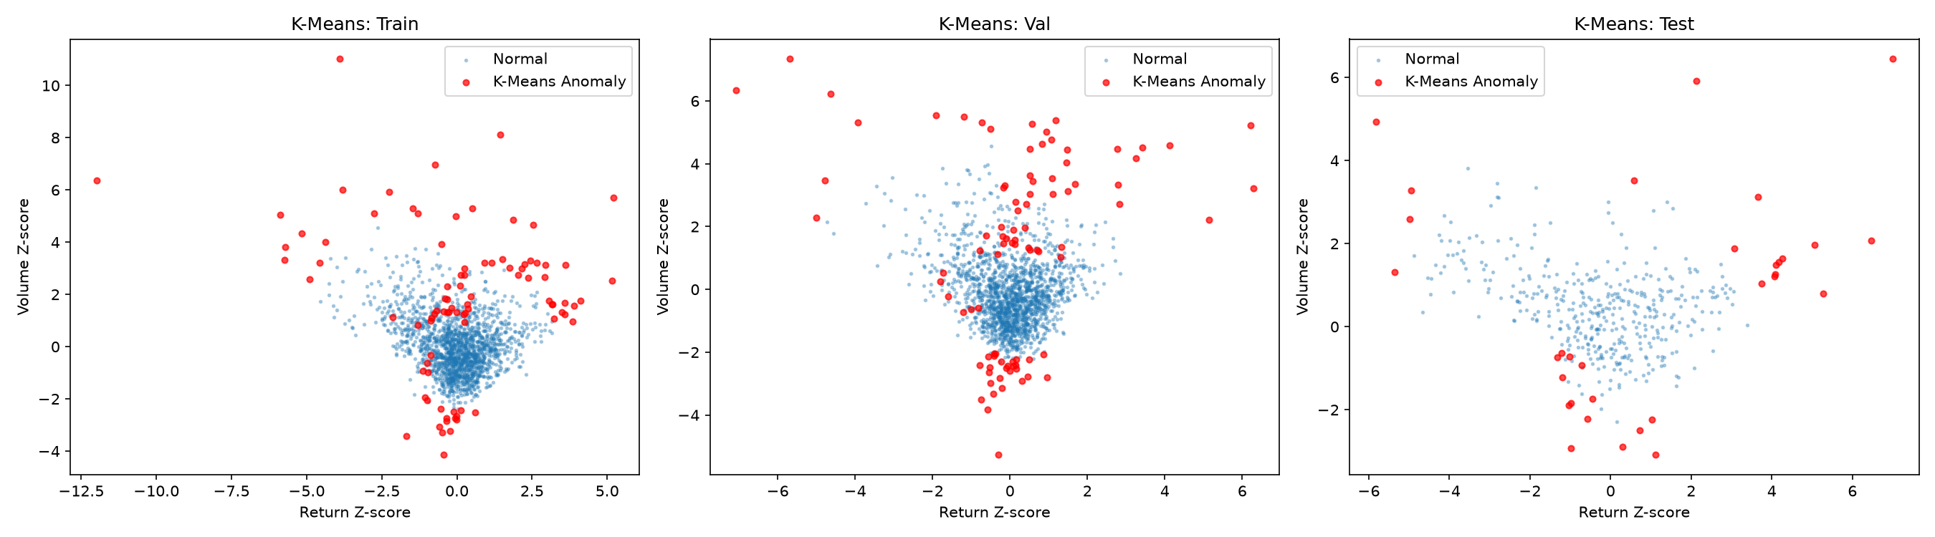

7.3 DBSCAN k-Distance Plot
The k-distance plot shows the sorted 15-nearest-neighbor distances. The red dashed line marks the chosen eps = 0.645, which targets approximately 5% noise rate.
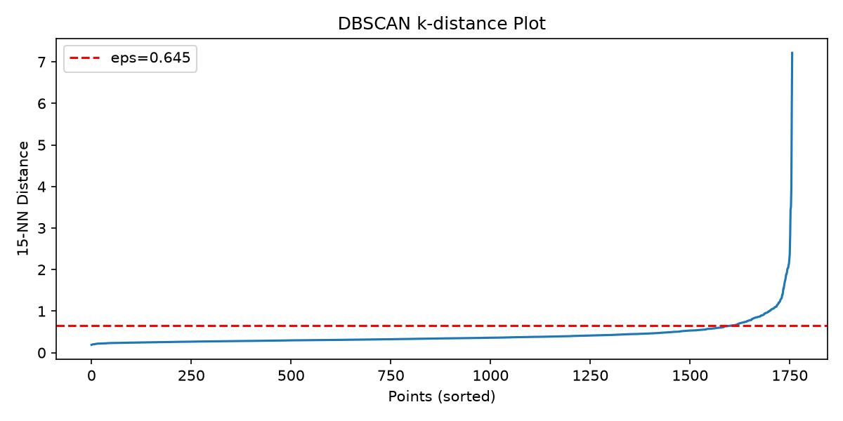

7.4 Test Period Market Dashboard
Three panels showing the COVID crash period: market returns (with red lines on anomaly dates), breadth (fraction of stocks up, threshold at 0.3), and daily flag rate. The dramatic deterioration in late February and March 2020 is clearly visible.
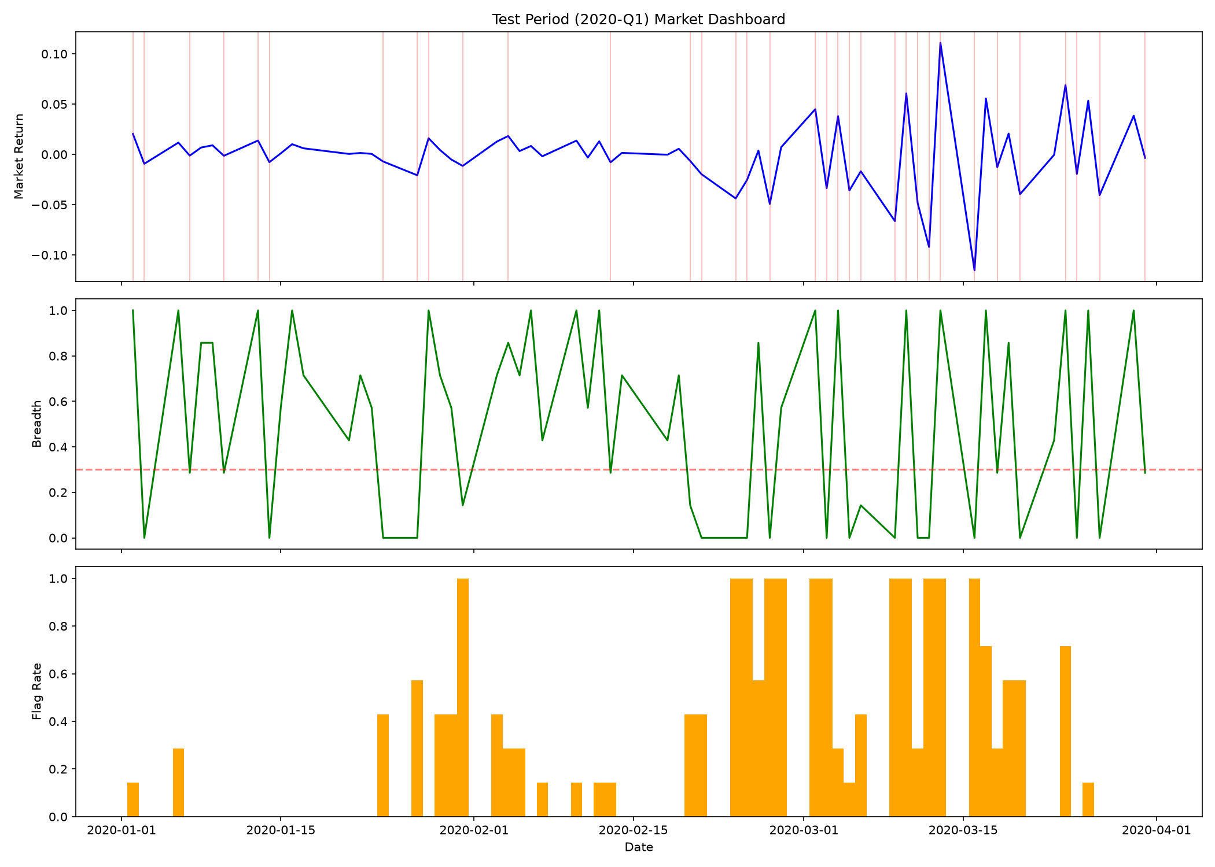

7.5 Cumulative Returns with Anomaly Flags
Cumulative returns for all tickers with X markers on anomaly days. Shows how anomalies cluster around major market moves, especially the COVID crash in early 2020.
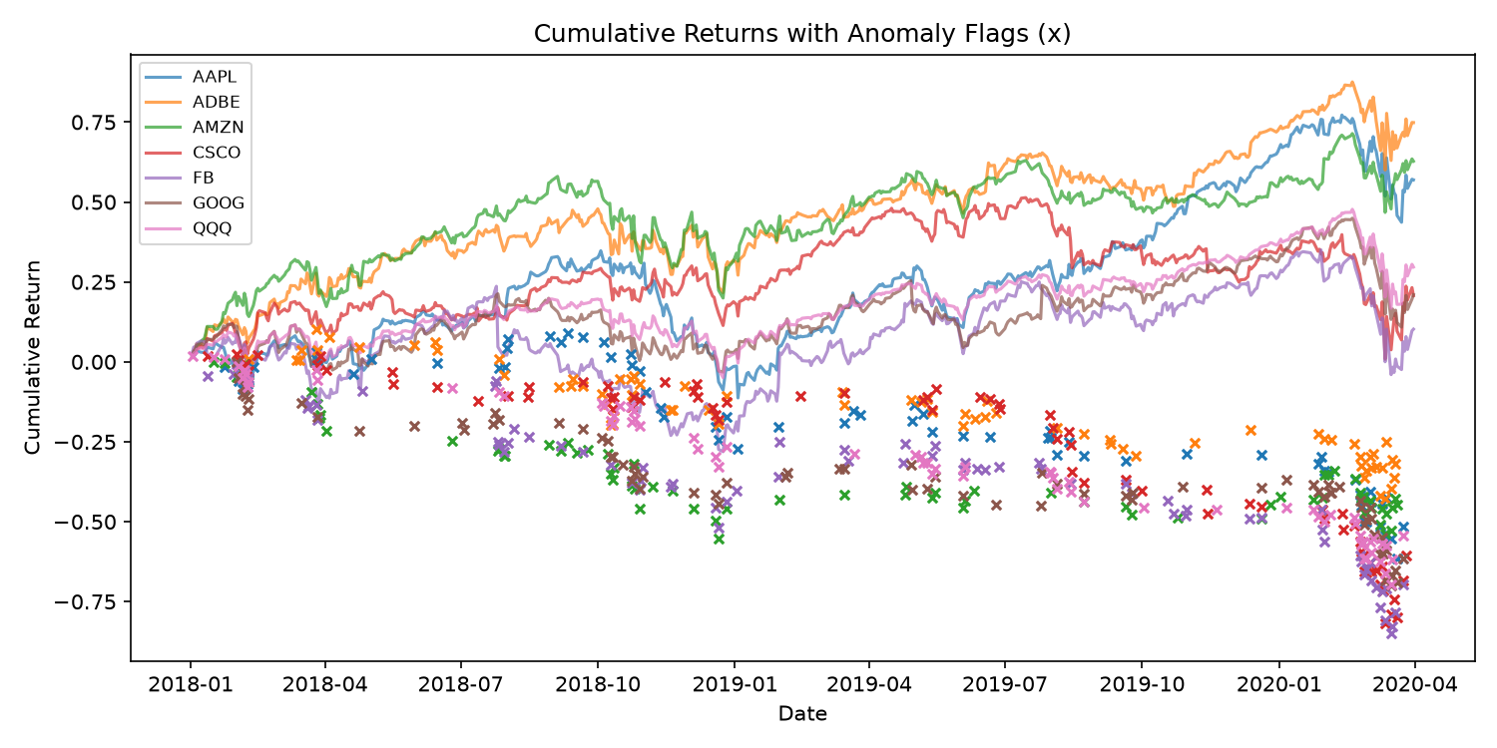

8. Case Studies

8.1 February 27, 2020 - Market-Wide Crash
This was one of the worst days during the initial COVID sell-off. Market return was -4.93% with breadth at 0.00 (zero tickers had positive returns). All 7 tickers were flagged by the rule-based detector:
Ticker | Type | ret_z | vol_z | Severity
QQQ | crash + volume_shock | -4.98 | 2.58 | 98.9
CSCO | crash | -3.18 | 2.05 | 97.8
AAPL | crash + volume_shock | -4.13 | 2.68 | 97.8
ADBE | crash | -3.33 | 2.19 | 97.6
GOOG | crash | -4.34 | 1.49 | 96.6
AMZN | crash | -3.16 | 1.38 | 95.9

8.2 March 16, 2020 - Black Monday
The worst single day in the test period with market return of -11.54% and breadth at 0.00. All tickers experienced extreme crashes, with FB dropping 14.25% (ret_z = -4.88). Severity scores ranged from 87 to 97, confirming truly exceptional market stress.

8.3 March 2020 Summary
March 2020 had 17 out of 22 trading days flagged as market anomalies, with 78 individual stock anomaly events. The top crashes included ADBE (ret_z = -5.36 on March 9), FB (ret_z = -4.88 on March 16), and QQQ (ret_z = -4.66 on March 16). Notable bounce-back spikes occurred on March 13 (ADBE +6.47 ret_z) and March 2 (AAPL +5.07 ret_z).

9. Project Structure & How to Run

9.1 Directory Layout
anamoly detection/
data/stocks/ - Individual stock CSV files
data/etfs/ - ETF CSV files (QQQ)
src/__init__.py - Package init
src/config.py - Configuration & constants
src/data_loader.py - Load & clean CSV data
src/features.py - Rolling feature computation
src/detector.py - Rule-based detection & severity
src/clustering.py - K-Means & DBSCAN models
src/walkforward.py - Main pipeline orchestration
src/query.py - Date query interface
src/monthly.py - Monthly mini-report
output/ - Generated CSVs, plots, reports

9.2 Commands
# Run full pipeline
python -m src.walkforward
# Query a specific date
python -m src.query --date 2020-02-27
# Generate monthly report
python -m src.monthly --month 2020-02

10. Conclusion
This project demonstrates that simple statistical methods can effectively detect unusual market behavior without labeled data or complex models. Key takeaways:
- Rolling features prevent leakage: By computing statistics using only past data, the system simulates real-time detection.
- Multiple methods provide complementary views: Rule-based detection catches obvious extremes, K-Means finds structural outliers, DBSCAN identifies isolated anomalies.
- COVID crash validation: The test period (2020-Q1) proved the system works in extreme conditions, correctly flagging the historic market crash.
- Flag rate control: K-Means (5-7%) and DBSCAN (2-5%) maintain disciplined anomaly rates within the target 2-8% range.
Disclaimer: This is educational analytics only and not investment advice.

