**MayBankTenantCostExtraction**

**Steps to Run the Project –**

1. Configure the Tenant Values in Config File in MBTenantExtraction_Data\Config.xlsx folder and Sheet name “TenantAmount”  
   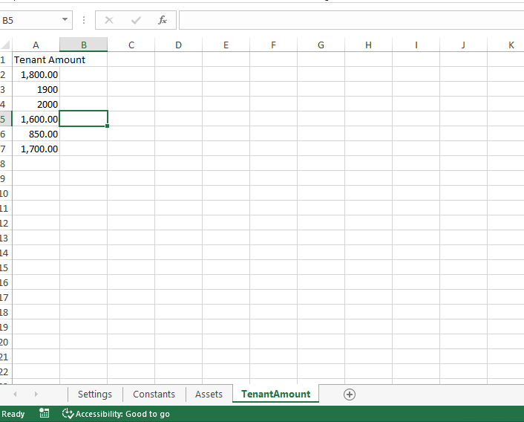
2. Copy the pdf files (for which you want to run) to MBTenantExtraction_Data\Input\New_PdfFiles
3. Run the Project
4. Status Report will be saved to folder MBTenantExtraction_Data\Output\Status_Files
5. Processed Pdf files will be moved to folder MBTenantExtraction_Data\Input\Processed_PdfFiles