ORIGINAL RAW DATASET(250 MRI-CASES)
https://zenodo.org/records/7153326
Hernandez Petzsche, M. R., de la Rosa, E., Hanning, U., Wiest, R., Valenzuela, W., Reyes, M., ... & Kirschke, J. S. (2022).
ISLES 2022: A multi-center magnetic resonance imaging stroke lesion segmentation dataset.
Scientific Data, 9(1), 762.

PRE-PROCESSED-MRI-DATA (EXECUTED LOCALLY): G-DRIVE
https://drive.google.com/drive/folders/1f0Po-w4fZu1ERCf5DbZQtZ_Hhzkdijbk?usp=sharing
below pre-processing correction and overlay are used
N4 Bias Correction | Removes intensity inhomogeneities from MRI images using N4 bias field correction
Register Image and Mask | Aligns images using registration with mutual information metric
Comprehensive Overlay | Creates RGB overlays for visualization

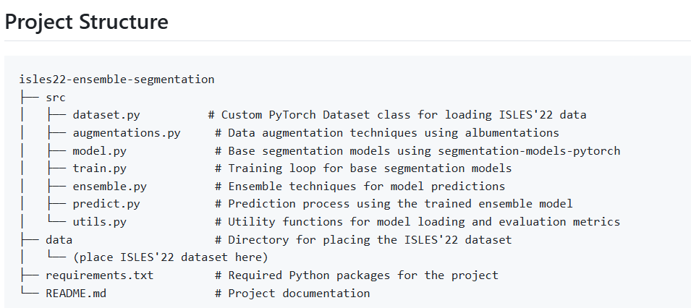
PIPELINE PROJECT STRUCTURE

