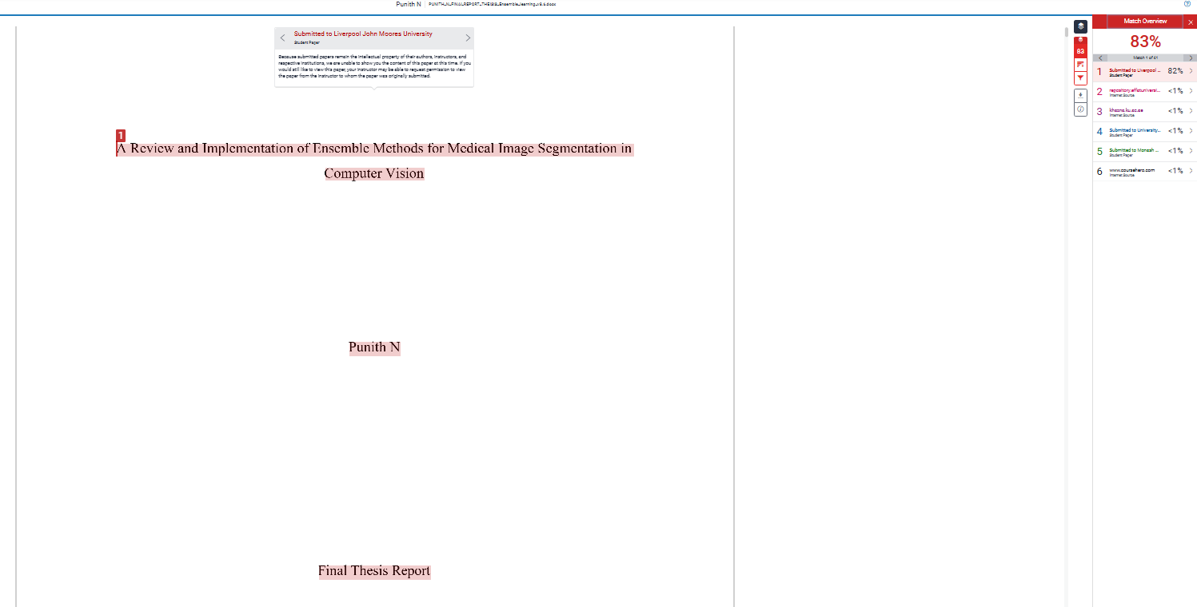
LJMU canvas is considering my own previously submitted paper and giving high TURNITIN score.
As Per Upgrad guidelines, I have taken screenshot and provided here for justification
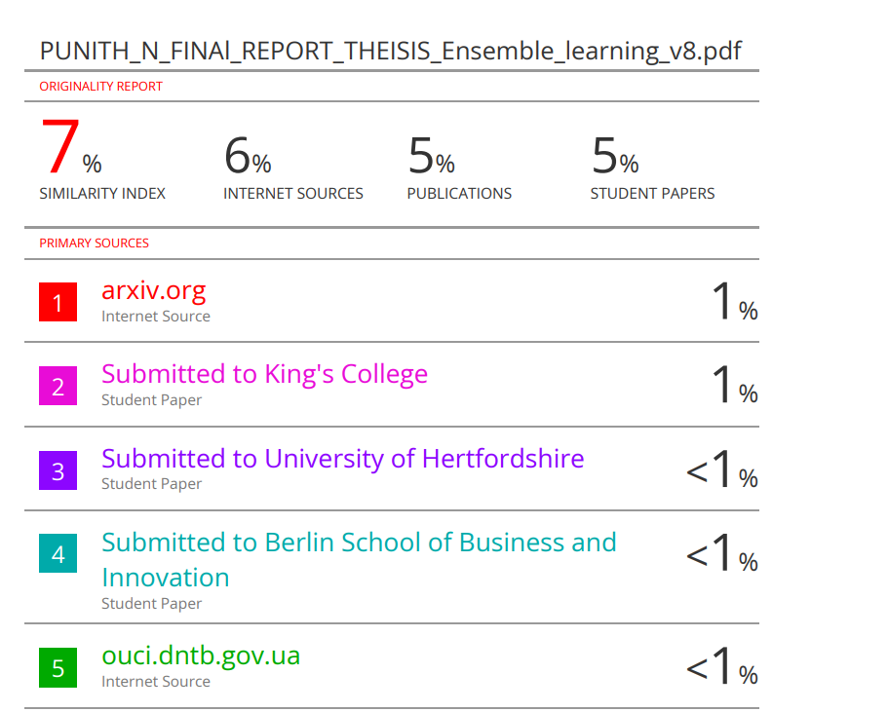
in Old assignment canvas

