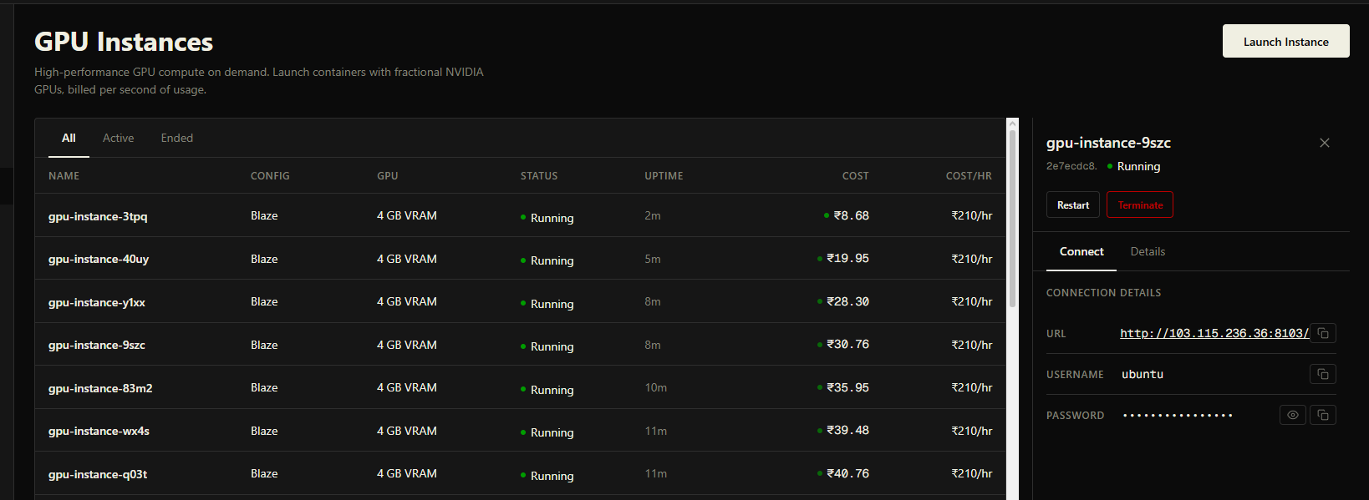

[Nest] 2140178 - 06/26/2026, 12:11:48 PM LOG [ComputeService] Session launching: sessionId=523788f3-9988-4676-999d-64c6bd52969d containerName=laas-523788f3
[Nest] 2140178 - 06/26/2026, 12:12:00 PM DEBUG [ComputeService] Reconciling 30 active sessions
[Nest] 2140178 - 06/26/2026, 12:12:00 PM DEBUG [ComputeService] Skipping 404 for starting session 523788f3-9988-4676-999d-64c6bd52969d (age: 12s)
[Nest] 2140178 - 06/26/2026, 12:12:04 PM ERROR [ComputeService] Session 523788f3-9988-4676-999d-64c6bd52969d launch failed: NVMe-oF setup unexpected error: Command '['sudo', 'nvme', 'discover', '-t', 'tcp', '-a', '10.10.100.132', '-s', '4420']' timed out after 15 seconds
[Nest] 2140178 - 06/26/2026, 12:12:04 PM ERROR [ComputeService] Session 523788f3-9988-4676-999d-64c6bd52969d release reason details: NVMe-oF setup unexpected error: Command '['sudo', 'nvme', 'discover', '-t', 'tcp', '-a', '10.10.100.132', '-s', '4420']' timed out after 15 seconds
[Nest] 2140178 - 06/26/2026, 12:12:30 PM DEBUG [ComputeService] Reconciling 29 active sessions

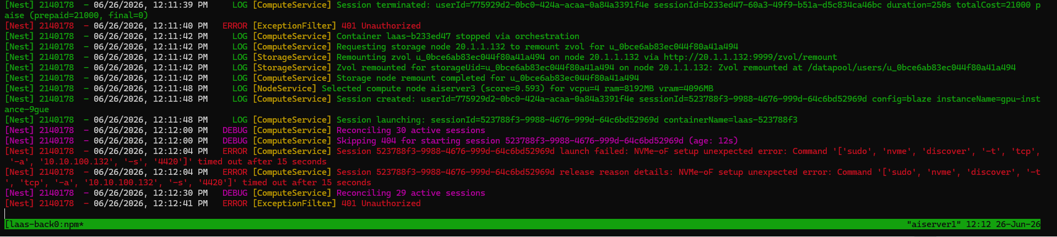

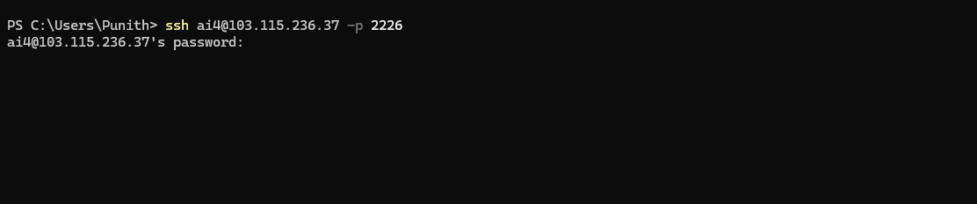
The system basically hangs up!!

