LAAS — LAB AS A SERVICE
Technical Architecture Document
━━━━━━━━━━━━━━━━━━━━━━━━━━━━━━━━━━━━━━━━

Version: v1.0
Date: March 2026
Status: POC Validated | Production Ready
Prepared for: KSRCE-GKT AI Lab
Classification: CONFIDENTIAL — Internal Use Only

TABLE OF CONTENTS

01 EXECUTIVE SUMMARY
02 PLATFORM OVERVIEW & OBJECTIVES
03 SYSTEM ARCHITECTURE (HLD)
04 HARDWARE SPECIFICATIONS
05 GPU FRACTIONAL DESKTOP ARCHITECTURE
06 INFRASTRUCTURE ARCHITECTURE
07 STORAGE ARCHITECTURE (ZFS/NFS)
08 AUTHENTICATION & AUTHORIZATION
09 MONITORING & OBSERVABILITY
10 APPLICATION ARCHITECTURE
11 BILLING & PAYMENT SYSTEM
12 SESSION LIFECYCLE
13 ISOLATION & MULTI-TENANCY
14 DATA FLOW & INTEGRATION MODEL
15 FAILURE ANALYSIS & MITIGATIONS
16 ARCHITECTURE RECONSIDERATIONS & LESSONS
17 RISK ASSESSMENT
18 TECHNOLOGY STACK SUMMARY
A APPENDIX A — API ENDPOINT REFERENCE
B APPENDIX B — ALERT RULES REFERENCE

SECTION 01 — EXECUTIVE SUMMARY
LaaS (Lab as a Service) delivers GPU-accelerated remote desktops and ephemeral compute environments to university students via fractional GPU sharing on RTX 5090 hardware. The platform combines Selkies EGL Desktop, WebRTC streaming, ZFS/NFS persistent storage, and enterprise-grade monitoring to create a unique educational computing platform.
KEY DIFFERENTIATOR
4-8 concurrent GPU-accelerated full desktop sessions per consumer GPU — no commercial platform offers this capability. Achieved through HAMi-core CUDA API interception and NVIDIA MPS (Multi-Process Service) for driver-level VRAM and compute partitioning.

Technology Stack Overview
|
|_> Frontend: Next.js 15, React 19, TypeScript 5.7, Tailwind CSS 4, Zustand 5
|_> Backend: NestJS 11 + Fastify, Prisma 6, PostgreSQL, Redis
|_> Host Services: Python Flask for storage provisioning (ZFS/NFS)
|_> Infrastructure: Docker CE, nvidia-container-toolkit, HAMi-core, CUDA MPS
|_> Monitoring: Prometheus 3.4, Grafana 11.5, Loki 3.4, Alertmanager 0.28

SECTION 02 — PLATFORM OVERVIEW & OBJECTIVES
Business Model
4 on-premises machines monetized for multi-tenant use. Revenue streams include university semester contracts, per-user storage allocation, per-session compute billing, and mentorship services planned for Phase 3.
Target Users
|
|_> University students — Stateful desktop sessions with persistent storage + ephemeral compute
|_> Faculty — Teaching labs, course management, assignment grading
|_> Researchers — High-performance GPU workloads, exclusive machine access
|_> Public users — Ephemeral compute only (Jupyter, Code-Server, SSH CLI)
Operational Modes
Mode 1: Stateful GUI Desktop — Full KDE Plasma desktop via Selkies EGL, 15GB persistent ZFS storage, CPU+GPU compute tiers, session booking required.
Mode 2: Ephemeral Compute — Jupyter notebooks, Code-Server, SSH CLI access, no persistent storage, no booking required, pay-per-use.
Compute Tier Configuration
Tier | vCPU | RAM | GPU VRAM | Best For
Starter | 2 | 4GB | None | Light coding, documentation
Standard | 4 | 8GB | None | MATLAB, general development
Pro | 4 | 8GB | 4GB | Blender, ML inference
Power | 8 | 16GB | 8GB | Heavy simulation, 3D rendering
Max | 8 | 16GB | 16GB | Large model training
Full Machine | 16 | 64GB | 32GB | Exclusive research/DL

SECTION 03 — SYSTEM ARCHITECTURE (HLD)
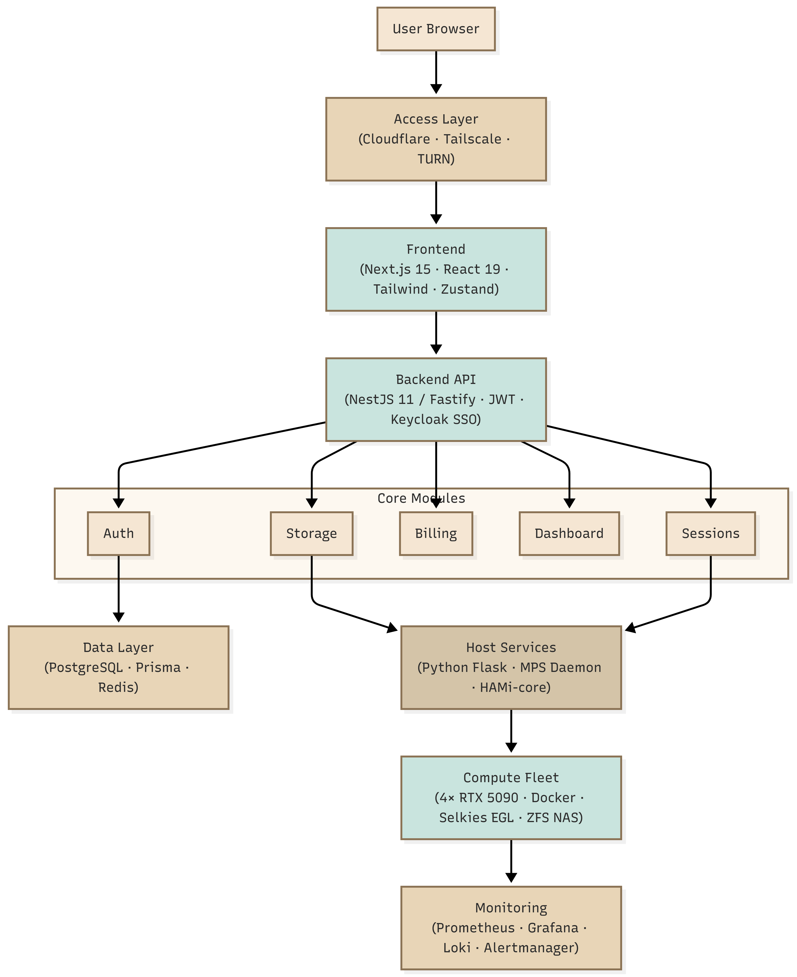
Fig. hld-application-architecture
Layered Architecture
Access Layer — Cloudflare Tunnel for public HTTPS ingress, Tailscale for administrative access. No public IP addresses exposed on compute nodes.
Frontend Layer — Next.js 15 with React 19, server-side rendering, Zustand for state management, Tailwind CSS 4 for styling. Lambda.ai Utilitarian Minimalism design system.
Backend Layer — NestJS 11 running on Fastify for maximum performance. JWT authentication with Keycloak SSO integration. RESTful API with OpenAPI documentation.
Data Layer — PostgreSQL via Prisma 6 ORM, Redis for caching and session state, ZFS datasets for user storage with NFS export.
Infrastructure Layer — 4× compute nodes (Proxmox VE 8.x), TrueNAS Scale NAS, Docker CE with nvidia-container-toolkit, HAMi-core for GPU fractioning, CUDA MPS daemon.

SECTION 04 — HARDWARE SPECIFICATIONS
Compute Node Fleet
Component | Model | Qty
CPU | AMD Ryzen 9 9950X3D (16C/32T) | 4
GPU | Zotac RTX 5090 Solid OC 32GB | 4
RAM | G.SKILL DDR5 6000MHz 64GB | 4
Storage | Samsung 990 EVO Plus 2TB | 4
Motherboard | ASUS ProArt X670E-Creator | 4
PSU | Corsair AX1600i 1600W | 4

FLEET TOTAL CAPACITY
64 CPU cores • 256GB system RAM • 128GB GPU VRAM • 8TB NVMe storage

Network Attached Storage
TrueNAS Scale with 4×4TB drives in RAIDZ1 configuration providing approximately 12TB usable capacity. 10GbE connectivity to compute nodes.
NVMe Partition Layout (Per Node)
Partition | Size | Filesystem | Purpose
p1 | 128GB | EXT4 | Proxmox OS + swap
p2 | 500GB | EXT4 | Docker images + layers
p3 | 1100GB | LVM | Container scratch space
p4 | 240GB | EXT4 | Shared read-only datasets

Network Infrastructure
Mikrotik CRS309 10GbE switch with 4 VLANs:
|
|_> VLAN 10: Management — Proxmox UI, SSH, monitoring endpoints
|_> VLAN 20: Stateful — Desktop session traffic, NFS mounts
|_> VLAN 30: Ephemeral — Jupyter, Code-Server, SSH sessions
|_> VLAN 40: Proxy — Cloudflare Tunnel, external ingress

SECTION 05 — GPU FRACTIONAL DESKTOP ARCHITECTURE
BREAKTHROUGH CAPABILITY
This section describes the core innovation of LaaS: running 4-8 concurrent GPU-accelerated full desktop sessions on a single consumer RTX 5090 GPU. No other commercial platform offers this capability.

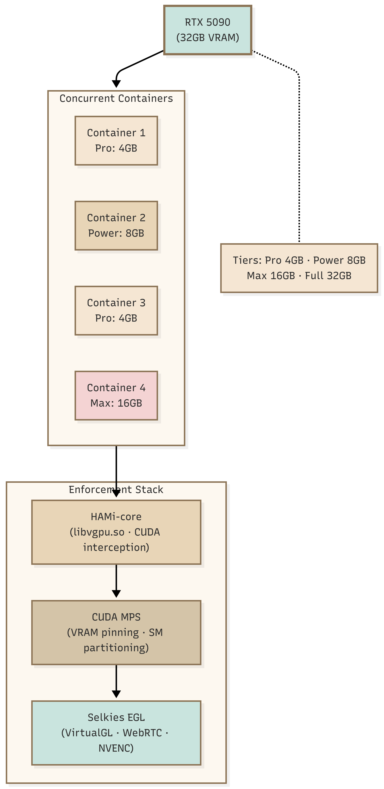
Fig. gpu-fractional-architecture
Technology Stack
1. Selkies EGL Desktop — Full KDE Plasma desktop environment running inside Docker containers. GPU rendering via VirtualGL EGL backend. WebRTC streaming with NVENC hardware encoding for sub-50ms latency.
2. HAMi-core (libvgpu.so)— CUDA API interception library providing software-level GPU partitioning:
|
|_> cuMemAlloc interception — Enforces per-container VRAM allocation limits
|_> cuDeviceGetAttribute override — Reports fake VRAM visibility to applications
|_> cuLaunchKernel throttling — Limits compute kernel execution rate
3. CUDA MPS (Multi-Process Service) — NVIDIA driver-level GPU sharing:
|
|_> CUDA_MPS_PINNED_DEVICE_MEM_LIMIT — Secondary VRAM enforcement
|_> CUDA_MPS_ACTIVE_THREAD_PERCENTAGE — SM (Streaming Multiprocessor) partitioning
|_> Isolated VA (Virtual Address) spaces — Memory isolation between clients
Competitive Advantage
Platform | Concurrent/GPU | VRAM Tiers | Desktop Stream
RunPod | 1 (exclusive) | All-or-nothing | No
Vast.ai | 1 (exclusive) | Exclusive | No
Lambda Labs | 1 per user | Exclusive | No
Google Colab | Shared (preemption) | Fractional | No (notebook only)
LaaS | 4-8 | 4/8/16/32 GB | Yes (WebRTC)

SECTION 06 — INFRASTRUCTURE ARCHITECTURE
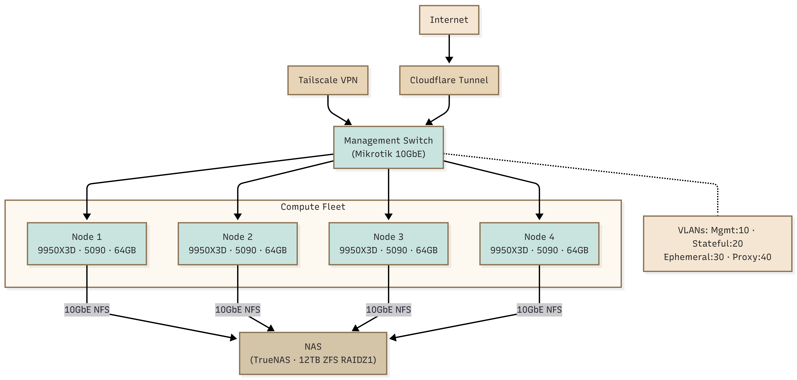
Fig.infrastructure-architecture
Node Configuration
Each compute node runs:
|_> Proxmox VE 8.x — Hypervisor and container management
|_> NVIDIA Driver 555.x — GPU driver with CUDA 12.x support
|_> nvidia-container-toolkit — Docker GPU integration
|_> CUDA MPS Daemon — Multi-process GPU sharing service
|_> Docker CE — Container runtime
|_> HAMi-core (libvgpu.so) — Preloaded via LD_PRELOAD for CUDA interception
Dynamic Scheduling
No static node roles — all nodes capable of running any workload type. Session scheduler evaluates available capacity (CPU, RAM, VRAM) across fleet and assigns sessions to optimal node.
OPERATIONAL REQUIREMENT
HDMI dummy dongles required on all GPUs for headless rendering. Without a connected display (or dummy plug), the GPU will not initialize display outputs required for EGL.
SECTION 07 — STORAGE ARCHITECTURE (ZFS/NFS)
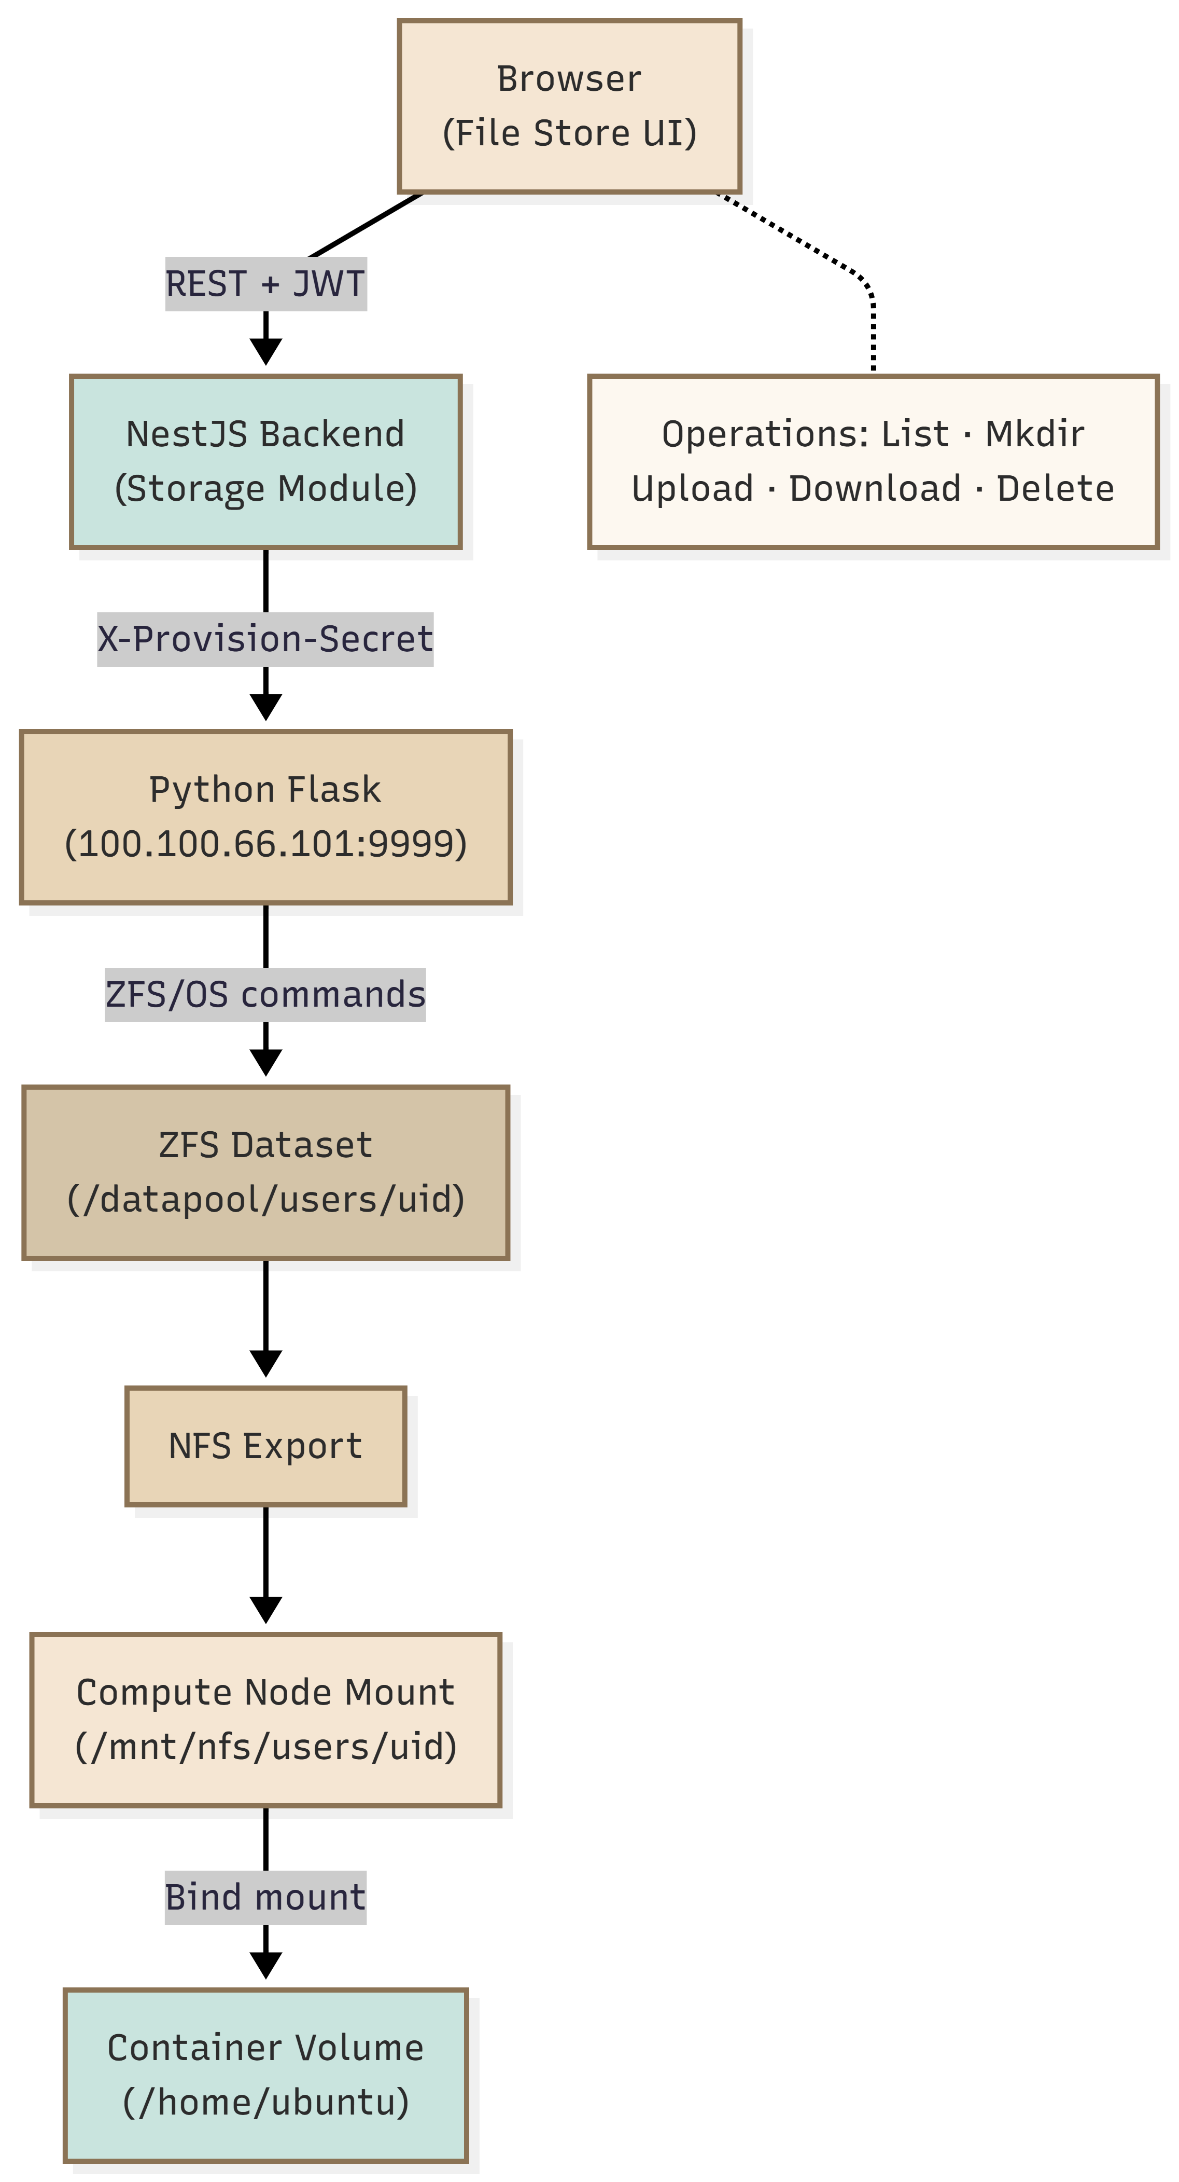
Fig. file-store-architecture
Design Principles
Hard partition between stateful user data and ephemeral compute data. User files persist across sessions; container scratch space is destroyed on session end.
Per-User ZFS Dataset
# Dataset path
datapool/users/<storage_uid>
# Quota enforcement
zfs set quota=15G datapool/users/<storage_uid>
# Automatic snapshots every 6 hours
zfs-auto-snapshot --label=hourly --keep=4 datapool/users/<storage_uid>

NFS Export Configuration
Individual NFS export per user dataset, mounted on compute nodes at /mnt/nfs/users/<uid>. Bind mounted into containers:
docker run -v /mnt/nfs/users/<uid>:/home/ubuntu ...

LESSON LEARNED
NFS gotcha discovered during POC: Must export individual child datasets, not the parent dataset. Exporting the parent causes permission and mount issues.

File Operations Pipeline
Browser → NestJS Backend → Python Flask Host Service → ZFS
Supported operations: List, Create folder, Upload (500MB limit), Download, Delete.

SECTION 08 — AUTHENTICATION & AUTHORIZATION

Fig. auth-Sequence
Authentication Paths
|
|_> University SSO — Keycloak brokering to institution IdP (Google Workspace or LDAP)
|_> Public OAuth — Direct Google/GitHub authentication
|_> Local Authentication — Email + password with OTP verification
Storage Provisioning
SSO users from registered universities automatically receive 15GB ZFS dataset provisioned on first login. Public OAuth users do not receive persistent storage (ephemeral only).

Token Lifecycle
JWT access tokens (15min expiry) + refresh tokens (7 day expiry). Tokens stored in localStorage. Automatic refresh on 401 response.
RBAC Model
Users → UserOrgRoles → Organizations → Roles → Permissions
Permissions are action-based (e.g., session:create, storage:upload, billing:view).

SECTION 09 — MONITORING & OBSERVABILITY
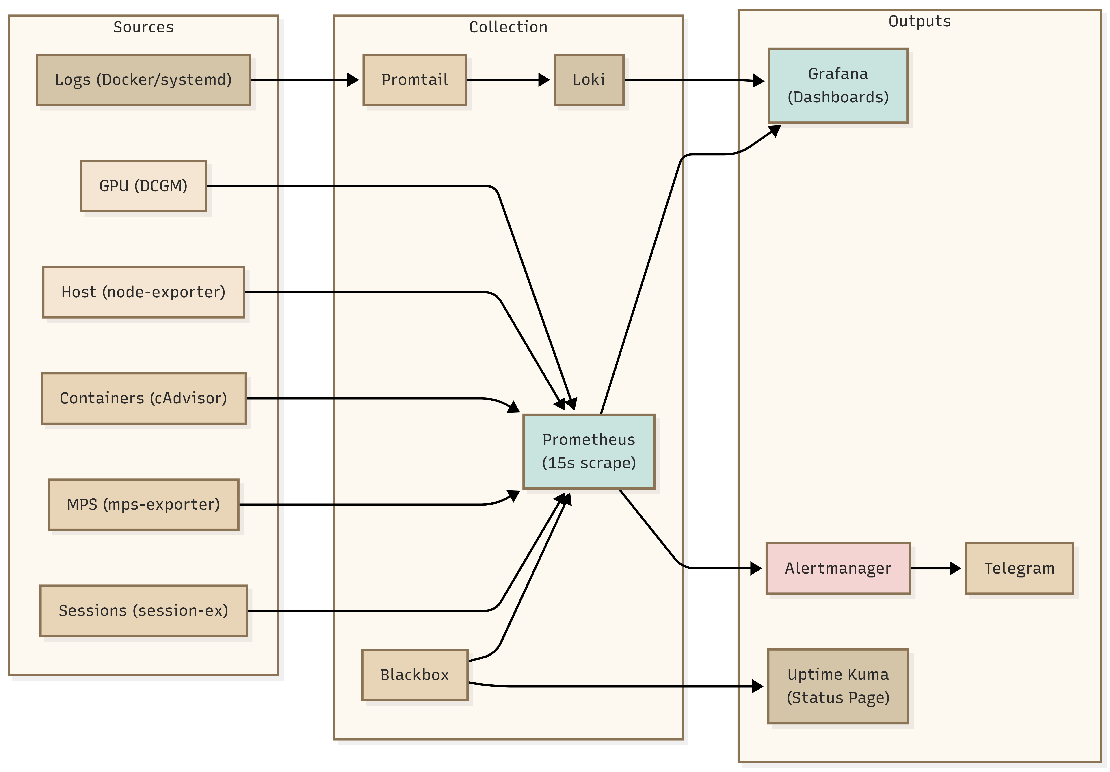
Fig. monitoring-architecture
Monitoring Stack
Component | Version | Purpose
Prometheus | 3.4.0 | Metrics collection and alerting
Grafana | 11.5.0 | Visualization and dashboards
Loki | 3.4.2 | Log aggregation
Alertmanager | 0.28.1 | Alert routing and deduplication
Uptime Kuma | 1.23.x | Synthetic monitoring

Metrics Exporters
Exporter | Port | Metrics
DCGM | 9400 | GPU temp, power, VRAM, ECC errors
node-exporter | 9100 | CPU, RAM, disk, network, NFS
cAdvisor | 8999 | Container CPU%, RAM%, I/O
mps-exporter | 9500 | MPS state, faults, NVENC sessions
session-exporter | 9501 | Active sessions, VRAM allocation
Blackbox | 9115 | HTTP/TCP endpoint probes

Alert Categories
|
|_> GPU Alerts — Temperature, power draw, VRAM overcommit, MPS faults, ECC errors
|_> Session Alerts — Startup timeout, concurrent limit, WebRTC FPS degradation
|_> Host Alerts — Disk space, NFS mount health, CPU/RAM saturation
|_> Security Alerts — Failed login attempts, suspicious activity patterns
Log Aggregation
Promtail agents scrape container logs, systemd journal, and CUDA MPS logs. Forwarded to Loki for storage. Grafana LogQL for querying and visualization.

SECTION 10 — APPLICATION ARCHITECTURE
10.1 Backend (NestJS 11 + Fastify)
Modular architecture with clear separation of concerns:
Module | Responsibility
AuthModule | JWT issuance, Keycloak integration, SSO flows
StorageModule | File operations, ZFS provisioning orchestration
DashboardModule | User metrics, session history, billing summary
PaymentModule | Razorpay integration, wallet management
MailModule | Transactional emails, OTP delivery
PrismaModule | Database connection, query building

Key dependencies: Prisma 6.0, Razorpay 2.9.6, Keycloak Admin 26.5.5, PDFKit 0.18, bcrypt, Zod for validation.
10.2 Frontend (Next.js 15)
Technology stack: React 19, TypeScript 5.7, Tailwind CSS 4, Zustand 5 for state, Recharts 3.8 for charts, Radix UI for accessible components.
Design system: Lambda.ai Utilitarian Minimalism — Clean typography, subtle animations, dark/light mode support with warm color palette.

10.3 Database (PostgreSQL + Prisma)
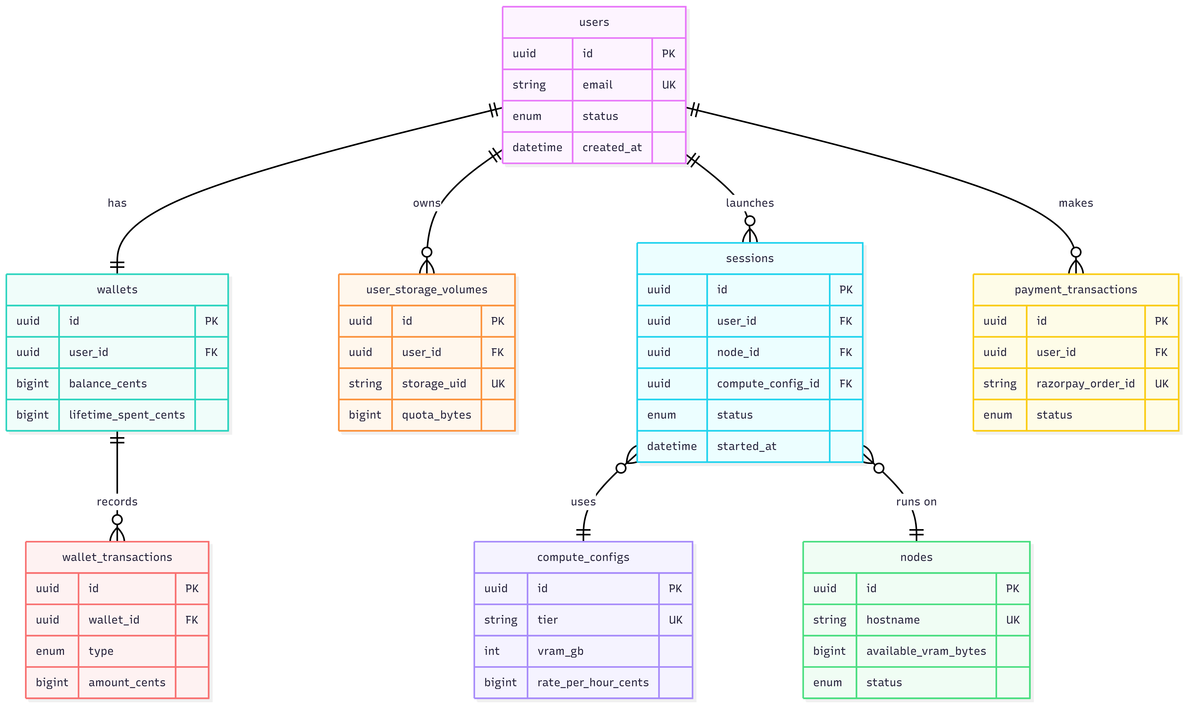
Fig. database-erd
Domain | Tables | Purpose
Auth & Identity | users, user_profiles, refresh_tokens, login_history, otp_verification | User management
Organizations | universities, university_idp_configs, departments, user_groups | Multi-tenancy
Storage | user_storage_volumes, storage_extensions, os_switch_history | Persistent storage
Infrastructure | nodes, base_images, node_base_images | Fleet management
Compute | compute_configs, compute_config_access | Tier definitions
Sessions | bookings, sessions, session_events | Session lifecycle
Billing | wallets, wallet_holds, wallet_transactions, billing_charges, payment_transactions, invoices | Payments
Academic | courses, labs, lab_assignments, lab_submissions, lab_grades | LMS integration

10.4 Python Host Service
Flask application running on port 9999 on each compute node. Provides ZFS provisioning and file operations. Secured with X-Provision-Secret header, path traversal protection, and storageUid validation.

SECTION 11 — BILLING & PAYMENT SYSTEM
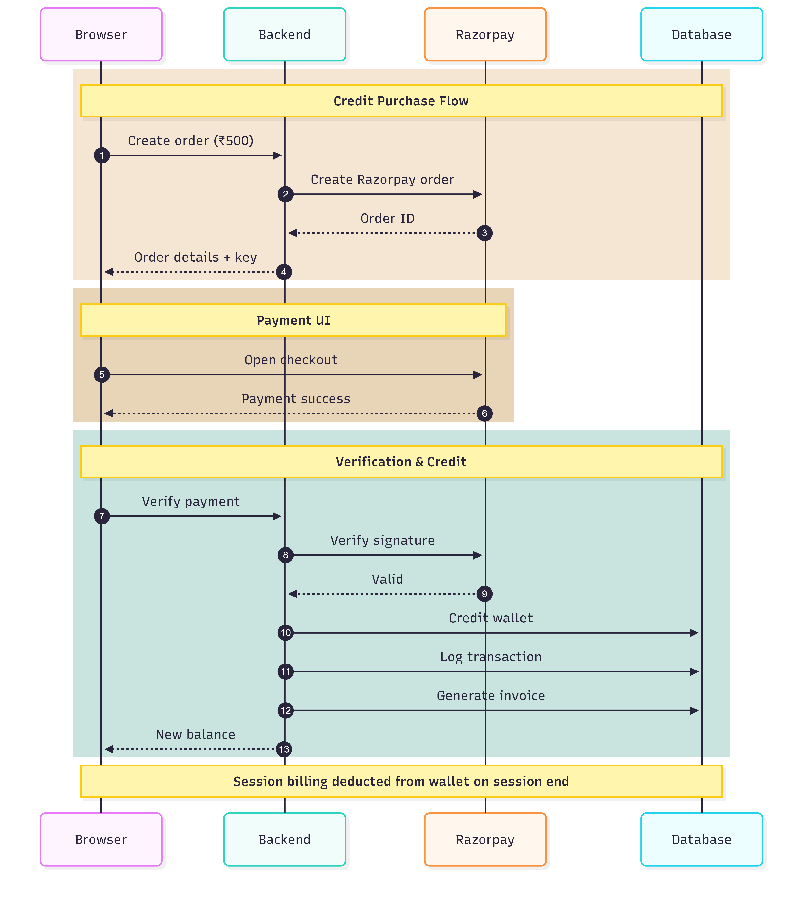
Fig. billing-payment-flow

Payment Integration
Razorpay payment gateway (test mode during POC, INR currency). Flow:
|
|_> User initiates wallet recharge → Backend creates Razorpay order
|_> User completes payment in Razorpay UI
|_> Razorpay webhook → Backend verifies signature → Credits wallet
|_> Invoice generated with PDFKit → Emailed to user
Wallet Model
Prepaid balance stored in paise (1/100 of INR). Wallet holds placed for active sessions to reserve funds. Spend limits configurable per user/organization.
Per-Session Billing
Billing formula: duration (minutes) × tier rate = charge amount
Charge deducted from wallet on session end. Hold released after successful capture.

SECTION 12 — SESSION LIFECYCLE
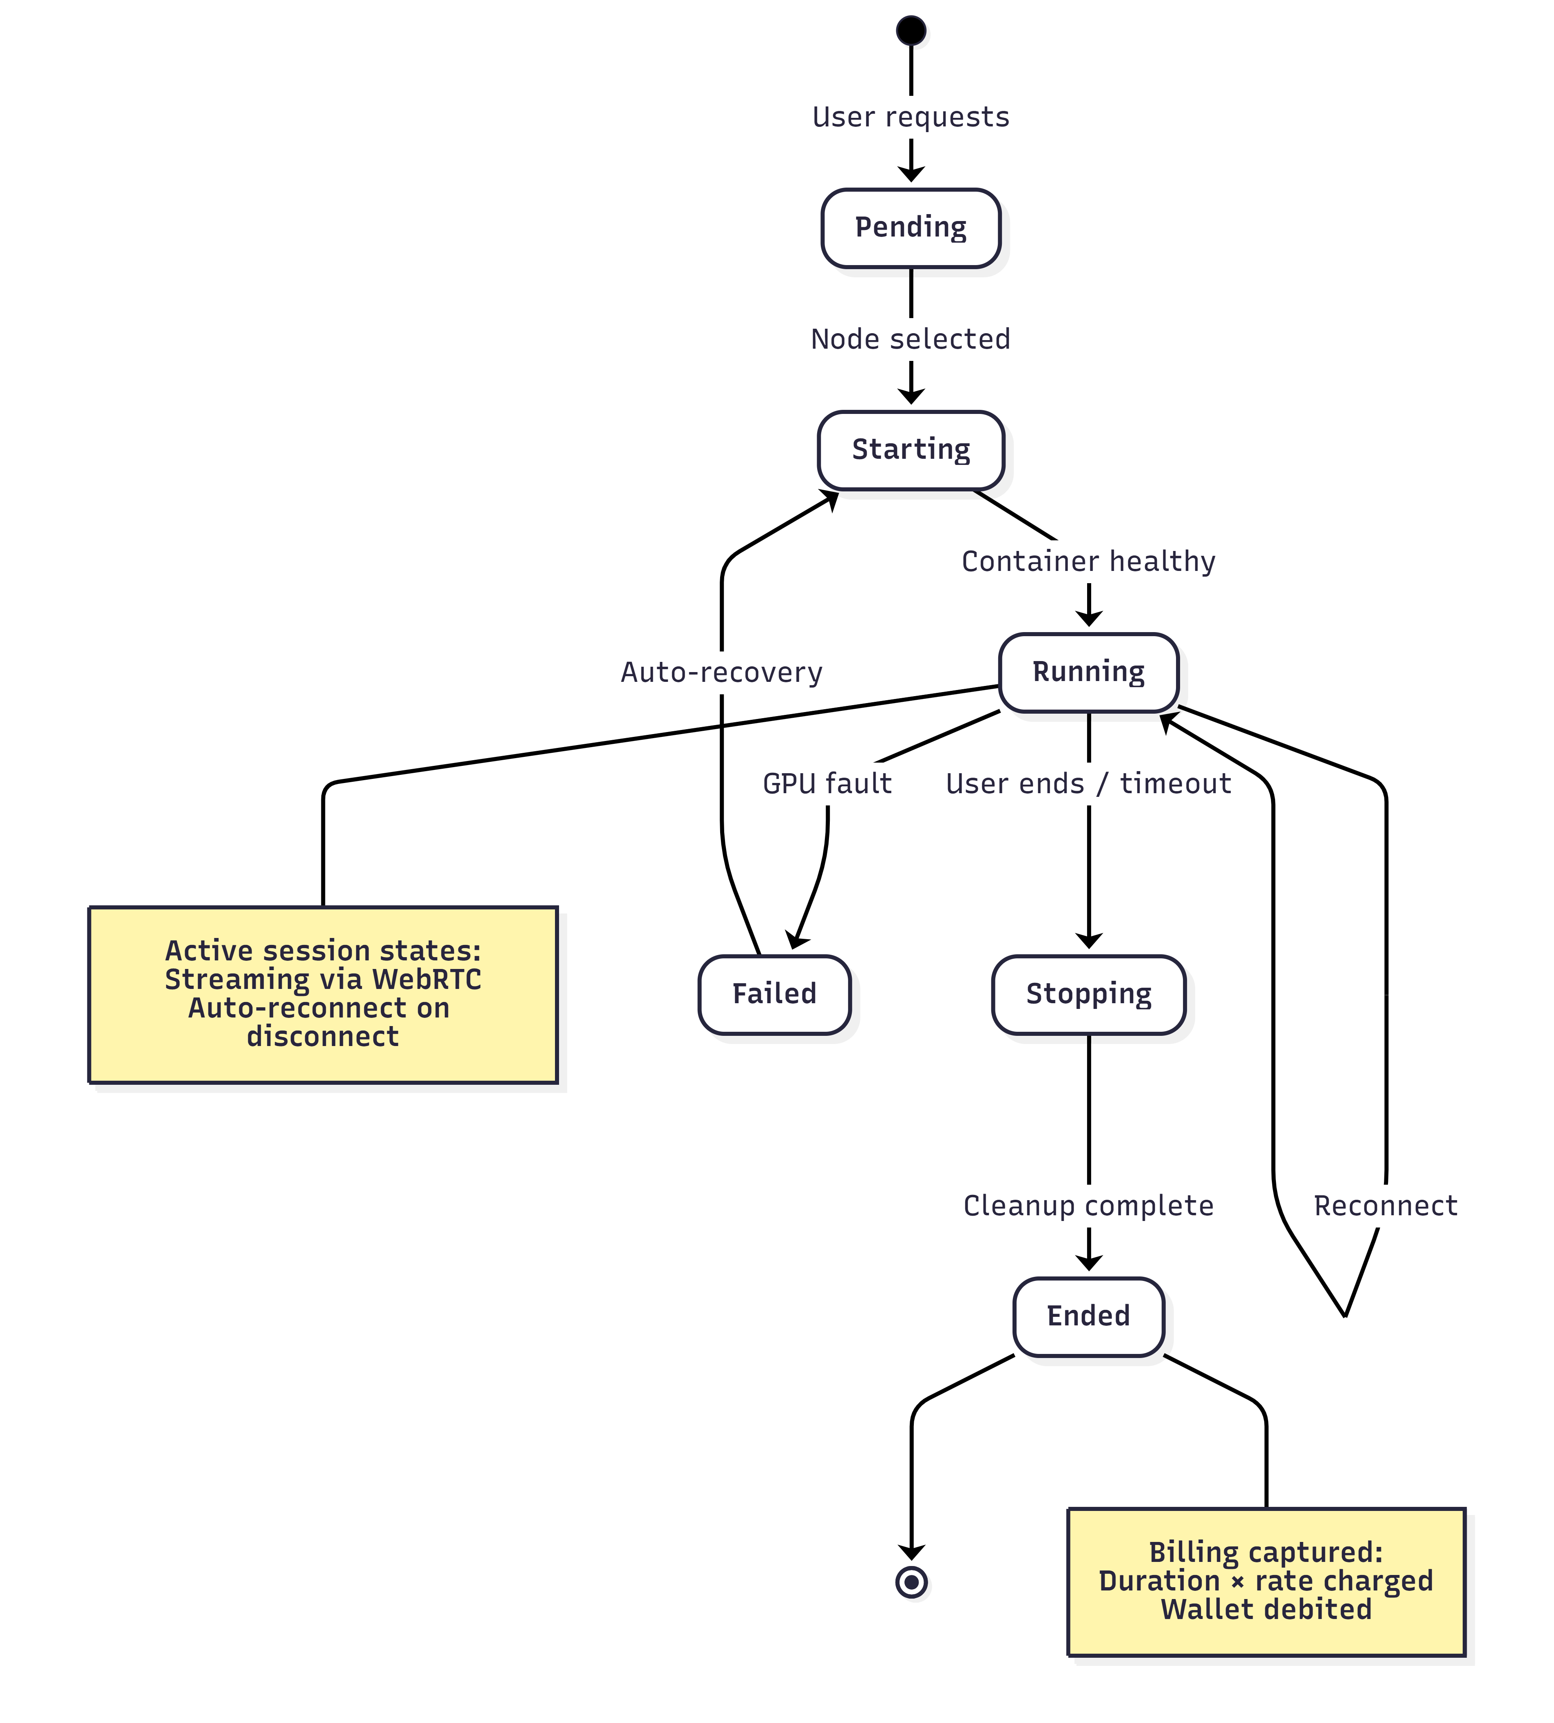
Fig. session-lifecycle
Session Launch Flow
|
|_> User selects compute tier → Backend checks fleet capacity
|_> Backend creates session record → Calls compute node API
|_> Node executes docker run with HAMi+MPS environment variables
|_> Container starts → Health poll until ready (30s timeout)
|_> WebRTC URL returned to user → Desktop stream begins
Docker Run Configuration
docker run -d \
--name session-<session_id> \
--gpus all \
-e CUDA_MPS_PINNED_DEVICE_MEM_LIMIT=0=8G \
-e CUDA_MPS_ACTIVE_THREAD_PERCENTAGE=25 \
-e LD_PRELOAD=/usr/lib/libvgpu.so \
-e VGPU_MEMORY_LIMIT=8589934592 \
-v /mnt/nfs/users/<uid>:/home/ubuntu \
selkies-gstreamer:latest

Session States
pending → starting → running → reconnecting → stopping → ended/failed
Crash Recovery
MPS fault detection → Watchdog triggers auto-recovery → Container restart → Session reconnection prompt to user.

SECTION 13 — ISOLATION & MULTI-TENANCY
Layer | Isolation Level | Mechanism
CPU/RAM | Hard | cgroups v2
Filesystem | Hard | Docker RO layers + NFS mount
Process | Strong | PID namespaces
Network | Strong | Network namespaces + VLANs
GPU VRAM | Enforced | HAMi-core + MPS
GPU Compute | Enforced | HAMi-core + MPS
GPU VA Space | Isolated | MPS (Volta+ GPUs)
GPU L2/Bandwidth | Shared | Cannot partition consumer GPUs

PERFORMANCE CONSIDERATION
Honest assessment: 10-30% performance variability under peak co-tenancy conditions due to shared GPU L2 cache and memory bandwidth. This is acceptable for educational workloads and significantly better than preemption-based alternatives.

SECTION 14 — DATA FLOW & INTEGRATION MODEL

Fig. data-flow-diagram
Primary Data Flows
|
|_> User Authentication — Browser → Frontend → Backend → Keycloak/Database
|_> Session Launch — Frontend → Backend → Node Scheduler → Docker → WebRTC
|_> File Operations — Frontend → Backend → Flask Host Service → ZFS/NFS
|_> Metrics Collection — Exporters → Prometheus → Grafana → Alertmanager
|_> Payments — Frontend → Backend → Razorpay → Webhook → Wallet
External Integrations
System | Integration Type | Data Flow
Keycloak | OIDC/OAuth2 | SSO authentication, token validation
Razorpay | REST API + Webhooks | Payment orders, verification
Cloudflare | Tunnel | HTTPS ingress, DDoS protection
Tailscale | WireGuard mesh | Admin VPN access

SECTION 15 — FAILURE ANALYSIS & MITIGATIONS
Architecture Evolution
Version | Date | Model | Issues Encountered
v1 | Jan 2026 | KVM VMs + GPU passthrough | D3cold power bug, no fractional GPU
v2 | Feb 2026 | Hybrid VMs + Containers | Mode switching complexity
v3 | Mar 2026 | Unified Containers | Current — all major issues resolved

D3cold Power State Bug
Initial VM approach caused GPU to enter D3cold power state after VM shutdown, requiring host reboot to recover. Eliminated by moving to container-only architecture where GPU remains attached to host.
NVENC Concurrent Session Limit
Consumer GPUs have 3-5 concurrent NVENC session limit. Resolved using nvidia-patch to remove artificial driver limit.
RTX 5090 Constraints
HARDWARE LIMITATION
RTX 5090 (consumer GPU) does not support vGPU, MIG, or SR-IOV hardware partitioning. Software partitioning via HAMi-core + MPS is the only viable approach.

SECTION 16 — ARCHITECTURE RECONSIDERATIONS & LESSONS
Why Containers Over VMs
|
|_> Faster startup time (seconds vs minutes)
|_> Lower overhead (no hypervisor layer)
|_> GPU remains attached to host — no D3cold issues
|_> Easier resource management with cgroups
Why Not Kubernetes on Day 1
|
|_> Complexity overhead for 4-node cluster
|_> GPU scheduling in K8s requires additional tooling
|_> Docker Compose sufficient for POC validation
|_> Planned migration to K8s for production scale-out
Why ZFS Over Ceph
|
|_> Native quotas and snapshots without additional tooling
|_> Lower operational complexity for small cluster
|_> Excellent NFS integration
|_> Per-user datasets provide strong isolation

SECTION 17 — RISK ASSESSMENT
Technical Risks
Risk | Likelihood | Impact | Mitigation
GPU driver crash | Low | High | Watchdog + auto-recovery
NFS mount failure | Medium | High | Health checks + alerting
MPS fault | Low | Medium | Per-client isolation + restart
VRAM overcommit | Medium | Medium | HAMi-core enforcement

Operational Risks
Risk | Likelihood | Impact | Mitigation
Power failure | Low | High | UPS + graceful shutdown
Network partition | Low | High | Redundant uplinks
Storage full | Medium | Medium | Quota enforcement + alerts

Licensing Risks
Risk | Likelihood | Impact | Mitigation
NVIDIA EULA violation | Low | High | Legal review of MPS usage
NVENC patch legality | Medium | Medium | Educational use exemption

SECTION 18 — TECHNOLOGY STACK SUMMARY
Category | Technology | Version
Frontend Framework | Next.js | 15.x
UI Library | React | 19.x
Language | TypeScript | 5.7
Styling | Tailwind CSS | 4.x
State Management | Zustand | 5.x
Backend Framework | NestJS | 11.x
HTTP Server | Fastify | 5.x
ORM | Prisma | 6.0
Database | PostgreSQL | 16.x
Cache | Redis | 7.x
Container Runtime | Docker CE | 26.x
GPU Toolkit | nvidia-container-toolkit | 1.16
GPU Sharing | HAMi-core + CUDA MPS | Custom
Desktop Streaming | Selkies EGL + WebRTC | Latest
Monitoring | Prometheus | 3.4.0
Visualization | Grafana | 11.5.0
Logging | Loki | 3.4.2
Payment Gateway | Razorpay | 2.9.6

SECTION A — API ENDPOINT REFERENCE
Authentication Endpoints
Method | Path | Description
POST | /auth/login | Email/password login
POST | /auth/register | New user registration
POST | /auth/refresh | Refresh access token
POST | /auth/logout | Revoke refresh token
GET | /auth/sso/keycloak | Initiate Keycloak SSO
GET | /auth/sso/callback | SSO callback handler

Storage Endpoints
Method | Path | Description
GET | /storage/files | List user files
POST | /storage/files | Upload file (500MB limit)
GET | /storage/files/:path | Download file
DELETE | /storage/files/:path | Delete file
POST | /storage/folders | Create folder
GET | /storage/usage | Get storage usage

Session Endpoints
Method | Path | Description
POST | /sessions | Launch new session
GET | /sessions/:id | Get session status
POST | /sessions/:id/stop | Stop session
GET | /sessions/:id/connect | Get WebRTC URL

Billing Endpoints
Method | Path | Description
GET | /wallet | Get wallet balance
POST | /wallet/recharge | Create recharge order
POST | /wallet/webhook | Razorpay webhook
GET | /invoices | List invoices
GET | /invoices/:id/pdf | Download invoice PDF

SECTION B — ALERT RULES REFERENCE
GPU Alerts
Alert Name | Condition | Severity
GPUTemperatureHigh | temp > 85°C for 5m | warning
GPUTemperatureCritical | temp > 95°C for 1m | critical
GPUPowerDraw | power > 450W for 10m | warning
GPUVRAMOvercommit | allocated > physical | critical
GPUMPSFault | mps_fault_count > 0 | critical
GPUECCError | ecc_errors > 10 | warning

Session Alerts
Alert Name | Condition | Severity
SessionStartupTimeout | starting > 60s | warning
SessionConcurrentLimit | sessions > max_per_node | warning
WebRTCFPSDrop | fps < 20 for 2m | warning
SessionOrphaned | no heartbeat for 10m | critical

Host Alerts
Alert Name | Condition | Severity
DiskSpaceLow | free < 10% | warning
DiskSpaceCritical | free < 5% | critical
NFSMountUnhealthy | mount check failed | critical
CPUSaturation | usage > 90% for 15m | warning
RAMSaturation | usage > 95% for 5m | warning

Security Alerts
Alert Name | Condition | Severity
FailedLoginSpike | > 10 failures in 5m | warning
SuspiciousAPIPattern | anomaly detection trigger | warning
UnauthorizedAccess | 401/403 spike | critical

