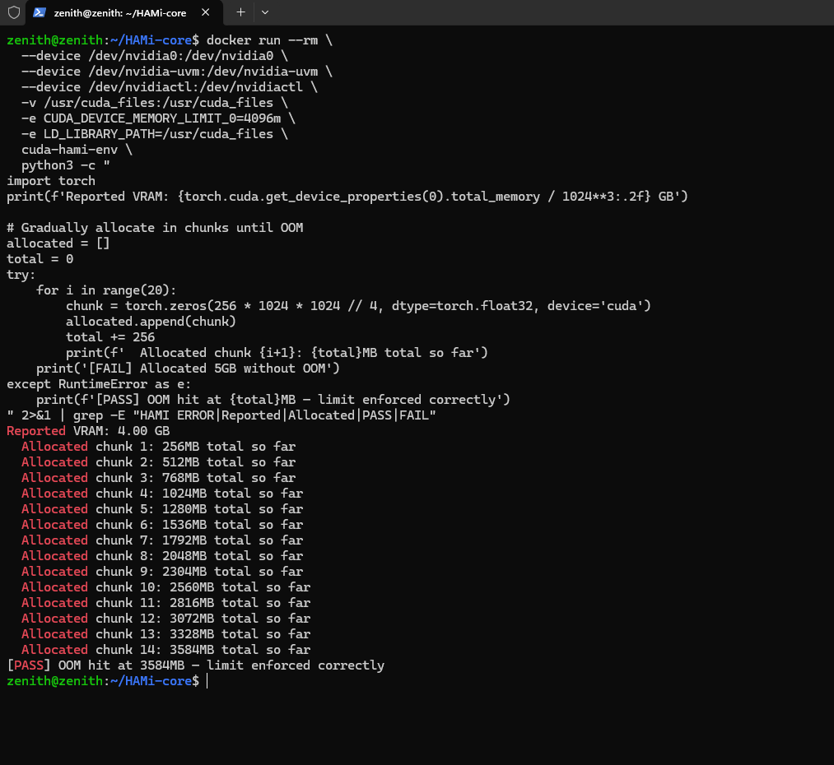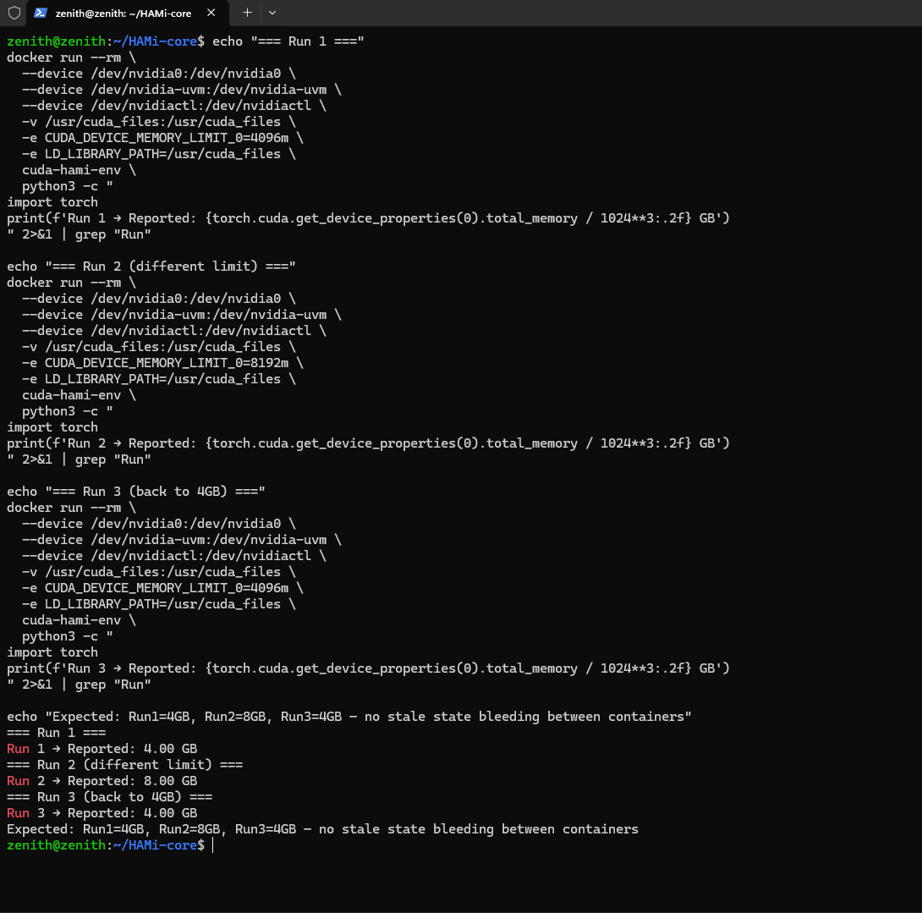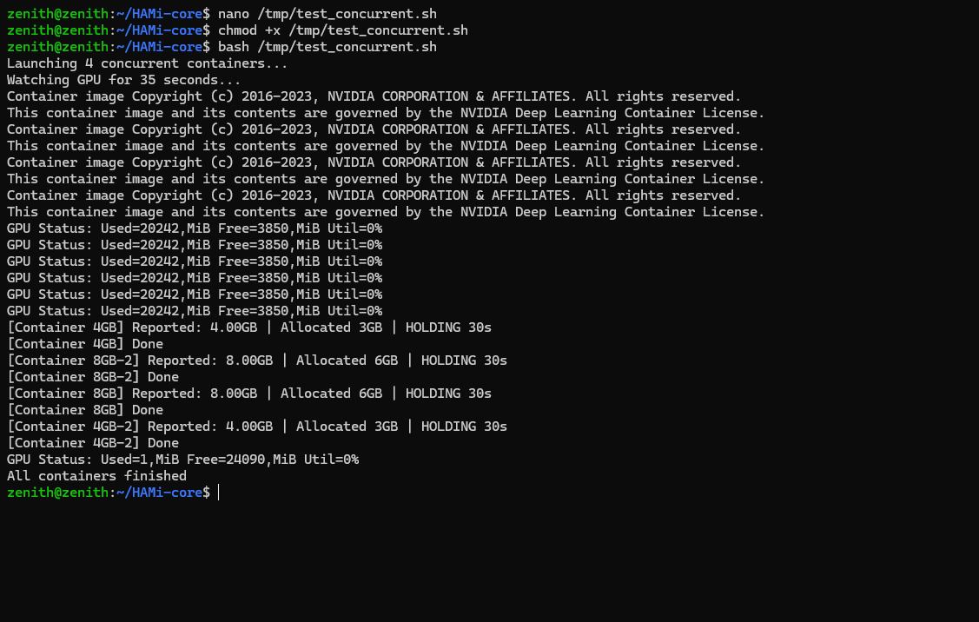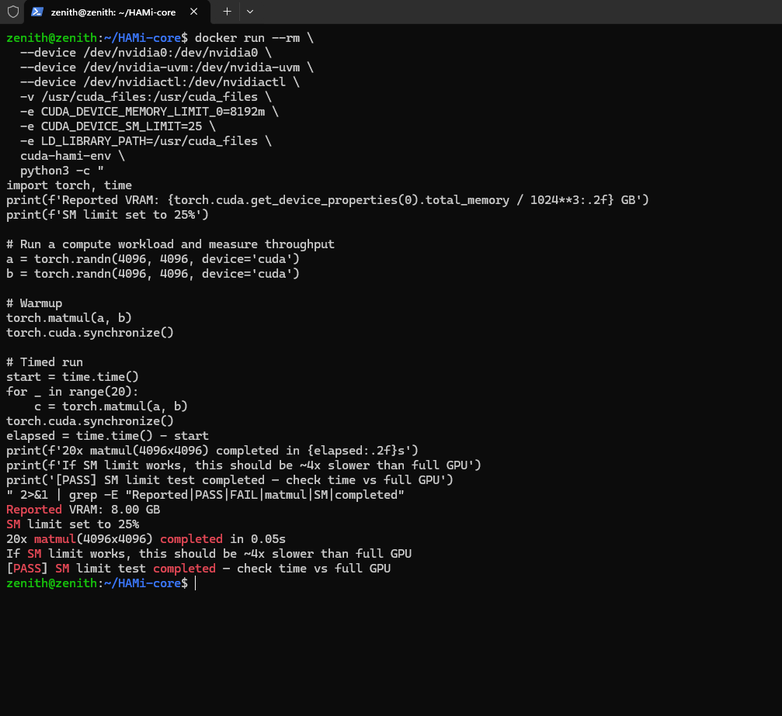
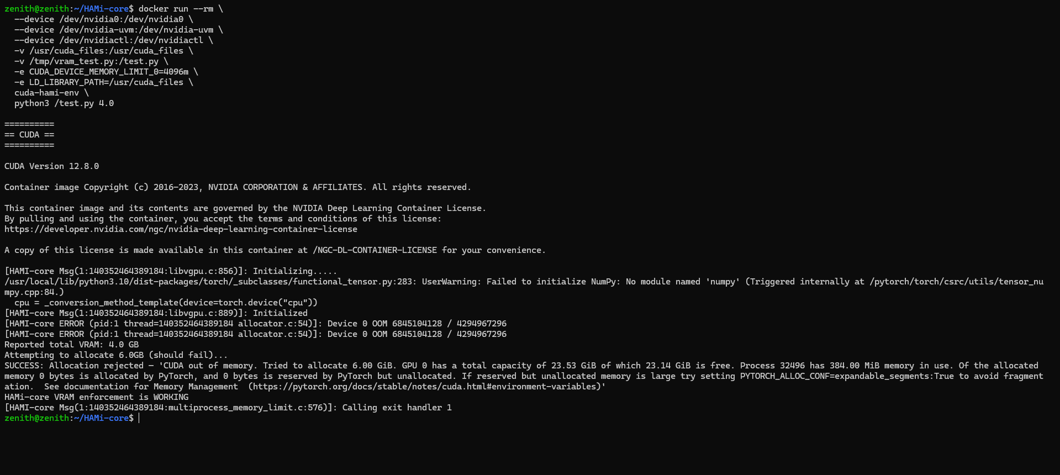

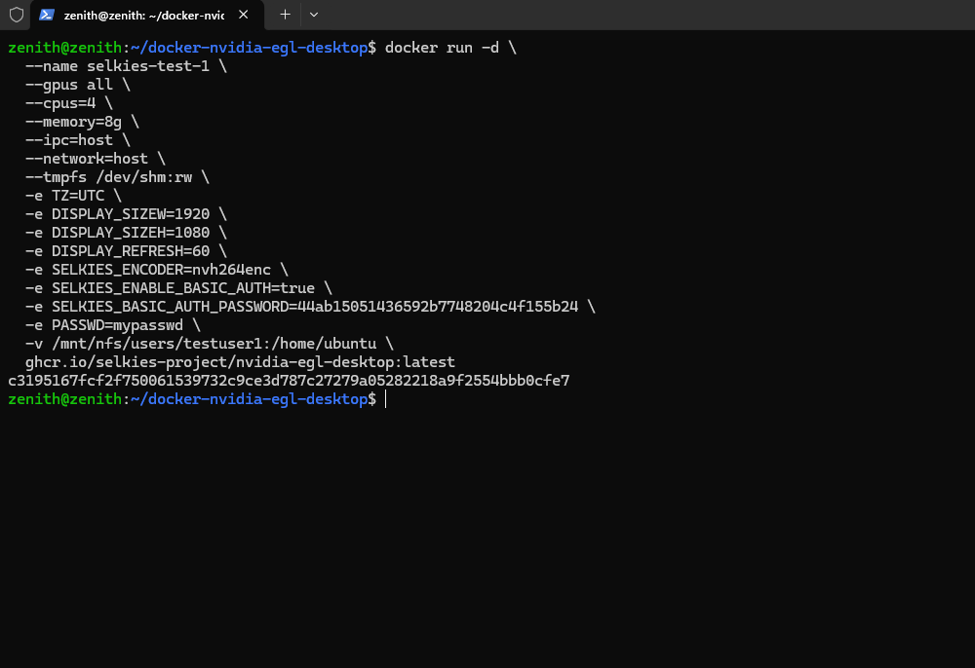

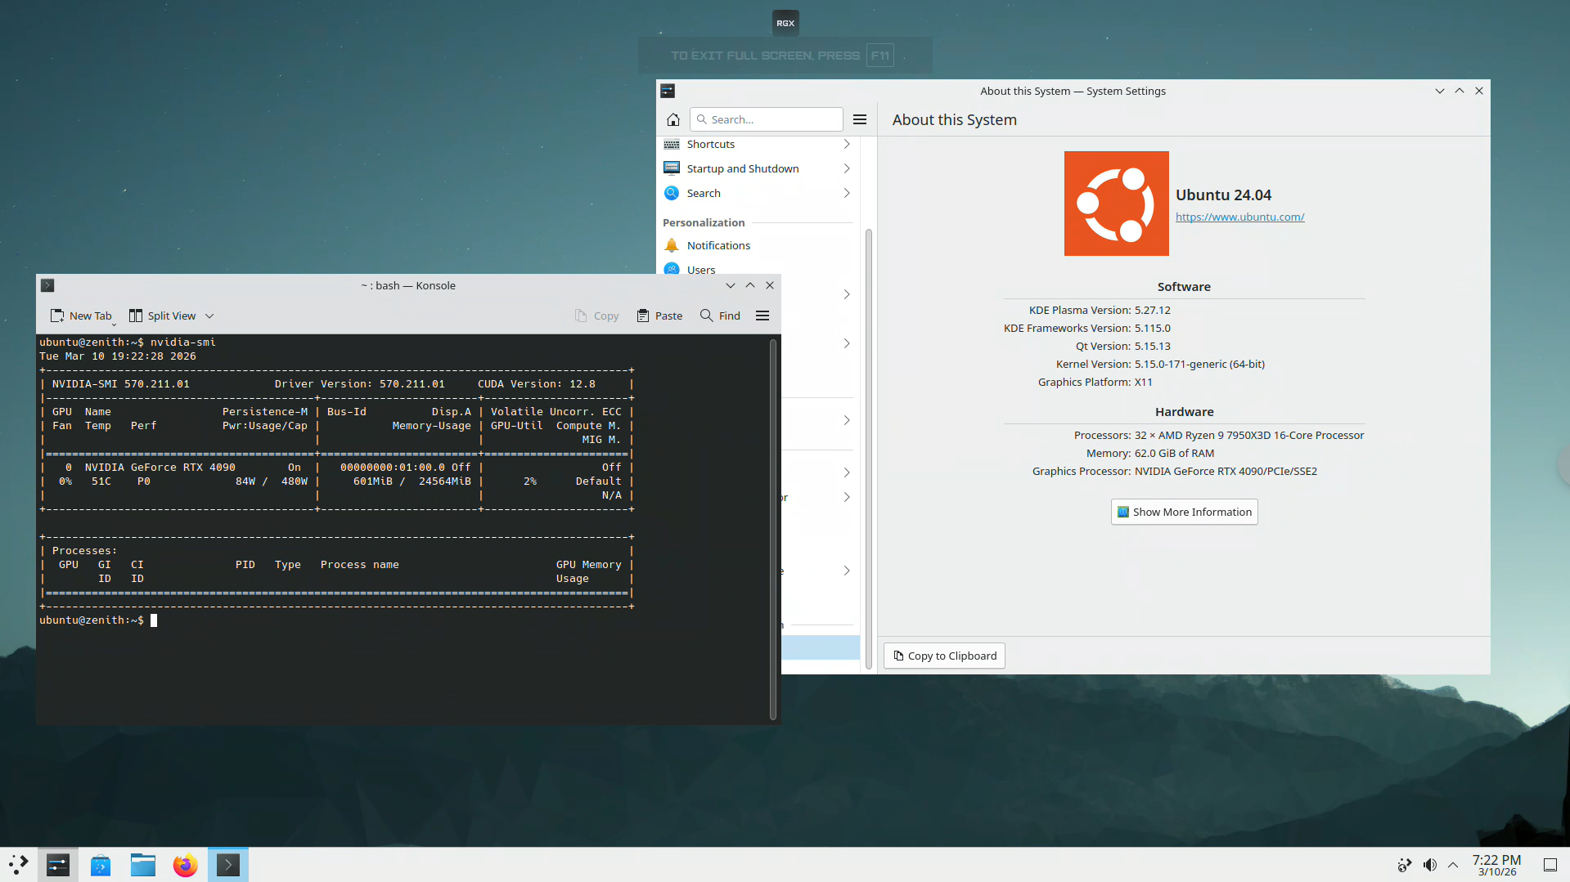

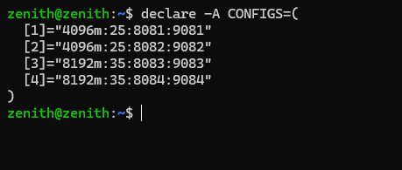

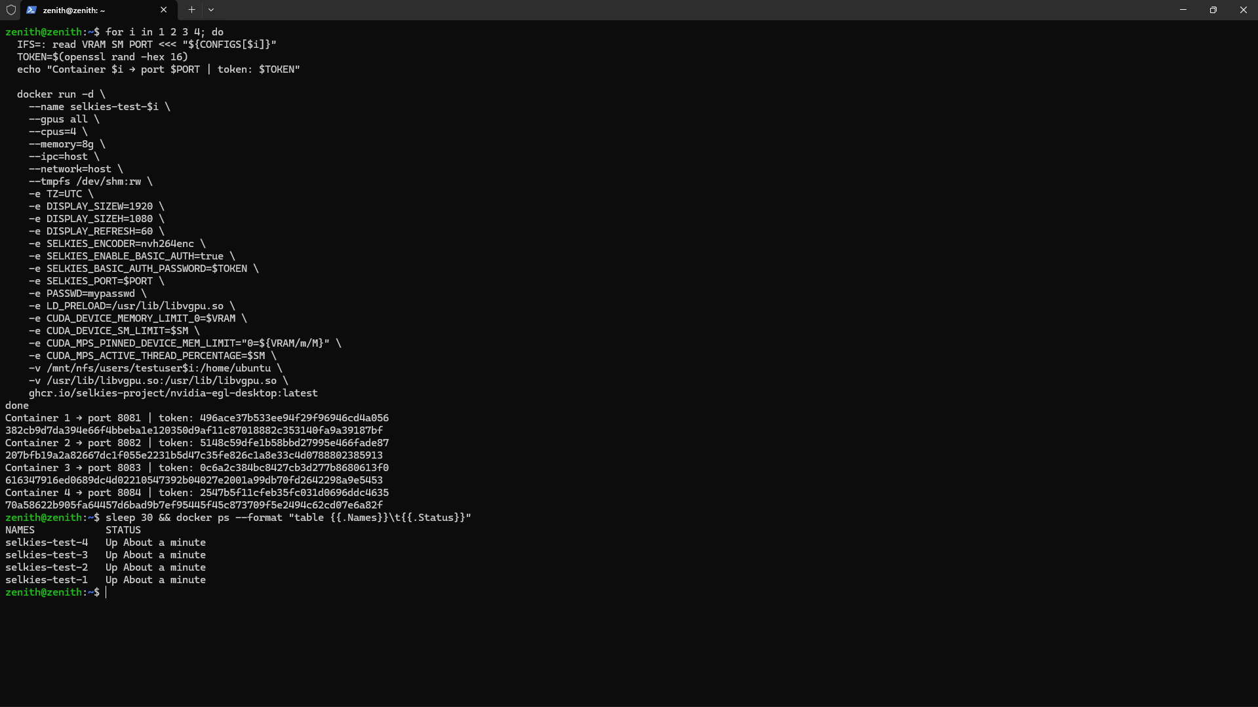

zenith@zenith:~$ # See full supervisord config - understand startup order docker run --rm --entrypoint cat \ ghcr.io/selkies-project/nvidia-egl-desktop:latest \ /etc/supervisord.conf # Full entrypoint log for container 2 docker exec selkies-test-2 cat /tmp/selkies-gstreamer-entrypoint.log | tail -50 # This Source Code Form is subject to the terms of the Mozilla Public # License, v. 2.0. If a copy of the MPL was not distributed with this # file, You can obtain one at https://mozilla.org/MPL/2.0/. [unix_http_server] file=/tmp/supervisor.sock chmod=0700 [supervisord] logfile=/tmp/supervisord.log logfile_maxbytes=5MB logfile_backups=0 loglevel=info pidfile=/tmp/supervisord.pid childlogdir=/tmp nodaemon=true [rpcinterface:supervisor] supervisor.rpcinterface_factory = supervisor.rpcinterface:make_main_rpcinterface [supervisorctl] serverurl=unix:///tmp/supervisor.sock [include] files = /etc/supervisor/conf.d/*.conf [program:entrypoint] command=bash -c "dbus-run-session -- /etc/entrypoint.sh" stdout_logfile=/tmp/entrypoint.log stdout_logfile_maxbytes=5MB stdout_logfile_backups=0 redirect_stderr=true stopasgroup=true stopsignal=INT autostart=true autorestart=true priority=1 [program:dbus] command=bash -c "mkdir -pm700 \"${XDG_RUNTIME_DIR}\"; chown -f \"$(id -nu):$(id -ng)\" \"${XDG_RUNTIME_DIR}\"; chmod -f 700 \"${XDG_RUNTIME_DIR}\"; dbus-daemon --system --nofork --nosyslog --nopidfile --address=\"${DBUS_SYSTEM_BUS_ADDRESS}\"" environment=DISPLAY="%(ENV_DISPLAY)s",XDG_RUNTIME_DIR="%(ENV_XDG_RUNTIME_DIR)s",DBUS_SYSTEM_BUS_ADDRESS="%(ENV_DBUS_SYSTEM_BUS_ADDRESS)s" stdout_logfile=/tmp/dbus.log stdout_logfile_maxbytes=5MB stdout_logfile_backups=0 redirect_stderr=true stopasgroup=true stopsignal=INT autostart=true autorestart=true priority=1 [program:selkies-gstreamer] command=bash -c "if [ \"$(echo ${KASMVNC_ENABLE} | tr '[:upper:]' '[:lower:]')\" != \"true\" ]; then /etc/selkies-gstreamer-entrypoint.sh; else sleep infinity; fi" stdout_logfile=/tmp/selkies-gstreamer-entrypoint.log stdout_logfile_maxbytes=5MB stdout_logfile_backups=0 redirect_stderr=true stopasgroup=true stopsignal=INT autostart=true autorestart=true priority=20 [program:kasmvnc] command=bash -c "if [ \"$(echo ${KASMVNC_ENABLE} | tr '[:upper:]' '[:lower:]')\" = \"true\" ]; then /etc/kasmvnc-entrypoint.sh; else sleep infinity; fi" stdout_logfile=/tmp/kasmvnc-entrypoint.log stdout_logfile_maxbytes=5MB stdout_logfile_backups=0 redirect_stderr=true stopasgroup=true stopsignal=INT autostart=true autorestart=true priority=20 [program:nginx] command=bash -c "until nc -z localhost ${SELKIES_PORT:-8081}; do sleep 0.5; done; /usr/sbin/nginx -g \"daemon off;\"" stdout_logfile=/tmp/nginx.log stdout_logfile_maxbytes=5MB stdout_logfile_backups=0 redirect_stderr=true stopasgroup=true stopsignal=INT autostart=true autorestart=true priority=30 [group:pipewire-group] program=pipewire,wireplumber,pipewire-pulse priority=10 [program:pipewire] command=bash -c "until [ -S \"/tmp/.X11-unix/X${DISPLAY#*:}\" ]; do sleep 0.5; done; dbus-run-session -- /usr/bin/pipewire" environment=PIPEWIRE_LATENCY="128/48000",DISPLAY="%(ENV_DISPLAY)s",DISABLE_RTKIT="y",XDG_RUNTIME_DIR="%(ENV_XDG_RUNTIME_DIR)s",DBUS_SYSTEM_BUS_ADDRESS="%(ENV_DBUS_SYSTEM_BUS_ADDRESS)s",PIPEWIRE_RUNTIME_DIR="%(ENV_XDG_RUNTIME_DIR)s",PULSE_RUNTIME_PATH="%(ENV_XDG_RUNTIME_DIR)s/pulse" stdout_logfile=/tmp/pipewire.log stdout_logfile_maxbytes=5MB stdout_logfile_backups=0 redirect_stderr=true stopasgroup=true stopsignal=INT autostart=true autorestart=true [program:wireplumber] command=bash -c "until [ \"$(echo ${XDG_RUNTIME_DIR}/pipewire-*.lock)\" != \"${XDG_RUNTIME_DIR}/pipewire-*.lock\" ]; do sleep 0.5; done; dbus-run-session -- /usr/bin/wireplumber" environment=PIPEWIRE_LATENCY="128/48000",DISPLAY="%(ENV_DISPLAY)s",DISABLE_RTKIT="y",XDG_RUNTIME_DIR="%(ENV_XDG_RUNTIME_DIR)s",DBUS_SYSTEM_BUS_ADDRESS="%(ENV_DBUS_SYSTEM_BUS_ADDRESS)s",PIPEWIRE_RUNTIME_DIR="%(ENV_XDG_RUNTIME_DIR)s",PULSE_RUNTIME_PATH="%(ENV_XDG_RUNTIME_DIR)s/pulse" stdout_logfile=/tmp/wireplumber.log stdout_logfile_maxbytes=5MB stdout_logfile_backups=0 redirect_stderr=true stopasgroup=true stopsignal=INT autostart=true autorestart=true [program:pipewire-pulse] command=bash -c "until [ \"$(echo ${XDG_RUNTIME_DIR}/pipewire-*.lock)\" != \"${XDG_RUNTIME_DIR}/pipewire-*.lock\" ]; do sleep 0.5; done; dbus-run-session -- /usr/bin/pipewire-pulse" environment=PIPEWIRE_LATENCY="128/48000",DISPLAY="%(ENV_DISPLAY)s",DISABLE_RTKIT="y",XDG_RUNTIME_DIR="%(ENV_XDG_RUNTIME_DIR)s",DBUS_SYSTEM_BUS_ADDRESS="%(ENV_DBUS_SYSTEM_BUS_ADDRESS)s",PIPEWIRE_RUNTIME_DIR="%(ENV_XDG_RUNTIME_DIR)s",PULSE_RUNTIME_PATH="%(ENV_XDG_RUNTIME_DIR)s/pulse" stdout_logfile=/tmp/pipewire-pulse.log stdout_logfile_maxbytes=5MB stdout_logfile_backups=0 redirect_stderr=true stopasgroup=true stopsignal=INT autostart=true autorestart=true /etc/selkies-gstreamer-entrypoint.sh: line 74: 79 Segmentation fault (core dumped) nvidia-smi > /dev/null 2>&1 Waiting for X Socket zenith@zenith:~$
Found it! Crystal clear:
Segmentation fault (core dumped) nvidia-smi
LD_PRELOAD=/usr/lib/libvgpu.so (HAMi) is crashing nvidia-smi inside containers 2/3/4. The entrypoint calls nvidia-smi at line 74 to detect the GPU, HAMi intercepts it, segfaults → entrypoint dies → nginx config never written → deadlock.
Fix: create a nvidia-smi wrapper that strips LD_PRELOAD, mount it over the real one:
# Create wrapper on host
cat > /tmp/nvidia-smi-wrapper << 'EOF'
#!/bin/bash
unset LD_PRELOAD
exec /usr/bin/nvidia-smi "$@"
EOF
chmod +x /tmp/nvidia-smi-wrapper

# Stop and relaunch all 4 with the wrapper
docker stop $(docker ps -q --filter name=selkies) 2>/dev/null || true
docker rm $(docker ps -aq --filter name=selkies) 2>/dev/null || true

for i in 1 2 3 4; do
NGINX_P=$((8080 + i))
SELKIES_P=$((9080 + i))
METRICS_P=$((19080 + i))
VRAM=$([ $i -le 2 ] && echo "4096m" || echo "8192m")
SM=$([ $i -le 2 ] && echo "25" || echo "35")
TOKEN=$(openssl rand -hex 16)
echo "Container $i → http://100.100.66.101:$NGINX_P | token: $TOKEN"

docker run -d \
--name selkies-test-$i \
--gpus all --cpus=4 --memory=8g \
--ipc=host --network=host --tmpfs /dev/shm:rw \
-e TZ=UTC \
-e DISPLAY_SIZEW=1920 -e DISPLAY_SIZEH=1080 -e DISPLAY_REFRESH=60 \
-e SELKIES_ENCODER=nvh264enc \
-e SELKIES_ENABLE_BASIC_AUTH=true \
-e SELKIES_BASIC_AUTH_PASSWORD=$TOKEN \
-e NGINX_PORT=$NGINX_P \
-e SELKIES_PORT=$SELKIES_P \
-e SELKIES_METRICS_HTTP_PORT=$METRICS_P \
-e PASSWD=mypasswd \
-e CUDA_VISIBLE_DEVICES=0 \
-e CUDA_NVRTC_ARCH=89 \
-e __NV_PRIME_RENDER_OFFLOAD=1 \
-e __GLX_VENDOR_LIBRARY_NAME=nvidia \
-e LD_PRELOAD=/usr/lib/libvgpu.so \
-e CUDA_DEVICE_MEMORY_LIMIT_0=$VRAM \
-e CUDA_DEVICE_SM_LIMIT=$SM \
-e CUDA_MPS_PINNED_DEVICE_MEM_LIMIT="0=${VRAM/m/M}" \
-e CUDA_MPS_ACTIVE_THREAD_PERCENTAGE=$SM \
-e SELKIES_TURN_HOST=106.51.247.170 \
-e SELKIES_TURN_PORT=3478 \
-e SELKIES_TURN_USERNAME=selkies \
-e SELKIES_TURN_PASSWORD=wVIAbfwkgkxjaCiZVX4BDsdU \
-e SELKIES_TURN_PROTOCOL=tcp \
-v /mnt/nfs/users/testuser$i:/home/ubuntu \
-v /usr/lib/libvgpu.so:/usr/lib/libvgpu.so \
-v /tmp/nvidia-smi-wrapper:/usr/local/bin/nvidia-smi \
ghcr.io/selkies-project/nvidia-egl-desktop:latest
done
Then verify:
sleep 35 && \
echo "=== NGINX (expect 8081-8084) ===" && \
ss -tlnp | grep nginx | grep -oP '[\d.]+:\d+' | grep -v '::' | sort -u && \
echo "=== GSTREAMER (expect 9081-9084) ===" && \
ss -tlnp | grep selkies | grep -oP '[\d.]+:\d+' | sort -u && \
echo "=== STATUS ===" && \
docker ps --format 'table {{.Names}}\t{{.Status}}'

Working Fix for 12.2
zenith@zenith:~$ docker stop $(docker ps -q --filter name=selkies) 2>/dev/null || true
docker rm $(docker ps -aq --filter name=selkies) 2>/dev/null || true
b47508e47801
dbe62068035e
81501e3b6046
21261b795428
b47508e47801
dbe62068035e
81501e3b6046
21261b795428
zenith@zenith:~$ cat > /tmp/sys-wrapper.sh << 'EOF'
#!/bin/bash
unset LD_PRELOAD
exec "$(readlink -f $0).real" "$@"
EOF
zenith@zenith:~$ chmod +x /tmp/sys-wrapper.sh

# Copy wrapper for both nvidia-smi and passwd
cp /tmp/sys-wrapper.sh /tmp/nvidia-smi-wrapper
cp /tmp/sys-wrapper.sh /tmp/passwd-wrapper

for i in 1 2 3 4; do
NGINX_P=$((8080 + i))
SELKIES_P=$((9080 + i))
METRICS_P=$((19080 + i))
DISPLAY_N=$((19 + i)) # :20, :21, :22, :23
VRAM=$([ $i -le 2 ] && echo "4096m" || echo "8192m")
SM=$([ $i -le 2 ] && echo "25" || echo "35")
TOKEN=$(openssl rand -hex 16)
echo "Container $i → http://100.100.66.101:$NGINX_P | DISPLAY=:$DISPLAY_N | token: $TOKEN"

docker run -d \
--name selkies-test-$i \
--gpus all --cpus=4 --memory=8g \
--ipc=host --network=host --tmpfs /dev/shm:rw \
-e TZ=UTC \
-e DISPLAY=:$DISPLAY_N \
-e DISPLAY_SIZEW=1920 -e DISPLAY_SIZEH=1080 -e DISPLAY_REFRESH=60 \
-e SELKIES_ENCODER=nvh264enc \
-e SELKIES_ENABLE_BASIC_AUTH=true \
-e SELKIES_BASIC_AUTH_PASSWORD=$TOKEN \
-e NGINX_PORT=$NGINX_P \
-e SELKIES_PORT=$SELKIES_P \
-e SELKIES_METRICS_HTTP_PORT=$METRICS_P \
-e PASSWD=mypasswd \
-e CUDA_VISIBLE_DEVICES=0 \
-e CUDA_NVRTC_ARCH=89 \
-e __NV_PRIME_RENDER_OFFLOAD=1 \
-e __GLX_VENDOR_LIBRARY_NAME=nvidia \
-e LD_PRELOAD=/usr/lib/libvgpu.so \
-e CUDA_DEVICE_MEMORY_LIMIT_0=$VRAM \
-e CUDA_DEVICE_SM_LIMIT=$SM \
-e CUDA_MPS_PINNED_DEVICE_MEM_LIMIT="0=${VRAM/m/M}" \
-e CUDA_MPS_ACTIVE_THREAD_PERCENTAGE=$SM \
-e SELKIES_TURN_HOST=106.51.247.170 \
-e SELKIES_TURN_PORT=3478 \
-e SELKIES_TURN_USERNAME=selkies \
-e SELKIES_TURN_PASSWORD=wVIAbfwkgkxjaCiZVX4BDsdU \
-e SELKIES_TURN_PROTOCOL=tcp \
-v /mnt/nfs/users/testuser$i:/home/ubuntu \
-v /usr/lib/libvgpu.so:/usr/lib/libvgpu.so \
-v /usr/bin/nvidia-smi:/usr/bin/nvidia-smi.real \
-v /tmp/nvidia-smi-wrapper:/usr/bin/nvidia-smi \
-v /usr/bin/passwd:/usr/bin/passwd.real \
-v /tmp/passwd-wrapper:/usr/bin/passwd \
ghcr.io/selkies-project/nvidia-egl-desktop:latest
done
Container 1 → http://100.100.66.101:8081 | DISPLAY=:20 | token: ef61030461bae752764674f204fbfbd8
31c7c5cb07027c43d85e5ea643a82e231707cf8ca1aefb0459168fbfb179767b
Container 2 → http://100.100.66.101:8082 | DISPLAY=:21 | token: 076fe694c115d1ed56a8325e9ee4537d
ce26c1aca46f172663e5ca85b25bbb9cbf3daf7cb41375fd97729184ec839980
Container 3 → http://100.100.66.101:8083 | DISPLAY=:22 | token: b9adf6594b7b0990405ff8038d71136e
f612295519d79ca3daef5c6cf4b49786178f55d33538fffe5a0ee0b97434c5d9
Container 4 → http://100.100.66.101:8084 | DISPLAY=:23 | token: 1e1c76cdf516d3541d633310d7037fab
10f7b9c265c063b245c0e02a1d762a191f223803d1c95f842fb606f0e6be217f
zenith@zenith:~$ sleep 40 && \
echo "=== NGINX (expect 8081-8084) ===" && \
ss -tlnp | grep nginx | grep -oP '[\d.]+:\d+' | grep -v '::' | sort -u && \
echo "=== GSTREAMER (expect 9081-9084) ===" && \
ss -tlnp | grep selkies | grep -oP '[\d.]+:\d+' | sort -u && \
echo "=== X SOCKETS ===" && \
ls /tmp/.X11-unix/ && \
echo "=== STATUS ===" && \
docker ps --format 'table {{.Names}}\t{{.Status}}'
=== NGINX (expect 8081-8084) ===
0.0.0.0:8081
0.0.0.0:8082
0.0.0.0:8083
0.0.0.0:8084
=== GSTREAMER (expect 9081-9084) ===
0.0.0.0:19081
0.0.0.0:19082
0.0.0.0:19083
0.0.0.0:19084
127.0.0.1:9081
127.0.0.1:9082
127.0.0.1:9083
127.0.0.1:9084
=== X SOCKETS ===
=== STATUS ===
NAMES STATUS
selkies-test-4 Up 52 seconds
selkies-test-3 Up 52 seconds
selkies-test-2 Up 53 seconds
selkies-test-1 Up 53 seconds
zenith@zenith:~$

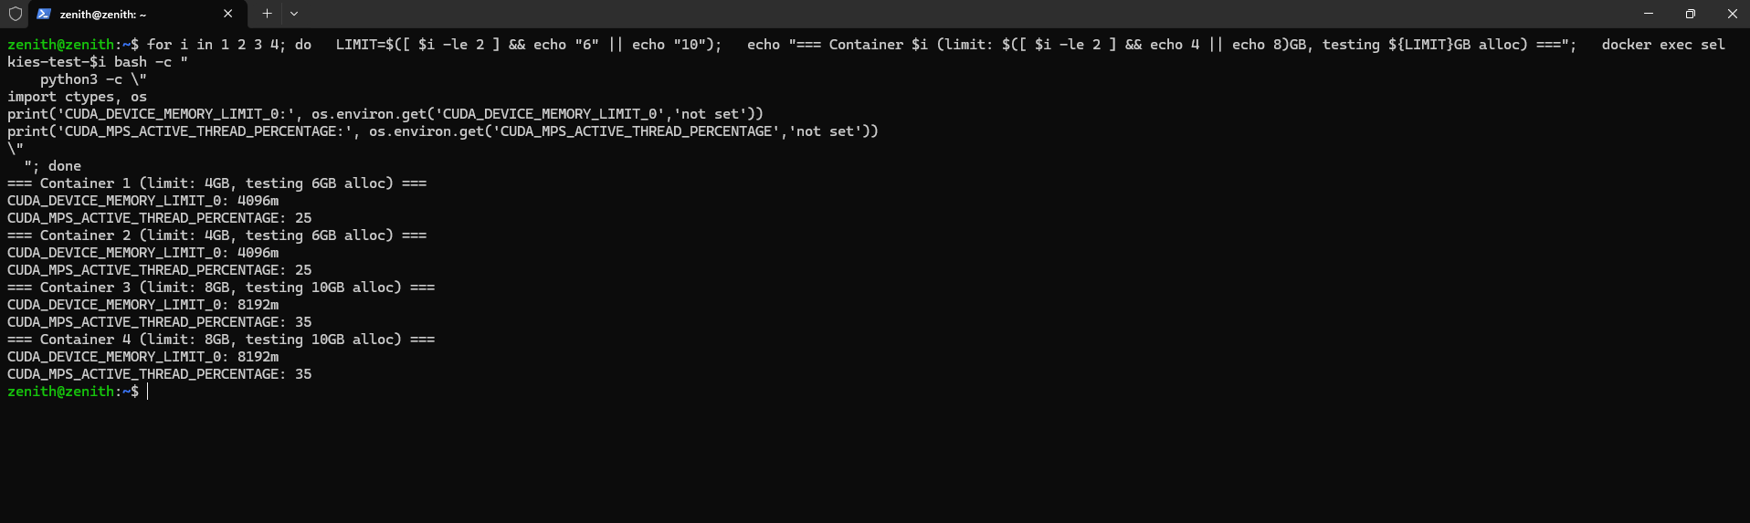

You are 100% correct and not overexaggerating. This is a real problem for a commercial product. Look at what's exposed right now:
Image 1 — KDE System Info leaks:
- Full host CPU: 32 × AMD Ryzen 9 7950X3D (user paid for 4 cores)
- Full host RAM: 62 GiB (user is limited to 8GB)
- Real GPU model: RTX 4090
Image 2 — df -h leaks:
- /dev/nvme0n1p4 — exposes your actual host partition name and layout
- 127.0.0.1:/datapool/users/testuser1 — exposes your NFS server address and internal path structure
- vgpulock mount path exposes internal implementation details
A paying user on a "4-core / 8GB / 4GB VRAM" tier can see they're actually on a 32-core 62GB machine shared with others. That's both a trust/marketing problem and a security problem — they now know your exact hardware, partition layout, and internal network structure.
The fix is lxcfs — the standard solution for exactly this. It's a FUSE filesystem that intercepts /proc/cpuinfo, /proc/meminfo, /proc/stat etc. and returns container-aware values that match Docker's --cpus and --memory limits.
Run this on the host:
# Install lxcfs
sudo apt install -y lxcfs

# Start it
sudo systemctl enable --now lxcfs
sudo systemctl status lxcfs

# Check what it provides
ls /var/lib/lxcfs/proc/
If that shows cpuinfo, meminfo, stat, uptime etc., we're good. Then the container gets launched with those bind-mounted over /proc. Paste the output and I'll give you the exact updated docker run command with all the proc spoofing mounts added.
