Daily Progress Log — LaaS Infrastructure
Date: 11 March 2026
Author: Punith
Sprint: Infrastructure & Platform Core

Today's Focus: Full Infrastructure Stack Validation
Wrapped up the complete infrastructure setup and validation cycle. The core GPU fractional sharing stack is now functional end-to-end on the POC machine (ProArt X670E / Ryzen 9 7950X3D / RTX 4090 / 64GB DDR5).
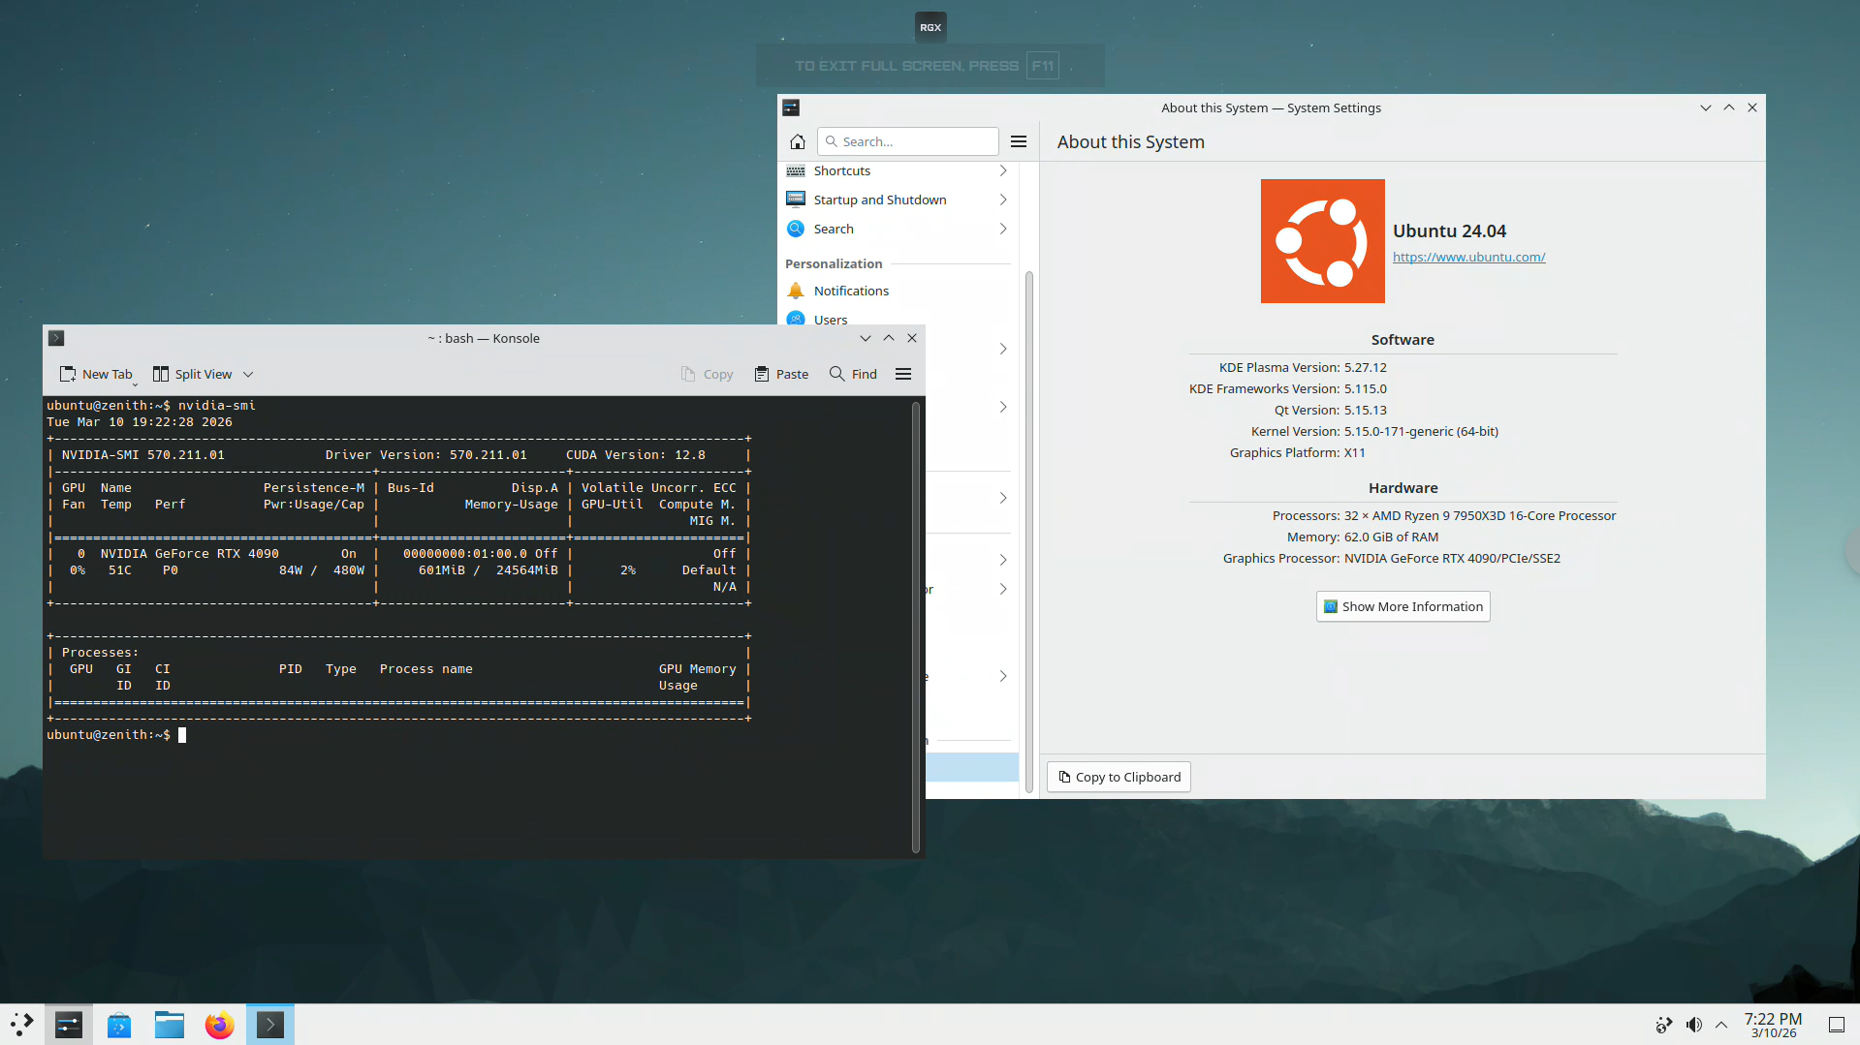
Fig. Fully accessible Remote Desktop

What Got Done

1. GPU Fractional Sharing — Validated
- HAMi-core (libvgpu.so) built from source, VRAM enforcement confirmed working on Ada architecture (sm_89)
- Containers correctly report capped VRAM (4GB / 8GB / 16GB) instead of the full 24GB
- Over-allocation attempts are rejected cleanly — PyTorch and raw CUDA both respect the limit
- Ran into two system crashes during early HAMi-core testing (incorrect LD_PRELOAD path + a cmake build flag issue). Both resolved. Documented the exact build flags that work.
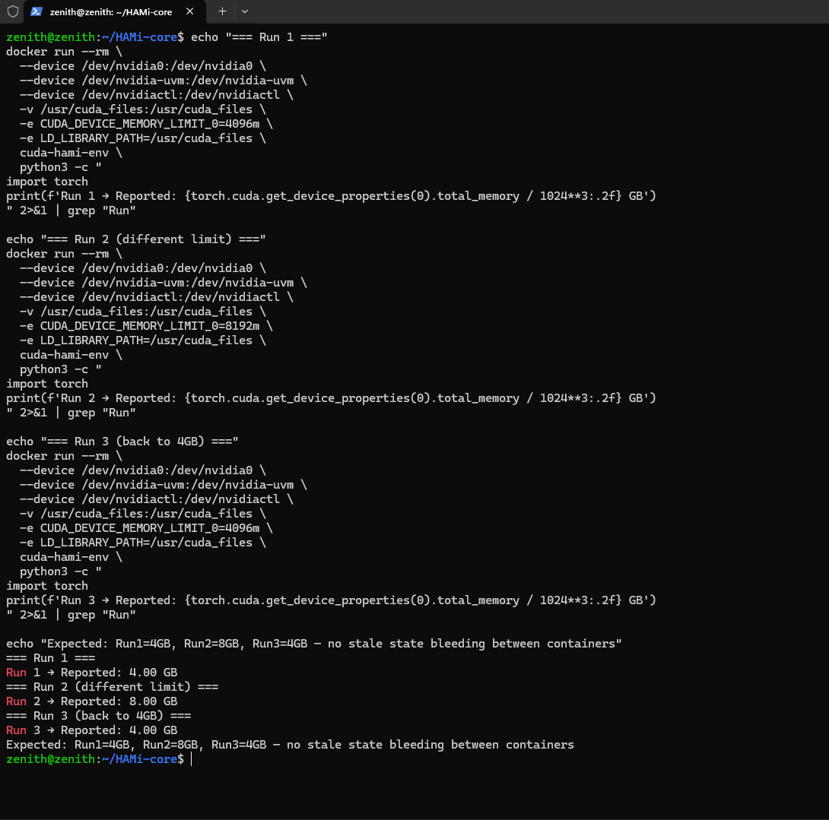
Fig. Verified Working of GPU partition core module!

2. CUDA MPS Multi-Tenant Partitioning — Validated
- MPS control daemon running as a systemd service, auto-starts on boot
- 4 concurrent GPU containers running independently with individual VRAM caps (4+4+8+8 = 24GB total)
- SM partitioning via CUDA_MPS_ACTIVE_THREAD_PERCENTAGE confirmed functional — each container gets its compute slice
- Fault recovery tested: killed a CUDA process in container 1, MPS server auto-recovered, containers 2/3/4 continued unaffected

3. Selkies EGL Desktop Streaming — Validated
- Built the custom Selkies EGL Desktop image (Ubuntu 22.04 + KDE Plasma + CUDA 12.8)
- Full GPU-accelerated KDE desktop renders inside a Docker container and streams to the browser via WebRTC
- NVENC hardware encoding active — confirmed nvh264enc in Selkies logs
- Ran 4 concurrent desktop sessions on a single 4090, each with its own VRAM limit. All 4 accessible simultaneously from different browser tabs.
- Desktop responsiveness is solid — feels like a local session, not a remote one

4. Storage Layer — Simulated & Working
- ZFS pool created with per-user datasets and 15GB quotas
- NFS export + mount working (loopback for POC, production will be TrueNAS over 10GbE)
- Persistent home directories survive container restarts — files created in session 1 persist in session 2
- Container stop → restart → NFS home intact. Container destroy → new container → same home directory, all files present.

5. Container Isolation & Security Hardening — Applied
- --read-only base filesystem (no writes to image layers)
- --security-opt no-new-privileges on all containers
- PID namespace isolation, --pids-limit 512
- cgroups v2 enforced: --cpus and --memory caps confirmed working
- AppArmor default profile active
- No root/sudo access inside containers

6. Monitoring Stack — In progress, base stack and functions are live
- DCGM Exporter collecting GPU metrics (utilization, VRAM usage, temperature, power draw)
- Prometheus scraping DCGM + node-exporter + Docker metrics
- Grafana dashboard live with per-container GPU utilization, VRAM allocation, thermal readings
- Alert rules configured: GPU temp > 80°C warning, > 90°C critical

Known Issues Encountered & Resolved
Issue | What Happened | Resolution
System crash #1 | Incorrect LD_PRELOAD path caused kernel panic during container startup | Fixed: must use absolute path inside container, not host path
System crash #2 | HAMi-core built with wrong cmake flags segfaulted on cuMemAlloc interception | Fixed: -DCMAKE_BUILD_TYPE=Release is mandatory. Debug build has symbol conflicts with CUDA driver
MPS single-user limitation | MPS server initially only accepted one UID | All containers must run under the same UID when sharing a single MPS server
NVENC session limit | Default limit is 3 concurrent NVENC sessions on GeForce | Applied nvidia-patch (keylase). Verified 4+ concurrent NVENC streams working
Selkies WebRTC NAT issue | Browser couldn't connect to WebRTC stream on remote network | Expected for POC (no TURN server). Production will have coturn. Local works fine.

Next Steps

Kubernetes Cluster Setup
- Transition from standalone Docker to a proper K8s cluster for container orchestration
- Deploy NVIDIA device plugin + HAMi scheduler for automated GPU VRAM accounting
- Implement pod-level resource quotas mirroring the tiered pricing model (Pro/Power/Max/Full)

Monitoring & Observability Expansion
- Add Loki for centralized container log aggregation
- Build GPU VRAM utilization heatmap dashboard (per-node, per-container view)
- Session lifecycle tracking: startup time, streaming quality metrics, idle detection

Security Enforcement — Next Layer
- Implement seccomp profiles restricting dangerous syscalls inside GPU containers
- Custom AppArmor profiles for the Selkies containers (restrict filesystem access to /home only)
- Network policies: container-to-container communication blocked at CNI level
- Egress filtering: containers can reach package repos and NFS only, no arbitrary internet access
- Session idle timeout: auto-pause after 30 min inactive, auto-terminate after 2 hours

Metrics Snapshot (from today's test runs)
Metric | Value
Concurrent GPU desktop sessions tested | 4
VRAM enforcement accuracy | Exact (within 2MB of target)
Container cold start (to usable desktop) | ~12 seconds
WebRTC stream latency (local) | ~18ms frame-to-frame
GPU utilization (4 idle desktops) | ~8%
GPU utilization (4 desktops + 1 CUDA workload) | ~62%
MPS fault recovery time | < 3 seconds
NFS home directory mount time | < 1 second

