NAME :- N PUNITH KUMAR
REG NO :- 192525156
COURSE CODE:- CSA0207
COURSE NAME:-DATA STRUCTURE DATE:-31-07-2026
CO2-Debugging Exam

Q1)
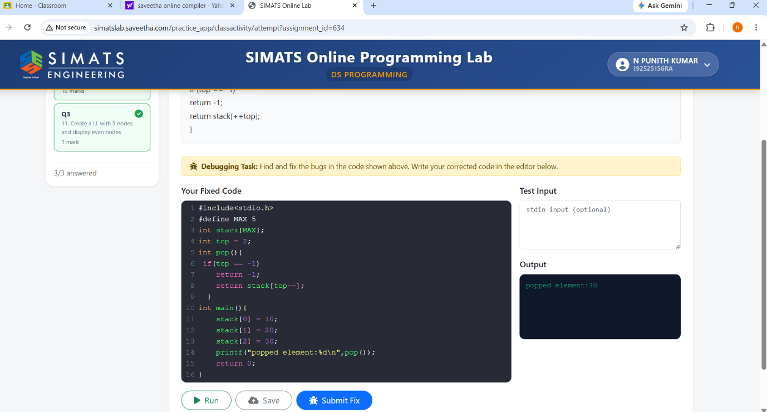
Q2) 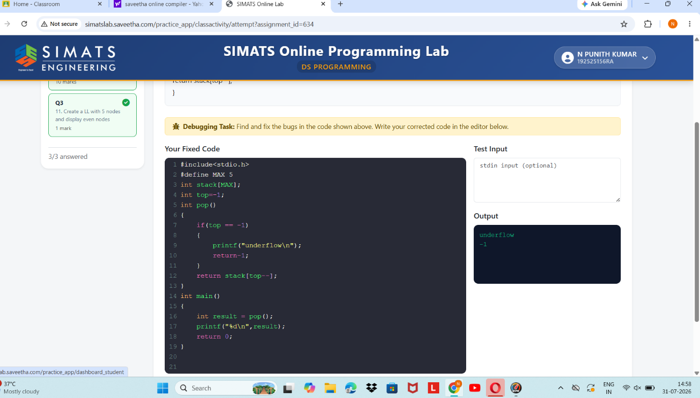
Q3)

