**Self-Examination Chatbot for anxiety and depression:**

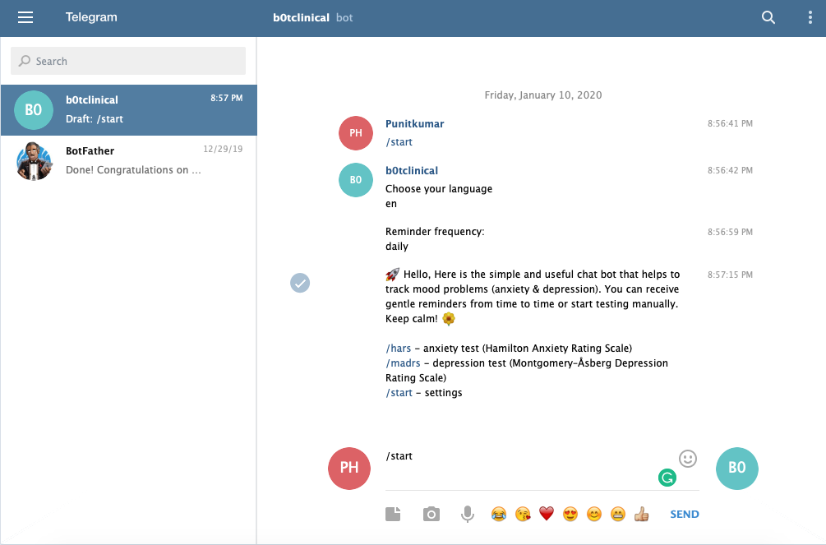

Fig: 2.Initial menu from chatbot application

In above figure shows the initial menu from the chatbot application where user need to choose language and remainder for examination. The Application is coded using python language and sqlit3 database.

And for list of phrases for the examination application is maintained with separate template module so that it other clinical modules can be added in future. And application can remind the user on daily and monthly basics and stores the data in sperate database file that can be used for analysis. And application uses telegram as platform/API to deploy.

Telegram has defined set of libraries for request and response. Updater to send request and Command handler for the command like /start, /export, CallbackQueryHandler library.

And to generate the graphs and plot the values generated from user seaborn and matplotlib libraries are used. And csv library used to generate csv format file of the stored data.

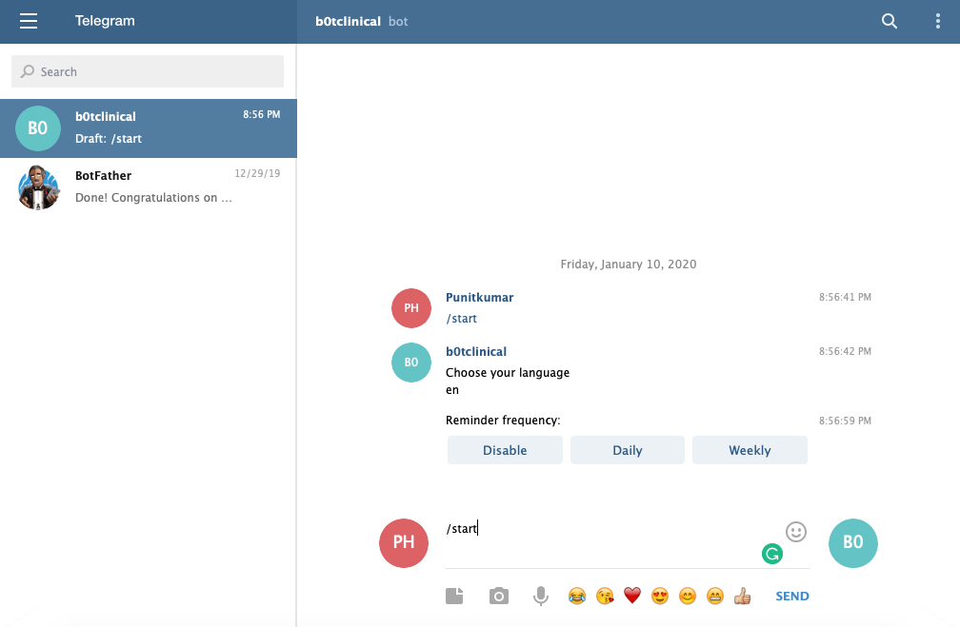

Figure.3. Remainder frequency

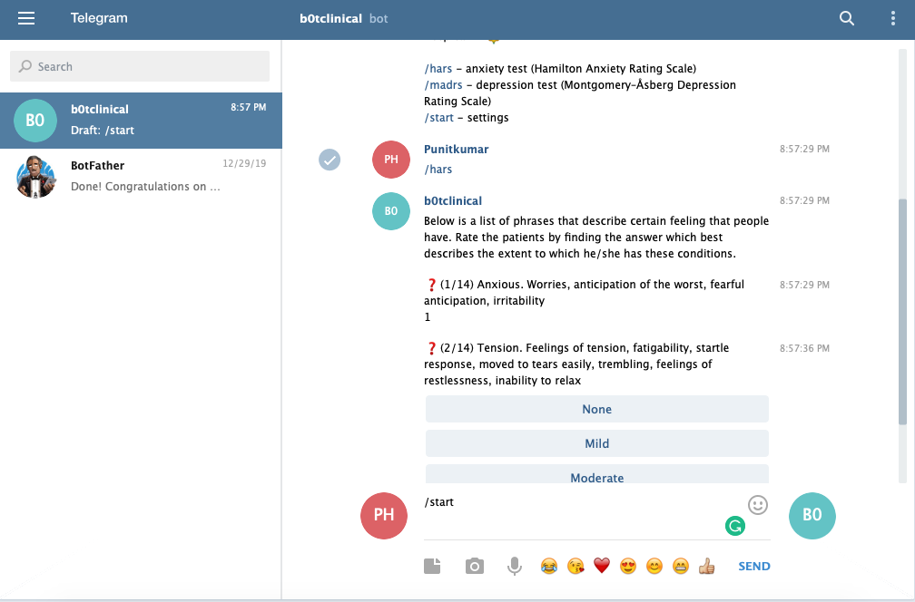

Figure.4. HAM-A questioner format

The Figure.3.shows the HAM-A list of phrase questioner format with index options

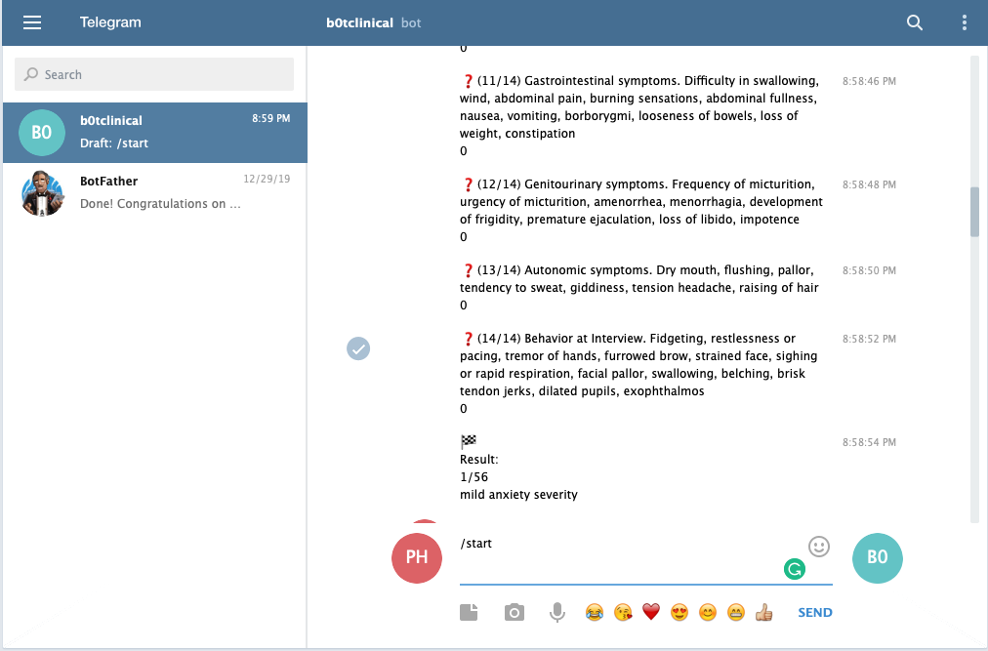

Figure.5. HAM-A result

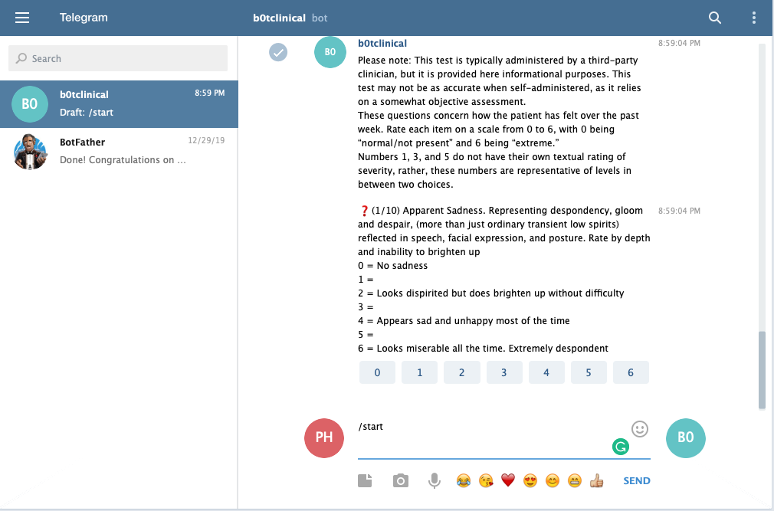

Figure.6.MADRS phrase format

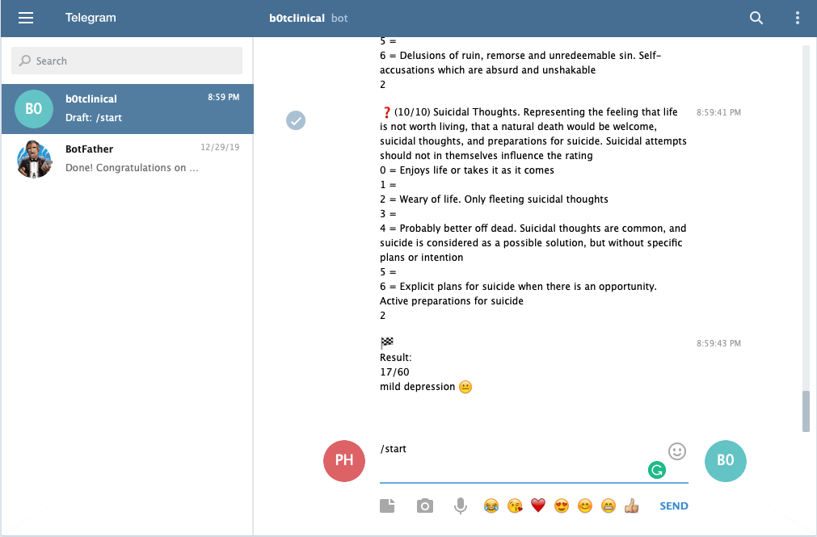

Figure.7.MADRS result

This section introduces how the experiment is conducted, followed by the experimental 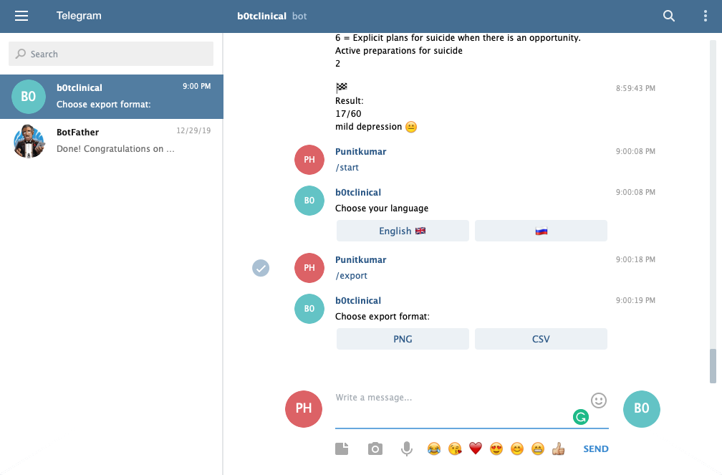

Figure.9: Data Export format options

In the application user can export the data generated in past with report view option of .png and .csv format

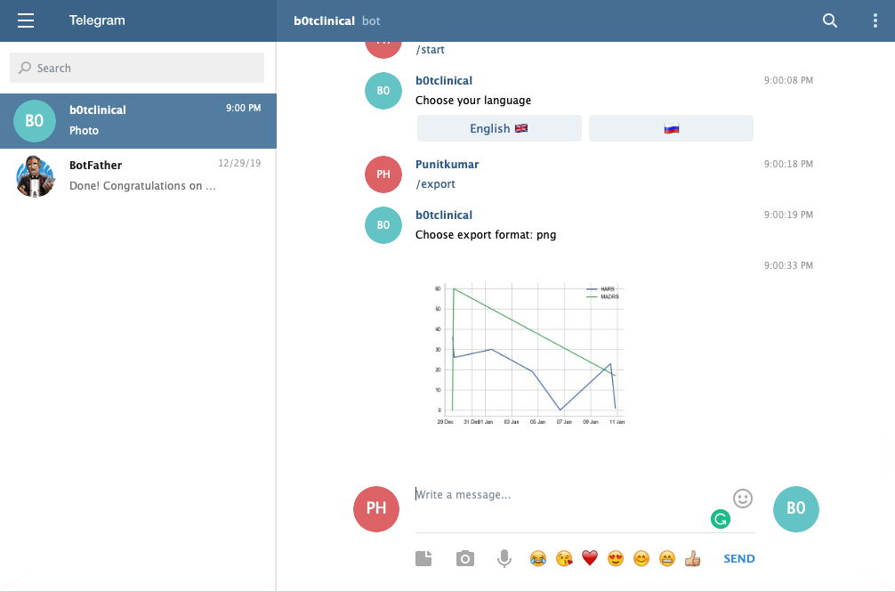

Figure.10: Exported Data with Graph representation in .png format

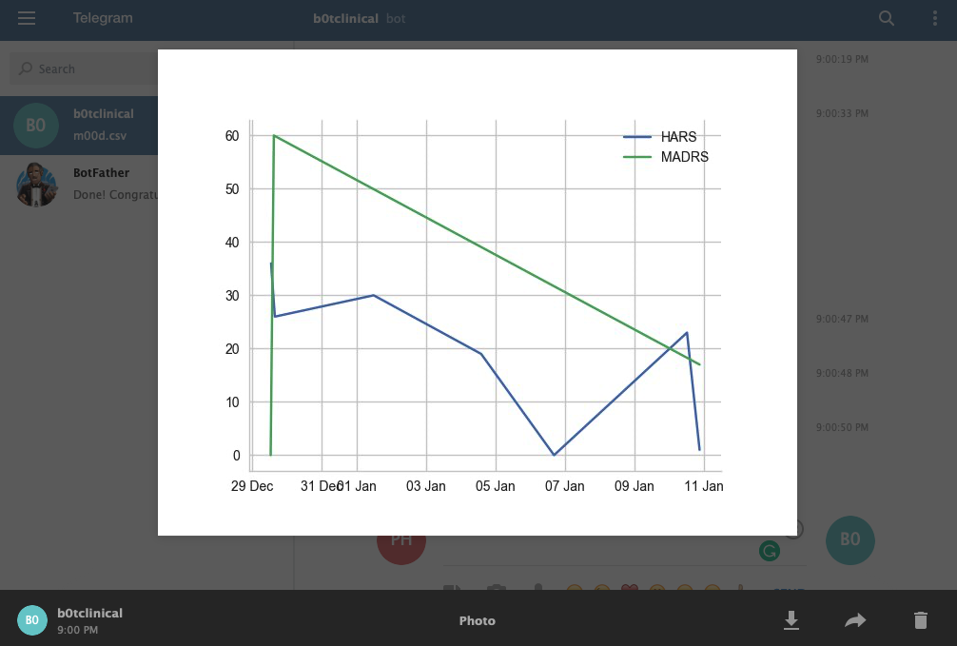

Figure.11 Graph representation

In the above figure shows the score form the past questioner of the user when exported in .png format from the application with score on y-axis and date on x-axis.

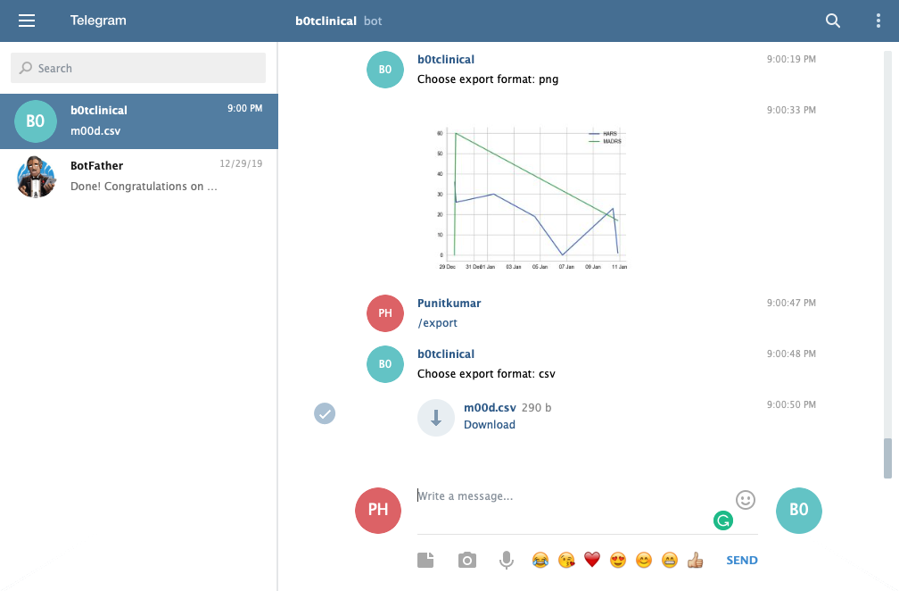

Figure.12 Exported Data with Graph representation in .csv format

The second option of report view is .csv(comma separated values) will give an values file that will download immediately.

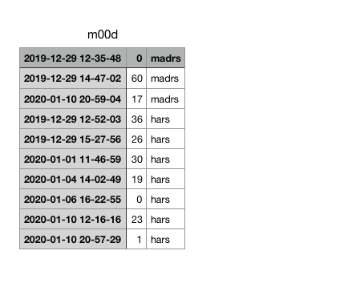

Figure.13 .csv representation

In the above figure shows the .csv format file overview of data generated from user.