Success of Bank Telemarketing

29/05/23

## Importing all the libraries

library(rpart)  
library(rpart.plot)  
library(randomForest)  
library(caret)

## Data Exploration

# Set working directory to file location  
setwd("D:/JCU/Semester/2023 SP51 trisemester 2/MA3405 Statistical Data Mining for Big Data/CAPSTONE PROJECT")  
  
# Read 'bank-additional-full.csv' file  
Data <- read.csv('bank-additional-full.csv', header = TRUE, sep = ";")  
  
# Summary of the data  
summary(Data)

## age job marital education   
## Min. :17.00 Length:41188 Length:41188 Length:41188   
## 1st Qu.:32.00 Class :character Class :character Class :character   
## Median :38.00 Mode :character Mode :character Mode :character   
## Mean :40.02   
## 3rd Qu.:47.00   
## Max. :98.00   
## default housing loan contact   
## Length:41188 Length:41188 Length:41188 Length:41188   
## Class :character Class :character Class :character Class :character   
## Mode :character Mode :character Mode :character Mode :character   
##   
##   
##   
## month day_of_week duration campaign   
## Length:41188 Length:41188 Min. : 0.0 Min. : 1.000   
## Class :character Class :character 1st Qu.: 102.0 1st Qu.: 1.000   
## Mode :character Mode :character Median : 180.0 Median : 2.000   
## Mean : 258.3 Mean : 2.568   
## 3rd Qu.: 319.0 3rd Qu.: 3.000   
## Max. :4918.0 Max. :56.000   
## pdays previous poutcome emp.var.rate   
## Min. : 0.0 Min. :0.000 Length:41188 Min. :-3.40000   
## 1st Qu.:999.0 1st Qu.:0.000 Class :character 1st Qu.:-1.80000   
## Median :999.0 Median :0.000 Mode :character Median : 1.10000   
## Mean :962.5 Mean :0.173 Mean : 0.08189   
## 3rd Qu.:999.0 3rd Qu.:0.000 3rd Qu.: 1.40000   
## Max. :999.0 Max. :7.000 Max. : 1.40000   
## cons.price.idx cons.conf.idx euribor3m nr.employed   
## Min. :92.20 Min. :-50.8 Min. :0.634 Min. :4964   
## 1st Qu.:93.08 1st Qu.:-42.7 1st Qu.:1.344 1st Qu.:5099   
## Median :93.75 Median :-41.8 Median :4.857 Median :5191   
## Mean :93.58 Mean :-40.5 Mean :3.621 Mean :5167   
## 3rd Qu.:93.99 3rd Qu.:-36.4 3rd Qu.:4.961 3rd Qu.:5228   
## Max. :94.77 Max. :-26.9 Max. :5.045 Max. :5228   
## y   
## Length:41188   
## Class :character   
## Mode :character   
##   
##   
##

# Structure of the data  
str(Data)

## 'data.frame': 41188 obs. of 21 variables:  
## $ age : int 56 57 37 40 56 45 59 41 24 25 ...  
## $ job : chr "housemaid" "services" "services" "admin." ...  
## $ marital : chr "married" "married" "married" "married" ...  
## $ education : chr "basic.4y" "high.school" "high.school" "basic.6y" ...  
## $ default : chr "no" "unknown" "no" "no" ...  
## $ housing : chr "no" "no" "yes" "no" ...  
## $ loan : chr "no" "no" "no" "no" ...  
## $ contact : chr "telephone" "telephone" "telephone" "telephone" ...  
## $ month : chr "may" "may" "may" "may" ...  
## $ day_of_week : chr "mon" "mon" "mon" "mon" ...  
## $ duration : int 261 149 226 151 307 198 139 217 380 50 ...  
## $ campaign : int 1 1 1 1 1 1 1 1 1 1 ...  
## $ pdays : int 999 999 999 999 999 999 999 999 999 999 ...  
## $ previous : int 0 0 0 0 0 0 0 0 0 0 ...  
## $ poutcome : chr "nonexistent" "nonexistent" "nonexistent" "nonexistent" ...  
## $ emp.var.rate : num 1.1 1.1 1.1 1.1 1.1 1.1 1.1 1.1 1.1 1.1 ...  
## $ cons.price.idx: num 94 94 94 94 94 ...  
## $ cons.conf.idx : num -36.4 -36.4 -36.4 -36.4 -36.4 -36.4 -36.4 -36.4 -36.4 -36.4 ...  
## $ euribor3m : num 4.86 4.86 4.86 4.86 4.86 ...  
## $ nr.employed : num 5191 5191 5191 5191 5191 ...  
## $ y : chr "no" "no" "no" "no" ...

## Data Preprocessing

# Check for missing values.  
missing_counts <- colSums(is.na(Data))  
missing_counts

## age job marital education default   
## 0 0 0 0 0   
## housing loan contact month day_of_week   
## 0 0 0 0 0   
## duration campaign pdays previous poutcome   
## 0 0 0 0 0   
## emp.var.rate cons.price.idx cons.conf.idx euribor3m nr.employed   
## 0 0 0 0 0   
## y   
## 0

# No missing values in data set.  
  
# Convert categorical variables to factors  
categorical_cols <- c("job", "marital", "education", "default", "housing", "loan", "contact", "month", "day_of_week", "poutcome", "y")  
Data[categorical_cols] <- lapply(Data[categorical_cols], as.factor)  
  
# Split the data into training and testing sets (80% for training, 20% for testing)  
set.seed(123)  
train_index <- sample(nrow(Data), 0.8 * nrow(Data))  
train_data <- Data[train_index, ]  
test_data <- Data[-train_index, ]  
dim(train_data)

## [1] 32950 21

dim(test_data)

## [1] 8238 21

## Decision Tree

# Build the decision tree model  
tree_model <- rpart(y ~ ., data = train_data, method = "class")  
tree_predictions <- predict(tree_model, newdata = test_data, type = "class")  
# Visualize the decision tree  
rpart.plot(tree_model)

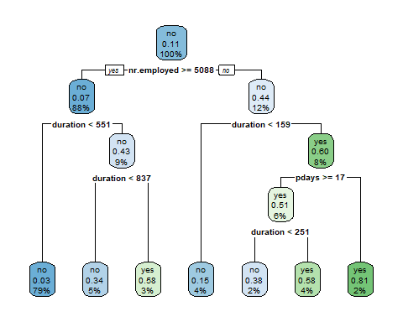

## Logistic Regression

# Build the logistic regression model  
logit_model <- glm(y ~ ., data = train_data, family = "binomial")  
  
# Make predictions using the logistic regression model  
logit_predictions <- predict(logit_model, newdata = test_data, type = "response")  
logit_predictions <- ifelse(logit_predictions > 0.5, "yes", "no")  
  
# Convert predicted variable to factor with same levels as actual variable  
logit_predictions <- factor(logit_predictions, levels = levels(test_data$y))

## Random Forest

# Build the Random Forest  
rf_model <- randomForest(y ~ ., data = train_data)  
rf_predictions <- predict(rf_model, newdata = test_data, type = "class")  
  
# Variable Importance Plot for Random Forest  
varImpPlot(rf_model)

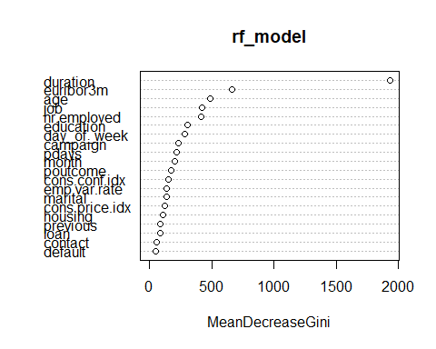

## Model Evaluation

# Evaluate the performance of the models  
tree_confusion <- confusionMatrix(tree_predictions, test_data$y)  
logit_confusion <- confusionMatrix(logit_predictions, test_data$y)  
rf_confusion <- confusionMatrix(rf_predictions, test_data$y)  
  
# Display Confusion Matrices  
print(tree_confusion)

## Confusion Matrix and Statistics  
##   
## Reference  
## Prediction no yes  
## no 7115 398  
## yes 248 477  
##   
## Accuracy : 0.9216   
## 95% CI : (0.9156, 0.9273)  
## No Information Rate : 0.8938   
## P-Value [Acc > NIR] : < 2.2e-16   
##   
## Kappa : 0.5532   
##   
## Mcnemar's Test P-Value : 4.564e-09   
##   
## Sensitivity : 0.9663   
## Specificity : 0.5451   
## Pos Pred Value : 0.9470   
## Neg Pred Value : 0.6579   
## Prevalence : 0.8938   
## Detection Rate : 0.8637   
## Detection Prevalence : 0.9120   
## Balanced Accuracy : 0.7557   
##   
## 'Positive' Class : no   
##

print(logit_confusion)

## Confusion Matrix and Statistics  
##   
## Reference  
## Prediction no yes  
## no 7168 489  
## yes 195 386  
##   
## Accuracy : 0.917   
## 95% CI : (0.9108, 0.9228)  
## No Information Rate : 0.8938   
## P-Value [Acc > NIR] : 9.052e-13   
##   
## Kappa : 0.4867   
##   
## Mcnemar's Test P-Value : < 2.2e-16   
##   
## Sensitivity : 0.9735   
## Specificity : 0.4411   
## Pos Pred Value : 0.9361   
## Neg Pred Value : 0.6644   
## Prevalence : 0.8938   
## Detection Rate : 0.8701   
## Detection Prevalence : 0.9295   
## Balanced Accuracy : 0.7073   
##   
## 'Positive' Class : no   
##

print(rf_confusion)

## Confusion Matrix and Statistics  
##   
## Reference  
## Prediction no yes  
## no 7121 403  
## yes 242 472  
##   
## Accuracy : 0.9217   
## 95% CI : (0.9157, 0.9274)  
## No Information Rate : 0.8938   
## P-Value [Acc > NIR] : < 2.2e-16   
##   
## Kappa : 0.5512   
##   
## Mcnemar's Test P-Value : 2.977e-10   
##   
## Sensitivity : 0.9671   
## Specificity : 0.5394   
## Pos Pred Value : 0.9464   
## Neg Pred Value : 0.6611   
## Prevalence : 0.8938   
## Detection Rate : 0.8644   
## Detection Prevalence : 0.9133   
## Balanced Accuracy : 0.7533   
##   
## 'Positive' Class : no   
##