2026


Proposal Report

by

<Team Name>

<Team ID>

December 2025

<Institute Name, City and Pin code>

Contents

1 Description of ASCEND 3
2 System Architecture (an example) 3
3 Identification of components with their specifications 4
4 ASCEND Realization plan 4
5 Testing Plan 5
6 Brief of system specification 5
7 Overview of the emergency response system. 6
8 Project management 6
9 Novelty in the overall proposal 7

Instructions
In your final version of the proposal report, please eliminate this page along with its template fields and text. Any text slated for removal is highlighted in light blue. Adhere to the template's section order and while the suggested section sizes are based on their importance to the overall challenge, feel free to adjust as needed. The descriptive text accompanying each section is provided as guidance and should be substituted with your own content. The tables contain essential information, and although it is recommended to maintain their current format, doing so is not mandatory. This page consolidates all proposal-related requirements for your convenience.

You can modify this template to improve its graphical appearance.

Note: The proposal report carries a weightage of 10 marks out of total marks of 100 for the entire challenge. The breakup of 90 marks will be announced during the qualification round of the challenge.
Before you start
Compose the Proposal Report (PR) only after thoroughly understanding the challenge requirements and constraints outlined in the preliminary rule book. This requires the team's ability to formulate a proposal that fulfils the specified requirements. In the initial phase of system design, teams create a baseline design for the entire system. Therefore, it's crucial for teams to meticulously review the preliminary rules and ensure that no requirement or constraint is overlooked. Additionally, the document should incorporate project management strategies to achieve the goal within the allocated time-frame.

Document Requirements:
- First page: Follow the template provided.
- Format: A4 size, PDF format with search capability.
- Length: Up to 20 pages, including the title page and lists of contents, figures, and tables.
- File size: Maximum 15 MB.
- Language: English.
- Appendices: None.
- Use a minimum font size of 10, with margins of at least 2.54 cm (1 inch) from all page edges (set to 'Normal' in MS Word).

The proposal should encompass the following information:

- Description of ASCEND illustrating various components and subsystems.
- System architecture aligned with challenge requirements.
- Identification of components with their specifications
- Outline the plan for realization of ASCEND with selected hardware and software.
- Develop a plan for testing and validation.
- Brief of system specification
- Overview of the emergency response system.
- Present the project management approach and timeline.
- Novelty in the overall proposal

Include any other relevant information.

Description of ASCEND
Provide a concise overview of the ASCEND, accompanied by a block schematic. Compare various potential options for rotorcraft and justify the selected approach.

Criteria for Assessment:
- Schematic representation of the ASCEND.
- Comprehensive understanding of the chosen rotorcraft.
- Explanation for selecting the proposed rotorcraft.
<Suggested length: 1-2 pages>

System Architecture (an example)

Provide system architecture for the ASCEND that aligns with the task requirements. Enumerate all the necessary sub-systems for the task, outlining their interdependencies and interface requirements. It is recommended to convey this information through a system architecture diagram. Below is an illustrative example of helicopter system architecture for reference
(Note: The example is provided for reference and for illustrative purpose only).
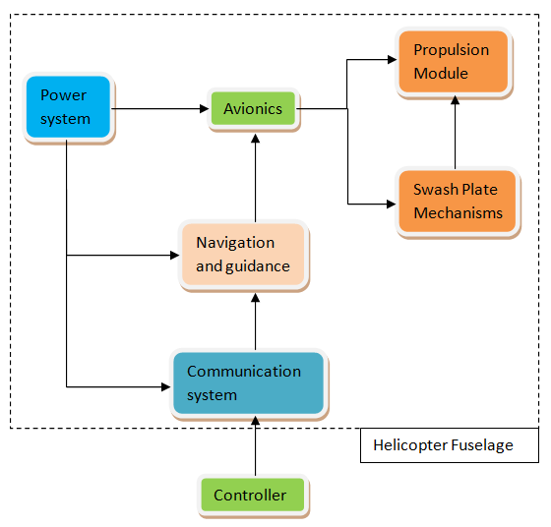
Criteria for Assessment:
- Illustration of the system architecture through a diagram.
- Identification of interfaces among different sub-systems.
- Inclusion of all essential sub-systems required in the system architecture.
<Suggested length: 1-2 pages>

Identification of components with their specifications
Enumerate, name and brief the following components/aspects as required for the selected architecture of the rotorcraft. Present the components with supporting images, diagrams, codes, methods, categories, model whichever is applicable. Compare various potential options for selected components and justify the selection approach.
Mechanical : Structure, Propulsion, any other actuators, etc.
Electrical : Power, Controller, etc.
Algorithms : Software platform, overall logics, etc.
Sensors : Optical, time of flight, inertial sensors, etc.
Other details : If any

<Suggested length: 1-2 pages>

A SCEND Realization plan
(Outline of ASCEND Realization plan with selected hardware (micro-UAV and Base-station) and software)
Upon identifying the components, teams should be ready to actualize them. Hardware must be classified according to their source of realization. For instance, motors will be directly procured from the market based on predetermined specifications, and the structure will be 3D printed, etc. The team is required to present the realization plan, preferably in a tabular format as provided below (Note: The example is given for reference and does not need to be followed in the same form).

No. | Hardware  Details | Procurement Source (Market/Fabrication/3D Printing/…..) | Specifications/ Realization Plan | Quantity
1 | Motor | Market | Torque, Speed  Voltage, Current  And so on… | 2
2 | Frame | Manufactured / procured etc. | 3D printed/ Machined / casting etc. | 1
3

Provide a concise description of the software implementation plan.

Criteria for Assessment:
- Categorization of identified hardware into various sources of realization.
- Specifications for purchased hardware.
- Realization plans for fabricated hardware.
- Implementation strategies for software.
<Suggested length: 2-3 pages>

Testing Plan
It is important to verify whether the realized system is performing to meet the intended requirements. The team should have a clear idea of the test plan for a complete system. A team needs to identify the relevant tests required to be performed on the sub-system and system level to perform the task. A brief plan for each test should be provided in the report.

Criteria for Assessment:
- Identification of required tests.
- Test plans for all identified tests.
- Expected outcome of all identified tests.
<Suggested length: 3-4 pages>

Brief of system specification
The team needs to present the system specification in tabular form. The specification given below is only basic and is incomplete. Brief specification shall give a general idea about size, category, features, capabilities of ASCEND etc.
Criteria for Assessment:
Sl. No. | Description | Specification
 | Overall mass
 | Overall dimensions
 | Power requirements
 | Flight time per charge
 | Number of propellers and their size
 | Features
 | Others | If any

<Suggested length: 1 to 2 pages>

Overview of the emergency response system.
Identify potential emergency situations anticipated during task execution. Present a system designed to address these situations, providing a brief explanation of its working principle. Additionally, consider including alternative emergency response systems, along with the rationale for choosing the proposed one.
For example, safety features of a rotor craft can be:
  - Fail safe mode: return to home, land on failure, Obstacle avoidance, etc.
  - Redundancy systems if any
Criteria for Assessment:
- Identification of emergency situations.
- Description of the Response System.
<Suggested length: 1-2 pages>

Project management

Teams are required to formulate a project management strategy, clearly delineating responsibilities among team members. The particulars should be presented, preferably in a tabular format as demonstrated here. Additionally, it should encompass schedule and budgetary requirements (Note: The example below is provided for reference and does not need to be followed in the same format).

No. | Task | Main Responsibility | Deadline for Completion | Secondary Responsibility
1 | Hardware Procurement | Team Member 3 | 26-01-2025 | Team Member 5
2 | Algorithms | Team Member 2 | 15-01-2026 | Team Member 1

Criteria for Assessment:
- Identification of responsibilities among team members with a system breakdown structure.
- Strategy for schedule management.
- Cost estimation.
<Suggested length: 1 page>

Novelty in the overall proposal
If a team believes that their approach contains originality, they should emphasize it in this section.

Criteria for Assessment:
- Originality in terms of system design, hardware/software selection, etc.
<Suggested length: 1-2 pages>

Disclaimer: The content in this template is an example and the matter should not be considered as input for proposal.

