

Guide for

International Checkout add-on for BigCommerce

(iframe based)

For iframe based integration, _ic_cart.html is uploaded to FTP, p value is changed in this file, free/flat or dynamic shipping charges can be passed, International Checkout button is added to cart page and mini cart.

**International Checkout, Inc**

(Ver 1.0)

# 1: Requirements to make integration

* + WebDAV Access
  + Back-end Access

# 2: Possibilities

* + Dynamic Shipping
  + Themed IC button
  + Mobile Version Integartion

# 3: Files attached

* + For Free Shipping -> _ic_cart.html
  + For Dynamic Shipping -> _ic_cart.html
  + cart content.html
  + FastCartThickBoxContent.html

# 4: Process

* Login to WebDAV using Cyberduck as shown here,

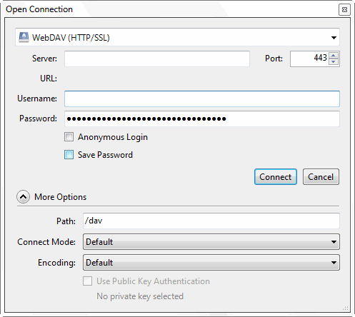

* Set p value of store in _ic_cart.html in required type of file either in Free Shipping or in Dynamic Shipping.
* Upload this file to WebDAV in \***template**\* folder.
* Login to back-end

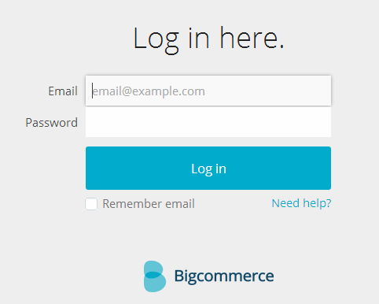

* Click on *Web Content -> Web Pages*.

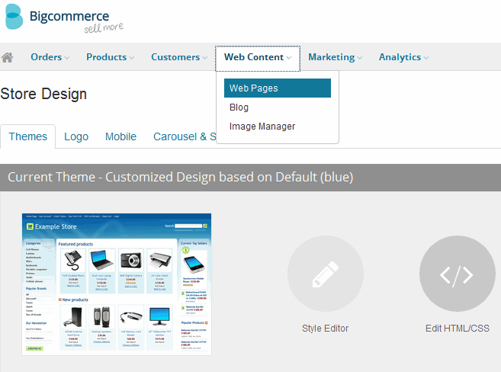

* Click on *Create a Web Page* button as shown here,

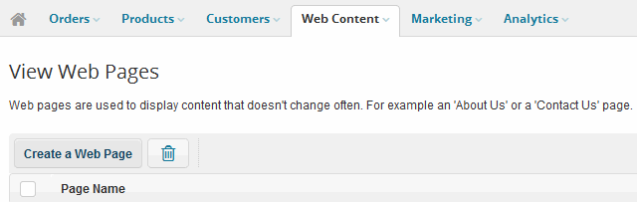

* Fill the fields as shown here and click on *Save & Exit* button,

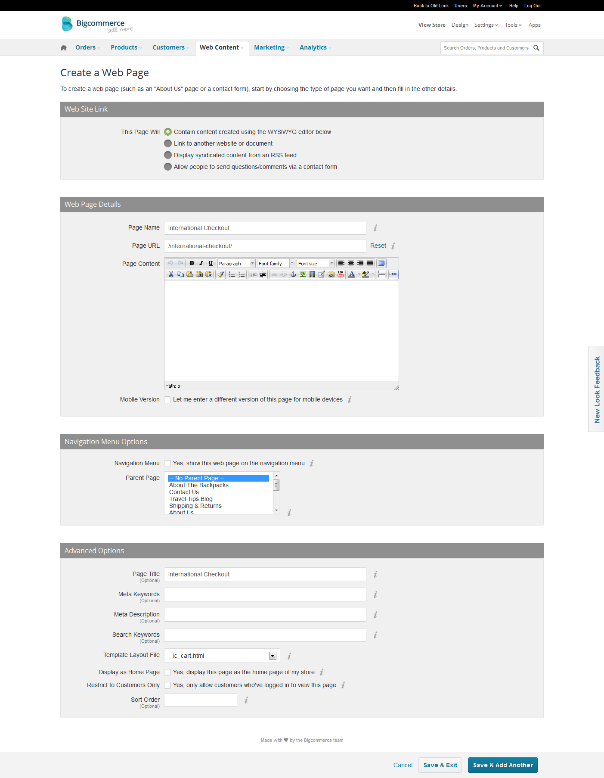

* Add some items in the cart.
* Open url www.storeurl.com/ international-checkout/ to view iframe based integration.

# 5: Add IC button on cart page

* Click on *Design* on top right menu
* Click on *Edit HTML/CSS* button under * Themes* tab as shown here,

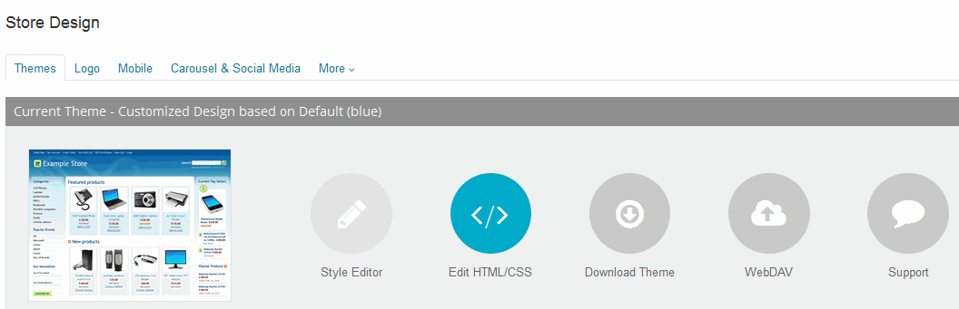

* In the new opened page, click on *cart.html* under *Other Template Files* as shown here,

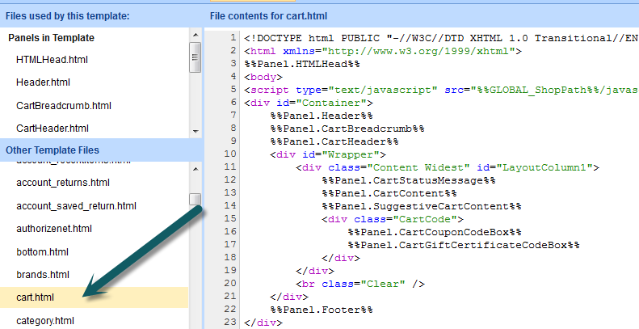

* Click on *CartContent.html* under *Files used by this template:* as shown here,

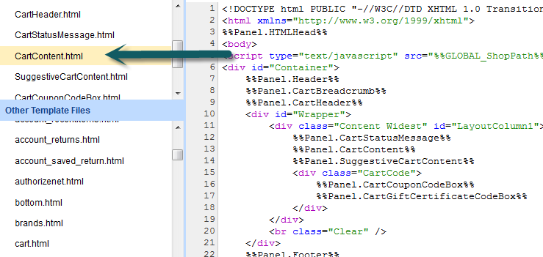

* Copy the code from *cart content.html* and paste above *%%GLOBAL_AdditionalCheckoutButtons%%* in the code in right panel under *CartContent.html* as shown here,

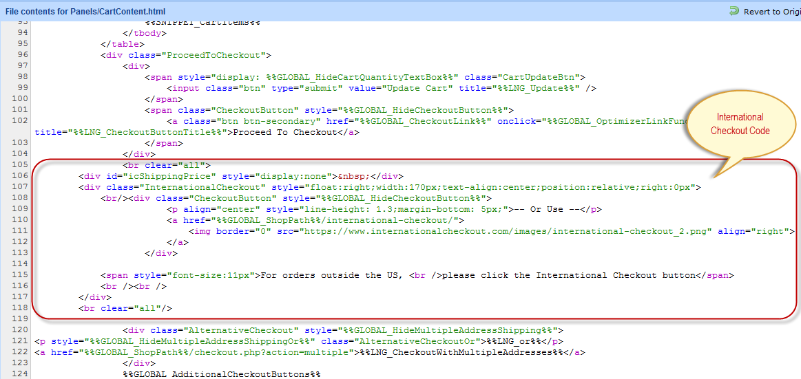

* Click on *Save* button as shown here,

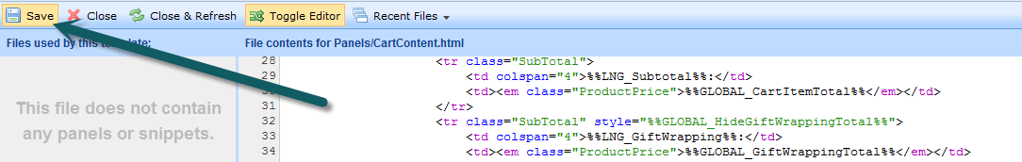

# 6: Add IC button on mini cart

* Search for *FastCartThickBoxContent.html* in the left panel under *Other Template Files*.
* Copy code from *FastCartThickBoxContent.html* and paste in the right panel code as shown here,

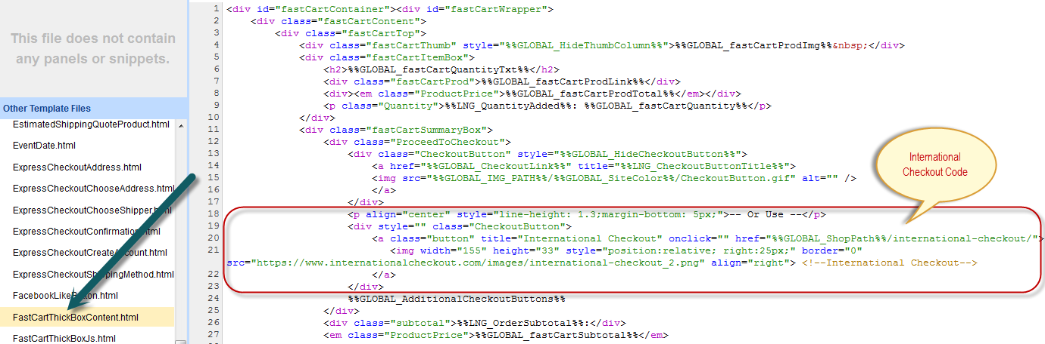

* Click on *Save* button

# 5: Mobile version integration

* Click on *Design* in the top right corner and then click on *Mobile* tab as shown here,

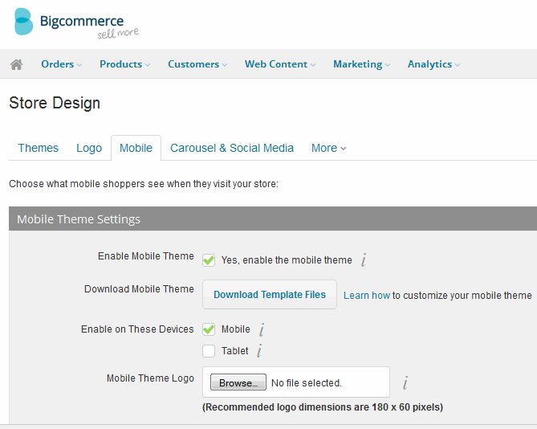

* If the checkbox for *Enable Mobile Theme* is enabled, click on *Download Template Files*.
* If the checkbox for *Enable Mobile Theme* is enabled, click on *Download Template Files*.
* Extract the downloaded zip file with the name *mobile_template*, open the file * mobile_template ->Panles -> CartContent.html*.
* Copy the code from * mobile_template ->Panles -> CartContent.html* in this guide and paste it in above opened file.

*You have successfully completed iframe based integration in BigCommerce for International Checkout.*