

Guide for

International Checkout add-on for Magento

(iframe based)

For iframe based integration, Ic add-on files are uploaded in FTP. After this step, Ic module is loaded in back-end in which setting for shipping charges, Ic button etc are made. The Ic integration can be enabled/disabled in the back-end also.

**International Checkout, Inc**

(Ver 1.1)

# 1: Requirements to make integration

* + FTP Access
  + Back-end Access

# 2: Possibilities

* + Dynamic Shipping
  + Themed IC button
  + Enable/Disable Integration

# 3: Files attached

* + App [Folder containing integration files and folders]

# 4: Process

* Upload the files and folder from Ic integration directory to FTP.
* Login to back-end.

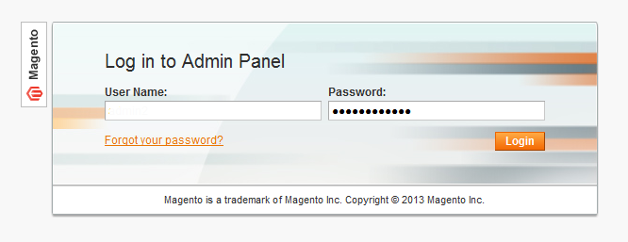

* Go to *System -> Configuration*.

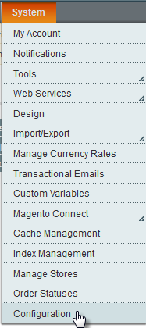

* Click on *Checkout* under *Sales* menu.

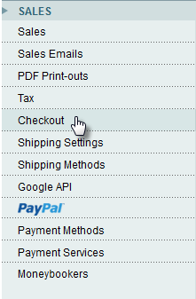

* Click on *International Checkout* tab.

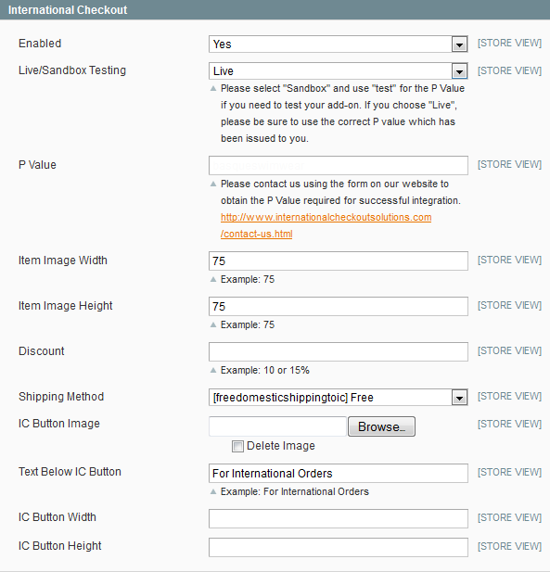

* If *International Checkout* tab is not visible under *Checkout* menu, go to *System > Cache Management* and click on *Flush Magento Cache* button.
* Go back to *System > Checkout*menu.
* In the *International Checkout* form as shown above, enter p value, select shipping method and make other settings.
* After you’ve completed these steps, an International Checkout button will be enabled on your shopping cart page.

*You have successfully completed iframe based integration in Magento for International Checkout.*