

Guide for

International Checkout add-on for Shopify

(iframe based)

For iframe based integration, a new template is created in template editor in the back-end and IC code is inserted in this new template. A new page is created and linked to this template. IC button is added on cart page.

**International Checkout, Inc**

(Ver : 1.0)

# 1: Requirements to make integration

* + Back-end Access

# 2: Possibilities

* + Dynamic Shipping
  + Themed IC button

# 3: Files attached



# 4: Process

* Select file *international-checkout - Dynamic Shipping.html* for dynamic shipping charges and *international-checkout - Free Shipping.html * for free shipping.
* Set p value in above selected file.
* Login to back-end,

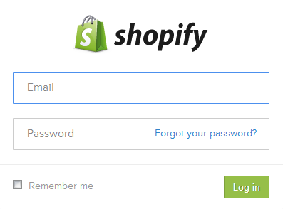

* Go to *Themes *

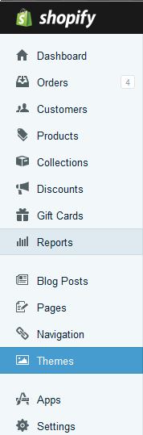

* Got to * Template Editor *

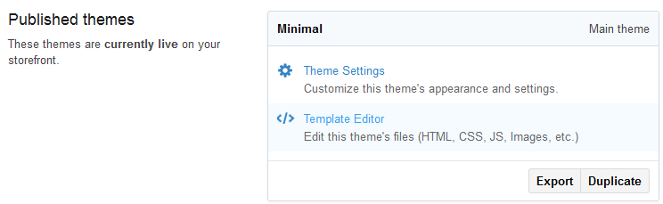

* Click on *add a new template *

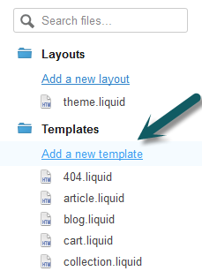

* Create a new template for a page for *international-checkout*,

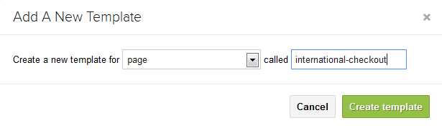

* Copy the code from the Ic file which was modified in the start of this process, paste it in this page *page.international-checkout.liquid * and save.

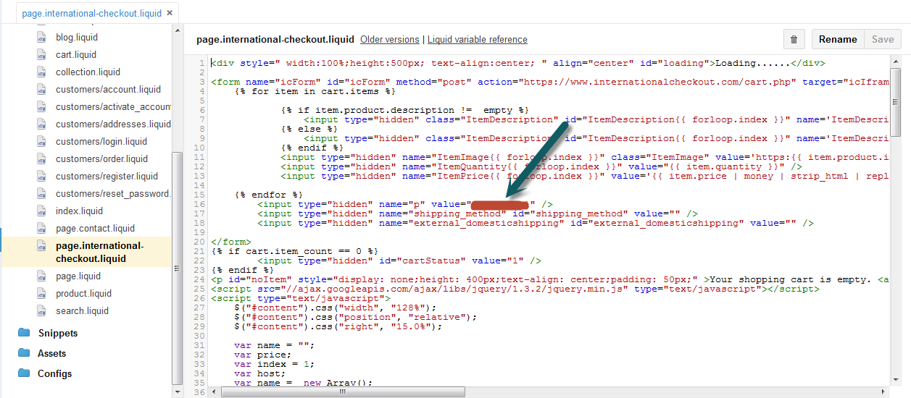

*Note: Please verify your p value in the code as shown above. Make changes in above code for width and Ic page position from line 27 to 29 according to theme as shown in above.*

* Click on *Pages * in the right menu.

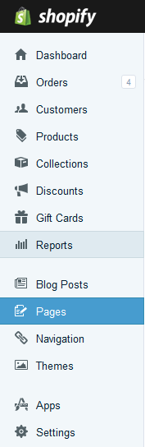

* Click on *Add page* button



* Enter * International Checkout * as a page title as shown below and save

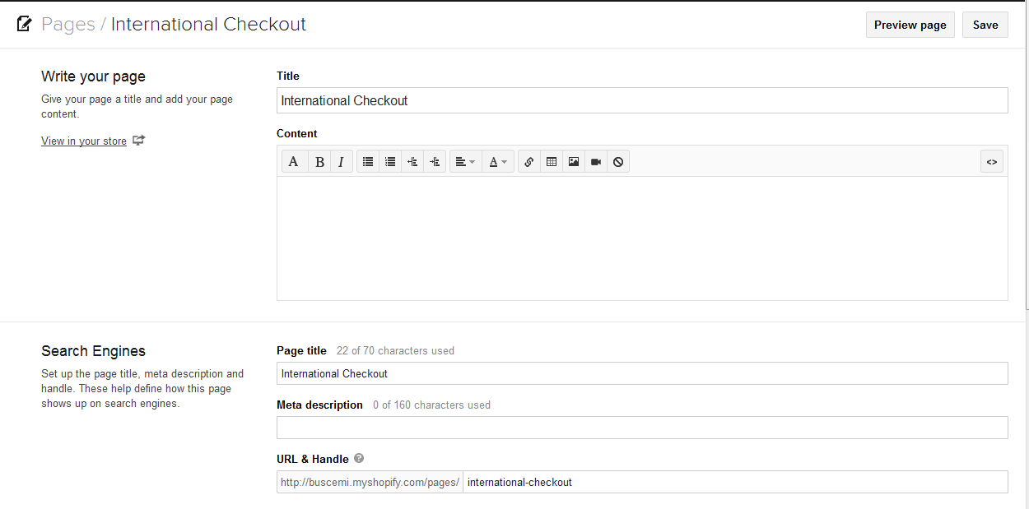

* Choose *page.international-checkout.liquid* from Template dropdown as shown below.

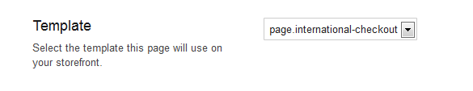

# 5: Add IC button on cart page

* Go to *Themes -> Template Editor*.
* Click on *cart.liquid* as shown here,

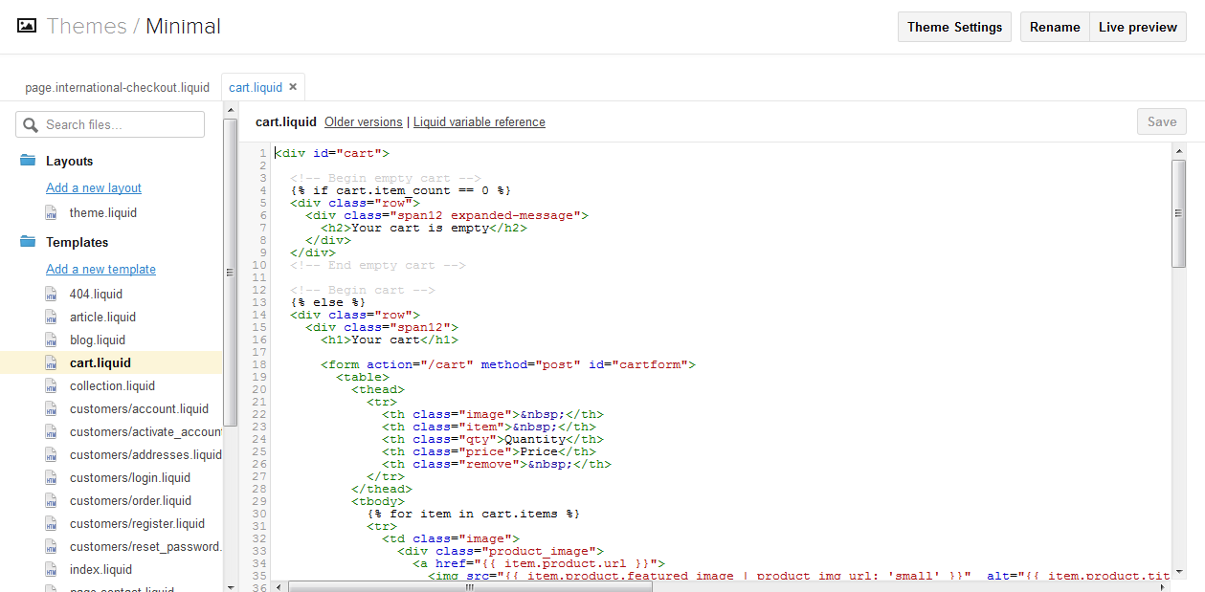

* Copy the code from *cart.liquid.html* from attachment and paste it in *cart.liquid* under store’s cart *Checkout* button code as shown above.
* Click on *Save* button.

*You have successfully completed iframe based integration in Shopify for International Checkout.*