

Guide for

International Checkout add-on for Volusion

(iframe based)

For iframe based integration, two articles are created in back-end under Articles section, one for iframe and other to build IC form. The code for Ic button is added in article ID #101 in Articles section also.

**International Checkout, Inc**

# 1: Requirements to make integration

* + FTP Access (if themed Ic button is required)
  + Back-end Access

# 2: Possibilities

* + Dynamic Shipping
  + Themed IC button

# 3: Files attached

* + IC-code-for-dynamic-shipping.html
  + IC-code-for-free-shipping.html
  + Article-101.txt
  + Iframe.html

# 4: Process

* Set p value of store in *IC-code-for-dynamic-shipping.html/IC-code-for-free-shipping.html *
* Login to back-end.
* Go to *Design -> Site Content* as shown here,

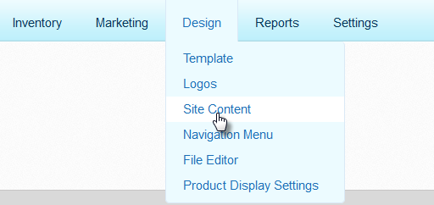

* Click on *View List* button on top right corner.



* Click on *Add* button.



* In the new article, select *Additional Support* in *Category ID*.
* Enter the code from *IC-code-for-dynamic-shipping.html/IC-code-for-free-shipping.html* into the *Article Body* field, then click *Save*.
* Please note the ID of created article.
* Once again go to *Design > Site Content* and click *View List* in the top right corner.
* Click on *Add* button and in the new article, select *Additional Support* in *Category ID*.
* Enter the code from *iframe.html* into the *Article Body* field, replace ABC_ID with noted ID, then click *Save*.
* Please note the ID of this created article.

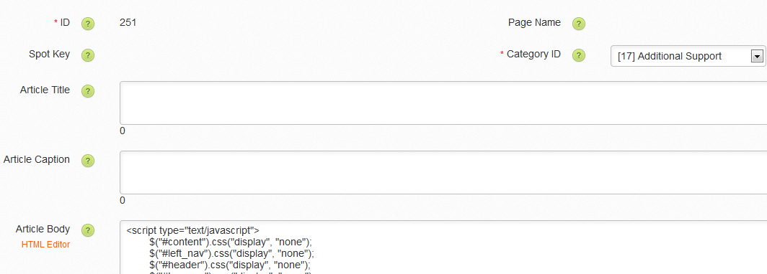

# 5: Add IC button on cart page

* Once again go to *Design > Site Content* and click *View List* in the top right corner.
* Click *Search*, enter “101” in the *ID* field, and click *Search*.
* In *Article 101*, enter the code from *Article-101.txt* into the *Article Body* field, replace ARTICLE_ID with noted ID, then click *Save*.
* After you’ve completed these steps, an International Checkout button will be enabled on your shopping cart page.

*You have successfully completed iframe based integration in Volusion for International Checkout.*