|  |  |
| --- | --- |
| **CLIMATE** |  |
| **RAINFALL** |  |
| There are four rainfall seasons during the year. These are :-   1. The South - west monsoon period (May to September) 2. The Intermonsoon period following the South-west monsoon (October to November) 3. The North - east monsoon period (December to February) 4. The Intermonsoon period following the North- east monsoon (March to April)   Rainfall is of three types- monsoonal, convectional and depressional. Monsoon rain occurs during the two monsoon periods, namely, the South - west and North - east, andis responsible for nearly 55% of the annualprecipitation. Convectional rain occurs during the intermonsoon periods, mainly in the afternoon or evening and is likely to be experienced anywhere over the Island. Depressional rain also occurs during the intermonsoonal periods, particularly during thesecond intermonsoon (October to November).  The annual average rainfall varies from below 1000 mm (39'') over a small region in the arid parts of the North - west and South - east of the Island to over 5000 mm (197'') at a few places in the Kegalle and NuwaraEliya districts (on the South - western slopes of the central hills).  Rainfall during the South - west monsoon is mostly over the South - western parts of the Island. At the beginning it occurs in the South- western low country. As winds strengthen, it spreads gradually to the interior, with considerable heavy rain in the hill country from June to August. South - west monsoon rainfall exceeds 3000 mm (118'') at a few places in the Kegalle and NuwaraEliya districts.  During the North - east monsoon, the eastern half of the Island receives from about 200 mm (8'') to over 1200 mm (47'') of rain. The higher rainfalls are experienced over the Rangala range of hills.  During the intermonsoon periods, winds are generally light except for the sea breeze which develops from about noon and is also responsible for the thundershowers that occur in the afternoon or evening. These showers may occur anywhere over the Island. Another source of rain during these periods is depressional activity.  Depressions are responsible for a good part of the precipitation during the intermonsoon period, October to November. Rainfall during this period is therefore widespread and exceeds 500 mm (20'') at many places. Taking the Island as a whole, this is the rainiest period of the year.  Conditions are similar during the other intermonsoonal period, from March to April, but the rainfall is less, mainly because of less depressional activity. |  |

Reference (<http://www.statistics.gov.lk/abstract2019/CHAP1>)

Jan - In Kurunegala, Sri Lanka, it is raining for 14 days, with typically 34mm (1.34") of accumulated precipitation. Throughout the year, in Kurunegala, there are 217.7 rainfall days, and 1165mm (45.87") of precipitation is accumulated.

Feb - In Kurunegala, in February, during 11.8 rainfall days, 54mm (2.13") of precipitation is typically accumulated. In Kurunegala, during the entire year, the rain falls for 217.7 days and collects up to 1165mm (45.87") of precipitation.

March - In March, the rain falls for 16.1 days. Throughout March, 54mm (2.13") of precipitation is accumulated. In Kurunegala, during the entire year, the rain falls for 217.7 days and collects up to 1165mm (45.87") of precipitation.

April - In Kurunegala, during 24.7 rainfall days, 120mm (4.72") of precipitation is typically accumulated. In Kurunegala, during the entire year, the rain falls for 217.7 days and collects up to 1165mm (45.87") of precipitation.

May- In May, the rain falls for 21.6 days. Throughout May, 117mm (4.61") of precipitation is accumulated. In Kurunegala, during the entire year, the rain falls for 217.7 days and collects up to 1165mm (45.87") of precipitation.

June - June is the month with the least rainfall. Rain falls for 14.7 days and accumulates 29mm (1.14") of precipitation.

July - In Kurunegala, during July, the rain falls for 16.6 days and regularly aggregates up to 58mm (2.28") of precipitation. Throughout the year, in Kurunegala, there are 217.7 rainfall days, and 1165mm (45.87") of precipitation is accumulated.

August - In Kurunegala, during August, the rain falls for 15.8 days and regularly aggregates up to 46mm (1.81") of precipitation. Throughout the year, in Kurunegala, there are 217.7 rainfall days, and 1165mm (45.87") of precipitation is accumulated.

September - In Kurunegala, during September, the rain falls for 15.2 days and regularly aggregates up to 72mm (2.83") of precipitation. In Kurunegala, [Sri Lanka](https://www.weather-atlas.com/en/sri-lanka), during the entire year, the rain falls for 217.7 days and collects up to 1165mm (45.87") of precipitation.

October- October is the month with the most rainfall. Rain falls for 22.4 days and accumulates 267mm (10.51") of precipitation.

November - In Kurunegala, during November, the rain falls for 23.9 days and regularly aggregates up to 201mm (7.91") of precipitation. In Kurunegala, during the entire year, the rain falls for 217.7 days and collects up to 1165mm (45.87") of precipitation.

December - In December, the rain falls for 20.9 days. Throughout December, 113mm (4.45") of precipitation is accumulated. In Kurunegala, during the entire year, the rain falls for 217.7 days and collects up to 1165mm (45.87") of precipitation.

Reference - [https://www.weather-atlas.com/en/sri-lanka/kurunegala-climate#climate_text_1](https://www.weather-atlas.com/en/sri-lanka/kurunegala-climate%23climate_text_1)

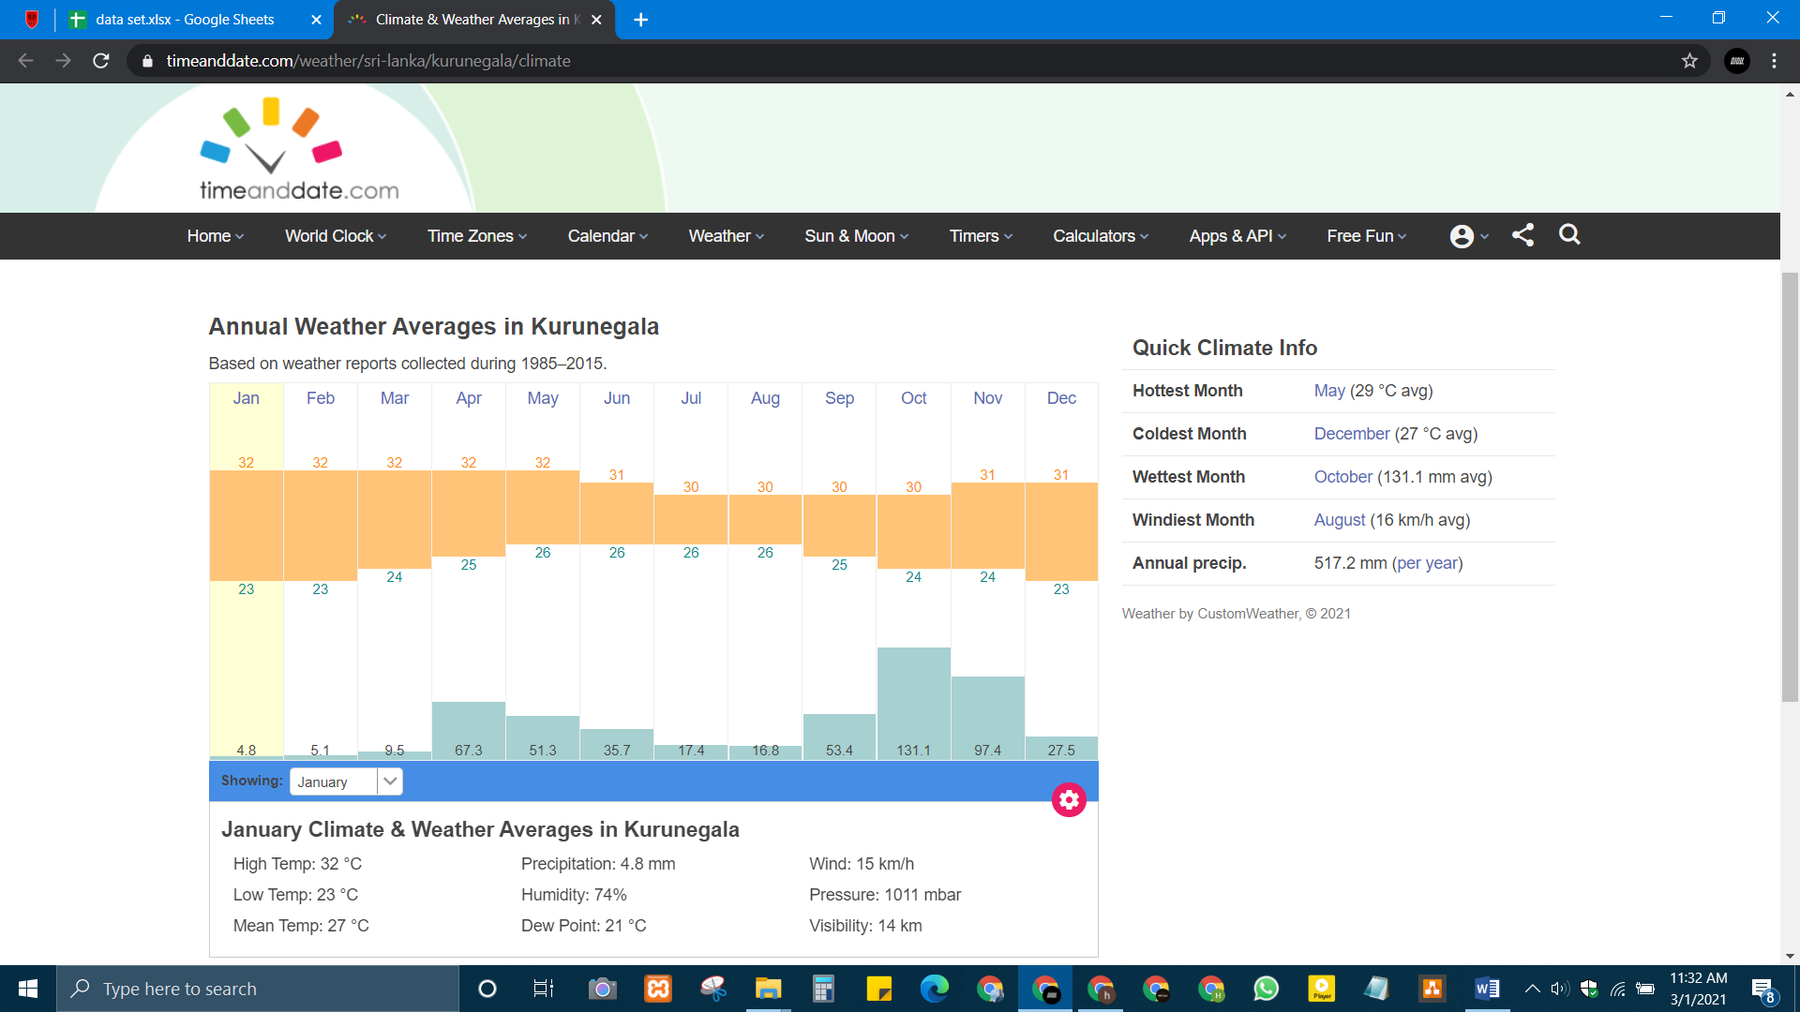

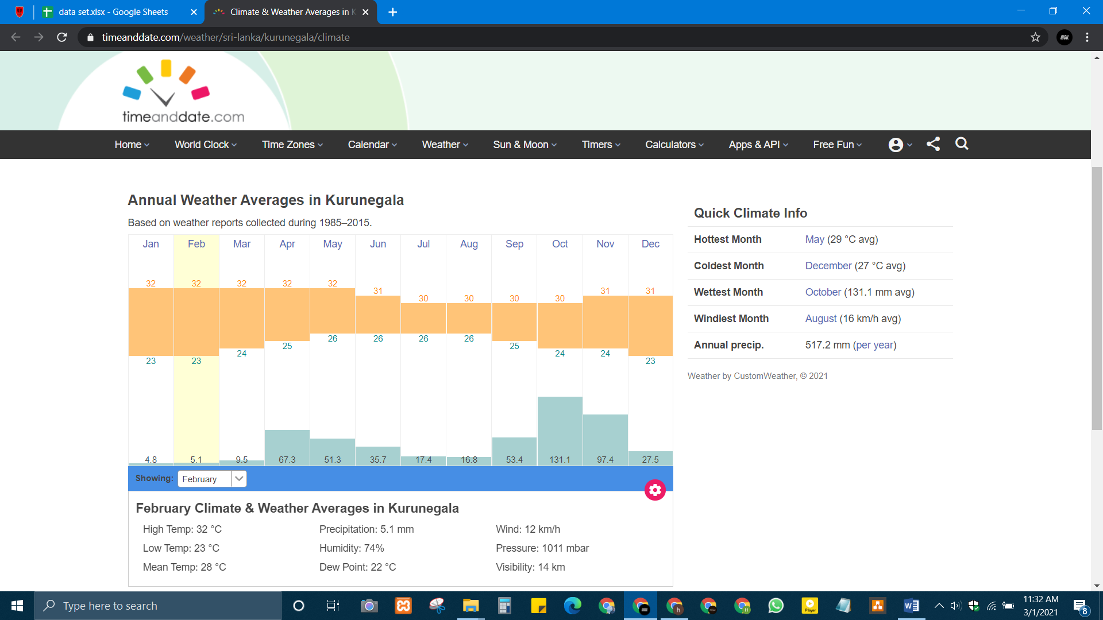

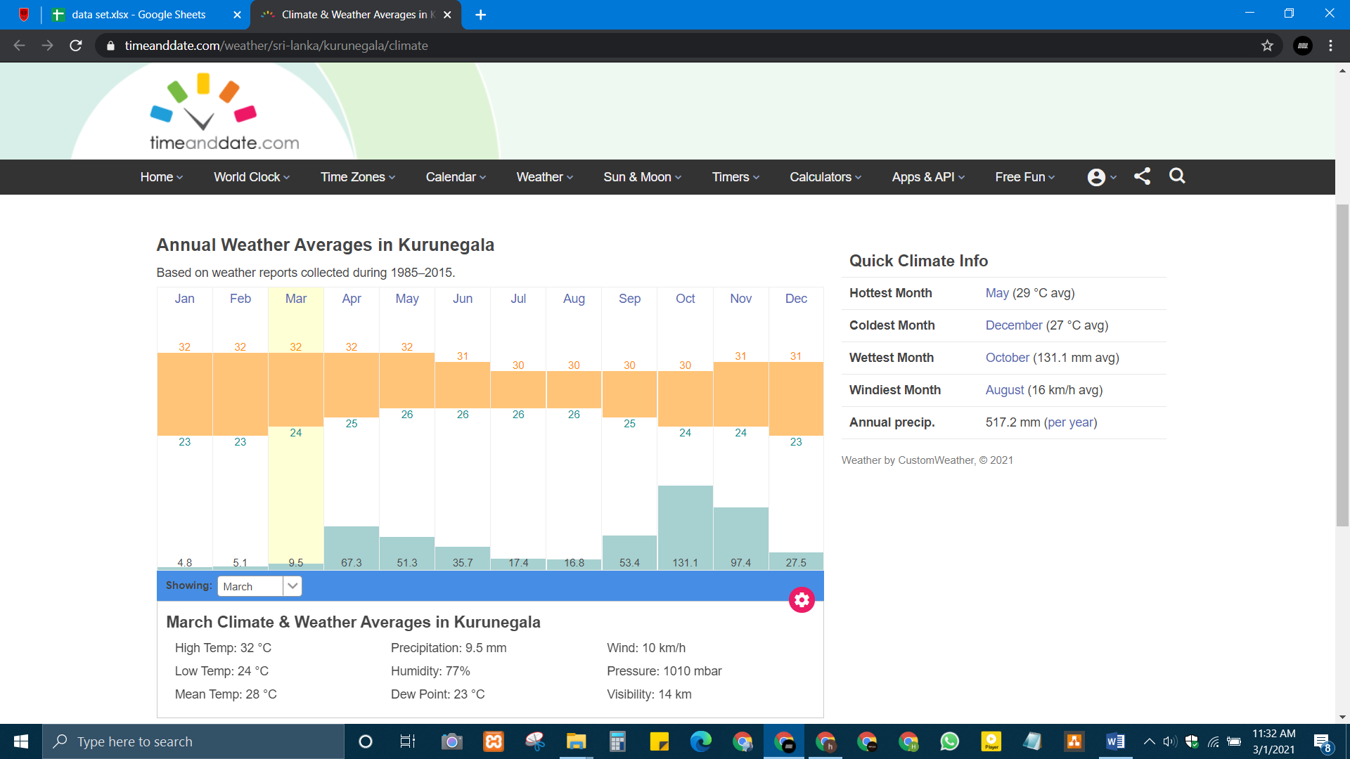

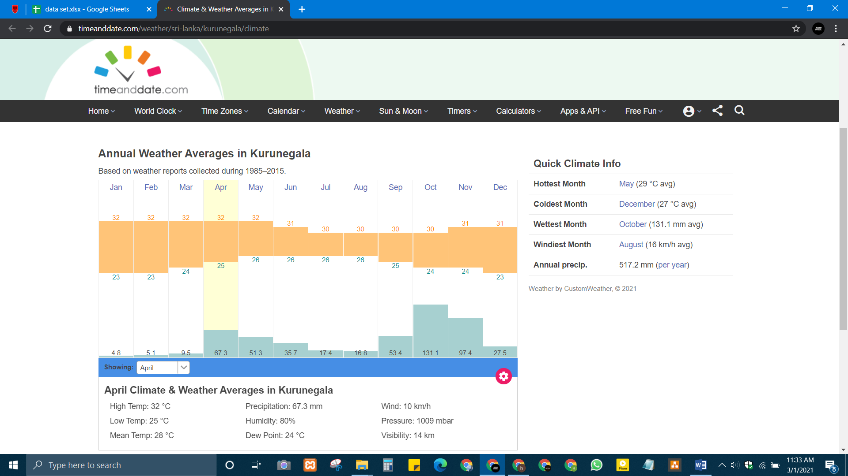

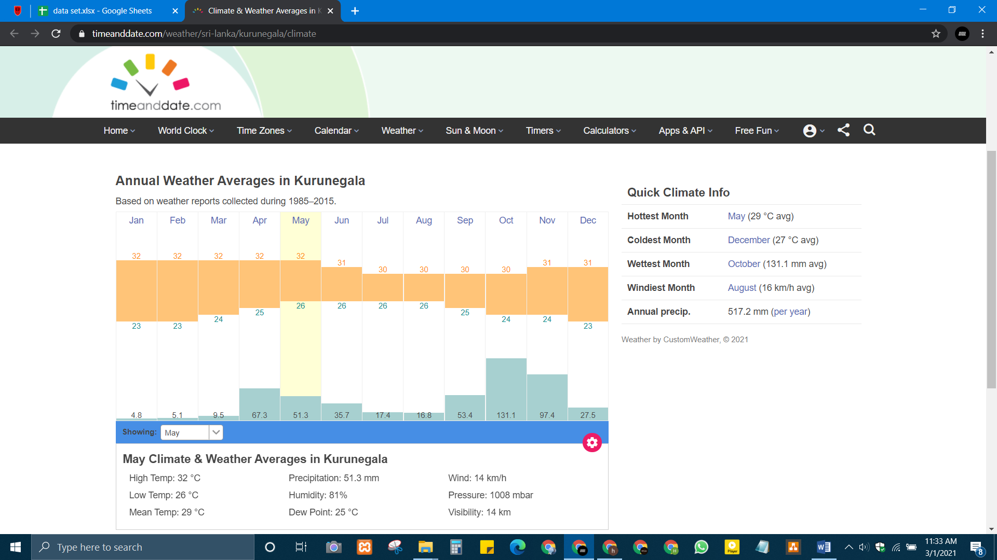

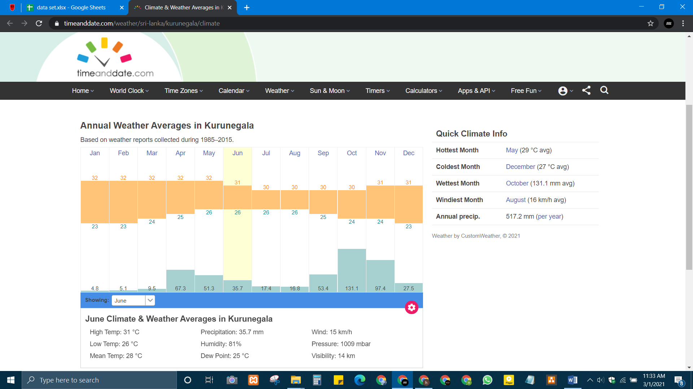

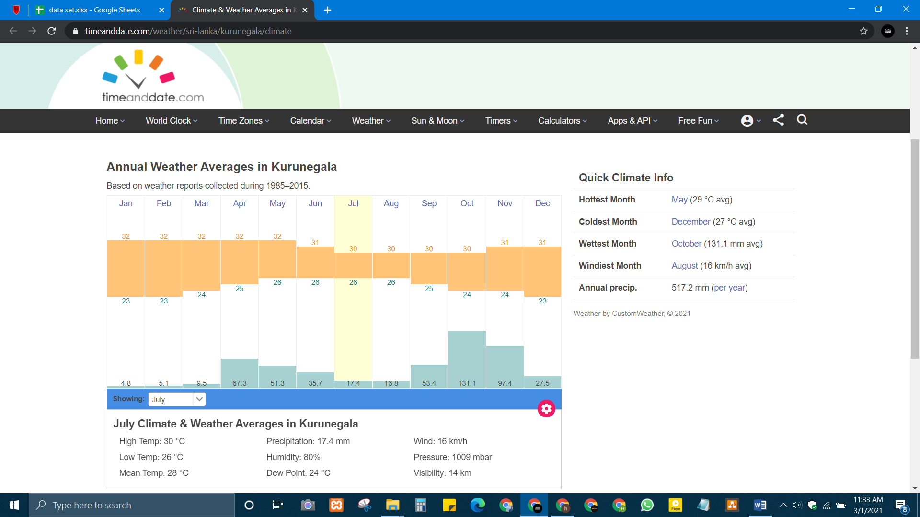

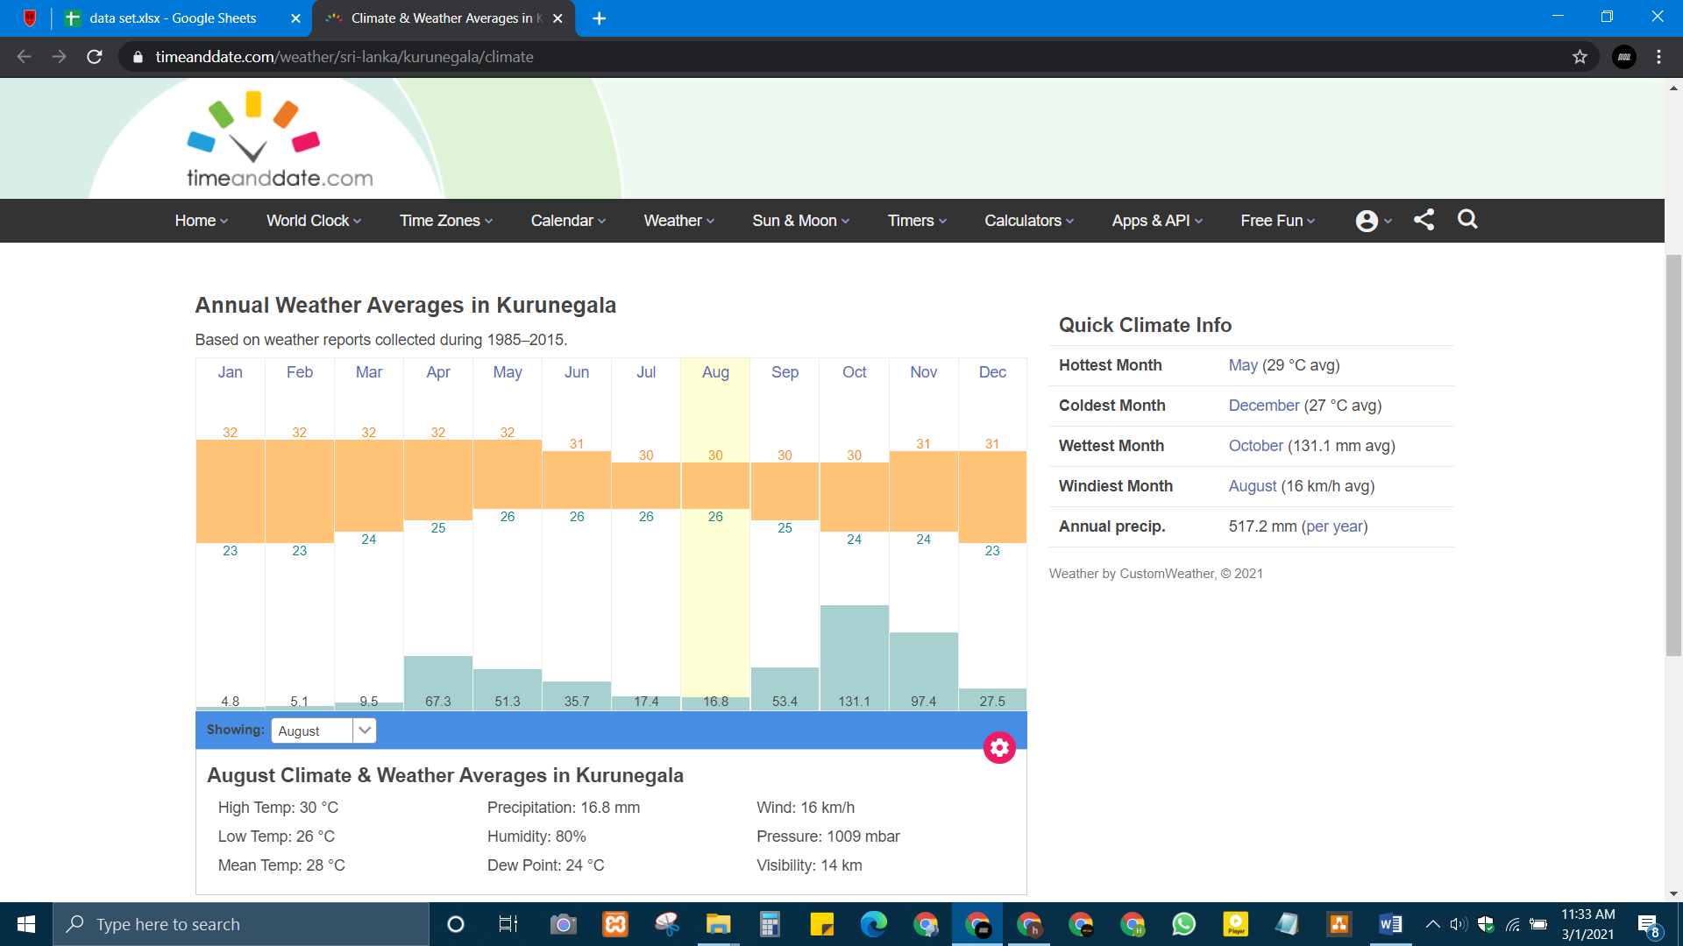

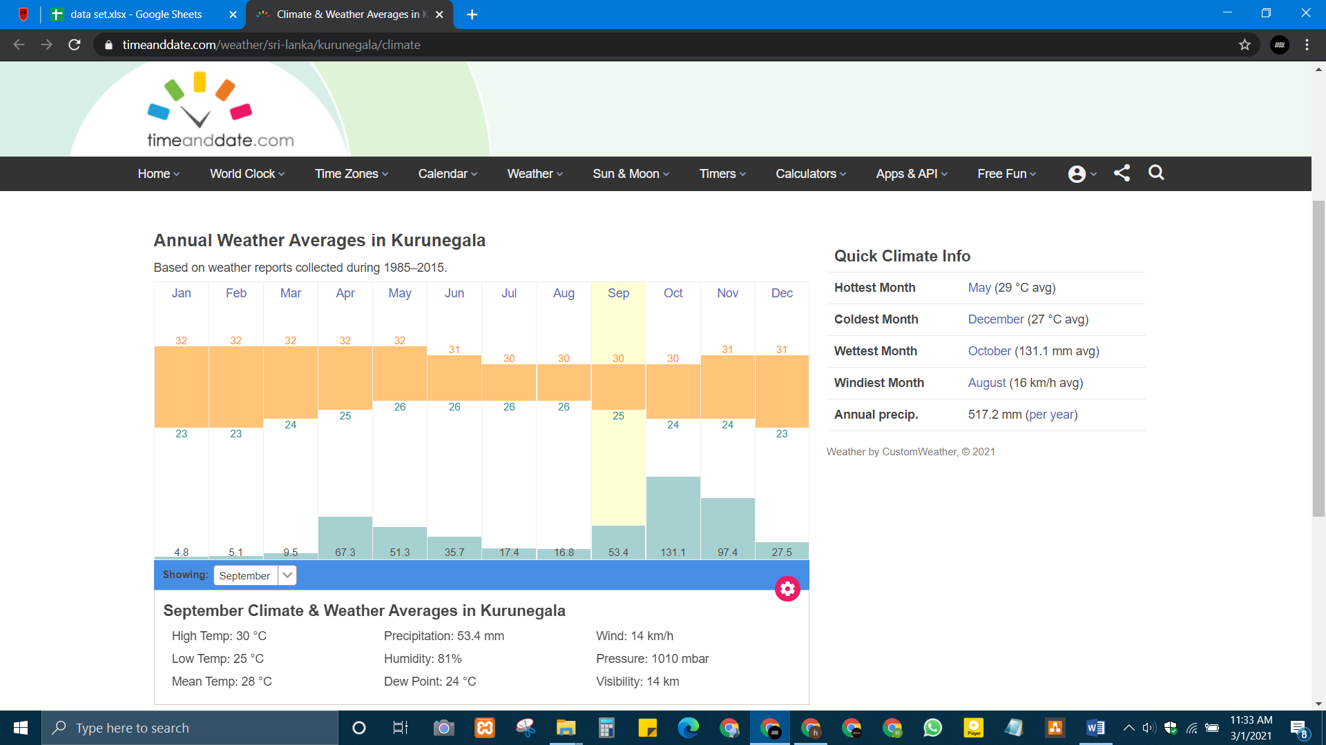

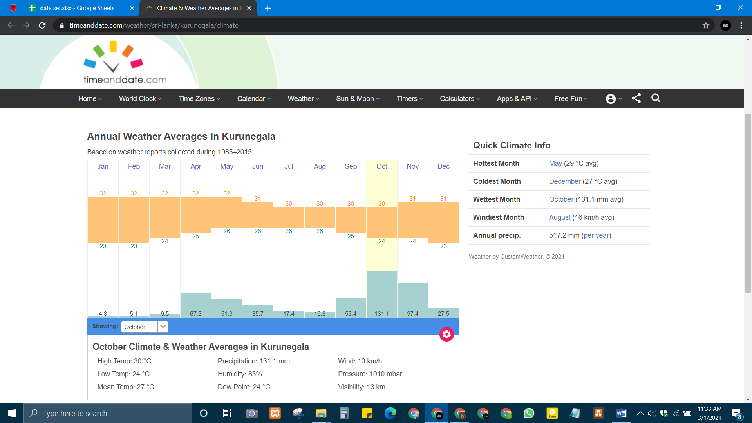

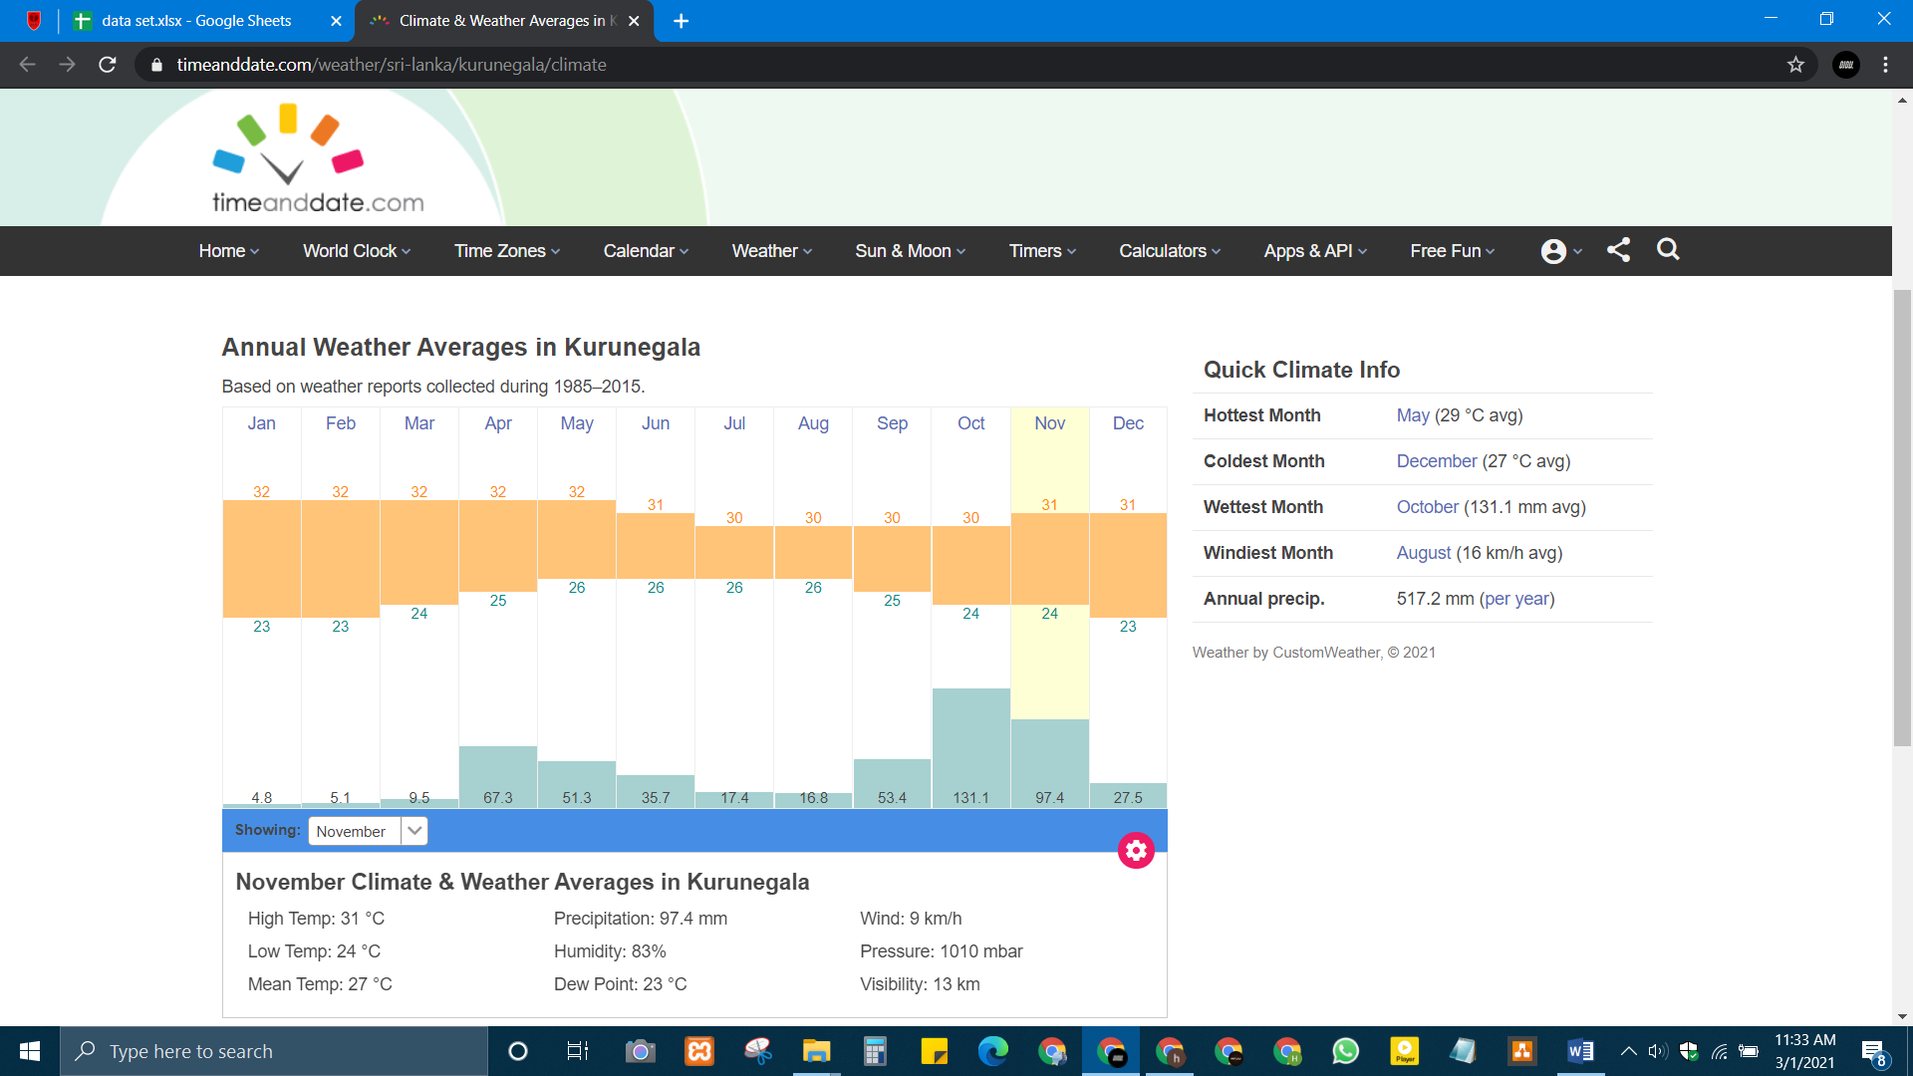

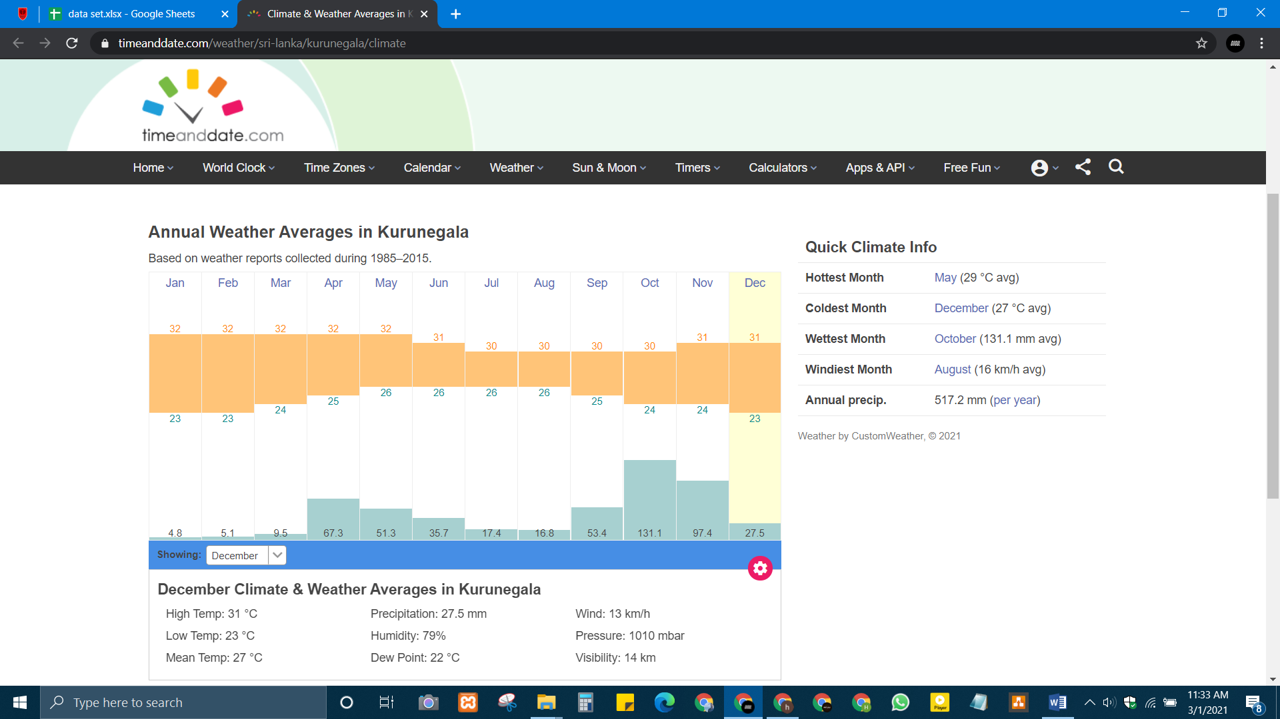

Reference - <https://www.timeanddate.com/weather/srilanka/kurunegala/climate>