**CURRICULUM VITAE**

**Rahul Kumar Rathaur** 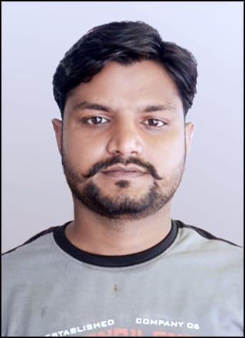

Mob no : 9616995551, 7750890286

Email id : rahulrathore169@gmail.com

**CAREER OBJECTIVE:**

**“ Looking for the Challenging and responsible opportunity, explore strength and potential in a professional organization to meet employers expectations.**

**ACADEMIC EDUCATION**

* High School from UP Board in the year 2010 with 1st Division.
* Intermediate from UP Board in the year 2012 with 1st Division.

**PROFESSIONAL QUALIFICATION**

* Graduation (B.Tech in Civil Engineering) from Dr. A P J Abdul Kalam Tecknical University in the year 2016 with 1st Division.

**WORK EXPEREINCE**

* Working experience for about 1.5 Years as Site Engineer In Kartik Construction Company In Odisha
* Working experience for about 6 Month as Site Manager cum Project Engineer In Kartik Construction Company In Shimla, Himachal Pradesh.
* Working experience for about 3 Years as Project Engineer In Kartik Construction Company In Allahabad

**COMPUTER SKILLS**

* CCC (B Grade).
* Internet Surfing.
* MS Office

**SKILLS**

* Public Speaking.
* Curriculum Planning.
* Positive Attitude.
* Possesses and analytical mind and a strong desire to pursue knowledge.

**STRENTH**

* Hardworking.
* Motivational creature.
* Self confidence.
* Good communication skills.

**PERSONAL / OTHER DETAIL**

Father’s Name : - Mr. Rajendra Prasad

Date of birth : - 03rd Feb 1994

Gender :- Male

Nationality : - Indian

Languages Known : - English, Hindi, Oriya

Marital Status :- Unmarried

Address :- Vill- Mai Hardo Patti, Post- Bahari, District- Sant Ravidas Nagar( Uttar Pradesh 221402)

**REFERENCES & DOCUMENTATION AVAILABLE ON REQUEST**

I hereby declare that the above mentioned statements are true and correct to the best of my knowledge.

**Date:**

**Place: Lucknow (Rahul Kumar Rathaur)**