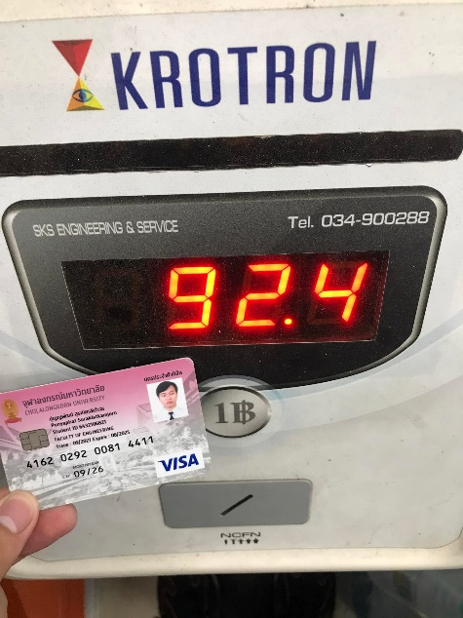Metabolism & Energy

เพศชาย

น้ำหนัก 92.4 kg

ส่วนสูง 174 cm

อายุ 19 ปี

Overall energy

Overall energy

Basal Metabolism Rate = 66 + (13.7 x Weight (kg) ) + (5 x Height (cm) ) - ( 6.8 x Age (yr) )

= 66 + (13.7 x 92.4) + (5 x 174) – (6.8 x 19)

= 2072.68

Physical Activity = 1.375

Energy needed = 2072.68 x 1.375 = 2849.935

Specific Dynamic Action = 2849.935 x 10% = 284.994

Total energy needed = 2849.935 + 284.994 = 3134.929

______________________________________________________________________________________________

CHO-containing food 55% = 3134.929 × 0.55 = 1724.21

Food-fat 30% = 3134.929 × 0.30 = 940.48

Protein 15% = 3134.929 × 0.15 = 470.24

Energy values of foods

CHO 4 kcal/g CHO-containing food = 1724.21 / 4 = 431.05 g

Fat 9 kcal/g Food-fat = 940.48 / 9 = 104.50 g

Protein 4 kcal/g Protein = 470.24 / 4 = 117.56 g