WEEK 3 ADVANCED DATA ANALYSIS REPORT
Advanced Data Analysis and Visualization in Logistics
Data Analyst Internship — Python

1. Executive Summary
This Week 3 project demonstrates an end-to-end exploratory data analysis (EDA) and visualization workflow for logistics operations using Python. A hypothetical dataset of 500 shipments is simulated to represent shipment volume, transport mode, distance, delivery time, transportation cost and service performance across five operating zones.
The analysis calculates central tendencies, examines distributions, compares transport modes and zones, evaluates relationships among numerical variables, and uses visualizations to identify operational patterns. Because the dataset is simulated, the numerical findings are illustrative rather than evidence about a real company.

2. Data Simulation and Dataset Structure
The hypothetical dataset contains 500 shipment records covering a 90-day period. It is designed to resemble the type of structured data that a logistics analyst might receive from a transport management or shipment system.
Variable | Type | Description | Analytical Use
Shipment_ID | ID | Unique shipment identifier | Record tracking
Date | Datetime | Shipment date | Time trends
Zone | Categorical | Operating/service zone | Geographic comparison
Transport_Mode | Categorical | Road, Rail or Air | Mode comparison
Shipment_Volume | Numeric | Shipment quantity/volume | Demand and capacity
Distance_km | Numeric | Estimated transport distance | Efficiency and cost
Delivery_Time_hr | Numeric | Delivery duration | Service performance
Transportation_Cost | Numeric | Estimated transport cost | Cost analysis
On_Time | Binary | 1 if within target, else 0 | Service reliability

3. Exploratory Data Analysis Methodology
The EDA follows four stages: (1) inspect the dataset and data types, (2) summarize central tendencies and spread, (3) visualize distributions and relationships, and (4) interpret patterns in relation to logistics performance.
Overall, the simulated dataset has an average shipment volume of 74.9 units and an average transport distance of 160.7 km. Mean delivery time is 4.38 hours, compared with a median of 4.01 hours. Mean transportation cost is 500.62, with a median of 419.10. The overall simulated on-time rate is 87.4%.

4. Central Tendency and Descriptive Statistics
Variable | Mean | Median | Std. Dev. | Minimum | Maximum
Shipment_Volume | 74.90 | 69.25 | 36.73 | 9.30 | 234.00
Distance_km | 160.66 | 146.40 | 91.66 | 11.00 | 629.40
Delivery_Time_hr | 4.38 | 4.01 | 2.33 | 0.50 | 16.33
Transportation_Cost | 500.62 | 419.10 | 348.98 | 86.07 | 2961.66
Mean and median values are compared because a substantial difference between them can indicate skewness or unusually large observations. Standard deviation describes the variability of each measure and helps identify metrics that have wide operational variation.

5. Visualization 1 — Delivery-Time Distribution
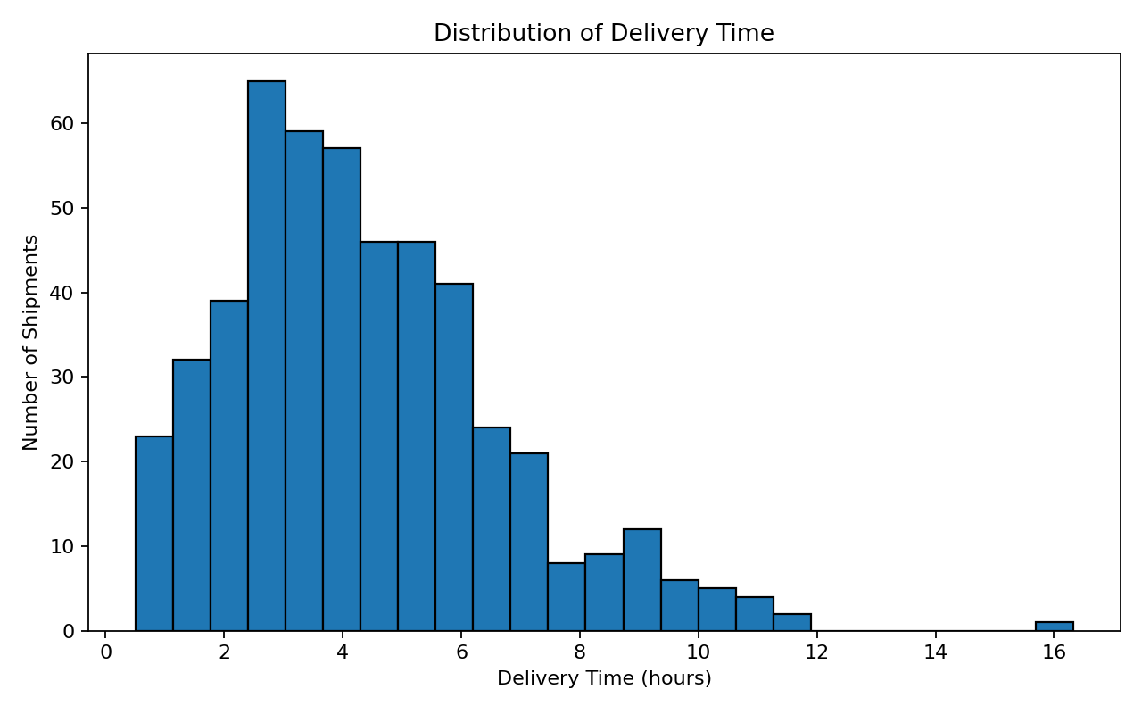
Interpretation: The histogram shows how delivery times are distributed across shipments. It helps identify the typical delivery-time range, skewness and unusually long trips. A logistics manager can use this view to determine whether a mean delivery time adequately represents normal operations or whether the distribution is highly variable.

6. Visualization 2 — Average Delivery Time by Transport Mode
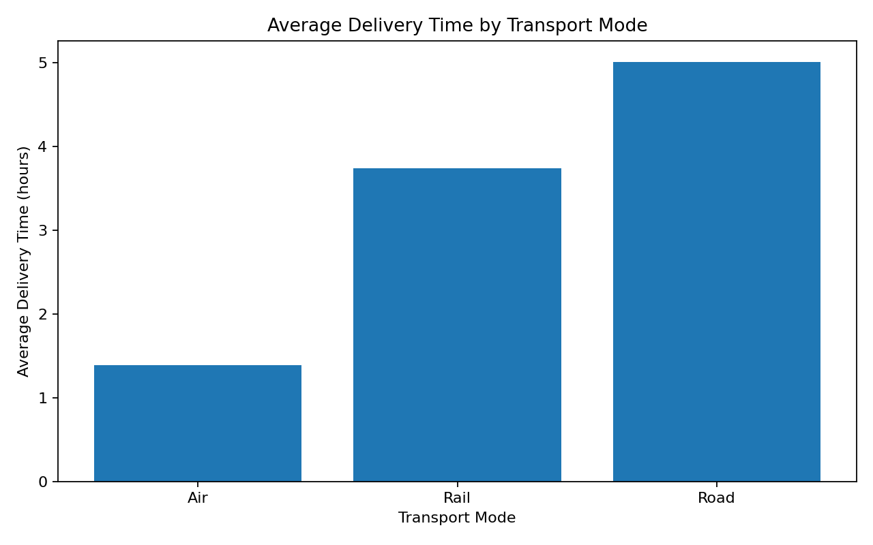
Interpretation: The bar chart compares the average delivery time of Road, Rail and Air shipments. The simulated data show that air shipments have the shortest travel time, while road and rail have longer average times. In practice, such a comparison would help planners balance speed, cost, capacity and service requirements rather than selecting a transport mode using time alone.
Mode-level summary:
Mode | Shipments | Avg Time (hr) | Avg Cost | On-Time (%)
Air | 49.0 | 1.39 | 1178.06 | 100.0
Rail | 107.0 | 3.74 | 311.28 | 97.0
Road | 344.0 | 5.01 | 463.01 | 83.0

7. Visualization 3 — Shipment Volume vs Transportation Cost
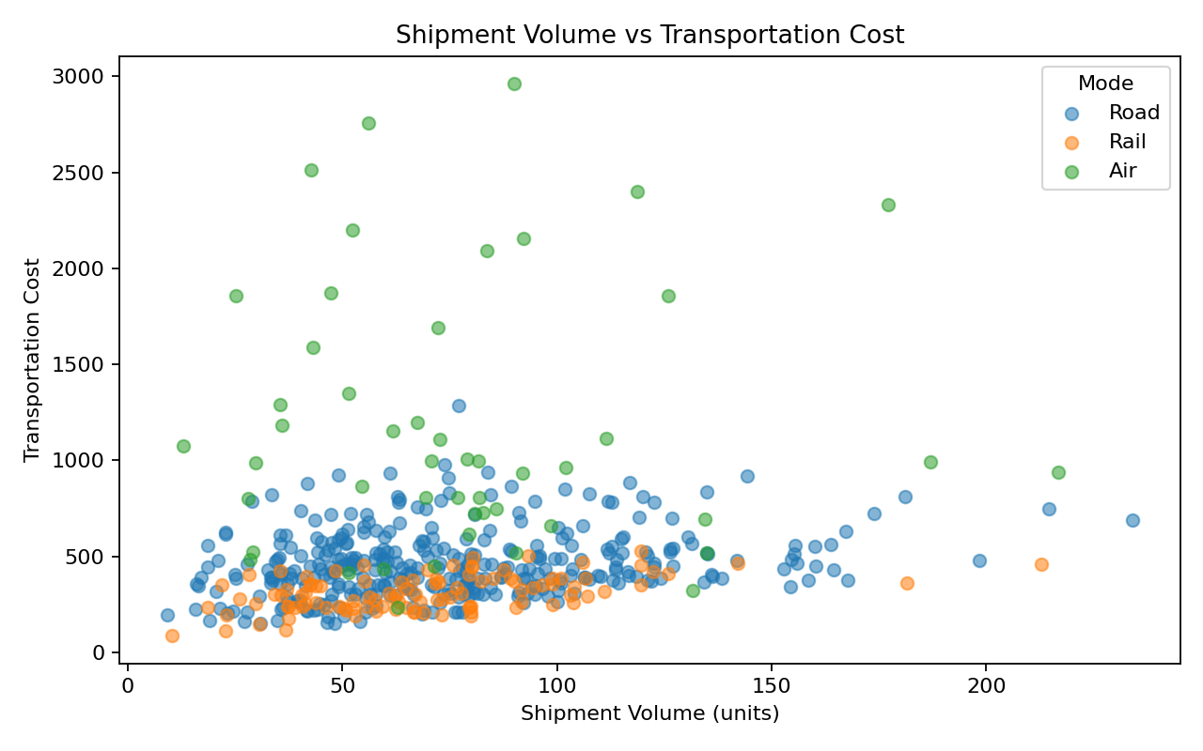
Interpretation: The scatter plot examines whether larger shipments tend to have higher transportation costs. A positive relationship would indicate that shipment volume is an important cost driver. The separate markers for transport modes also show whether the cost pattern differs by mode. This is useful when evaluating consolidation and mode-selection strategies.

8. Visualization 4 — Average Transportation Cost by Zone
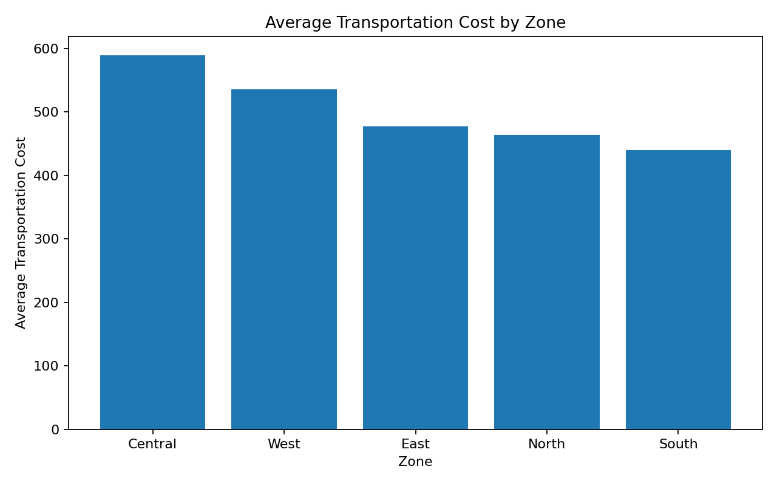
Interpretation: The zone comparison highlights areas with relatively high average transportation cost. A high-cost zone may require further investigation into distance, shipment mix, transport mode, service constraints or route availability. Visualization makes it easier to prioritize operational investigation.

9. Visualization 5 — Correlation Analysis
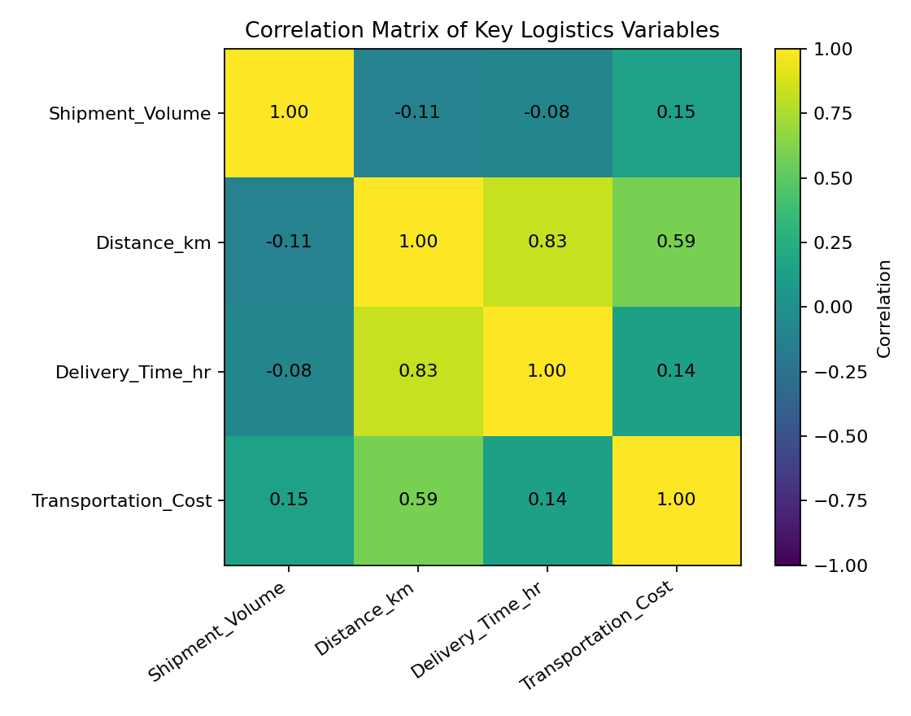
Interpretation: The correlation matrix summarizes linear relationships among shipment volume, distance, delivery time and cost. A strong positive correlation does not prove causation, but it can identify variables worth investigating in later regression or predictive modeling. Correlation should be interpreted alongside operational knowledge.

10. Key Analytical Insights
- Delivery time varies across shipments, with a simulated mean of 4.38 hours and median of 4.01 hours. The distribution is more informative than a single average.
- Transport mode is an important segmentation variable because delivery speed and cost characteristics differ by mode.
- Shipment volume and transportation cost should be examined together because larger shipments can increase cost, but the relationship can vary by transport mode.
- Zone-level cost comparisons can reveal potential bottlenecks or high-cost service areas that deserve deeper investigation.
- Distance is a logical operational driver of delivery time and transportation cost, but other factors such as mode, congestion, handling time and service constraints can also influence performance.
- Correlation analysis is useful for identifying candidate predictors, but it should not be interpreted as proof of causation.

11. Python Code Used for the Analysis
import pandas as pd
import matplotlib.pyplot as plt
df = pd.read_csv("week3_hypothetical_logistics_dataset.csv")
# Basic inspection
print(df.shape)
print(df.info())
print(df.describe())
# Central tendency
print(df["Delivery_Time_hr"].mean())
print(df["Delivery_Time_hr"].median())
# Distribution
plt.hist(df["Delivery_Time_hr"], bins=25)
plt.xlabel("Delivery Time (hours)")
plt.ylabel("Number of Shipments")
plt.title("Distribution of Delivery Time")
plt.show()
# Group comparison
mode_avg = df.groupby("Transport_Mode")["Delivery_Time_hr"].mean()
mode_avg.plot(kind="bar", title="Average Delivery Time by Transport Mode")
plt.ylabel("Hours")
plt.show()
# Relationship analysis
print(df[[
"Shipment_Volume", "Distance_km",
"Delivery_Time_hr", "Transportation_Cost"
]].corr())

12. How the Visualizations Support Logistics Decisions
Visualization | Question Answered | Decision Support
Histogram | What is the normal delivery-time pattern? | Set realistic service expectations and detect long delays.
Bar chart | Which transport mode is faster? | Support transport-mode comparison.
Scatter plot | Does volume relate to cost? | Identify cost drivers and consolidation opportunities.
Zone bar chart | Which zones have higher costs? | Prioritize zone-level investigation.
Correlation matrix | Which numeric variables move together? | Select candidate variables for further modeling.

13. Recommendations
- Track delivery-time distributions rather than relying only on average delivery time.
- Compare transport modes using a balanced view of speed, cost and on-time performance.
- Investigate high-cost zones using distance, shipment volume and mode mix before changing operations.
- Use correlation analysis as an exploratory tool and validate important relationships with regression or other statistical methods.
- For a production system, add actual route, fuel, driver, warehouse handling, congestion and service-time variables to improve explanatory power.
- Repeat the analysis over time so that planners can detect changes in demand, cost and service performance.

14. Limitations
- The dataset is entirely simulated for academic demonstration and does not represent a real logistics company.
- The cost and delivery-time formulas are assumptions created for the simulation.
- No real road-network routing, weather, congestion, warehouse processing time or driver constraints are included.
- The analysis is descriptive and exploratory; it does not establish causal relationships.
- The results should not be used directly for real operational decisions without validation against actual business data.

15. Conclusion
This Week 3 analysis demonstrates how Python can transform logistics records into interpretable evidence. Descriptive statistics establish the scale and variability of key metrics, while visualizations reveal distributions, group differences and relationships that are difficult to identify from raw rows alone.
The main analytical value is not simply producing charts, but connecting each chart to a logistics question and a potential decision. In a real organization, this workflow could support service-level monitoring, transport-mode selection, cost-driver analysis and bottleneck identification. The next stage could extend the analysis into predictive modeling and optimization using validated operational data.

16. References and Tools
- Python documentation: https://docs.python.org/3/
- Pandas documentation: https://pandas.pydata.org/docs/
- Matplotlib documentation: https://matplotlib.org/stable/
- scikit-learn documentation: https://scikit-learn.org/stable/

